SEC Form 4

FORM 4

Check this box if no longer subject to Section
- Form 4 or Form 5 obligations may continue. See Instruction 1(b).

UNITED STATES SECURITIES AND EXCHANGE COMMISSION
Washington, D.C. 20549
Washington, D.C. 20549 |  | OMB APPROVAL
STATEMENT OF CHANGES IN BENEFICIAL OWNERSHIP
STATEMENT OF CHANGES IN BENEFICIAL OWNERSHIP |  | OMB Number: | 3235-0287
 |  | Estimated average burden
Filed pursuant to Section 16(a) of the Securities Exchange Act of 1934 |  | hours per response: | 0.5
or Section 30(h) of the Investment Company Act of 1940
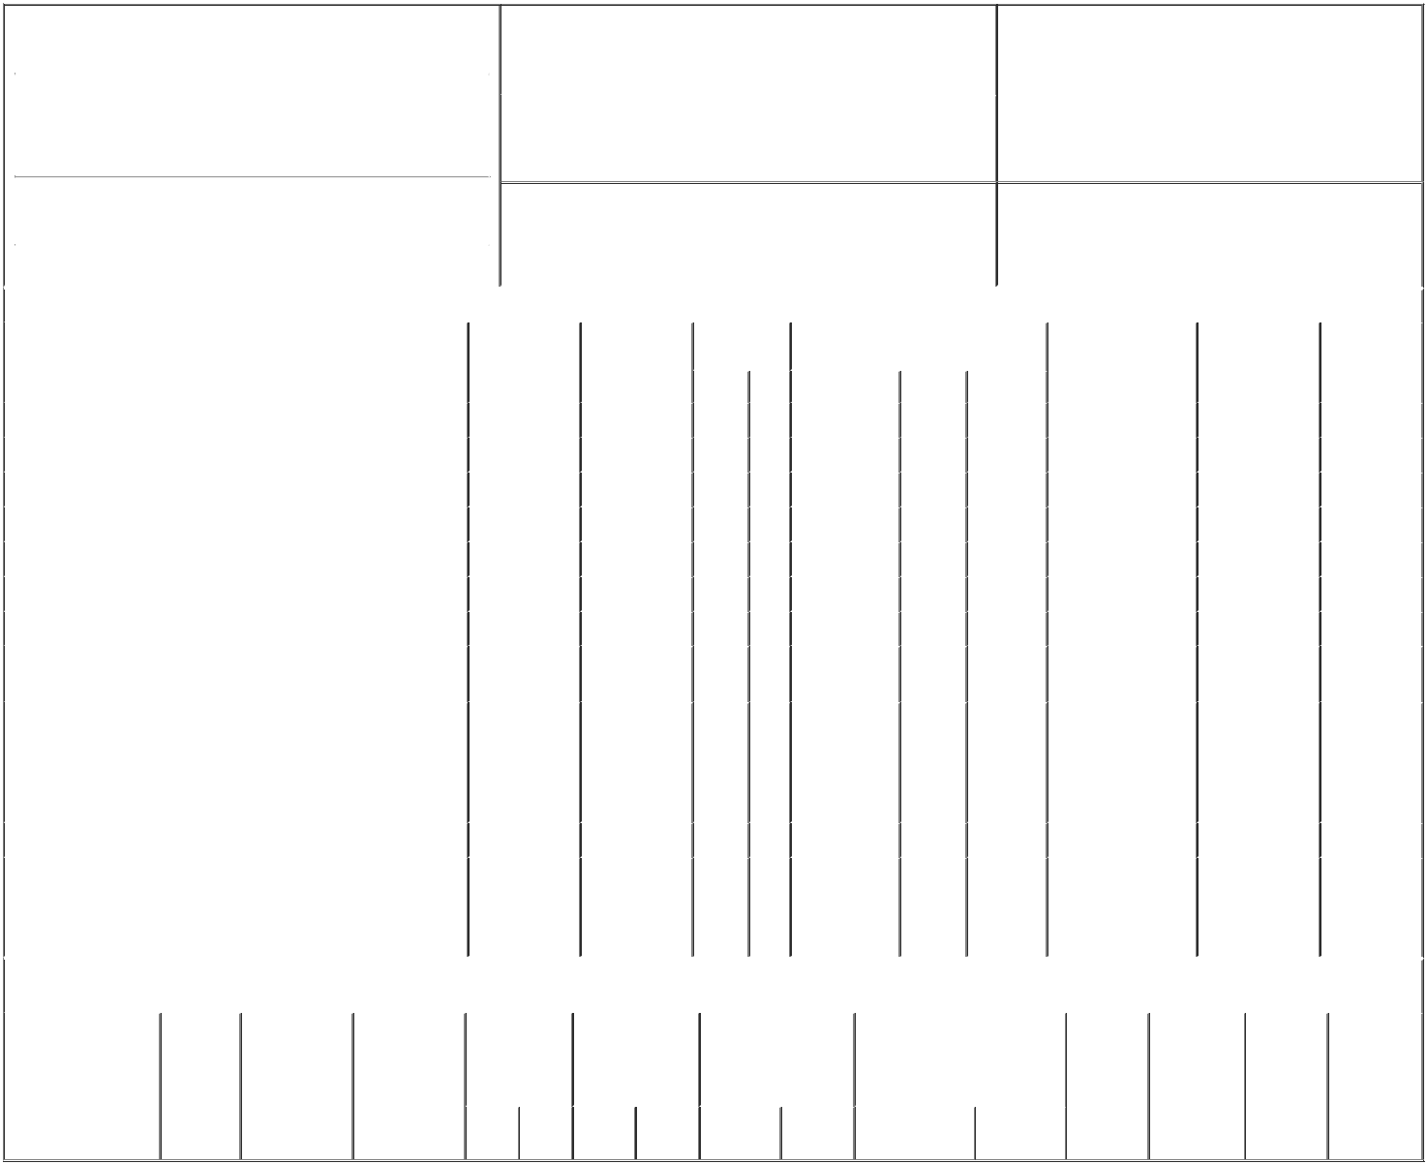

1. Name and Address of Reporting Person* |  |  |  | 2. |  |  |  | Issuer Name and Ticker or Trading Symbol
 | KOTICK ROBERT A |  |  |  |  |  | Activision Blizzard, Inc. [ ATVI ]
 | (Last) | (First) |  | (Middle)
 | (Last) |  |  |  |  |  |  | Date of Earliest Transaction (Month/Day/Year)
 | C/O ACTIVISION BLIZZARD, INC. |  |  | 3.
 |  |  |  | 08/07/2021

3100 OCEAN PARK BOULEVARD

- Relationship of Reporting Person(s) to Issuer (Check all applicable)

X | Director | 10% Owner
X | Officer (give title | Other (specify below)
X | below) | Other (specify below)

Chief Executive Officer

 | (Street) |  |  |  |  |  | 4. If Amendment, Date of Original Filed (Month/Day/Year) |  |  |  |  |  |  |  | 6. Individual or Joint/Group Filing (Check Applicable Line)
 |  | SANTA MONICA | CA | 90405 |  |  |  |  |  |  |  |  |  |  | X |  |  | Form filed by One Reporting Person
 |  |  |  |  |  |  |  |  |  |  |  |  |  |  |  |  |  | Form filed by More than One Reporting Person
 |  | (City) | (State) | (Zip)
 |  |  |  |  | Table I - Non-Derivative Securities Acquired, Disposed of, or Beneficially Owned
 | 1. Title of Security (Instr. 3) |  |  |  |  | 2. Transaction |  | 2A. Deemed |  | 3. Transaction |  | 4. Securities Acquired (A) or Disposed Of |  |  |  |  | 5. Amount of Securities |  |  | 6. Ownership |  | 7. Nature of
 |  |  |  |  |  | Date |  | Execution Date, |  | Code (Instr. 8) |  | (D) (Instr. 3, 4 and 5) |  |  |  |  | Beneficially Owned |  |  | Form: Direct (D) or |  | Indirect
 |  |  |  |  |  | (Month/Day/Year) |  | if any |  |  |  |  |  |  |  |  | Following Reported |  |  | Indirect (I) (Instr. 4) |  | Beneficial
 |  |  |  |  |  |  |  | (Month/Day/Year) |  | Code | V | Amount |  | (A) or (D) | Price |  | Transaction(s) (Instr. 3 |  |  |  |  | Ownership
 |  |  |  |  |  |  |  |  |  | Code | V | Amount |  | (A) or (D) | Price |  | and 4) |  |  |  |  | (Instr. 4)
 | Common Stock, par value $0.000001 per share |  |  |  |  | 08/07/2021 |  |  |  | A |  | 116,317⁽¹⁾ |  | A | $0 |  | 4,889,884 |  |  |  | D
 | Common Stock, par value $0.000001 per share |  |  |  |  | 08/07/2021 |  |  |  | F |  | 183,723⁽¹⁾ |  | D | $0 |  | 4,706,161 |  |  |  | D
 | Common Stock, par value $0.000001 per share |  |  |  |  | 08/07/2021 |  |  |  | F |  | 231,624⁽²⁾ |  | D | $0 |  | 4,474,537 |  |  |  | D
 | Common Stock, par value $0.000001 per share |  |  |  |  | 08/07/2021 |  |  |  | F |  | 71,381⁽²⁾ |  | D | $0 |  | 4,403,156 |  |  |  | D
 | Common Stock, par value $0.000001 per share |  |  |  |  | 08/07/2021 |  |  |  | F |  | 140,626⁽²⁾ |  | D | $0 |  | 4,262,530 |  |  |  | D
 | Common Stock, par value $0.000001 per share |  |  |  |  | 08/07/2021 |  |  |  | F |  | 70,067⁽²⁾ |  | D | $0 |  | 4,192,463 |  |  |  | D
 | Common Stock, par value $0.000001 per share |  |  |  |  | 08/07/2021 |  |  |  | F |  | 139,789⁽²⁾ |  | D | $0 |  | 3,908,698⁽³⁾ |  |  |  | D
 | Common Stock, par value $0.000001 per share |  |  |  |  |  |  |  |  |  |  |  |  |  |  |  | 1 |  |  |  | I | By ASAC II
 |  |  |  |  |  |  |  |  |  |  |  |  |  |  |  |  |  |  |  |  | I | LLC⁽⁴⁾
 |  |  |  |  |  |  |  |  |  |  |  |  |  |  |  |  |  |  |  |  |  | By UTMAs
 |  |  |  |  |  |  |  |  |  |  |  |  |  |  |  |  |  |  |  |  |  | for the
 | Common Stock, par value $0.000001 per share |  |  |  |  |  |  |  |  |  |  |  |  |  |  |  | 4,800 |  |  |  | I | benefit of
 |  |  |  |  |  |  |  |  |  |  |  |  |  |  |  |  |  |  |  |  |  | minor
 |  |  |  |  |  |  |  |  |  |  |  |  |  |  |  |  |  |  |  |  |  | children⁽⁵⁾
 | Common Stock, par value $0.000001 per share |  |  |  |  |  |  |  |  |  |  |  |  |  |  |  | 36,918 |  |  |  | I | By GRATs⁽⁶⁾
 |  |  |  |  |  |  |  |  |  |  |  |  |  |  |  |  |  |  |  |  |  | By
 | Common Stock, par value $0.000001 per share |  |  |  |  |  |  |  |  |  |  |  |  |  |  |  | 2 |  |  |  | I | Delmonte
 |  |  |  |  |  |  |  |  |  |  |  |  |  |  |  |  |  |  |  |  | I | Investments,
 |  |  |  |  |  |  |  |  |  |  |  |  |  |  |  |  |  |  |  |  |  | _{LLC}(7)
 |  |  |  |  | Table II - Derivative Securities Acquired, Disposed of, or Beneficially Owned
 |  |  |  |  |  | (e.g., puts, calls, warrants, options, convertible securities)
 | 1. Title of Derivative |  | 2. | 3. Transaction | 3A. Deemed | 4. Transaction |  | 5. Number of |  | 6. Date Exercisable and |  |  | 7. Title and Amount of Securities |  |  |  |  | 8. Price of | 9. Number of |  | 10. | 11. Nature of
 | Security (Instr. 3) |  | Conversion | Date | Execution Date, | Code (Instr. 8) |  | Derivative |  | Expiration Date |  |  | Underlying Derivative Security |  |  |  |  | Derivative | derivative |  | Ownership | Indirect
 |  |  | or Exercise | (Month/Day/Year) | if any |  |  | Securities Acquired |  | (Month/Day/Year) |  |  | (Instr. 3 and 4) |  |  |  |  | Security | Securities |  | Form: | Beneficial
 |  |  | Price of |  | (Month/Day/Year) |  |  | (A) or Disposed of |  |  |  |  |  |  |  |  |  | (Instr. 5) | Beneficially |  | Direct (D) or | Ownership
 |  |  | Derivative |  |  |  |  | (D) (Instr. 3, 4 and |  |  |  |  |  |  |  |  |  |  | Owned |  | Indirect (I) | (Instr. 4)
 |  |  | Security |  |  |  |  | 5) |  |  |  |  |  |  |  |  |  |  | Following |  | (Instr. 4)
 |  |  |  |  |  |  |  |  |  |  |  |  |  |  |  |  |  |  | Reported
 |  |  |  |  |  |  |  |  |  |  |  |  |  |  | Amount or |  |  |  | Transaction(s)
 |  |  |  |  |  |  |  |  |  | Date |  | Expiration |  |  | Number of |  |  |  | (Instr. 4)
 |  |  |  |  |  | Code V |  | (A) | (D) | Exercisable |  | Date | Title |  | Shares

Explanation of Responses:

- The performance conditions underlying this previously disclosed performance-based restricted stock unit award were achieved at the maximum level and as a result the reporting person received 116,317 shares of the Company's common stock in excess of shares previously disclosed at the target level. Pursuant to the terms of the award agreement, the Company withheld 183,723 of the shares otherwise earned in order to satisfy the resulting tax withholding obligation.

- The performance conditions underlying these previously disclosed performance-based restricted stock unit awards were achieved at the maximum level. Pursuant to the terms of the award agreements, the Company withheld an aggregate of 653,487 shares of the shares otherwise earned in order to satisfy the resulting tax withholding obligation.

- The performance conditions underlying the performance-based restricted stock unit award previously disclosed on August 9, 2017 were not achieved, therefore 143,976 shares did not vest and have been removed from reported holdings.

- The reporting person and Brian G. Kelly are the managers of ASAC II LLC. The reporting person disclaims beneficial ownership of the Company's common stock held by ASAC II LLC except to the extent of his pecuniary interest therein.

- The reporting person disclaims beneficial ownership of the Company's common stock held by these UTMAs except to the extent of his pecuniary interest therein.

- These shares are held by grantor retained annuity trusts for the benefit of the reporting person's children, of which the reporting person is the trustee.

- Reflects shares of the Company's common stock indirectly beneficially owned through Delmonte Investments, LLC, of which the reporting person is a member and manager.

Remarks:

 | /s/ Robert A. Kotick |  | 08/10/2021
 | ** Signature of Reporting Person |  | Date
Reminder: Report on a separate line for each class of securities beneficially owned directly or indirectly.
* If the form is filed by more than one reporting person, see Instruction 4 (b)(v).
** Intentional misstatements or omissions of facts constitute Federal Criminal Violations See 18 U.S.C. 1001 and 15 U.S.C. 78ff(a).
Note: File three copies of this Form, one of which must be manually signed. If space is insufficient, see Instruction 6 for procedure.
Persons who respond to the collection of information contained in this form are not required to respond unless the form displays a currently valid OMB Number.



