UNITED STATES

SECURITIES AND EXCHANGE COMMISSION

Washington, D.C. 20549

SCHEDULE 14A

Proxy Statement Pursuant to Section 14(a) of the Securities

Exchange Act of 1934 (Amendment No. 1)

Filed by the Registrant Filed by a Party other than the Registrant

Check the appropriate box:
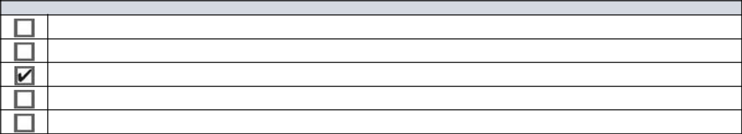

Preliminary Proxy Statement

CONFIDENTIAL, FOR USE OF THE COMMISSION ONLY (AS PERMITTED BY RULE 14a-6(e)(2))

Definitive Proxy Statement

Definitive Additional Materials

Soliciting Material Pursuant to §240.14a-12

ACTIVISION BLIZZARD, INC.
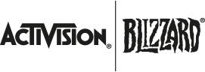

(Name of Registrant as Specified In Its Charter)

(Name of Person(s) Filing Proxy Statement, if other than the Registrant)

Payment of Filing Fee (Check the appropriate box):
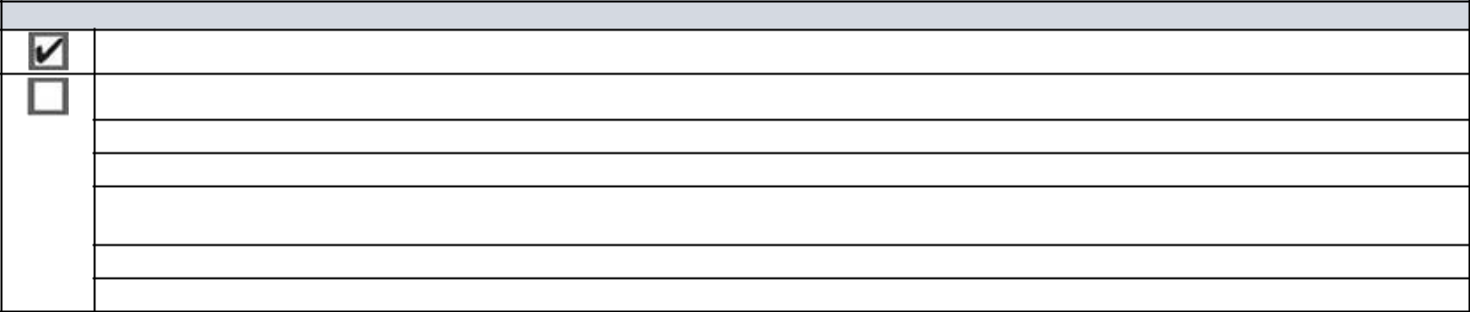

No fee required.

Fee computed on table below per Exchange Act Rules 14a-6(i)(4) and 0-11.

- Title of each class of securities to which transaction applies:

- Aggregate number of securities to which transaction applies:

- Per unit price or other underlying value of transaction computed pursuant to Exchange Act Rule 0-11 (set forth the amount on which the filing fee is calculated and state how it was determined):

- Proposed maximum aggregate value of transaction:

- Total fee paid:

Explanatory Note

We are filing this definitive revised proxy statement of Activision Blizzard, Inc. (the “Company”) for the 2021 Annual Meeting of Shareholders to correct certain typographical, transcription and formatting errors contained in the definitive proxy statement of the Company that was filed with the Securities and Exchange Commission on April 30, 2021.

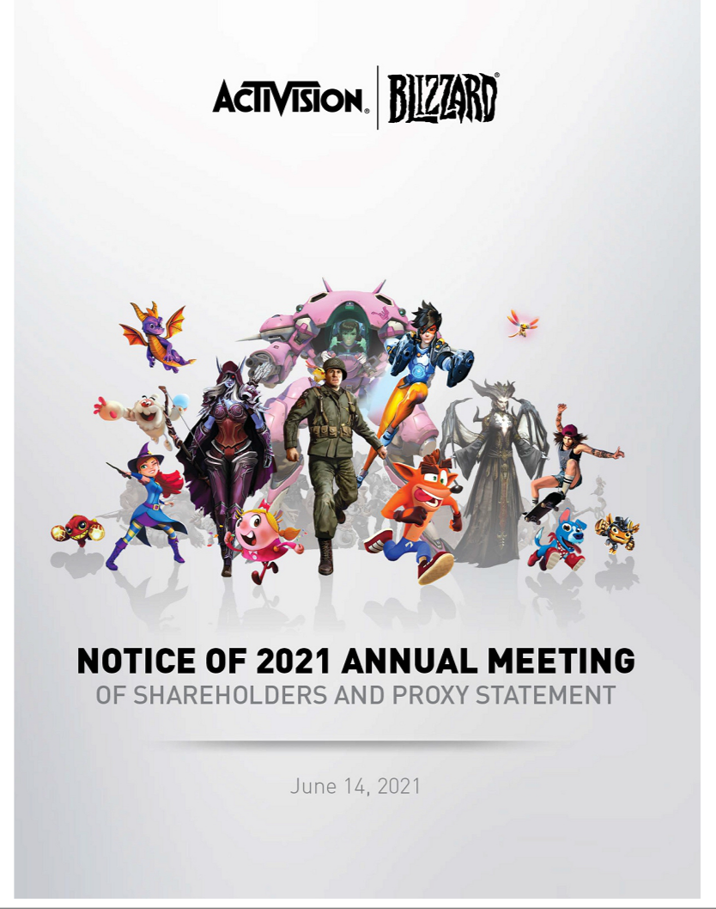

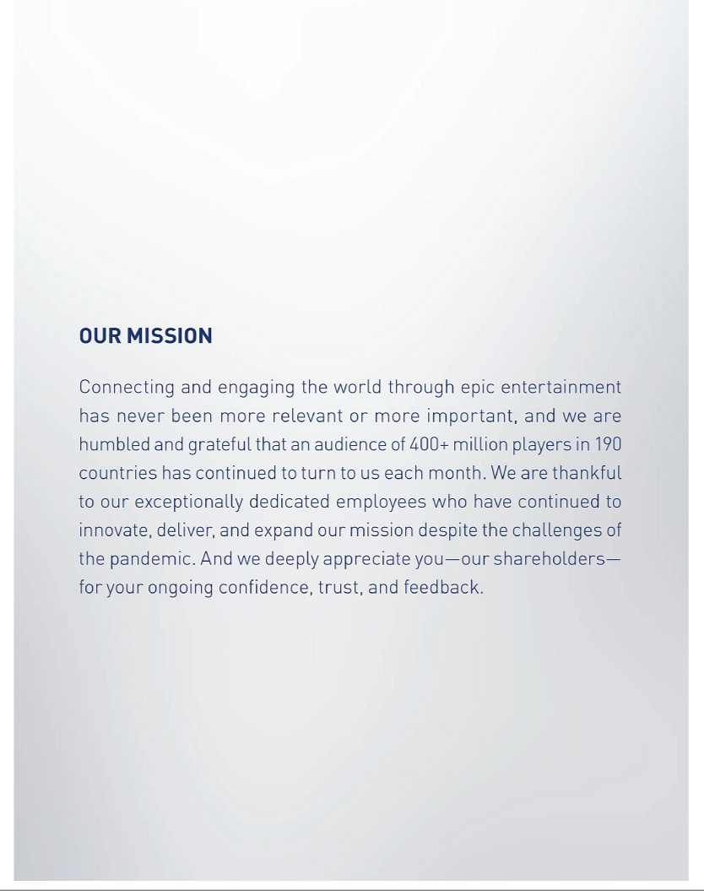

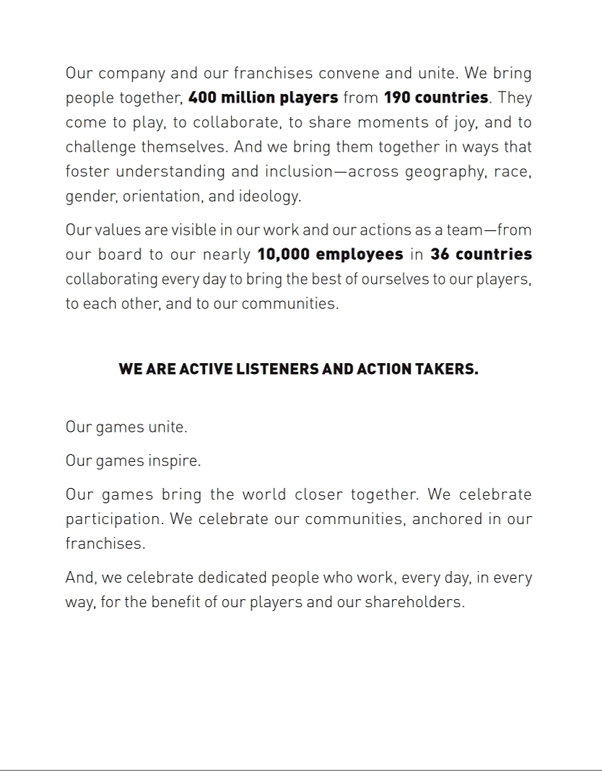

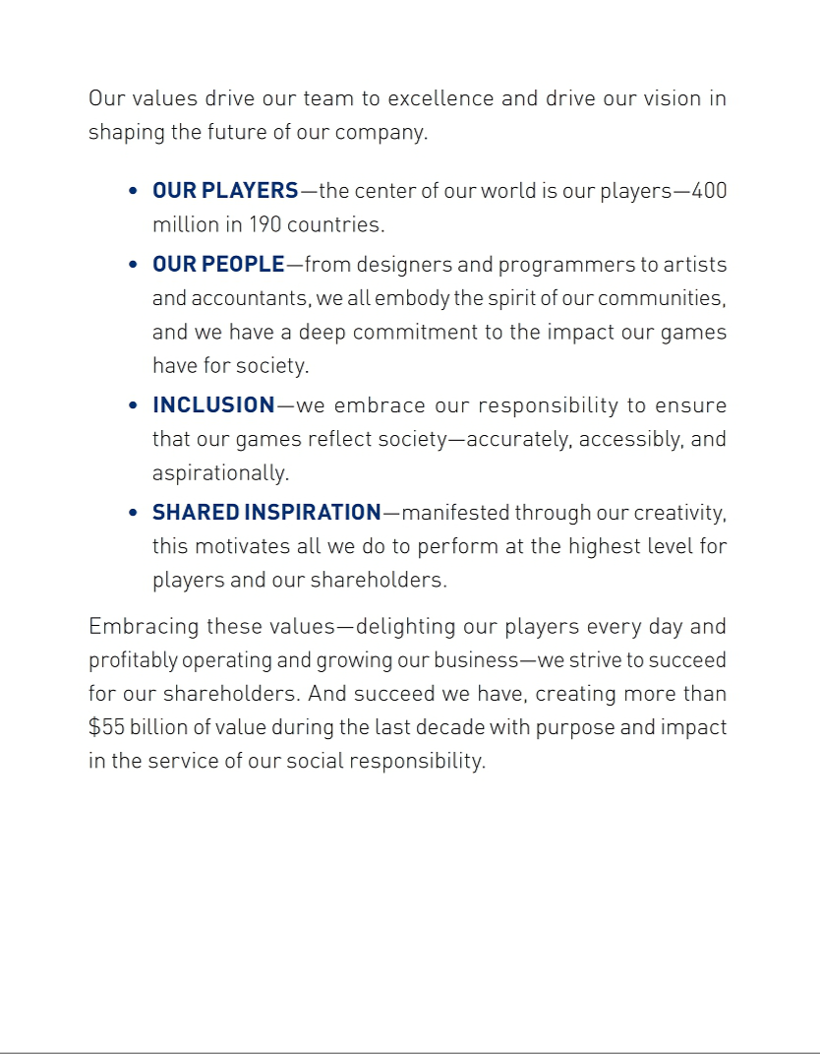

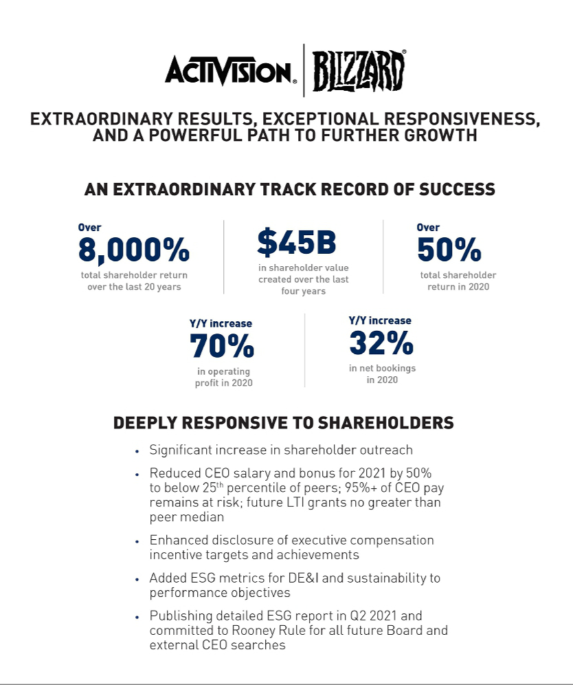

April 30, 2021

DEAR FELLOW SHAREHOLDERS:

With so much of the world tested by extraordinary social, environmental, economic, and public health challenges, we are proud of the role that Activision Blizzard plays in serving the public by keeping people connected, and by using our powerful global platform to comfort, inspire, and draw communities together.

OUR MISSION—connecting and engaging the world through epic entertainment—has never been more relevant nor more important, and we are humbled and grateful that an audience of 400+ million players in 190 countries has continued to turn to us each month. We are thankful to our exceptionally dedicated employees who have continued to innovate and execute on our mission despite the challenges of the pandemic. And we deeply appreciate you—our shareholders—for your ongoing confidence, trust, and feedback.

Activision Blizzard has a long track record of focus and operational excellence, driving increased value for our shareholders. That continued in 2020. With the safety of our employees always our priority, we successfully transitioned nearly 10,000 employees safely and efficiently to work from home. And our team didn’t miss a beat, delivering content of the highest quality, creating new ways for our players to connect and find community, significantly expanding our delivery of live, online content to fans around the world, and substantially growing our presence on mobile platforms. And, we delivered $45 billion in additional value to our shareholders since 2016.

The consistency, expertise, and remarkable dedication of our team members are key reasons for this growth and are why, over the last 20 years, we have achieved financial, operational, and creative success. Our total shareholder return over the past two decades has exceeded 8,100%, compared to 322% for the S&P 500. If you had invested $1,000 in our company 20 years ago, that investment, including dividend reinvestment, would have been worth $82,190 at the end of 2020, or around 20 times the S&P 500’s $4,223 over the same period.


With Total Shareholder Return for 2020 at over 50%—outperforming most of our direct competitors and far exceeding the S&P 500’s 18%—our record results in 2020 illustrate the scale of the opportunity for our company, the strength of our pipeline, and our agility. The key to our success has come from our significant investments in people and new content, focused execution of our multi-year strategy to grow our franchises, audience of global players, and expansion to new platforms, and strong execution in premium content, in-game operations, expanding our presence on mobile, and ramping up new engagement models.

We are fortunate to have some of the most popular and successful entertainment franchises in the world as we continue to develop our pipeline of new content across multiple platforms. We had roughly 400 million players in 2020, and we’re accelerating our path to reach 1 billion players per month as we deploy our Call of Duty model to other franchises and pursue a clear path to drive expanded reach, engagement, and player investment across our largest franchises. We expect to grow earnings per share meaningfully in 2021 and then build upon that financial performance in 2022. We will continue to pursue new opportunities to build on our already leading franchises, reintroduce franchises from our rich library, and develop original intellectual property—and in an industry with only a few franchises generating $1 billion a year in revenue, we have three and expect to add an additional two $1 billion franchises over the next few years.

www.activisionblizzard.com ACTIVISION BLIZZARD, INC. 2021 Proxy Statement 5

Supporting Our Employees and Communities through the Pandemic

From the earliest moments of the COVID-19 pandemic, we took action to support our employees, our players, and our communities. When traditional medical services came under huge demand at the onset of the pandemic, we created an extensive network of physicians to help ensure that our employees and their families had access to medical advice. To directly support the communities in which our employees live and work and our players thrive, we donated more than $5 million to aid hospitals, healthcare organizations, and nonprofits that were treating COVID-19 patients, vaccinating frontline workers, creating opportunities for veterans, and conducting promising drug trials and convalescent plasma therapies.

Continuing to Foster Inclusive Workplaces and Gaming Environments

At Activision Blizzard, we have a clear responsibility to make our workplaces and our games more diverse, equitable, and inclusive—and we are continuing to work hard to effect change and make a bigger positive impact. Inclusive game and content design are central to who we are, and our franchises have characters that are as diverse as our gamers, including characters of color, characters from the LGBTQ+ community, non-binary characters, characters of differing abilities, and autistic characters—a commitment we will continue to seek to expand.

To keep providing engaging gaming experiences that will resonate with our diverse players, our own company must continue to reflect the diversity and values of our players and fans. We remain committed to developing an employee base that represents the global communities in which we operate. To this end, we enhanced our sourcing, hiring, and retention practices even further in 2020 to improve our impact and it will remain an ongoing process. We have also significantly enhanced the diversity of our leadership team. At the same time, we are continuing to invest in diversity, equity, and inclusion programs across the globe and expanded career pathways for talented people, especially those from backgrounds that have been historically underrepresented in technology and entertainment.

While there is still important work to do, we are proud of the accomplishments we have made on this front, such as more than doubling the number of women in leadership roles in our game development functions and receiving a perfect score of 100 on the Human Rights Campaign Foundation’s Corporate Equality Index, as well as, receiving the distinction of being a “Best Place to Work for LGBTQ Equality.” We remain focused on doing even more to drive this commitment forward in the months ahead.

Thank You to Our Shareholders for Your Trust, Insights, and Feedback

On behalf of the entire Activision Blizzard team, thank you for your continued support—and for the ongoing dialogue and feedback. The important changes we have made over the past 12 months based on the insights you have shared have continued to allow us to grow profitably with purpose and impact. We appreciate your belief in our team and the work we are doing to serve our players, fans, and local communities around the world. We will continue to deliver superior shareholder returns with purpose and impact in the service of our social responsibility.

Sincerely,

Robert A. Kotick Brian Kelly



www.activisionblizzard.com ACTIVISION BLIZZARD, INC. 2021 Proxy Statement 6

MEETING INFORMATION

WHEN | WHERE
Monday, June 14, 2021 | Via live audio webcast at:
9:00 a.m., Pacific Time | https://viewproxy.com/ATVI/2021


WAYS TO VOTE

BY INTERNET | BY TELEPHONE | BY MAIL
BY INTERNET | Call (800) 690-6903 or the | Sign, date, and return
www.proxyvote.com | Call (800) 690-6903 or the | Sign, date, and return
www.proxyvote.com | number on your proxy card. | your proxy card.




NOTICE OF 2021 ANNUAL MEETING OF SHAREHOLDERS

In light of the COVID-19 pandemic, the Annual Meeting of Shareholders of Activision Blizzard, Inc. will be held via live audio webcast, on Monday, June 14, 2021, at 9:00 a.m., Pacific Time.

To attend the meeting, visit https://viewproxy.com/ATVI/2021. Certain materials customarily made available at shareholder meetings (including the proxy materials and our shareholder list) will be available during the virtual meeting. Additional details regarding the logistics of the meeting can be found in the accompanying proxy statement, on the Investor Relations section of our website (https://investor.activision.com/), and at https://materials.proxyvote.com/00507V.

The Activision Blizzard, Inc. Board of Directors set April 19, 2021, as the record date for determining the shareholders entitled to receive notice of, and to vote at, the annual meeting.

www.activisionblizzard.com ACTIVISION BLIZZARD, INC. 2021 Proxy Statement 7

Shareholders are being asked to vote on the following matters at the 2021 annual meeting of shareholders.

 | OUR BOARD’S
 | RECOMMENDATION
Proposal 1. Election of Directors (page 24)
Our Board and its Nominating and Corporate Governance Committee believe that our ten director nominees | FOR
are well-qualified to provide oversight of the Company’s business for the benefit of all of the Company’s
shareholders
Proposal 2. Advisory vote to approve our executive compensation (page 122)
Our Board and its Compensation Committee believe that our compensation policies and practices enable us to | FOR
deliver superior returns to our shareholders and allow us to motivate, attract, and retain the key executive talent
necessary for our long-term success
Proposal 3. Ratification of the appointment of PricewaterhouseCoopers LLP as the Company’s
independent registered public accounting firm (page 131) | FOR
Our Board and its Audit Committee believe that continued retention of PricewaterhouseCoopers LLP as the | FOR
Company’s independent registered public accounting firm is in the best interests of the Company and its
shareholders

Your vote is important. Whether or not you plan to attend the virtual meeting, I urge you to promptly submit a proxy to vote your shares by following the instructions on page 137 of the enclosed proxy statement. If you are able to attend the meeting and wish to vote in person, you may withdraw your proxy at that time.

By Order of the Board of Directors
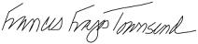

Frances Fragos Townsend

Corporate Secretary
April 30, 2021

Important Notice Regarding the Availability of Proxy Materials for the Shareholder Meeting to be Held on Monday, June 14, 2021. The proxy statement and our 2021 annual report to shareholders are each available at: https://materials.proxyvote.com/00507V

www.activisionblizzard.com ACTIVISION BLIZZARD, INC. 2021 Proxy Statement 8

TABLE OF CONTENTS

PROXY SUMMARY |  | 10
Executive Compensation Highlights |  | 12
PROPOSAL 1 ELECTION OF DIRECTORS |  | 23
Our Director Nominees |  | 23
CORPORATE GOVERNANCE MATTERS |  | 30
Communications With Our Board |  | 44
EXECUTIVE COMPENSATION |  | 50
Compensation Discussion and Analysis |  | 52
Compensation Committee Report |  | 87
Executive Compensation Tables |  | 88
PROPOSAL 2 ADVISORY VOTE TO APPROVE THE COMPANY’S EXECUTIVE |  | 122
COMPENSATION |  | 122
DIRECTOR COMPENSATION |  | 123
CERTAIN RELATIONSHIPS AND RELATED PERSON TRANSACTIONS |  | 127
AUDIT-RELATED MATTERS |  | 129
PROPOSAL 3 RATIFICATION OF APPOINTMENT OF INDEPENDENT |  | 131
REGISTERED PUBLIC ACCOUNTING FIRM |  | 131
BENEFICIAL OWNERSHIP MATTERS |  | 133
EQUITY COMPENSATION PLAN INFORMATION |  | 136
INFORMATION ABOUT THE 2021 ANNUAL MEETING |  | 137
DIRECTOR NOMINATIONS AND OTHER SHAREHOLDER PROPOSALS FOR |  | 141
OUR 2022 ANNUAL MEETING |  | 141
AVAILABILITY OF PROXY MATERIALS ON THE INTERNET; DELIVERY OF
DOCUMENTS TO SECURITY HOLDERS SHARING AN ADDRESS; FINANCIAL |  | 143
AND OTHER INFORMATION |  | 143
OTHER MATTERS |  | 144
HELPFUL RESOURCES |  | 145
www.activisionblizzard.com | ACTIVISION BLIZZARD, INC. | 2021 Proxy Statement

Back to Contents

PROXY SUMMARY

This summary highlights information contained elsewhere in this proxy statement for the 2021 annual meeting of the shareholders of Activision Blizzard, Inc., a Delaware corporation (the “Company”). This summary does not contain all the information that you should consider, and you should read the entire proxy statement before voting. For more complete information regarding the Company’s 2020 performance, please review our annual report to shareholders for the period ended December 31, 2020, which is being provided to our shareholders at the same time as this proxy statement. Capitalized terms used in this summary are defined elsewhere in the proxy statement.

2020 FINANCIAL AND OPERATIONAL PERFORMANCE—EXCEPTIONAL YEAR-OVER-YEAR SUCCESS

2020 saw strong early returns on our comprehensive, multi-year strategy and investments in growth. Our business experienced strong year-over-year results, as we delivered deeper and more consistent experiences for players across multiple platforms. Much of our growth was driven by increased investment in our biggest franchises, along with strong execution in premium content, in-game operations, our expanded presence on mobile, ramped up new engagement models, and some impact from the pandemic. Investors recognized our progress against our strategy and our strong financial performance and the Company’s market capitalization increased sharply over the year.
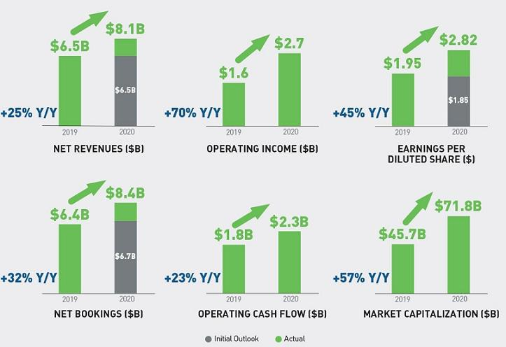

www.activisionblizzard.com ACTIVISION BLIZZARD, INC. 2021 Proxy Statement 10

Back to Contents

CONTINUING OUR TRAJECTORY OF SIGNIFICANT GROWTH IN SHAREHOLDER VALUE

The strong performance of the business and the associated shareholder value creation in 2020 is consistent with the Company’s long-term track record. Our market capitalization has grown over 19,000% over the last two decades— from $366 million in 2000, to over $70 billion by 2020.
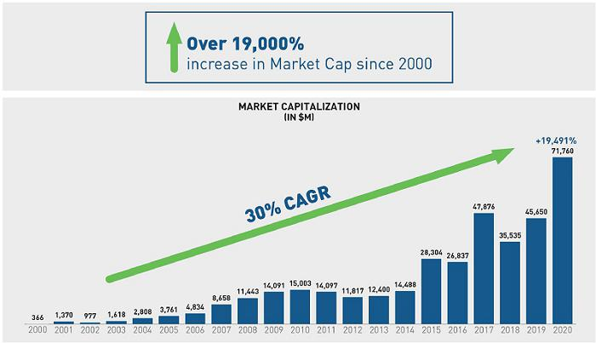

www.activisionblizzard.com ACTIVISION BLIZZARD, INC. 2021 Proxy Statement 11

Back to Contents

EXECUTIVE COMPENSATION HIGHLIGHTS

Compensation Aligns Pay with Performance

At Activision Blizzard, exceptional results and compensation ensure we can recruit, develop, and retain an extraordinarily talented workforce with diverse experiences and backgrounds. Our executive compensation program is designed to motivate and reward exceptional performance, while also driving future growth and recognizing the success and continued player focus throughout Activision Blizzard. As shown below, a significant amount of compensation for our leadership team—including 99% of the compensation for our CEO—is performance-based and at risk.
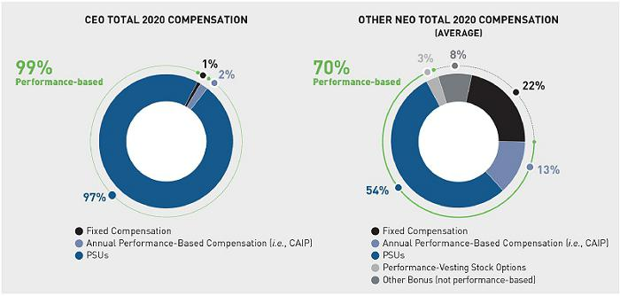

In 2020, the CEO, after consultation with the Compensation Committee, voluntarily elected to take no pay for the last four pay periods of the year, equating to a 15% reduction in his annual salary. Additionally, in April 2021, the CEO agreed, based on discussions with the Compensation Committee, to reduce his salary rate in 2021 from $1,750,000 to $875,000, equating to a 50% reduction in his contractual annual salary. The Compensation Committee took these actions to address shareholder concerns regarding the quantum of the CEO’s compensation and result in salary being positioned below the current peer 25th percentile of $1,000,000. These are the first changes to his base pay since 2017. The base salaries for our other named executives have not changed since February 2019 or, if more recent, their date of appointment.

www.activisionblizzard.com ACTIVISION BLIZZARD, INC. 2021 Proxy Statement 12

Back to Contents

Significantly Increased Engagement with Shareholders

The Company regularly engages with shareholders to solicit feedback as part of an ongoing effort to understand and consider our shareholders’ perspectives with respect to our executive compensation, corporate governance practices, human capital management, and any other matters of importance to them. Our engagement with shareholders, while always extensive, was substantially greater in 2020, than in prior years.

In 2020, our compensation program received the support of 57% of the total votes cast at our annual meeting. Over the ensuing several months, Activision’s Board and management team actively sought feedback from shareholders to better understand what motivated their votes. As part of these efforts, we offered engagement with our CEO, Mr. Kotick, and Chair of the Compensation Committee, Mr. Morgado, to shareholders owning approximately 66% of outstanding shares, including each of our top 50 institutional holders. We held over 70 meetings, engaging with over 50 institutions owning approximately 63% of outstanding shares. Our Board was directly involved in the majority of these dialogues, with a member of our Compensation Committee and/or CEO (and, in most cases, both) participating in over 40 meetings with shareholders owning approximately 59% of outstanding shares. To ensure candid discussions, in conversations where the CEO participated, he offered to step off the call when executive compensation was discussed.
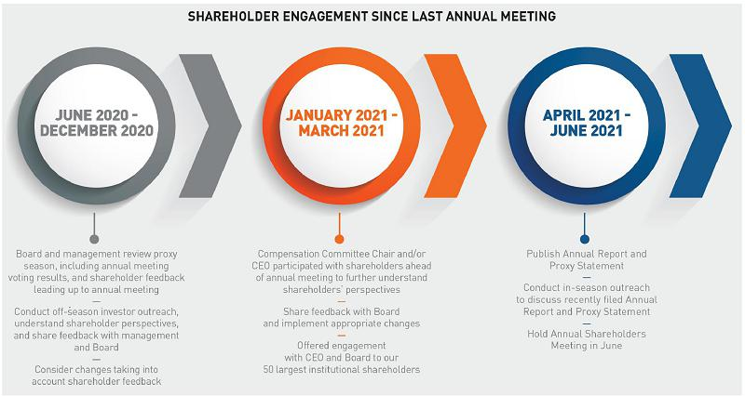

www.activisionblizzard.com ACTIVISION BLIZZARD, INC. 2021 Proxy Statement 13

Back to Contents
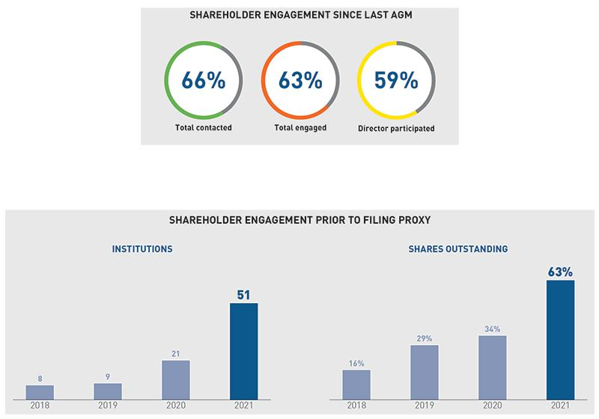

Our Lead Independent Director and Compensation Committee members shared this extensive feedback with our entire Board, and that feedback has been instrumental in shaping decisions that we believe are simultaneously responsive to shareholder concerns and appropriate for the Company.

www.activisionblizzard.com ACTIVISION BLIZZARD, INC. 2021 Proxy Statement 14

Back to Contents

Responsiveness to Shareholders – The Board Is Committed to Addressing Investor Feedback

What we heard How we responded Impact of Action

CEO’s EMPLOYMENT AGREEMENT

Base Salary

Quantum of CEO pay

exceeds that of some peers

● | CEO elected to take no salary for the last four pay periods | ● | 15% reduction in 2020 salary
 | of 2020 | ● | 2021 salary below 25th percentile of peer
● | Reduced CEO 2021 salary by 50% from $1.75 million to |  | group, with commensurate decrease in
 | $875,000 |  | target annual cash bonus (CAIP)
Corporate Annual Incentive Plan (CAIP)
● | Reduced CAIP cash bonus as a result of salary reduction | ● | 12% reduction in 2020 target CAIP
● | Capped maximum potential 2021 and 2022 CAIP payouts | ● | 2021 and 2022 target bonuses well below
 | to 2X base salary |  | 25th percentile of peer group
 | (effectively capped “at target”)

Long-Term Incentives

- Amended agreement to limit CEO annual LTI award grant values to no greater than median peer CEO LTI grant values for 2021 and 2022

- In aggregate, CEO target compensation expected to be below median target CEO compensation

Preference for PSUs ● | Amended LTI program design for 2021 and 2022 extension | ● | Further strengthen performance linkage of
over stock options | period to ensure 100% of CEO LTI awards denominated in |  | incentives
 | performance-vesting restricted share units
Concern regarding ● | Eliminated potential to earn the “transformative transaction | ● | Further strengthen pay for performance and
additional award | award,” with immediate effect |  | further incentivize creation of long-term value
potential based on
outcome of M&A

Concern regarding

award
structures

- Eliminated the “shareholder value creation incentive” with respect to all equity grants made after April 2021, when the 2016 employment agreement was amended

- Further strengthen performance linkage of incentives, and minimize potential for duplicative payments for the same performance results

COMPENSATION PROGRAM DESIGN

Higher emphasis of | ● | Increased financial metric weight, from 60% to 80% for the | ● | Enhance alignment of incentive with financial
annual incentive on |  | CEO beginning in 2021, and for other executives beginning |  | outcomes
financial metrics |  | in 2022
Preference for ESG | ● | Added an ESG component which may include diversity, | ● | Directly link incentive payout with ESG
objectives in |  | inclusion, promotion and the hiring of veterans, and |  | performance
incentive design |  | sustainability as part of executive strategic objectives
 |  | beginning in 2021
COMPENSATION PROGRAM DISCLOSURE
Enhance disclosure | ● | Enhanced disclosure of target-setting to provide context for | ● | Increase transparency of incentive structure
of goal-setting |  | the rigor of targets in “Corporate Annual Incentive Plan
process |  | (CAIP) Bonuses” section of the proxy

Enhance disclosure of strategic component of annual incentive award

- Enhanced disclosure related to strategic objectives and performance for 2020 annual incentive award—see “Corporate Annual Incentive Plan (CAIP) Bonuses” section

- Increase transparency of incentive structure and evaluation

Provide additional disclosure regarding peer group composition

- Enhanced disclosure of peer group analysis process—see “Decision Making Approach to Executive Compensation” section

- Provide context that the most relevant peers are companies that create world class creative content, are at the forefront of digital innovation, and compete globally for talent

www.activisionblizzard.com ACTIVISION BLIZZARD, INC. 2021 Proxy Statement 15

Back to Contents

OUR DIRECTOR NOMINEES

Set forth below is information about the nominees for election to our Board of Directors, each of whom currently serves on the Board:

 |  |  | Committee Memberships
 |  |  |  |  | Nominating
 |  |  |  |  | and Corporate
 |  | Director | Audit | Compensation | Governance
Name/ Principal Occupation | Age | Since Independent | Committee | Committee | Committee

Reveta Bowers | 72 | 2018
Interim CEO of the Center for Early |  | ✓
Education
Robert Corti | 71 | 2003
Retired CFO of Avon Products |  | ✓
Hendrik Hartong III | 54 | 2015
Chairman and CEO of |  | ✓
Brynwood Partners
Brian Kelly (Chairman) | 58 | 1995
Chairman of the Board of |  | —
Activision Blizzard
Robert Kotick | 58 | 1991
CEO of Activision Blizzard |  | —
Barry Meyer | 77 | 2014
Retired Chairman and CEO of |  | ✓
Warner Bros. Entertainment
Robert Morgado* | 78 | 1997
Retired Chairman and CEO of |  | ✓
Warner Music Group
Peter Nolan | 62 | 2013
Senior Advisor to |  | ✓
Leonard Green & Partners
Dawn Ostroff | 61 | 2020
Chief Content and Advertising |  | ✓
Business Officer of Spotify Technology
S.A.
Casey Wasserman | 46 | 2015
Chairman and CEO of Wasserman |  | ✓
Member |  | 6 |  | 9 | 4
Chairperson
Chairperson |  |  | Audit | Compensation | Nominating and
*Lead Independent Director |  |  | Committee | Committee | Corporate
 |  |  | Meetings | Meetings | Governance










Committee

Meetings

www.activisionblizzard.com ACTIVISION BLIZZARD, INC. 2021 Proxy Statement 16

Back to Contents
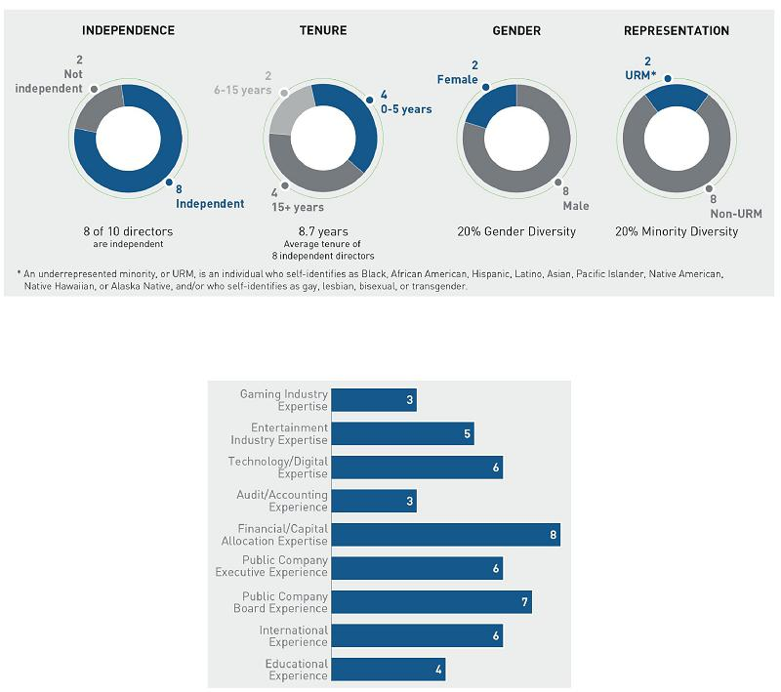

www.activisionblizzard.com ACTIVISION BLIZZARD, INC. 2021 Proxy Statement 17

Back to Contents

CORPORATE GOVERNANCE HIGHLIGHTS

We follow best practices in corporate governance—not just among our peer group, but in the market generally.
Highlights of our corporate governance program include:

Accountability to | ● | Our common stock is our only outstanding class of stock, with one vote per share.
our Shareholders | ● | Our shareholders elect directors every year, for one-year terms, with a majority vote standard.
 | ● | All shareholder voting matters are decided by a simple majority vote.
 | ● | Our Bylaws contain a shareholder proxy access provision, which permits certain shareholders to include
 |  | director nominees in our proxy statements.
 | ● | We do not have a “poison pill” or similar anti-takeover provision in place.
 | ● | Our shareholders have the right to act by written consent.
Board | ● | Eight of our ten director nominees are independent.
Independence | ● | We have a separate chairman and chief executive officer, and a lead independent director.
 | ● | Our independent directors regularly meet in executive sessions.
 | ● | All the members of our three standing Board committees—our Audit, Compensation, and Nominating and
 |  | Corporate Governance committees—are independent.

Board Diversity ● We codified our longstanding commitment to including qualified women and racially/ethnically diverse candidates in the pool from which any new independent director nominee is chosen. We also made a public commitment to apply this practice—commonly known as the “Rooney Rule”—for all future Board searches.

- Two of our ten directors are women, and two of our ten directors are members of “underrepresented communities.”

Board Policies and ● Our Board annually reviews its performance, as well as the performance of each of its standing committees.

^{Practices} ● Our Board actively engages in chief executive officer succession planning, and reviews succession plans for our other executives annually.

- Our Nominating and Corporate Governance Committee oversees risks associated with overall governance and Board succession planning, as well as ESG.

- Our Compensation Committee annually evaluates our Chief Executive Officer’s performance.

- Our Audit Committee oversees cybersecurity risk.

Active Board | ● | Our Board annually reviews our management’s conclusions and recommendations regarding current and
Oversight of Risk |  | future potential strategic enterprise-level risks, as well as the strategies used to mitigate such risks.
Strategy | ● | Our Board assumes an active role in overseeing risk management and in providing strategic guidance for
 |  | the Company, while delegating certain risk management oversight functions to standing committees, each of
 |  | which regularly reports to our Board.

Risk Mitigation and Alignment of Interests

- We have adopted robust stock ownership guidelines for executives and directors.

- In the event of an earnings restatement, we have a policy to “claw back” certain performance-based compensation (including both cash and equity incentives) paid or awarded to the executives responsible.

- We prohibit our employees (including our executives) and directors from “shorting” Company stock, engaging in “puts,” “calls,” or other hedging transactions involving Company stock, or using margin accounts with Company stock.

- None of our executive officers or directors has any shares of Company stock pledged.

www.activisionblizzard.com ACTIVISION BLIZZARD, INC. 2021 Proxy Statement 18

Back to Contents

STOCK OWNERSHIP GUIDELINES

In order to align the interests of our management with those of our shareholders, we believe that every executive officer should maintain a meaningful ownership stake in the Company. Accordingly, the Compensation Committee has adopted guidelines providing that our Chief Executive Officer is expected to beneficially own shares of our Common Stock with a value at least equal to fifty times (i.e., 50x) their then-current annual base salary and that all other executive officers, as well as the President of each of Activision, Blizzard, and King, are expected to beneficially own shares of our Common Stock with a value at least equal to their then-current annual base salary.

The individuals subject to these guidelines are expected to accumulate the required stock within five years (so that any person who has been subject to the guidelines since the date on which these guidelines were adopted in 2012 should be in compliance, and any person who subsequently became subject to them (e.g., upon their election as an executive officer) has five years from the date on which they became subject to them to be in compliance). Further, if such a person does not satisfy these guidelines within the five-year period, then, until they satisfy the guidelines, they will be required to hold 50% of the net shares received upon exercise of stock options or upon the vesting of restricted share units awards received, provided such shares received are under equity awards made after the adoption of the ownership guidelines and that such awards are, per their terms, explicitly subject to them.

As of April 1, 2021, each person who, as of that date, had been subject to the guidelines for five or more years satisfied them.

CONTACTING THE COMPANY

The Company reviews feedback sent to us from any of our shareholders, no matter the size of their holdings. If you would like to communicate directly with our full Board, our independent directors, any committee of our Board, any other group of directors, and/or any individual director, you may contact us using any one of these methods:

By Mail | Email | Phone
mail to | send email to | Investor
Activision Blizzard, Inc. | ir@activision.com | Relations
c/o Corporate Secretary | (310) 255-2000
3100 Ocean Park Boulevard
Santa Monica,
California 90405
www.activisionblizzard.com | ACTIVISION BLIZZARD, INC. | 2021 Proxy Statement 19




Back to Contents

PROXY STATEMENT

GENERAL

PURPOSE OF THIS PROXY STATEMENT

This proxy statement is furnished in connection with the solicitation by our Board of Directors (our “Board”) of proxies from holders of issued and outstanding shares of the Company’s common stock (“Common Stock”). The proxies being solicited will be used at the annual meeting of our shareholders to be held on Monday, June 14, 2021, via live audio webcast at https://viewproxy.com/ATVI/2021, at 9:00 a.m., Pacific Time, and at any adjournment or postponement of the meeting (the “Annual Meeting”). All references in this proxy statement to “the Company,” “we,” “us,” “our,” and “Activision Blizzard” refer to Activision Blizzard, Inc.

NOTICE OF INTERNET AVAILABILITY OF PROXY MATERIALS

We will be mailing a notice regarding the Internet availability of these proxy materials (containing instructions on how to access the proxy materials and vote shares through the Internet) to shareholders on or about April 30, 2021.

FINANCIAL MEASURES USED IN THIS PROXY STATEMENT

Use of Non-GAAP Financial Measures

All financial measures used in this proxy statement are presented in accordance with generally accepted accounting principles (“GAAP”), unless explicitly identified as non-GAAP. Internally, as a supplement to our GAAP financial measures, our management uses certain non-GAAP financial measures in assessing our operating results, as well as in planning and forecasting. In particular, our management believes these measures facilitate comparison of operating performance between periods and facilitate an understanding of the operating results of Activision Blizzard by excluding certain items that may not be indicative of the Company’s core business, operating results, or future outlook. Further, our management believes that the presentation of these non-GAAP measures provides useful information to measure Activision Blizzard’s financial and operating performance. These non-GAAP measures are not intended to be considered in isolation from, as a substitute for, or as more important than the financial information prepared and presented in accordance with GAAP. In addition, non-GAAP measures have limitations in that they do not reflect all of the items associated with the Company’s results of operations as determined in accordance with GAAP. In the future, Activision Blizzard may also consider whether other significant non-recurring items should also be excluded in calculating the non-GAAP measures used by the Company.

Our non-GAAP measures are not based on a comprehensive set of accounting rules or principles, and such measures do not have a standardized meaning across companies. Therefore, other companies may use the same or similarly named measures, but exclude different items, which may not provide investors a comparable view of Activision Blizzard’s performance in relation to other companies.

Financial Metrics Used to Measure 2020 Compensation-Related Performance

Consistent with past years, the financial objectives used by our management and our Compensation Committee to assess our employees’ 2020 performance were based on adjusted non-GAAP measures rather than the non-GAAP measures we use when reporting our financial results. These non-GAAP measures differ as our adjusted non-GAAP measures exclude the impact of deferrals from our revenue accounting treatment on certain of our online-enabled products. Internally, our management uses these adjusted non-GAAP measures in assessing our operating results, as well as in planning and forecasting. Our management believes

www.activisionblizzard.com ACTIVISION BLIZZARD, INC. 2021 Proxy Statement 20

Back to Contents

this is appropriate because doing so enables an analysis of performance based on the timing of actual transactions with our customers and provides a more timely indication of trends in our operating results. Further, as our management and our Compensation Committee continue to believe that these adjusted non-GAAP measures are an effective way to internally assess our operating performance, the Company currently expects to continue utilizing these adjusted non-GAAP measures for purposes of compensation-related performance objectives in the future.

Specifically, the Compensation Committee used the following non-GAAP (excluding deferrals) measures to assess the 2020 performance of one or more of our named executive officers.

AB Adjusted Operating Income

“AB Adjusted Operating Income” means Activision Blizzard’s GAAP operating income, excluding the impacts from share-based compensation, amortization of intangibles from purchase price accounting, restructuring and related charges, and the deferral of revenues and recognition of deferred revenues, along with related cost of revenues, on certain of our online enabled products.

AB Adjusted EPS

“AB Adjusted EPS” is calculated by dividing the AB Adjusted Net Income by the weighted average diluted shares outstanding, where “AB Adjusted Net Income” means Activision Blizzard’s GAAP net income, excluding the impacts from the items noted above under “AB Adjusted Operating Income,” along with the associated tax impacts of those items, losses incurred on extinguishment of debt from redemption activities and the associated tax impact.

AB Adjusted Free Cash Flow

“AB Adjusted Free Cash Flow” means Activision Blizzard’s GAAP cash flows from operating activities, less capital expenditures, and excluding certain unplanned one-time items or other adjustments related to impacts identified as being excluded from AB Adjusted Operating Income.

Emerging Business Adjusted Operating Income

“Emerging Business Adjusted Operating Income” means Activision Blizzard’s GAAP operating income from certain of our emerging businesses (including our esports and consumer product activities), excluding the impacts from share-based compensation, amortization of intangibles from purchase price accounting, restructuring and related charges, and the deferral of revenues and recognition of deferred revenues, along with related cost of revenues, on certain of our online enabled products.

Consistent with past years, at the time it established the measures to be used to assess 2020 financial performance for compensation purposes, the Compensation Committee reserved the discretion, when measuring performance, to exclude the impact of any extraordinary transaction (i.e., a non-recurring corporate transaction or legal expense matter that results in expenses exceeding $10 million for the year). No such adjustments were made for 2020.

Further, when a financial measure is used to assess performance underlying a bonus opportunity under our Corporate Annual Incentive Plan (the “CAIP”) or an equity award the performance of which is determined by reference to an annual operating plan approved by our Board (such plan for any given year, the “AOP”) or long-range strategic plan, constant foreign exchange rates are assumed, which means we convert current period results into dollars using the average exchange rate at the time we established the targets (e.g., at the time the relevant AOP was established), rather than the actual exchange rates during the relevant period.

References to U.S. Dollars

All dollar amounts referred to in or contemplated by this proxy statement refer to U.S. dollars.

www.activisionblizzard.com ACTIVISION BLIZZARD, INC. 2021 Proxy Statement 21

Back to Contents

Cautionary Statement with Respect to Forward-Looking Statements

This proxy statement contains, or incorporates by reference, statements reflecting our views about our future performance that constitute forward-looking statements within the meaning of the Private Securities Litigation Reform Act of 1995. Such statements consist of any statement other than a recitation of historical facts and include, but are not limited to: (1) projections of revenues, expenses, income or loss, earnings or loss per share, cash flow, or other financial items; (2) statements of our plans and objectives, including those related to releases of products or services and restructuring activities; (3) statements of future financial or operating performance, including the impact of tax items thereon; (4) expectations concerning vesting and satisfaction of performance conditions with respect to equity awards; and (5) statements of assumptions underlying such statements. Activision Blizzard, Inc. generally uses words such as “outlook,” “forecast,” “will,” “could,” “should,” “would,” “to be,” “plan,” “aims,” “believes,” “may,” “might,” “expects,” “intends,” “seeks,” “anticipates,” “estimate,” “future,” “positioned,” “potential,” “project,” “remain,” “scheduled,” “set to,” “subject to,” “upcoming,” and other similar words and expressions to help identify forward-looking statements. Forward-looking statements are subject to business and economic risks, reflect management’s current expectations, estimates, and projections about our business, and are inherently uncertain and difficult to predict.

We caution that a number of important factors, many of which are beyond our control, could cause our actual future results and other future circumstances to differ materially from those expressed in any forward-looking statements. Such factors include, but are not limited to: the ongoing global impact of COVID-19 (including, without limitation, the potential for significant short- and long-term global unemployment and economic weakness and a resulting impact on global discretionary spending; potential strain on the retailers and distributors who sell our physical product to customers; effects on our ability to release our content in a timely manner; the impact of large-scale intervention by the Federal Reserve and other central banks around the world, including the impact on interest rates; and volatility in foreign exchange rates); our ability to consistently deliver popular, high-quality titles in a timely manner; concentration of revenue among a small number of franchises; our ability to satisfy the expectations of consumers with respect to our brands, games, services, and/or business practices; our ability to attract, retain and motivate skilled personnel; rapid changes in technology and industry standards; competition, including from other forms of entertainment; increasing importance of revenues derived from digital distribution channels; risks associated with the retail sales business model; the continued growth in the scope and complexity of our business, including the diversion of management time and attention to issues relating to the operations of our newly acquired or started businesses and the potential impact of our expansion into new businesses on our existing businesses; substantial influence of third-party platform providers over our products and costs; risks associated with transitions to next-generation consoles; success and availability of video game consoles manufactured by third parties; risks associated with the free-to-play business model, including dependence on a relatively small number of consumers for a significant portion of revenues and profits from any given game; our ability to realize the expected financial and operational benefits of, and effectively implement and manage, our previously-announced restructuring actions; our ability to quickly adjust our cost structure in response to sudden changes in demand; risks and costs associated with legal proceedings; intellectual property claims; changes in tax rates or exposure to additional tax liabilities, as well as the outcome of current or future tax disputes; our ability to sell products at assumed pricing levels; reliance on external developers for development of some of our software products; the amount of our debt and the limitations imposed by the covenants in the agreements governing our debt; the seasonality in the sale of our products; counterparty risks relating to customers, licensees, licensors, and manufacturers; risks associated with our use of open source software; piracy and unauthorized copying of our products; insolvency or business failure of any of our partners; risks and uncertainties of conducting business outside the United States; increasing regulation of our business, products, and distribution in key territories; compliance with continually evolving laws and regulations concerning data privacy; reliance on servers and networks to operate our games and our proprietary online gaming service; potential data breaches and other cybersecurity risks; and the other factors identified in “Risk Factors” included in “Risk Factors” included in Part I, Item 1A of our most recent Annual Report on Form 10-K. The forward-looking statements contained herein are based on information available to us as of the date of this proxy statement and we assume no obligation to update any such forward-looking statements. Although these forward-looking statements are believed to be true when made, they may ultimately prove to be incorrect. These statements are not guarantees of our future performance and are subject to risks, uncertainties, and other factors, some of which are beyond our control and may cause actual results to differ materially from current expectations.

www.activisionblizzard.com ACTIVISION BLIZZARD, INC. 2021 Proxy Statement 22

Back to Contents

PROPOSAL 1 ELECTION OF DIRECTORS

GENERAL

Our shareholders are being asked to elect ten directors at the Annual Meeting. Those elected will serve a one-year term and until their respective successors are duly elected or appointed and qualified or until their earlier death, resignation, or removal. Unless shareholders instruct otherwise, proxies solicited by this proxy statement will be voted for the election of each nominee. However, if any nominee becomes unable to stand for election as a director at the Annual Meeting, the proxy may be voted for a substitute designated by our Board.

OUR DIRECTOR NOMINEES

Our Board is committed to building a Board with diverse experiences and backgrounds. In 2020, the Board formally adopted its commitment to actively seek women and minority candidates for the pool from which board candidates are chosen.

We believe effective oversight comes from a board of directors that represents a diverse set of perspectives, backgrounds, and experiences that provide the collective skills, expertise, and independence necessary for independent oversight. Accordingly, the Nominating and Corporate Governance Committee takes into account the diversity of the Board in selecting new director candidates.

In order to have a knowledgeable Board composed of individuals with distinguished records of leadership and success, the Nominating and Corporate Governance Committee has established criteria it desires in a member of our Board. As a company with a global customer base in the interactive entertainment industry, we consider leadership abilities gained from senior roles as executive officers and/or board members of large, global corporations in the media, entertainment and/or technology fields to be particularly relevant to the business of the Company. We believe that all of our director nominees bring, or will bring, to our Board the practical wisdom and strong professional characteristics, judgment, and leadership abilities necessary to keep our Company performing competitively in the market. For more information about the qualifications we require our directors (and director nominees) to have, see “Corporate Governance Matters—Board of Directors and Committees—Identification of Candidates for Election to Our Board—Experience, Skills, and Other Characteristics of Our Director Candidates” below.

The following biographies of our director nominees describe their noteworthy experience. Also described below are certain individual qualifications and skills of each of our director nominees that we believe contribute, or will contribute, to our Board’s effectiveness and success. For information regarding each nominee’s current Board committee membership, if any, see “Corporate Governance Matters—Board of Directors and Committees—Board Committees” below.

www.activisionblizzard.com ACTIVISION BLIZZARD, INC. 2021 Proxy Statement 23

Back to Contents

REVETA BOWERS


Ms. Bowers has served as an independent governance and organizational consultant for nonprofit organizations since 2016. From 1972 to 2016, she served as a teacher and administrator at The Center for Early Education, an independent school for children, and on July 1, 2020, she returned as Interim CEO. From 1993 to 2003, she served on the board of directors of The Walt Disney Company, a global entertainment company.

Interim CEO of the Center for Early Education

Director since: 2018

Activision Blizzard Committee Membership(s):

- Compensation Committee

Age: 72

Key Experience/Qualifications:

- Extensive public board experience, having served as an outside director of The Walt Disney Company from 1993 to 2003, and as a member of four committees of Disney’s board, including its compensation committee

- Serves as Chair of Common Sense Media, a non-profit organization dedicated to helping children use technology responsibly, safely, and effectively

- Serves as the Interim Head of School at the Center for Early Education and has served as an advocate for the use of gaming and technology to enhance childhood education

- B.A. in humanities from the University of Southern California and M.A. in developmental psychology from the College of Developmental Studies

Involvement with Other Organization(s):

- California Teacher Development Collaborative (CATDC) (seminar faculty member)

- Common Sense Media (Trustee Emeritus)

- California Partners Project (member of Advisory Board)

- Dream Fund for Scholars (member of Advisory Board)

- Edward E. Ford Foundation (member of Board of Advisors)

- FEDCO Charitable Foundation

- L.A. Philharmonic

- Rossier School of Education, University of Southern California (Chair of Board of Councilors)

ROBERT CORTI


Mr. Corti worked at Avon Products, a global manufacturer and marketer of beauty and related products, for more than 25 years. He joined Avon Products’ tax department as a tax associate in 1976 and held positions of increasing responsibility in the company’s finance department throughout his tenure there, including serving as an Executive Vice President and the Chief Financial Officer of Avon Products from 1998 until he retired from the Chief Financial Officer role in November 2005 and from the Executive Vice President role in March 2006.

Retired

Chief Financial Officer of Avon Products

Director since: 2003

Activision Blizzard Committee Membership(s):

- Audit Committee (Chair)

Age: 71

Key Experience/Qualifications:

- Financial expertise, particularly accounting and tax experience, gleaned in part from his long tenure in Avon’s finance department

- Unique perspective of having helped to guide a large public company with international operations through the changing economic and competitive landscape, gained from having served Avon for more than 25 years and working his way up to increasingly senior roles within that organization

- Consumer products industry experience from his tenure at Avon

- Certified public accountant

- Qualifies as an “audit committee financial expert” and is “financially sophisticated”

- B.A. in accounting from Queens College and M.B.A. in taxation from St. John’s University

Private Company Directorship(s):

- Bacardi Limited

Involvement with Other Organization(s):

- Manhattan Chapter of the Cystic Fibrosis Foundation

www.activisionblizzard.com ACTIVISION BLIZZARD, INC. 2021 Proxy Statement 24

Back to Contents

HENDRIK HARTONG III


Chairman and Chief Executive

Mr. Hartong serves as the Chairman and Chief Executive Officer of Brynwood Partners, a private equity firm specializing in the consumer products sector, which he joined in 2004 as a managing partner. Mr. Hartong was the President and Chief Executive Officer of Lincoln Snacks Company, a food products company, from 1998, at which point the company was publicly traded, until 2004, when Brynwood Partners divested its ownership in Lincoln Snacks. Prior to joining Lincoln Snacks, Mr. Hartong held various sales and marketing positions of increasing responsibility with Baskin Robbins USA Co. and Nestlé USA, Inc., both of which are food products companies, and, from 1996 to 1998, with Activision Publishing, Inc. (“Activision”), then our sole operating unit.

Officer of

Brynwood
Partners

Director since: 2015

Activision Blizzard Board Committee Membership(s):

- Audit Committee

Age: 54

Key Experience/Qualifications:

- Financial expertise, in particular, from having served as President and Chief Executive Officer of then-publicly traded Lincoln Snacks for six years

- Wealth of experience in the consumer products industry from his experience guiding Lincoln Snacks and the portfolio companies of Brynwood Partners

- Qualifies as “audit committee financial expert” and is “financially sophisticated”

- B.A. in history from Lafayette College and M.B.A. from Harvard University

Private Company Directorship(s):

- Brynwood Partners (Chairman and Chairman of Executive Committee)

- Harvest Hill Beverage Company (Chairman) (a company in which Brynwood Partners has a controlling ownership interest)

- Hometown Food Company (Chairman) (a company in which Brynwood Partners has a controlling ownership interest)

- Great Kitchens Food Company (Chairman) (a company in which Byrnwood Partners has a controlling ownership interest)

BRIAN KELLY


Mr. Kelly has held various positions of responsibility with Activision Blizzard since 1991, including serving as a director of the Company since July 1995, the Co-Chairman of our Board of Directors from October 1998 until 2013 and as Chairman of our Board of Directors since 2013.

Chairman of the

Board of
Activision Blizzard

Director since: 1995

Age: 58

Key Experience/Qualifications:

- Depth of institutional knowledge and understanding of our organization, which he possesses by virtue of his service as a senior executive of the Company from 1991 until 2008 and as a director of the Company for almost 25 years

- Superior leadership skills, devotion to the Company, and commitment to helping to ensure our ongoing success

- B.A. in accounting from Rutgers University and J.D. from Fordham University School of Law

Involvement with Other Organization(s):

- Call of Duty Endowment (co-founder)

- NewYork-Presbyterian Hospital (trustee)

- Juvenile Diabetes Cure Alliance (founder and Chairman)

www.activisionblizzard.com ACTIVISION BLIZZARD, INC. 2021 Proxy Statement 25

Back to Contents

ROBERT KOTICK


Mr. Kotick, our Founder and Chief Executive Officer, has been a director of Activision Blizzard since February 1991, following his purchase of a significant interest in the Company, which was then on the verge of insolvency. Mr. Kotick was our Chairman and Chief Executive Officer from February 1991 until July 2008, when he became our President and Chief Executive Officer. He served as our President from July 2008 until June 2017.

Chief Executive

Officer of
Activision Blizzard

Director since: 1991

Age: 58

Key Experience/Qualifications:

- Depth of institutional knowledge and understanding of our organization, as well as practical experience in a chief executive officer role, that he possesses by virtue of his 30 years of service to the Company, including as our Chief Executive Officer and, previously, as our President and the Chairman of our Board

- Perspective as a board member at a variety of other organizations and his experience in helping those organizations achieve their diverse goals and overcome a wide range of challenges through changing economic and social times

Other Public Company Directorship(s):

- The Coca-Cola Company (since 2012)

Involvement with Other Organization(s):

- Call of Duty Endowment (co-founder and Co-Chairman)

- Los Angeles County Museum of Art (Vice Chairman of Board and Chairman of Committee of Trustees)

- Harvard-Westlake School (member of Board of Trustees)

BARRY MEYER


Mr. Meyer retired as the Chairman of Warner Bros. Entertainment Inc., an American producer of film, television, and music, at the end of 2013. He joined Warner Bros. as a Director of Business Affairs in 1971 and held positions of increasing responsibility throughout his tenure there, eventually serving as Warner Bros.’ Chief Executive Officer and Chairman from October 1999 until March 2013 and as Chairman through December 2013. Mr. Meyer founded the consulting firm North Ten Mile Associates following his retirement from Warner Bros., and currently serves as the Manager and Co-Chief Executive Officer of that firm.

Retired

Chairman and
Chief Executive
Officer of Warner
Bros.
Entertainment

Director since: 2014

Activision Blizzard Board Committee Membership(s):

- Nominating and Corporate Governance Committee

Age: 77

Key Experience/Qualifications:

- Over 40 years of leadership and managerial experience in one of the largest entertainment production companies in the world, including serving as its Chief Executive Officer

- In-depth knowledge of both the business and creative aspects of the entertainment industry, both from his years at Warner Bros. and the leadership positions he held in various cultural institutions dedicated to visual and cinematic arts

- Wealth of experience in nearly every facet of the entertainment industry

- Deep understanding of the unique challenges faced by large, multinational public companies

- B.A. in English from the University of Rochester and J.D. from Case Western Reserve University School of Law

Involvement with Other Organization(s):

- Federal Reserve Bank of San Francisco (former Chairman)

- Academy of Motion Picture Arts & Sciences (member)

- Academy of Television Arts & Sciences (member and former Governor)

- Hollywood Radio and Television Society (member)

- Human Rights Watch (Director Emeritus)

- Smithsonian National Museum of American History (Vice Chairman of Advisory Board)

- USC School of Cinematic Arts (member of Board of Councilors)

www.activisionblizzard.com ACTIVISION BLIZZARD, INC. 2021 Proxy Statement 26

Back to Contents

ROBERT MORGADO


Mr. Morgado, our lead independent director, is Chairman of Maroley Media Group, a media entertainment investment company he established in 1995. He previously served as the Chairman and the Chief Executive Officer of Warner Music Group, a music content company comprised of recorded music and music publishing businesses, from 1985 to 1995.

Retired

Chairman and
Chief Executive
Officer of Warner

Music Group

Director since: 1997

Activision Blizzard Board Committee Membership(s):

- Compensation Committee (Chair)

- Nominating and Corporate Governance Committee (Chair)

Age: 78

Key Experience/Qualifications:

- Extensive experience as a chief executive officer and a director at a variety of media and entertainment companies

- Perspective as the founder and chair of a media entertainment investment company

- B.A. in history and philosophy from Chaminade University of Honolulu and M.P.A. from The State University of New York

Private Company Directorship(s):

- Kaanapali Kai (Chairman)

- Nest Top (controlling shareholder of Nest Family and Nest Learning Systems)

Involvement with Other Organization(s):

- Maui Arts & Cultural Center

PETER NOLAN


Senior Advisor to Leonard Green & Partners

Mr. Nolan is the Chairman of Nolan Capital, a private investment company, and is also a senior advisor to Leonard Green & Partners, L.P., a private equity firm, and was previously the managing partner of Leonard Green & Partners. Prior to becoming a partner at Leonard Green & Partners in 1997, Mr. Nolan served as a managing director and the Co-Head of Donaldson, Lufkin and Jenrette’s Los Angeles Investment Banking Division from 1990 to 1997, as a First Vice President in corporate finance at Drexel Burnham Lambert from 1986 to 1990, and as a Vice President at Prudential Securities, Inc. from 1982 to 1986. Prior to 1982, Mr. Nolan was an associate at Manufacturers Hanover Trust Company. Mr. Nolan served on the Company’s Board from December 2003 until July 2008, when he resigned in connection with the 2008 business combination of Activision, Inc. and Vivendi Games, Inc. (the “Vivendi Games Combination”).

Director

since: 2013 (and from 2003 to 2008)

Activision Blizzard Board Committee Membership(s):

- Audit Committee

Age: 62

Key Experience/Qualifications:

- Extensive experience in corporate finance and investment banking, including leadership roles at large international corporations with worldwide operations

- Extensive and wide-ranging experience is demonstrated by his current directorships in other companies operating in various industries

- Depth of institutional knowledge about the Company from his service on our Board from 2003 to 2008

- Qualifies as an “audit committee financial expert” and is “financially sophisticated”

- B.S. in agricultural economics and finance and M.B.A., both from Cornell University

Other Public Company Directorship(s):

- AerSale Holdings, Inc. (since 2020)

Private Company Directorship(s):

- Diamond Wipes International, Inc. (a company in which Nolan Capital has an ownership interest)

- Golden Road Food Services, LLC (a company in which Nolan Capital has an ownership interest)

- Ortega National Parks (a company in which Nolan Capital has an ownership interest)

www.activisionblizzard.com ACTIVISION BLIZZARD, INC. 2021 Proxy Statement 27

Back to Contents

DAWN OSTROFF


Chief Content and Advertising Business Officer of Spotify

Director since: 2020

Ms. Ostroff is the Chief Content and Advertising Business Officer of Spotify Technology S.A., an international media services provider. She has held the role of Chief Content Officer since 2018 and, in January 2020, became the Chief Content and Advertising Business Officer. Prior to joining Spotify, Ms. Ostroff co-founded Condé Nast Entertainment, a studio and distribution network for film, television, premium digital video, social media and virtual reality, where she served as the President from 2011 to 2018. Ms. Ostroff held a number of positions in the media and entertainment industry before founding Condé Nast Entertainment, including serving as the President of Entertainment for The CW Television Network from 2006 to 2011, the President of United Paramount Network from 2002 to 2006, the Executive Vice President of Entertainment at Lifetime Television from 1999 to 2002, the Senior Vice President of Programming and Production at Lifetime Television from 1996 to 1999, the Division Senior Vice President, Creative Affairs of Twentieth Century Fox Film from 1993 to 1996, the President of Michael Jacobs Productions at The Walt Disney Company from 1989 to 1993, and the Vice President of Business Development at The Kushner-Locke Company from 1984 to 1989.

Activision Blizzard Board Committee Membership(s):

- Compensation Committee

Age: 61

Key Experience/Qualifications:

- Wealth of experience in media, entertainment, and advertising, stemming from her over 35 years of experience at a variety of media and entertainment companies

- Strong leadership skills, illustrated by her numerous positions of responsibility throughout her career, including as an executive of an international media services provider and a founder of a studio and distribution network

- B.S. in journalism from Florida International University

Other Public Company Directorship(s):

- Westfield Corporation (from 2016 to 2018)

Private Company Directorship(s):

- Anonymous Content

Involvement in Other Organization(s):

- New York University Faculty of Arts and Science (member of the Board of Overseers)

CASEY WASSERMAN


Mr. Wasserman is the Chairman and Chief Executive Officer of Wasserman, a sports, entertainment, and lifestyle marketing and management agency that he founded in 2002. Mr. Wasserman also serves as the President and Chief Executive Officer of the Wasserman Foundation.

Chairman and Chief Executive Officer of Wasserman

Director since: 2015

Activision Blizzard Board Committee Membership(s):

- Nominating and Corporate Governance Committee

Age: 46

Key Experience/Qualifications:

- Extensive management expertise in entertainment, sports, and lifestyle marketing gained from his work as Chairman and Chief Executive Officer of Wasserman, which represents brands, properties, and talent on a global basis

- B.A. in political science from the University of California at Los Angeles

Other Public Company Directorship(s):

- Saban Capital Acquisition Corp. (from 2017 to 2020)

Private Company Directorship(s):

- Vox Media

Involvement in Other Organization(s):

- LA 2028 Organizing Committee for the Olympic and Paralympic Games 2028 (Chairman)

- Los Angeles County Museum of Art (member of Board of Trustees)

- UCLA Centennial Campaign (member of Executive Committee) (from 2014 to 2019)

www.activisionblizzard.com ACTIVISION BLIZZARD, INC. 2021 Proxy Statement 28

Back to Contents

REQUIRED VOTE AND BOARD RECOMMENDATION

In accordance with our bylaws, a director nominee will be elected in an uncontested election only if the number of shares voted “for” that nominee exceeds the number of shares that are voted “against” that nominee. For more information, see “Information About the 2021 Annual Meeting—What are my voting options with respect to each proposal and how many votes are required to approve each proposal” below and “Corporate Governance Matters— Board of Directors and Committees—Offer of Resignation in Connection with Failure to Receive Offer of Resignation in Connection with Failure to Receive a Majority of “For” Votes” below.

YOUR BOARD UNANIMOUSLY RECOMMENDS THAT YOU VOTE FOR THE ELECTION OF EACH NOMINEE FOR DIRECTOR.

www.activisionblizzard.com ACTIVISION BLIZZARD, INC. 2021 Proxy Statement 29

Back to Contents

CORPORATE GOVERNANCE MATTERS

OVERVIEW

Our Board has long adhered to governance principles designed to assure its continued vitality and excellence in the execution of its duties. Our Board has responsibility for management oversight and providing strategic guidance for the Company. Our Board believes that it must remain well-informed about the issues, risks, and opportunities facing the Company so that our Board members can exercise their fiduciary responsibilities to all of our shareholders. Our Board recognizes the importance of constantly improving our corporate governance practices and is committed to regularly reviewing the specific elements of our corporate governance framework and making changes to them when our Board deems them to be in the best interests of the Company and its shareholders.

BOARD OF DIRECTORS AND COMMITTEES

Our Director Nominees

We believe that our director nominees bring to our Board the practical wisdom and strong personal and professional characteristics, judgment, and leadership abilities necessary to keep our Company performing competitively in the market. For a biography of each of our director nominees, please see “Proposal 1—Election of Directors” above.

Identification of Candidates for Election to Our Board

Nominating and Corporate Governance Committee Process

Pursuant to our Corporate Governance Principles and Policies and the Nominating and Corporate Governance Committee’s charter, both of which can be viewed on our website at http://investor.activision.com/corporate-governance.cfm, the Nominating and Corporate Governance Committee identifies and evaluates potential candidates to serve as members of our Board. The committee may consider candidates suggested by its members, other directors, and senior management and may, at the Company’s expense, retain search firms, consultants, and other advisors to identify, screen, and/or evaluate candidates. Candidates may be interviewed in person by directors and management. In addition, the Nominating and Corporate Governance Committee will consider nominating persons who are submitted by shareholders, as described immediately below. We will apply the Rooney Rule to any search for a new independent director.

www.activisionblizzard.com ACTIVISION BLIZZARD, INC. 2021 Proxy Statement 30

Back to Contents

Shareholder Recommendation of Director Candidates

Our shareholders may recommend independent director nominees directly to the Nominating and Corporate Governance Committee. In accordance with our Corporate Governance Principles and Policies, the Nominating and Corporate Governance Committee will review the qualifications of, and make recommendations to our Board regarding, any such shareholder recommendation that is submitted to us in writing and includes the following information:

- the name, address, phone number, and email address of the shareholder and evidence of the shareholder’s ownership of our Common Stock, including the number of shares beneficially owned by such person and the length of time of such ownership;

- the name of the director candidate, the candidate’s address, phone number, and email address, the candidate’s resume or a list of their qualifications to be a director of Activision Blizzard, and the candidate’s consent to be named a director, if nominated, and to serve as a director, if elected; and

- a description of any agreements, arrangements, understandings, or relationships between the shareholder and the director candidate and any other persons (including those persons’ names), pursuant to which the recommendation is made.

In addition, shareholders may submit nominees directly to our shareholders for election as directors in accordance with our bylaws, including pursuant to the “proxy access” provisions, pursuant to which eligible shareholders may include nominees in our proxy materials. For more information, please see “Director Nominations and Other Shareholder Proposals for our 2022 Annual Meeting” below.

Experience, Skills, and Other Characteristics of Our Director Candidates

In accordance with our Corporate Governance Principles and Policies, all director nominees, whether or not they are incumbent directors, are expected to have the appropriate experience, skills, and other characteristics essential to serving as an effective Board member, assessed in the context of the perceived needs of our Board at the time, which may include:

 |  | Experience and Skills
✓ | Gaming Industry Expertise | ✓ | Entertainment Industry Expertise
✓ | Technology/Digital Industry Expertise | ✓ | Audit/Accounting Expertise
✓ | Financial/Capital Allocation Expertise | ✓ | Public Company Executive
✓ Public Company Board Experience |  | ✓ | International Experience

In accordance with the Nominating and Corporate Governance Committee’s charter, the Nominating and Corporate Governance Committee, in its selection of director candidates, considers the following attributes, among others: experience; knowledge; skills; expertise; personal and professional integrity; character; business judgment; time availability in light of other commitments; dedication; and independence. The committee evaluates each director nominee’s experience, skills, and other characteristics to ensure that they are consistent with the interests of our shareholders and complementary with the existing Board’s composition and needs. In doing so, it considers whether the nominee has experience or skills in the areas of media, entertainment, digital technology, international operations, strategic planning, corporate governance, accounting and finance, law, or other areas that are relevant to our activities and our Board’s effectiveness. As noted above, the Nominating and Corporate Governance Committee also takes diversity into account and, to that end, as set forth in our Corporate Governance Principles and Policies, the Company has committed that the pool from which new independent director nominees are chosen will include qualified women and racially/ethnically diverse candidates.

The Nominating and Corporate Governance Committee evaluates candidates recommended by shareholders using the same criteria as for other candidates recommended by its members or other members of the Board.

www.activisionblizzard.com ACTIVISION BLIZZARD, INC. 2021 Proxy Statement 31

Back to Contents

Independence Determinations

In making its determination regarding director independence, our Board reviews and discusses all relevant information regarding each director’s relationships, transactions or arrangements, as required by the independence guidelines of the rules for companies listed on The Nasdaq Stock Market (the “Nasdaq Rules”), including current and prior relationships that each director or any of their family members has with the Company, our executive management, and our independent accounting firm. To assist our Board in making these determinations, each director and/or director nominee is required to complete a questionnaire every year.

Based on the information provided by each director concerning their background, employment, and affiliations, our Board affirmatively determined that each of Messrs. Corti, Hartong, Meyer, Morgado, Nolan, and Wasserman and Mses. Bowers and Ostroff is an independent director within the meaning of the Nasdaq Rules.

Our Board determined there are no relationships or activities between the Company and any of these directors that require further review by our Board or that would interfere with the exercise of independent judgment in carrying out the responsibilities of a director, as none of these directors and/or director nominees has a direct or indirect material relationship with the Company.

Board Leadership Structure

Our Board believes that the division between the role of the chief executive officer and the chair of the Board is appropriate because our chief executive officer is responsible for the day-to-day management of the Company, while the responsibility of our Board is to oversee the chief executive officer’s performance of their function. As such, our chief executive officer does not serve as the chair of our Board. Having different individuals serve as the chief executive officer and the chair allows the chief executive officer to focus on their operational responsibilities, while keeping a measure of independence between the oversight function of our Board and those operating decisions.

Our Board also has appointed a lead independent director, whose duties include:

- coordinating the activities of the independent directors, and serving as a liaison between the CEO or Chair and our senior management, on the one hand, and the independent directors, on the other;

- presiding at Board meetings in the Chair’s absence;

- presiding at executive sessions of the independent directors and has the authority to call additional executive sessions or meetings of the independent directors;

- making themselves available for consultation and direct communication with major shareholders;

- assisting the Board, the CEO, and other members of management in promoting compliance with and implementation of the Corporate Governance Principles and Policies; and

- monitoring and evaluating the performance of the CEO, along with the members of the Compensation Committee and the other independent directors.

www.activisionblizzard.com ACTIVISION BLIZZARD, INC. 2021 Proxy Statement 32

Back to Contents

Other Directorships

Pursuant to our Corporate Governance Principles and Policies, our directors must obtain the approval of the Nominating and Corporate Governance Committee before accepting any board membership at another publicly held company. No director may serve on the boards of more than four other publicly held companies.

Offer of Resignation in Connection with Failure to Receive a Majority of “For” Votes

In accordance with our bylaws, a director nominee will be elected in an uncontested election only if the number of shares voted “for” that nominee exceeds the number of shares that are voted “against” that nominee by the holders of shares present in person or by proxy at the meeting and entitled to vote on the election of directors. If a nominee who currently serves as a director is not re-elected, Delaware law and our bylaws provide that the director will continue to serve on our Board as a “holdover director” (i.e., until their successor has been duly elected and qualified, or until their earlier death, resignation or removal). Pursuant to our Corporate Governance Principles and Policies, if a director fails to receive the required number of votes for re-election, they must offer to resign from our Board.

Our Board or, at its discretion, the Nominating and Corporate Governance Committee, without the participation of the director offering their resignation, will consider whether the continued service of any director so offering to resign is appropriate, by considering any factors it deems relevant (e.g., the underlying reasons for the “against” votes, the length of service and qualifications of the director, that director’s contributions to our Company, and the skills and characteristics of that director) and, if our Board or the Nominating and Corporate Governance Committee, as the case may be, determines that the director continues to contribute significantly to the Company, their membership on our Board may continue.

Offer of Resignation upon Change in Professional Role

Pursuant to our Corporate Governance Principles and Policies, unless the Nominating and Corporate Governance Committee determines otherwise, if an independent director retires, changes employment, or otherwise has a significant change in their professional role or responsibilities that may reasonably be seen to affect their ability to serve, they must offer to resign from our Board. Similarly, unless our Board or the Nominating and Corporate Governance Committee determines otherwise, or the director has an agreement with us to the contrary, if a director who is employed by us retires, resigns, or otherwise has a significant change in their professional role or responsibilities, they must offer their resignation from our Board.

Our Board or, at our Board’s discretion, the Nominating and Corporate Governance Committee, without, in either case, the participation of the director offering their resignation, will consider whether the continued service of any director so offering to resign is appropriate in light of that change and, if our Board or the Nominating and Corporate Governance Committee, as the case may be, determines that the director continues to contribute significantly to the Company, their membership on our Board may continue.

www.activisionblizzard.com ACTIVISION BLIZZARD, INC. 2021 Proxy Statement 33

Back to Contents

Continuing Focus on Board Effectiveness

Our Board and its standing committees are focused on effectively overseeing our business for the benefit of our shareholders.
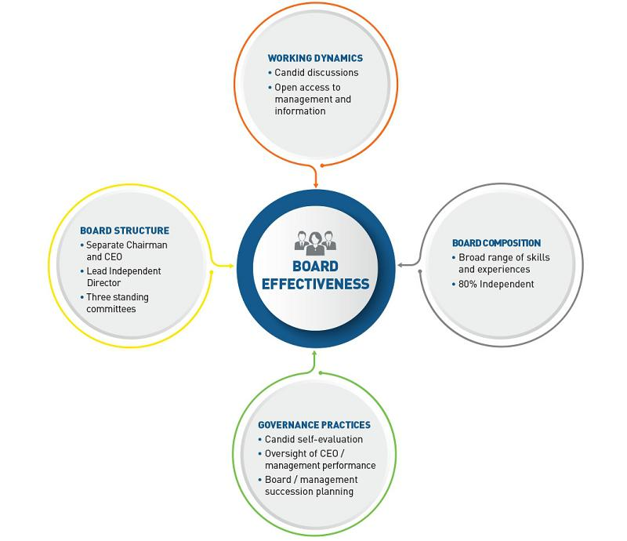

Board Meetings

In accordance with our Corporate Governance Principles and Policies, our Board generally meets at least quarterly, as well as in conjunction with the annual meeting of our shareholders. Our Board met nine times during 2020, including at least once per quarter and in conjunction with the 2020 annual meeting of our shareholders. Each person who served on our Board during 2020 attended over 80% of the aggregate of (1) the total number of meetings held by our Board during the period for which they was a director and (2) the total number of meetings held by each committee on which they served during the period in which they so served during the year.

Our Corporate Governance Principles and Policies also require that the independent directors meet in executive sessions outside of the presence of our management at least two times per year. Four such executive sessions took place during 2020.

In accordance with our Corporate Governance Principles and Policies, all directors are expected to attend annual meetings of our shareholders. All ten directors who were then serving on the Board attended the 2020 annual meeting as did Ms. Ostroff, who was then a nominee.

www.activisionblizzard.com ACTIVISION BLIZZARD, INC. 2021 Proxy Statement 34

Back to Contents

Annual Board, Committee, and Director Self-Evaluations

We recognize the critical role that Board and committee evaluations play in ensuring the effective functioning of our Board. To this end, the Nominating and Corporate Governance Committee annually leads an evaluation of our Board’s overall performance and the overall performance of each of our Board’s standing committees, which seeks to identify specific opportunities, if any, for improvement.
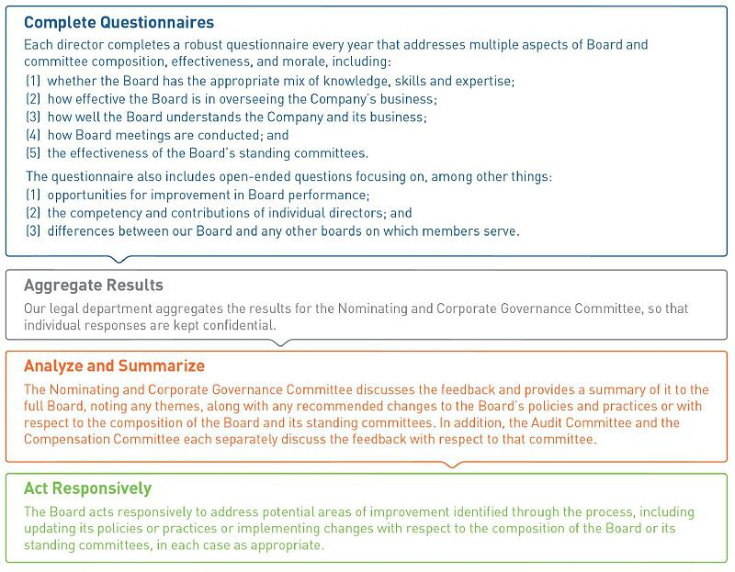

www.activisionblizzard.com ACTIVISION BLIZZARD, INC. 2021 Proxy Statement 35

Back to Contents

Director Orientation and Continuing Education

Board Orientation

New directors are provided with a comprehensive director orientation manual upon joining our Board that provides them with important information about the Company, our Board, and the general roles and responsibilities of directors of publicly traded companies. Each new director is also invited to attend an “onboarding day,” during which they meet with our executives and other key members of our senior management.

Continuing Education

We recognize the benefit of continuing education for our directors. In addition to the education routinely provided to our directors by our executives and other key members of our senior management at meetings of our Board and its committees on topics impacting the Company, including emerging risks, industry trends, technological developments, economic forecasts, and competitive challenges, we may engage third parties to provide in-boardroom education. To supplement the education we provide, we also encourage our directors to attend external programs and provide financial and administrative support to the directors in connection therewith.

Board Committees

Our Board has three standing committees—the Audit Committee, the Compensation Committee, and the Nominating and Corporate Governance Committee—each of which operates under a written charter approved by our Board. Further, from time to time, our Board forms special or ad hoc committees to which our Board delegates authority to administer certain of its duties.

Set forth below is the current membership of each of our Board’s standing committees. Each current committee member served in the role shown below through 2020 and continues to serve in that role.

Also set forth below is a summary of the purpose and key responsibilities of each of the three standing Board committees.

www.activisionblizzard.com ACTIVISION BLIZZARD, INC. 2021 Proxy Statement 36

Back to Contents

AUDIT COMMITTEE

Members: Robert Corti (Chair), Hendrik Hartong III, Peter Nolan Meetings Held in 2020: Six, including at least once per quarter


Purposes & Key Responsibilities

- Selecting, evaluating, and overseeing our independent registered public accounting firm, including determining that firm’s compensation and evaluating that firm’s independence

– Our independent registered public accounting firm reports directly to the Audit Committee

– Before we or any of our subsidiaries engage our independent registered public accounting firm to render audit or non-audit services, the Audit Committee must pre-approve the engagement (see “Audit-Related Matters—Pre-Approval Policies and Procedures” below)

- Overseeing the annual audits and quarterly reviews of our financial statements and our internal control over financial reporting by our independent registered public accounting firm

- Overseeing our financial reporting process and internal control, including:

– reviewing and evaluating the adequacy and effectiveness of our internal control over financial reporting and our management’s assessment of the same

– reviewing, and discussing with the independent registered public accounting firm, the results of the annual audit of our financial statements, including any comments or recommendations of our independent registered public accounting firm, and, based on that review and discussions and other considerations, recommending to our Board whether those financial statements should be included in our Annual Report on Form 10-K

– reviewing, and discussing with our management, our internal audit projects and the performance of our internal audit function

– discussing with our management the Company’s process for assessing and managing our exposure to risk, including overall enterprise risk and insurance

– meeting periodically with our management, including our Chief Financial Officer, our Chief Accounting Officer, our chief internal audit executive, and our independent registered public accounting firm in separate executive sessions, to discuss any matters that the Audit Committee or any of the above persons or firms believe warrants Audit Committee attention

- Overseeing policies regarding hiring employees from our independent registered public accounting firm and establishing procedures for the receipt and retention of accounting-related complaints and concerns

- Overseeing our policies relating to the ethical handling of conflicts of interest, including related party transactions (see “Certain Relationships and Related Person Transactions—Policies and Procedures Regarding Transactions with Related Parties” below)

- Overseeing our cybersecurity risk management programs and receiving periodic updates from management regarding cybersecurity, data privacy, data security, and other risks relevant to the Company’s information technology
Membership

- Must have at least three members

- All Audit Committee members must be determined by our Board to be independent directors under the Nasdaq Rules and the rules of the U.S. Securities and Exchange Commission (“SEC”) and otherwise satisfy the Nasdaq Rules and the rules of the SEC with respect to audit committee membership

- No director may serve as a member of our Audit Committee if that director serves on the audit committees of more than two other public companies, unless our Board determines that the simultaneous service would not impair the ability of that director to effectively serve on our Audit Committee

- All Audit Committee members must understand fundamental financial statements

- At least one Audit Committee member must be designated by the Board as an “audit committee financial expert” as defined in the applicable rules of the SEC

- No Audit Committee member can have participated in the preparation of the financial statements of Activision Blizzard or any of our current subsidiaries at any time during the three years prior to the proposed appointment of that Audit Committee member

- Based upon information provided by each member of the Audit Committee concerning his background, employment, and affiliations, our Board has determined that each is an independent director under the Nasdaq Rules and the rules of the SEC and that each otherwise satisfies the Nasdaq requirements for audit committee membership (including that each meets the independence criteria set forth in Rule 10A-3 of the Securities Exchange Act of 1934 (as amended, the “Exchange Act”) and is able to read and understand fundamental financial statements)

- Our Board has also determined that each Audit Committee member is an “audit committee financial expert” as defined in the applicable rules of the SEC and that each is “financially sophisticated” within the meaning of the Nasdaq Rules

Meetings

Must meet at least quarterly

Committee Charter

Our Audit Committee’s charter, which describes the composition and responsibilities of the committee, may be viewed on our website at http://investor.activision.com/corporate-governance.cfm

Engagement of Outside Consultants

The Audit Committee’s charter authorizes it to engage independent counsel or other consultants or advisors, as it deems appropriate

www.activisionblizzard.com ACTIVISION BLIZZARD, INC. 2021 Proxy Statement 37

Back to Contents

COMPENSATION COMMITTEE

Members: Robert Morgado (Chair), Reveta Bowers, Dawn Ostroff Meetings Held in 2020: Nine, including at least once per quarter


Purposes & Key Responsibilities

- Discharging our Board’s responsibilities relating to compensation paid to our directors and executive officers and overseeing compensation under our equity incentive plans and other compensation policies, programs, agreements, and arrangements

– The Compensation Committee consults with our management in formulating compensation plans, but ultimately the Compensation Committee exercises independent judgment in approving the compensation of our executive officers

– Please see “Executive Compensation—Compensation Discussion and Analysis—Decision-Making Approach to Executive Compensation—Roles of the Key Participants in the Executive Compensation Decision-Making Process” and “—Our Board’s Role in Risk Oversight—Compensation Risk Management” below for a further description of such responsibilities

- Reviewing, and discussing with our management, the compensation-related disclosure included in our proxy statement and Annual Report on Form 10-K

- Reviewing and overseeing matters related to human capital management, including attracting, retaining, and developing talent

- Overseeing any proposals we submit to our shareholders on matters relating to executive compensation, including advisory votes on compensation and the frequency of such votes and approval of compensatory plans and any amendments to such plans

Engagement of Outside Consultants

- Our Compensation Committee’s charter authorizes it to engage independent counsel or other consultants or advisors, including compensation consultants, to advise the Compensation Committee with respect to compensation and benefits for our directors and our executive officers and other employees

– Since October 2013, the Compensation Committee has engaged Exequity LLP (“Exequity”) to act as its independent compensation consultant and to advise on issues related to executive compensation and benefits

– Exequity reports directly to the Compensation Committee and does not provide any services to us other than the services provided to the Compensation Committee

– The Compensation Committee has also retained the law firm of Paul Hastings LLP (“Paul Hastings”) as its legal advisor

- In accordance with its charter and the Nasdaq Rules, each year in connection with the engagement of any compensation consultant or any other external advisor, the Compensation Committee assesses the independence of the compensation consultant or advisor who advises the Compensation Committee, using the following factors:

– the provision of other services, if any, the compensation consultant provided to the Company;

– the significance of the fees paid by the Company as a percentage of the compensation consultant’s total revenues;

– the compensation consultant’s policies and procedures designed to prevent conflicts of interest;

– any business or personal relationships between the compensation consultant professionals engaged to advise our Compensation Committee and the members of our Compensation Committee;

– ownership of any Company stock by the compensation consultant professionals engaged to advise the Company; and

– any business or personal relationships between the compensation consultant professionals engaged to advise our Compensation Committee and our executive officers

- Our Compensation Committee assessed the independence of Exequity based on the evaluation of these factors, including information received from the compensation consultant addressing these factors, and believes that Exequity’s service to the Compensation Committee does not raise any conflicts of interest

- For additional information regarding the Compensation Committee, including its use of consultants, see “Executive Compensation —Compensation Discussion and Analysis” below

Membership

- Must have at least two members

- All Compensation Committee members must be:

– determined by our Board to be independent directors under the Nasdaq Rules, including the requirements with respect to compensation committee composition;

– “non-employee directors” as defined in Rule 16b-3 under the Exchange Act; and

– “outside directors” as defined under Section 162(m) (“Section 162(m)”) of the Internal Revenue Code, as amended (the “Internal Revenue Code”)

- Based upon information provided by each member of the Compensation Committee concerning their background, employment, and affiliations, our Board has determined that each is an outside director as defined under Section 162(m), a non-employee director as defined in Rule 16b-3 under the Exchange Act, and an independent director under the Nasdaq Rules

- Our Board has also determined that none of the members of the Compensation Committee has a relationship to the Company that is material to such director’s ability to be independent of management in connection with the duties of a Compensation Committee member

Meetings

Must meet at least four times annually

Committee Charter

Our Compensation Committee’s charter, which describes the composition and responsibilities of the committee, may be viewed on our website at http://investor.activision.com/corporate-governance.cfm

Compensation Committee Interlocks and Insider Participation

No member of our Compensation Committee (including Elaine Wynn who served on the Compensation Committee until June 2020) is or has been an executive officer or other employee of the Company. Additionally, in 2020, none of our executive officers served on the board of directors of any entity that had an executive officer serving on our Board

www.activisionblizzard.com ACTIVISION BLIZZARD, INC. 2021 Proxy Statement 38

Back to Contents

NOMINATING AND CORPORATE GOVERNANCE COMMITTEE

Members: Robert Morgado (Chair), Barry Meyer, Casey Wasserman

Meetings Held in 2020: Four
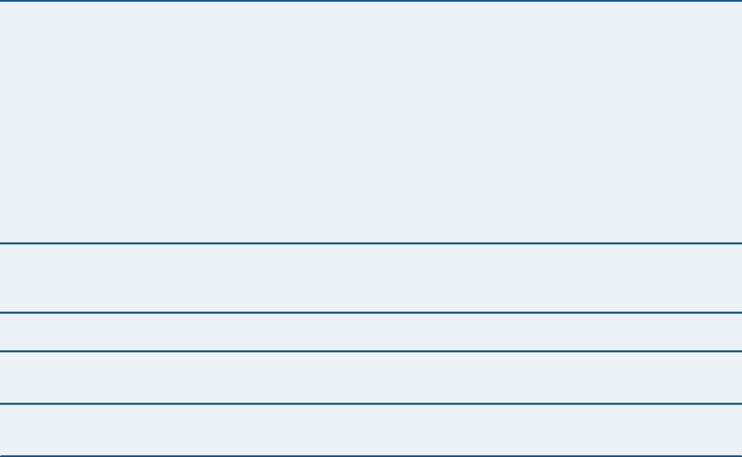

Purposes & Key Responsibilities

- Assisting in identifying and recruiting director nominees, ensuring that the Rooney Rule is applied to any search for a new independent director and any external search for a new chief executive officer

- Periodically evaluating the size of our Board and recommending to our Board any appropriate increase or decrease

- Making recommendations to our Board regarding the size and composition of each standing committee of our Board

- Overseeing the evaluation of our Board and its committees

- Providing oversight of our corporate governance affairs and those of our Board

- In consultation with the Board and each of the other Board committees, as needed, overseeing the Company’s environmental, social, and governance (“ESG”) strategy, practices, and policies, including the Company’s reporting on ESG matters

- Determining the appropriate engagement with shareholder groups and proxy advisory firms on our submissions to our shareholders (which, in the case of matters relating to executive compensation, will be done in conjunction with the Compensation Committee)

- Evaluating any shareholder proposals submitted to us for inclusion in any proxy statement for, and for consideration at, any meeting of our shareholders (which, in the case of shareholder proposals relating to the compensation of our directors or employees, will be done in conjunction with the Compensation Committee)

Membership

- Must have at least two members

- Based upon information provided by each member of the Nominating and Corporate Governance Committee concerning his background, employment, and affiliations, our Board has determined that each is an independent director under the Nasdaq Rules

Meetings

Must meet at least two times annually

Committee Charter

Our Nominating and Corporate Governance Committee’s charter, which describes the composition and responsibilities of the committee, may be viewed on our website at http://investor.activision.com/corporate-governance.cfm

Engagement of Outside Consultants

The Nominating and Corporate Governance Committee’s charter authorizes it to engage independent counsel or other consultants or advisors as it deems appropriate, including a search firm to assist in the identification of director candidates

www.activisionblizzard.com ACTIVISION BLIZZARD, INC. 2021 Proxy Statement 39

Back to Contents

Our Board’s Role in Risk Oversight

General Risk Oversight

It is the responsibility of our senior management to develop and implement the Company’s financial and strategic plans, and identify, evaluate, manage, and mitigate the risks inherent in those plans. It is our Board’s responsibility to understand and oversee those plans, the associated risks, and the steps that senior management is taking to manage and mitigate those risks. Our Board, its standing committees, and our senior management exercise this risk oversight function in a variety of ways, including:
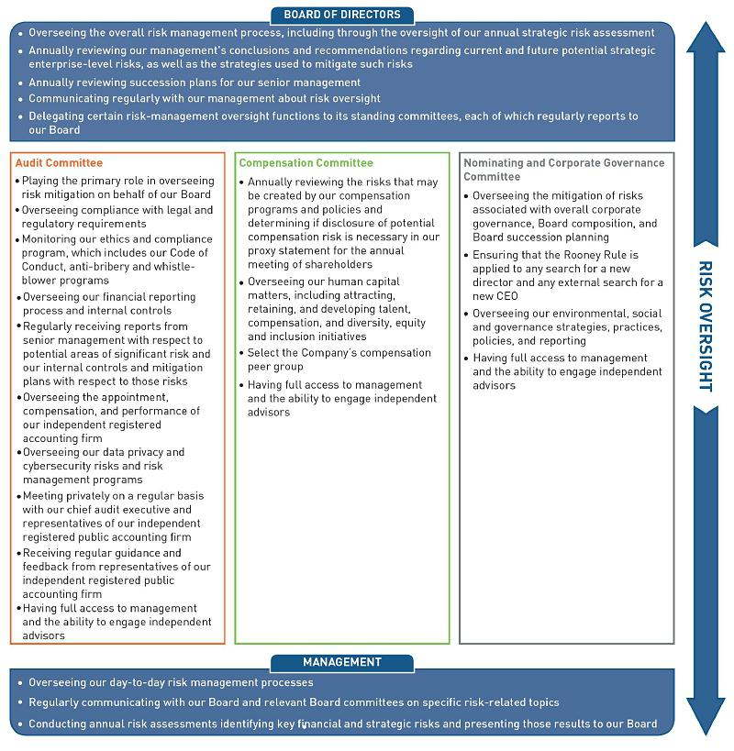

www.activisionblizzard.com ACTIVISION BLIZZARD, INC. 2021 Proxy Statement 40

Back to Contents

Cybersecurity Risk Oversight

In order to defend against, and respond to, security breaches and cyberattacks, we have developed a comprehensive program that is designed to protect and preserve the confidentiality, integrity, and continued availability of all information owned by, or in the care of, the Company and our partners. This program includes a cyber-incident response plan. Our Audit Committee oversees the identification and mitigation of potential cybersecurity risk, with the goals of protecting our intellectual property, maintaining consumer confidence, preserving employee data confidentiality, and minimizing information security threats to the Company and the users of our products and services. As part of this oversight, the Audit Committee receives regular updates with respect to the threats we face, and our risk mitigation plans to address those threats, from members of management with information security responsibilities. These updates include results of information security maturity assessments and recommendations that are informed, in part, by third-party independent reviews of our information security control environment and operating effectiveness.

Compensation Risk Management

The Compensation Committee, together with its independent compensation consultant, legal counsel, and members of our human resources team, reviews the Company’s incentive compensation plans and practices annually to determine if they encourage employees to take risks that are reasonably likely to have a material adverse effect on the Company. In 2020, as in previous years, this review consisted of an analysis of each of our incentive compensation programs for our executives and other employees, including eligibility, performance measures, payment targets and maximum payments, payment timing, and governance (including the applicable approval process). We concluded our compensation programs do not incentivize employees to take such risks.

The incentive compensation plans in which our employees participate are designed to encourage achievement of challenging targets aligned with shareholder interests and our overall corporate strategy. These plans provide upside opportunity for higher levels of performance, while mitigating potential risks. The following factors help mitigate risk:

- performance objectives underlying awards focus on long-term shareholder value creation and include an appropriate mix of financial and strategic targets and short- and long-term time horizons;

- cash bonuses represent just one element of our employees’ total compensation;

- cash bonuses are only paid if established performance metrics are achieved and/or the underlying business unit is profitable;

- our shareholder-approved incentive plan limits the size and value of the short- and long-term incentive awards that any individual may receive for a given year;

- equity awards, which represent a meaningful portion of the compensation paid to our executives, generally are subject to multi-year vesting schedules, and any vesting in respect of underlying performance measures is capped; and

- incentive awards for our executive officers are tied to an array of performance metrics, motivating a balanced focus on multiple measures of the Company’s health.

We also follow a number of governance policies that mitigate compensation-related risks, including:

- cash-based incentive awards generally require at least two levels of approval (awards to executive officers require the approval of the Compensation Committee and, except for the CEO themself, the CEO);

- all equity-based awards to any employee require Compensation Committee approval, in addition to management-level approval;

- written documentation underlying all of our cash-based incentive programs is required for our principal business units;

- our Compensation Committee annually reviews and approves the equity award guidelines for all eligible employees;

- we have a “clawback policy,” pursuant to which performance-based compensation to an executive may be recovered in the event of an earnings restatement due to the executive’s misconduct to the extent the amounts paid were in excess of what would have been paid had the restated numbers been used to determine payments;

- our equity award agreements provide that, should an executive officer breach their employment agreement with the Company, including post-termination obligations, the Company may recover certain realized gain in respect of their awards;

www.activisionblizzard.com ACTIVISION BLIZZARD, INC. 2021 Proxy Statement 41

Back to Contents

- stock ownership guidelines for our executive officers and the President of each of Activision, Blizzard Entertainment, Inc. (“Blizzard”), and King Digital Entertainment Limited (“King”) require each person subject to the guidelines to maintain equity ownership with a value equal to a specified multiple of their then-current base salary;

- our insider trading policies prohibit “shorting” our securities, engaging in “puts,” “calls,” or other hedging transactions involving our securities, or using margin accounts with our securities; and

- every employee must certify compliance with our Code of Conduct on an annual basis.
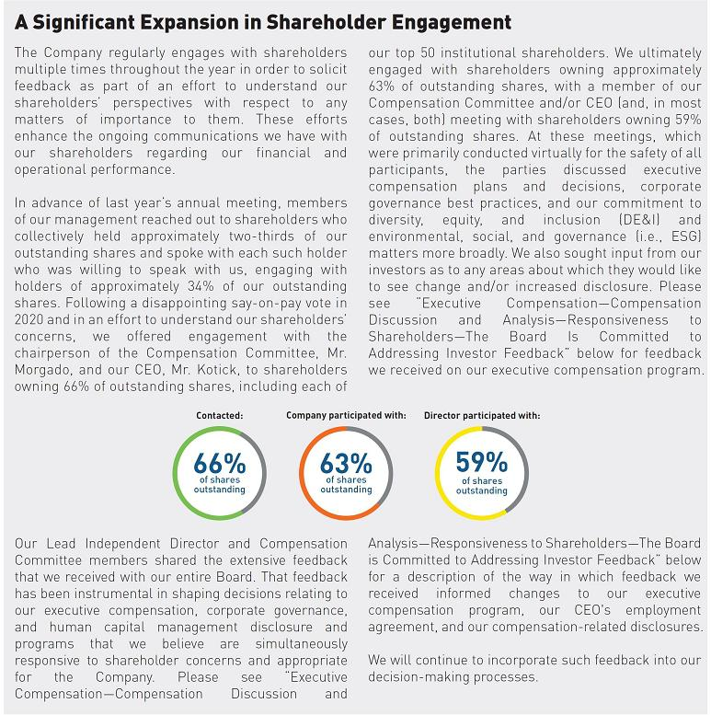

www.activisionblizzard.com ACTIVISION BLIZZARD, INC. 2021 Proxy Statement 42

Back to Contents

STOCK OWNERSHIP GUIDELINES

In order to align the interests of our management with those of our shareholders, we believe that every executive officer should maintain a meaningful ownership stake in the Company. Accordingly, the Compensation Committee has adopted guidelines providing that our Chief Executive Officer is expected to beneficially own shares of our Common Stock with a value at least equal to fifty times (i.e., 50x) their then-current annual base salary and that all other executive officers, as well as the President of each of Activision, Blizzard, and King, are expected to beneficially own shares of our Common Stock with a value at least equal to their then-current annual base salary.

The individuals subject to these guidelines are expected to accumulate the required stock within five years (so that any person who has been subject to the guidelines since the date on which these guidelines were adopted in 2012 should be in compliance, and any person who subsequently became subject to them (e.g., upon their election as an executive officer) has five years from the date on which they became subject to them to be in compliance). Further, if such a person does not satisfy these guidelines within the five-year period, then, until they satisfy the guidelines, they will be required to hold 50% of the net shares received upon exercise of stock options or upon the vesting of restricted share units awards received, provided such shares received are under equity awards made after the adoption of the ownership guidelines and that such awards are, per their terms, explicitly subject to them.

As of April 1, 2021, each person who, as of that date, had been subject to the guidelines for five or more years satisfied them.

POLITICAL ACTIVITIES

Pursuant to our Code of Conduct, Company resources may not be used for employees’ personal political activities, and lobbying activities are permitted only in compliance with applicable law and by individuals designated to represent the Company in such capacity. We made no political contributions in 2020.

Trade associations of which the Company is a member may take a stance on legislative matters or engage in lobbying on specific issues. Trade associations are independent organizations representing a variety of members and may take political or policy positions we do not share. You can find more information about the ways in which Activision Blizzard participates in public debate in the United States through direct and indirect advocacy at the federal, state and local level by accessing our Political Activities Disclosures on our website at http://investor.activision.com/corporate-governance.cfm.

CORPORATE GOVERNANCE PRINCIPLES AND POLICIES

Our Corporate Governance Principles and Policies establish a framework for the Board’s exercise of its duties and responsibilities in service of the best interests of the Company and our shareholders. They address, among other things, the role of our Board, the composition of our Board and that of its standing committees, meetings of the Board and its committees, and director stock ownership requirements. You can access our Corporate Governance Principles and Policies on our website at http://investor.activision.com/corporate-governance.cfm.

CODE OF CONDUCT

We have a code of ethics—our Code of Conduct—which applies to all our directors and employees worldwide, including our chair, chief executive officer, president, chief operating officer, chief administrative officer, chief financial officer, and chief accounting officer. We also have a chief compliance officer, who administers our ethics and compliance program. You can access our Code of Conduct on our website at http://investor.activision.com/corporate-governance.cfm. Furthermore, we will post any amendments to, or waivers of, the Code of Conduct that apply to our chief executive officer, chief financial officer, chief accounting officer, or any person performing similar functions, and any other related information, on that website.

www.activisionblizzard.com ACTIVISION BLIZZARD, INC. 2021 Proxy Statement 43

Back to Contents

COMMUNICATIONS WITH OUR BOARD

We believe that communication with our shareholders is very important, and the Company reviews feedback sent to us from any shareholder, no matter the size of their holdings. Our Corporate Secretary reviews all communications addressed to our Board, any of its committees, or one or more of our individual directors. Generally, communications that are advertising materials, promotions of a product or service, or patently offensive communications will not be forwarded. Communications that relate to our accounting practices, internal accounting controls, or auditing matters will be promptly forwarded to the chairperson of the Audit Committee. Communications that relate to any other matter that our Corporate Secretary, in her reasonable judgment, considers to be appropriate will be forwarded promptly to the addressee(s).

By Mail | Email | Phone
mail to | send email to | Investor
Activision Blizzard, Inc. | ir@activision.com | Relations
c/o Corporate Secretary |  | (310) 255-2000
3100 Ocean Park Boulevard
Santa Monica,
California 90405

OUR EXECUTIVE OFFICERS

Biographical summaries for our executive officers (including for Mr. Kotick, for whom a biographical summary is also set forth under “Proposal 1—Election of Directors” above) can be found in Item 1 of our Annual Report on Form 10-K for the year ended December 31, 2020, filed with the SEC on February 23, 2021 (our “2020 10-K”).

EXECUTIVE SUCCESSION PLANNING

As a part of various sessions during the year, our Board focuses on human capital, including by engaging in succession planning for our chief executive officer and other senior-most officers. Our Board’s goals are to have a process for effective executive development and succession and to be prepared for both the unexpected loss of a key leader and planned changes to our management team. In these sessions, among other things, our Board:

- reviews the assumptions, processes, and strategy for expected and unexpected events that may result in changes to our executive team;

- evaluates the Company’s organizational and operational needs and the overall qualifications, tenure, and experience of our executive team;

- considers the experience, performance, and skills of, and development opportunities for, possible internal successors to our chief executive officer and other executives; and

- discusses potential external successors to our chief executive officer and other executives.

www.activisionblizzard.com ACTIVISION BLIZZARD, INC. 2021 Proxy Statement 44

Back to Contents

ADDITIONAL CORPORATE GOVERNANCE DOCUMENTATION

In addition to finding our Corporate Governance Principles and Policies, Audit Committee Charter, Compensation Committee Charter, Nominating and Corporate Governance Committee Charter, Code of Conduct, and Policy on Recoupment of Performance-Based Compensation Related to Certain Financial Restatements on our website at http://investor.activision.com/corporate-governance.cfm, you can also find many of our other corporate governance documents. Please see “Helpful Resources” below for more information.

ENVIRONMENTAL, SOCIAL, AND GOVERNANCE HIGHLIGHTS

Our Board and its committees oversee matters related to our environmental, social, and governance (i.e., ESG) practices, performance, and disclosure. Through this process, directors provide management with feedback and guidance on the Company’s ESG efforts. Please see “—Board Committees” above for a description of our Board, its committees and their respective roles and responsibilities. In 2020, our management established both an ESG steering committee, which is currently chaired by our Chief Administrative Officer and includes our Corporate Secretary and Chief Compliance Officer, Chief People, Diversity & Inclusion Officer, Chief Legal Officer, Chief Financial Officer, SVP of Investor Relations, Chief Communications Officer, and a cross-functional, enterprise-wide ESG working group, which includes members of our executive management team and employees from all of our business units and corporate functions and supports the steering committee by identifying the ESG matters that are most relevant to our business. As part of our long-term strategy, we will continue to expand our internal ESG expertise and advance our reporting activities.
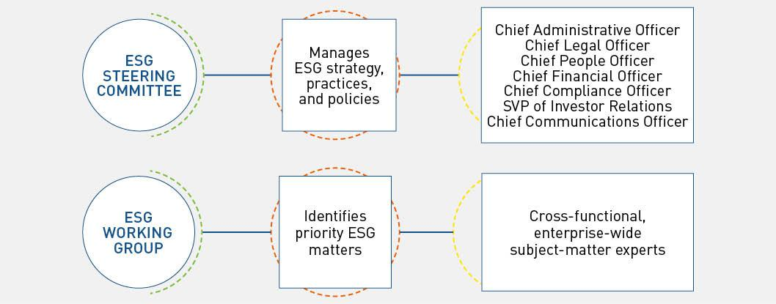

In addition to the preparation of our first annual ESG report, which we will publish later this quarter, our ESG efforts in 2020 focused on using our platforms and the resources in three key areas: (1) protecting our people in the fight against COVID-19; (2) driving diversity, equity, and inclusion in our communities; and (3) protecting our planet.

www.activisionblizzard.com ACTIVISION BLIZZARD, INC. 2021 Proxy Statement 45

Back to Contents

The Fight against COVID-19

The health and safety of our employees, players, and fans has been and continues to be a top priority. To that end, we swiftly launched several initiatives to support each of these vital groups in managing through the pandemic.

All of our facilities moved to a work-from-home model by mid-March 2020, completing an efficient, safe, and successful transition of nearly 10,000 employees to remote work. When traditional medical services came under huge demand at the onset of the pandemic, we created an extensive network of physicians in order to help ensure that our employees and their families had access to the very best medical care, including mental health care. We made a commitment to directly support the healthcare organizations in the communities in which our employees live and work. We donated more than $5 million dollars to aid hospitals, healthcare organizations, and nonprofits treating COVID-19 patients, vaccinating frontline workers, conducting promising drug trials and convalescent plasma therapies, creating opportunities for veterans, and providing employment services in these communities.

For our players and fans, we were proud to partner with the World Health Organization for the #PlayApartTogether campaign to leverage our game platforms to disseminate critical health and safety information while offering in-game events and rewards to promote social distancing. We also successfully transitioned our professional esports leagues, Overwatch League™ and Call of Duty League™, to a remote broadcast format to keep our players and fans safe while continuing to deliver world class esports content to our global audiences.

At the time of writing, the pandemic is still exacting a tragic toll upon so many. Most of our employees continue to work from home. However, we have the very best resources dedicated to the creation of policies and workplaces that will eventually allow our employees to return to the office with confidence that their healthcare needs and the needs of their families will remain our priority.

Driving Diversity, Equity, and Inclusion in our Communities

Video games have redefined what it means to interact socially, and this has been reinforced during the pandemic while other forms of social interaction have been limited. Our game Overwatch® celebrates diversity through the heroes it features. Of our 32 heroes in the game, there are 13 women, 12 heroes of color, two LGBTQ+ heroes, and one hero on the autism spectrum. The most prominent of our heroes, Tracer, is both a woman and identifies as a member of the LGBTQ+ community. Gaming connects people more deeply than any other form of media, bringing people together without regard to race, religion, ethnicity, sexual identity, and gender or gender expression. With our players engaging for over an hour per day when they play, our games can play an important, responsible, and positive role influencing popular culture, eliminating stereotypes, celebrating differences, and encouraging communities to embrace tolerance and understanding.

Our Company and Talent Pipeline

Driving diverse communities first means creating a diverse and inclusive culture with our own company. We know that the most innovative and compelling work only originates from a culture in which all employees can be, and bring, their authentic and best selves. Beyond being an equal opportunity employer, we are committed to building and sustaining a culture of DE&I, beginning with the tone from the top and extending through our company. Our continuous work in this space drives greater reach, engagement and growth and allows us to continually invest in building upon, expanding and amplifying our efforts, making DE&I a competitive advantage.

- Since 2016, the number of women in our game development leadership roles has more than doubled. The promotion rates for minorities and non-minorities are identical, and the promotion rate for women is slightly higher than the promotion rate for men.

- The pool from which any new independent nominee to our Board of Directors or external candidates for CEO are chosen will include qualified women and racially or ethnically diverse candidates.

- All slates for VP and above positions require diverse candidates. Our CEO has been clear that all positions at all levels of hiring should include diverse candidates.

- Hiring partners likewise are expected to provide a diverse slate of candidates for these positions.

www.activisionblizzard.com ACTIVISION BLIZZARD, INC. 2021 Proxy Statement 46

Back to Contents

- In 2020, to accelerate women into leadership roles, we created the “Kicking Glass” program, which aims to provide networking and exposure opportunities, development and mentoring to women and non-binary employees. This includes tailored modules for our employees at various stages in their careers.

- For the second year in a row, our University Relations team has partnered with STEM Advantage, an organization that mentors and prepares women and other students from underserved communities to pursue careers in science and technology, which helps us select the very best talent for our internship program.

- Our broader Talent Acquisition team is equally focused on connecting with underrepresented groups, such as participating in career fairs such as Grace Hopper Celebration and AfroTech World.

- Our support for the UNCF provided transformative scholarships to Historically Black Colleges and Universities for some of our nation’s most promising young adults.

- Our investment in Management Leadership for Tomorrow allowed the organization to double participation in its extraordinary career preparation program, equipping high-achieving Black, Latinx, and Indigenous Americans with skills and coaching to accelerate their careers.

Our In-Game Communities

Because of the size of our communities and the depth of our engagement, our games have the power to challenge stereotypes and reduce prejudice. We have some of the most diverse games in the world, including characters of color, characters from the LGBTQ+ community, characters of differing abilities, and non-binary characters. They increasingly reflect our communities, and we believe that content designed with diversity and inclusion enables these global communities to grow. It also drives deeper engagement, as fans—both new and old—connect with us in new and meaningful ways.

- We have developed a training program known as “Crush the Norm” to teach developers to use a tool we call the “Diversity Space Tool,” which challenges game designers to consider where the characters they create fall across a spectrum of various characteristics (e.g., culture, ethnicity, age, ability, sexual orientation, body type, and gender identity) to help our developers make diverse and inclusive choices.

- Our developers leverage the members of our Employee Networks, as well as the Company’s DE&I team, to provide feedback and input on content ranging from narratives to worlds/levels and character skins and name. For example, our LGBT+ & Allies Network provided input impacting some of our heroes’ storylines.

- Overwatch features one of the most diverse cast of characters in any video game. Of its 32 heroes, there are 13 women, 12 heroes of color, two LGBTQ+ heroes, and one hero on the autism spectrum. The most prominent—and one of the most effective—of our heroes, Tracer, is both a woman and identifies as a member of the LGBTQ+ community.

- Tony Hawk’sTM Pro SkaterTM 1+2 introduced a selection of new skaters, including two women skaters from Brazil and Japan, two African American women, and Leo Baker, a non-binary skater.

- Pelagos broke ground as one of the first explicitly transgender characters in the Warcraft® series. Presenting as female in his mortal life, he chose to be a man in Shadowlands.

- We also continue to introduce a variety of cosmetic options for our heroes that allow players to express themselves in-game. For example, players of World of Warcraft®: Shadowlands can fully customize their character—aside from their playable mythical race—without charge.

- This year, we also aligned with key cultural moments through special in-game engagements. Our Call of Duty® Crescent Moon event celebrated Ramadan, which resulted in more than one million views of game footage in the Middle East alone. And we joined our voice to the Black Lives Matter movement, broadcasting our message of solidarity and demand for action to every player who played a game of Call of Duty after the tragic passing of George Floyd.

- Inclusive design can help create accommodations and rich experiences that are enjoyable for our players with varying needs, abilities, and preference. We build industry leading technology to make our games more accessible to all, such as colorblind options, input device and control options, and many others.

Communities in Which We Live and Work

From company-sponsored programs to grassroots voluntary involvement, our employees love to give back and support programs and charities that are meaningful to them and our communities more broadly. Our efforts are focused on the Call of Duty Endowment, Veterans Day of Service, and STEAM learning.

www.activisionblizzard.com ACTIVISION BLIZZARD, INC. 2021 Proxy Statement 47

Back to Contents

Call of Duty Endowment

The flagship of our corporate social engagement efforts is the Call of Duty Endowment (CODE), which helps veterans find high-quality careers by supporting groups that prepare them for the job market and by raising awareness of the value vets bring to the workforce.

- CODE is on track to hit its goal of getting 100,000 veterans back to work by 2024, surpassing 81,000 veterans in 2020. This is a result of the more than $53 million in grants CODE has made since its inception.

- Even with unemployment rates skyrocketing in 2020, it was CODE’s most successful year ever with the placement of over 15,000 veterans into high-quality jobs. In 2020, an estimated 21% were women and approximately 28% were Black—metrics in which we take great pride, considering that women veterans and Black veterans compose just 10% and 12%, respectively, of the U.S. veteran community.

- We held our second CODE bowl in 2020, a charity esports event at which top Call of Duty streamers played Call of Duty®: Black Ops Cold War alongside members of all branches of the U.S. military and UK military, raising almost $700,000 for CODE. We also donated the proceeds of selected virtual CODE-themed items purchased in our games to veteran job placement. In 2020, sales of in-game items for our products raised $8.1 million, which will drive the placement of more than 15,000 veterans into jobs.
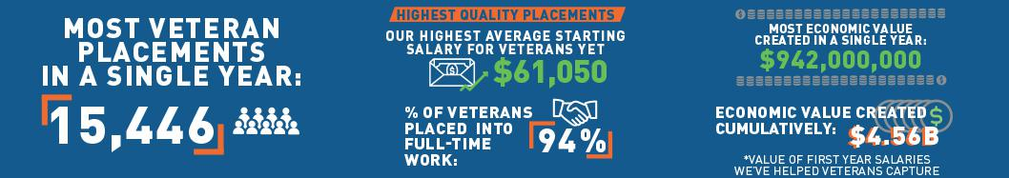

Please see CODE’s most recent annual report for more information, which may be viewed on CODE’s website at https://www.callofdutyendowment.org/.

Veterans Day of Service

Our Veterans Day of Service (VDOS) is a day for Activision Blizzard employees to take a day off work to volunteer for charities focused on creating a positive impact for veterans across the globe. While COVID-19 prevented our workforce from gathering in person in 2020, the 7th annual edition of this event took place virtually over the course of a week.

- In 2020, over 1,200 volunteers from Activision, Blizzard, and Corporate (including almost 80 interns and over 100 players and staff from all nine U.S. teams in our Call of Duty League) supported 21 unique charities by creating assistance kits curated to meet the specific needs of local veterans in their region (for example “stay well” kits and kits with blankets and hats for veterans facing homelessness).

STEAM Learning

In addition to our support of veterans, we have various community programs across the Company to promote STEAM learning and foster career opportunities for underrepresented groups in STEAM fields.

- Annually since 2016, we have partnered with Hello World!, a Swedish based non-profit organization that, through summer camps and weekend meetups, encourages and spreads interest and knowledge in science, technology, and art using digital tools, with an emphasis on girls and children from socioeconomically vulnerable areas.

- Since 2018, we have partnered with Girls Who Code, a nonprofit focused on closing the gender gap in technology, to host a seven-week Summer Immersion Program for high school-aged girls to learn coding and gain exposure to careers in tech.

- In 2020, we made a contribution to Ada, the National College for Digital Skills in London, of which we are one of the founding industry partners, and our employees served as industry mentors for students there, as well as judges for the games challenges.

- In 2020, we partnered with Gameheads, a nonprofit focused on supporting youth of color and preparing them for a successful career in tech / games, and hosted a user research-focused panel where students received feedback on their research efforts.

www.activisionblizzard.com ACTIVISION BLIZZARD, INC. 2021 Proxy Statement 48

Back to Contents

- We also participated in the THU Career Camp in 2020, which is a free three-day online event that allows attendees to boost their careers by meeting with top studios, participating in mentorships, attending skill and career development sessions, and mingling with fellow artists.

Protecting Our Planet

We are committed to doing our part to protect the planet for current and future generations. That’s why we think about our environmental impact across and beyond our offices. This includes the data centers we select, as well as our product use, packaging, and supply chain. In 2020, we derived approximately 82% of our revenues via digital channels. Digital share of revenue is increasing over time, and we are working to accelerate that transition.

- Globally we have committed to a 50% reduction in our plastic production over the next five years, using 2019 as a baseline. Our efforts to do that include:

– maximizing player value in the digital versions of our games and shifting the marketing emphasis to communicate this value to players;

– reducing materials that accompany games that are sold physically; and

– optimizing sizing and packaging.

- We plan to work toward achieving net zero emissions by 2050, in line with the Paris Agreement. Our work to that end includes:

– measuring and determining a baseline for our GHG emissions by 2022, and setting interim targets to show our progress towards achieving net zero;

– engaging with our landlords and property managers to advocate for environmentally friendly practices in our offices and other facilities; and

– working with data center providers to collect and analyze data on the energy, emissions, and water footprints, including power usage effectiveness (PUE) and water usage effectiveness (WUE), which measure the energy and water efficiency of data centers.

www.activisionblizzard.com ACTIVISION BLIZZARD, INC. 2021 Proxy Statement 49

Back to Contents

EXECUTIVE COMPENSATION

COMPENSATION COMMITTEE LETTER

Dear Fellow Shareholders,

2020 marked another extraordinary chapter in Activision Blizzard’s history. We are proud of the exceptional accomplishments of our management team under the leadership of our CEO, who has successfully managed the Company for 30 years. This was clearly the most difficult year in the Company’s history, which makes our record financial performance especially notable.

Our Company reached a then all-time high market capitalization of $71.8 billion and over the last four years we have generated a compound rate of return of 27% per year, compared to 16% per year for the S&P 500 over the same period. In 2020, we generated more than 57% in total shareholder returns and grew operating income by $1.1 billion, or a 70% increase.

Our pay-for-performance philosophy, which drives our compensation programs, continues to play a vital role in our success. As your Compensation Committee, we will provide an update on executive compensation, specifically the compensation earned by our CEO as a result of multiple years of tremendous performance, as well as a summary of the feedback received from our shareholder outreach program which included 73 meetings with 51 shareholders representing more than 60% of our outstanding shares. We want to thank our shareholders for engaging with us over the course of this last year.

We believe incentives should be inextricably linked to value creation, and our results this year reflect the value of our pay for performance commitment.

Our Compensation Philosophy

Our compensation philosophy continues to focus on the use of performance-based cash and equity incentives. Our annual equity dilution rates of the last three years have averaged 0.85%, in the bottom quartile of our peers. While our peer group continues to favor time-based restricted shares as a significant component of the equity mix for executives, we continue to principally use performance-based equity (performance share units and options) which represented the entirety of our equity mix in the last year.

Chief Executive Officer Compensation

In 2016, when the Board began to develop a new CEO agreement, Activision Blizzard had reached an all-time high market capitalization of approximately $30 billion, more than doubling our market capitalization during the CEO’s 2012 to 2016 contract period. In 2016, as the Compensation Committee set terms for a new five-year contract, it included an aggressive growth goal for the CEO, which if achieved would equate to more than doubling our market capitalization and represents more than a four-fold increase over a nine-year period. This was, by all accounts, an extraordinarily challenging goal that, if achieved, would create substantial value for our shareholders. With the assistance of our outside compensation advisors, we developed an incentive plan that would properly recognize the achievement of such exceptional performance.

We achieved our ambitious shareholder value creation goals, and last year, we awarded our CEO compensation reflecting this tremendous four-year achievement. As the term of the CEO’s contract was set to expire in 2021, we conducted the most extensive shareholder outreach program in our history to make certain our CEO compensation program reflects the practices our shareholders identified as most important with respect to our CEO’s rewards, and best positions us for continued achievement of ambitious goals for future shareholder value creation.

Shareholder feedback has directly informed several compensation program changes

In direct response to the feedback we heard in conversations with our shareholders, we extended Mr. Kotick’s 2016 employment agreement on April 28, 2021, amending it in several key aspects, and made several changes to our broader executive compensation program and disclosures.

Highlights of the changes to Mr. Kotick’s agreement, and other arrangements with the Company, are detailed further on pages 59-60, include:

- Reduced the contractual base salary and resulting contractual target annual bonus by 50%; which is now below the 25th percentile of our peer group;

- Increased the ownership requirement for our CEO from 10x base salary to 50x, which we believe is the largest ownership requirement of any Fortune 500 CEO;

www.activisionblizzard.com ACTIVISION BLIZZARD, INC. 2021 Proxy Statement 50

Back to Contents

- Eliminated other performance-based equity (stock options) and will now only use PSUs for the remainder of the contract, with the grant date value of the CEO’s annual equity award to be set at no greater than the median grant date value of long-term incentive awards for CEOs of our peers;

- Eliminated the “transformative transaction award” from the CEO’s employment agreement;

- Eliminated the “shareholder value creation incentive” with respect to grants made under the new contract extension; and

- Increased the weighting of financial metrics in the annual cash bonus program (i.e., the CAIP) for the CEO and the broader executive compensation team from 60% to 80%, and for the remaining 20% of strategic objectives, these will be based on measurable ESG initiatives (i.e., human capital management, corporate social responsibility, and sustainability goals, which may include diversity, equity and inclusion metrics centered around the hiring/promotion of members of underrepresented communities, hiring of veterans and sustainability).

We believe these changes accurately reflect the direction provided by our shareholders and reflect best practices in compensation and governance to grow long-term value for our shareholders.

Sincerely,
Your Compensation Committee

Robert Morgado (Chair), Reveta Bowers, and Dawn Ostroff

The following discussion and tables set forth information with regard to 2020 compensation for all services rendered to us and our subsidiaries by the named executive officers included in the “Summary Compensation Table” below (collectively, our “named executive officers” or “NEOs”).

For 2020, our named executive officers were:

Name | Position with Activision Blizzard | Years of Service (as of April 2021)
Robert Kotick | Chief Executive Officer | 30 years
Dennis Durkin | Executive Advisor and Former Chief Financial Officer | 9 years 1 month
Daniel Alegre | President and Chief Operating Officer | 1 year
Claudine Naughton | Chief People Officer | 1 year 8 months
Chris B. Walther | Chief Legal Officer | 11 years 6 months

Changes To Our Management Team In 2020

On April 7, 2020, Daniel Alegre joined the Company as our President and Chief Operating Officer from Alphabet Inc where he served as an executive for 15 years most recently as President, eCommerce.

Changes To Our Management Team In 2021

On February 1, 2021, Brian Bulatao joined the Company in the newly created position of Activision Blizzard’s Chief Administrative Officer. Mr. Bulatao most recently served as the Under Secretary of Management at the U.S. State Department, after having served with distinction in the U.S. military and as a Managing Director at Pallas Capital Partners.

On March 29, 2021, Armin Zerza, who joined the Company over five years ago as Chief Financial Officer of Blizzard and most recently served as the Chief Commercial Officer of Activision Blizzard and Chief Operating Officer of Blizzard, became our Chief Financial Officer.

www.activisionblizzard.com ACTIVISION BLIZZARD, INC. 2021 Proxy Statement 51

Back to Contents

COMPENSATION DISCUSSION AND ANALYSIS

This Compensation Discussion and Analysis describes the material elements of our compensation program and the rationale for the program and our compensation decisions, through:

- A description of the complex business environment in which we operate and our rigorous requirements for talent;

- A summary of our performance focused compensation principles and objectives;

- An outline of our decision-making approach related to performance focused executive compensation; and

- A description of the elements and rationale behind our performance focused compensation programs and awards for 2020.

Additionally, we provide a detailed summary of the feedback we received from our annual shareholder outreach program, which this past year was the most comprehensive outreach we have ever conducted. We provide a detailed description of modifications made to our executive compensation practices as a result of shareholder feedback, improvements we believe ensure we employ the best practices for aligning performance and rewards; and changes to our compensation practices in response to our 2020 say-on-pay vote, which was a lower level of support than we desire.

This CD&A includes:
Compensation Discussion and Analysis |  | 52
Executive Summary |  | 53
Responsiveness to Shareholders—The Board Is Committed to Addressing Investor Feedback |  | 58
Compensation Principles and Objectives |  | 61
Putting CEO Pay into Perspective: Aligning Pay and Superior Financial Performance |  | 65
Decision-Making Approach to Executive Compensation |  | 69
Elements of Our Executive Compensation Program for 2020 |  | 75
Additional Information |  | 87
Compensation Committee Report |  | 87
www.activisionblizzard.com | ACTIVISION BLIZZARD, INC. 2021 Proxy Statement | 52

Back to Contents

Executive Summary

Long-Term Company Performance

Under the leadership and strategic vision of our Founder and long-time CEO, Mr. Kotick, Activision Blizzard has consistently navigated the shifting dynamics of our industry to harness opportunities, create exceptional value for our shareholders, and become an employer of choice within the technology, media, and entertainment fields.

Since 1991, when our Chairman and Chief Executive Officer assumed responsibility for leading the Company, Activision Blizzard has significantly outperformed the S&P 500. If you had invested $1,000 in our

company 20 years ago, your investment, including dividend reinvestment, would have been worth $82,190 at the end of 2020, or approximately 20 times the S&P 500’s $4,223.

Our market capitalization has grown over 19,000%—from $366 million in 2000, to over $70 billion by 2020. The Company’s market capitalization more than doubled between 2012 and 2016, then on top of that extraordinary achievement, more than doubled again by the end of 2020.
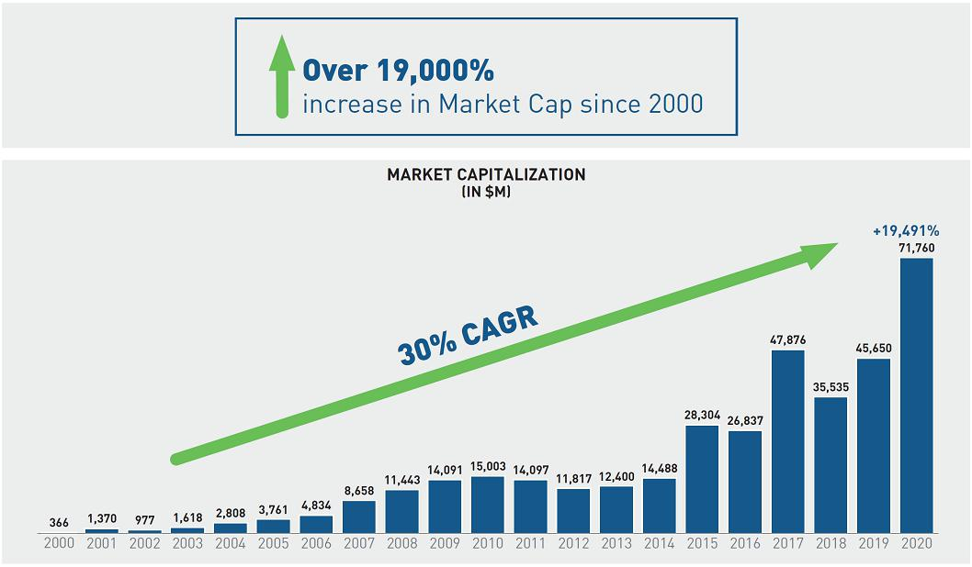

www.activisionblizzard.com ACTIVISION BLIZZARD, INC. 2021 Proxy Statement 53

Back to Contents

Over the last four-year period, the Company continued to deliver extraordinary growth, financial success, and shareholder value, including $45 billion in additional shareholder value. This success was underpinned by strong financial performance, with net revenues and operating margin, two important metrics, achieving record highs in 2020.
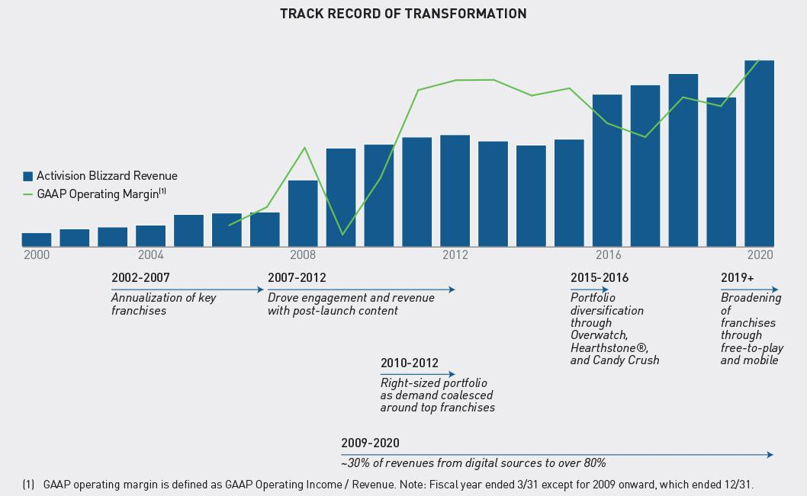

This strong performance would not have been possible without the leadership, vision, and operational expertise of Mr. Kotick, who has led Activision Blizzard through many transformative periods and made pivotal business decisions that have consistently delivered superior shareholder returns. For example, as PC gaming continued to rise, the decision to merge with Vivendi Games and integrate Blizzard in 2008 provided the Company with some of the

industry’s most successful franchises, development talent, and our own digital distribution platform: Battle.net®.

As players sought more physical interaction with games, our CEO stepped in front of the trend, acquiring RedOctane

in 2006 to turn Guitar Hero® into a pop culture icon and launched Skylanders® in 2011 to pioneer the “toys to life” category. The Company also foresaw mobile gaming becoming an increasingly important form of interactive entertainment and we acquired King, makers of Candy Crush, at a valuation of approximately 6x King’s 2015 adjusted EBITDA.

Building on this leadership, Activision Blizzard recently launched two free-to-play offerings in the multi-billion dollar Call of Duty franchise with Call of Duty: Mobile and Warzone, contributing to the Call of Duty franchise adding over $1 billion to Activision’s annual segment operating profit in 2020. In 2019, we initiated a broad reorganization across the Company that saw, among other things, increased developer resources on our largest franchises, enabling the release of more frequent high quality content, as well as further expansion across gaming platforms, geographies and business models. This work was already yielding demonstrable results for our shareholders in 2019 and positioned us well as we navigated the challenges presented by the COVID-19 pandemic in 2020, which required that we move all development to a work-from-home model, and navigate both the technical and team based challenges associated with not physically working face to face to drive innovation and creativity.

www.activisionblizzard.com ACTIVISION BLIZZARD, INC. 2021 Proxy Statement 54

Back to Contents

Our Corporate Strategy

This long-term performance has been enabled by our evolving franchise strategy designed to ensure we continue to deliver epic entertainment for our players, a creative, safe and inclusive environment for our employees, and value to our shareholders. Our current strategy is focused on expanding reach, engagement, and player investment for our portfolio of fully-owned franchises as we execute against four key strategic growth initiatives:

Strong cadence of | Growing stream of live | Expansion of our | New franchise
major content releases: | operations: | franchises to mobile: | engagement models:

Expanded franchise development teams are accelerating the cadence of major content releases across our portfolio of fully-owned franchises to invigorate our communities and attract new audiences.

We continue to grow our “live operations” capabilities, delivering year-round content, services, features, and events, to drive engagement and recurring revenues.

We are building on our mobile leadership by extending our console and PC franchises to the largest and fastest-growing gaming platform.

We are investing in new business models such as advertising and free to play to enable new opportunities for players to engage with our intellectual property, further enhancing the scale and financial performance of our franchises.

Fiscal 2020 Performance

In 2020, this strategy coupled with superior execution delivered the best financial results in the Company’s history. This was even more impressive given the unprecedented conditions we were working and living in over the last year during the COVID-19 pandemic. Our increased investment in our biggest franchises and opportunities and strong execution against our growth initiatives enabled us to engage our players and create value for our shareholders. While others in the industry struggled with the operational challenges COVID-19 presented, we capitalized on increased consumer demand for gaming by releasing high quality new experiences across multiple platforms. This included:

- The launch of Call of Duty: Warzone, a free-to-play Call of Duty experience which brought in tens of millions of players to the franchise and drove significant player investment through in-game content sales and purchases of premium Call of Duty content;

- Ongoing expansion of content for Call of Duty Mobile following its launch in October 2019, including the title’s launch in China in December 2020;

- The launch of World of Warcraft: Shadowlands; the latest expansion in the franchise, building on the substantial increase in World of Warcraft player numbers and engagement following the launch of Classic in August 2019; and

- Significant content updates for Candy Crush and other key franchises.

www.activisionblizzard.com ACTIVISION BLIZZARD, INC. 2021 Proxy Statement 55

Back to Contents

Our successful execution of these initiatives—part of a multi-year strategy to make the Company even stronger— drove significant growth across all key financial metrics, fueling significant value creation for our shareholders. Net bookings grew 32% year-over-year, operating income expanded 70% year-over-year and earnings per diluted share increased 45% year-over-year. In each case, our financial performance was well ahead of the initial outlook provided to investors in February 2020. Furthermore, we believe the strategic choices made in prior years and strong execution across premium content, in-game operations, expanding our presence on mobile, and ramping new engagement models on our largest franchises has positioned the business for structurally higher financial performance into the future.

www.activisionblizzard.com ACTIVISION BLIZZARD, INC. 2021 Proxy Statement 56

Back to Contents

This performance was also recognized externally by the stock market. In 2020, we created $26 billion of value for our shareholders. Our performance is even more impressive when you consider the longer-term trajectory: from 2012 to 2016 we more than doubled our market capitalization, and over the last four-year period of 2017 to 2020, we have again more than doubled our market capitalization—an aggressive goal that we are proud to have achieved. This value creation has consistently outperformed that of the S&P 500 and our peer group medians.
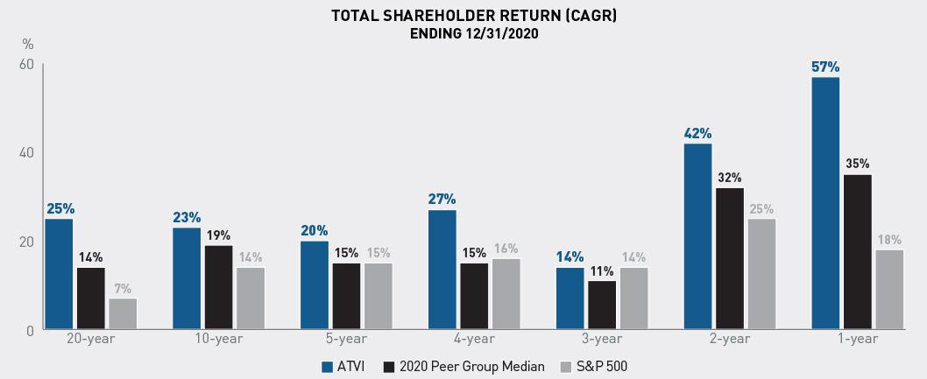

Total shareholder returns (TSR) based on ending price as of December 31, 2020 for each time period. 2020 peer group median reflects the median TSR of all peers in each time period unless they were not publicly traded during the time period or were excluded due to acquisition (e.g., CBS).

We believe this performance over both the long-term and near-term reflects the Company’s track record of disciplined capital allocation, focus on our largest opportunities, operational excellence, and our commitment to hiring and retaining top talent. This, coupled with our robust pay-for-performance mindset demonstrates our ability to further enhance the earnings profile of this Company. These have been core tenets of Mr. Kotick and his leadership team for 30 years, and we expect these same principles will continue to create meaningful value for our shareholders in the future.

This performance in 2020, and since 2017, was reflected in the outcomes under our variable performance-based compensation programs:

- Awards earned under our Corporate Annual Incentive Plan (i.e., the CAIP) ranged from 83% to 103% of target; and

- Performance-based long-term incentive payouts ranged from 90% to 135% for all NEOs, with the exception of the CEO’s 2020 long-term incentive, where 500% of target was achieved based on hitting the maximum performance level over the four-year performance period.

These outcomes are discussed in more detail in the balance of our CD&A.

www.activisionblizzard.com ACTIVISION BLIZZARD, INC. 2021 Proxy Statement 57

Back to Contents

Responsiveness to Shareholders—The Board Is Committed to Addressing Investor Feedback

The Compensation Committee considers shareholder input essential. While the results of the last say-on-pay vote were disappointing, it provided us the opportunity to renew our focus on integrating shareholder viewpoints in the executive compensation program. It also enabled us to advance our aspiration to be a model of pay for performance and shareholder alignment across the enterprise.

In 2020, our compensation program received the support of 57% of the total votes cast at our Annual Meeting. Over the ensuing several months, Activision’s Board and management team actively sought feedback from shareholders to better understand what motivated their votes. As part of these efforts, we offered engagement with our CEO, Mr. Kotick, and Chair of the Compensation Committee, Mr. Morgado, to shareholders owning approximately 66% of outstanding shares, including each of our top 50 institutional holders. We held over 70 meetings, engaging with over 50 institutions owning approximately 63% of outstanding shares. Our Board was directly involved in these dialogues, with a member of our Compensation Committee and/or CEO (and, in most cases, both) participating in over 40 meetings with shareholders owning approximately 59% of outstanding shares. To ensure candid discussions, in conversations where the CEO participated, he offered to step off the call when executive compensation was discussed. All feedback was shared with the Compensation Committee and this feedback directly informed several changes to our executive compensation program, our CEO’s current employment agreement and our compensation-related disclosures. Our engagement with shareholders prior to the filing of our 2020 proxy was substantially greater than in prior years.
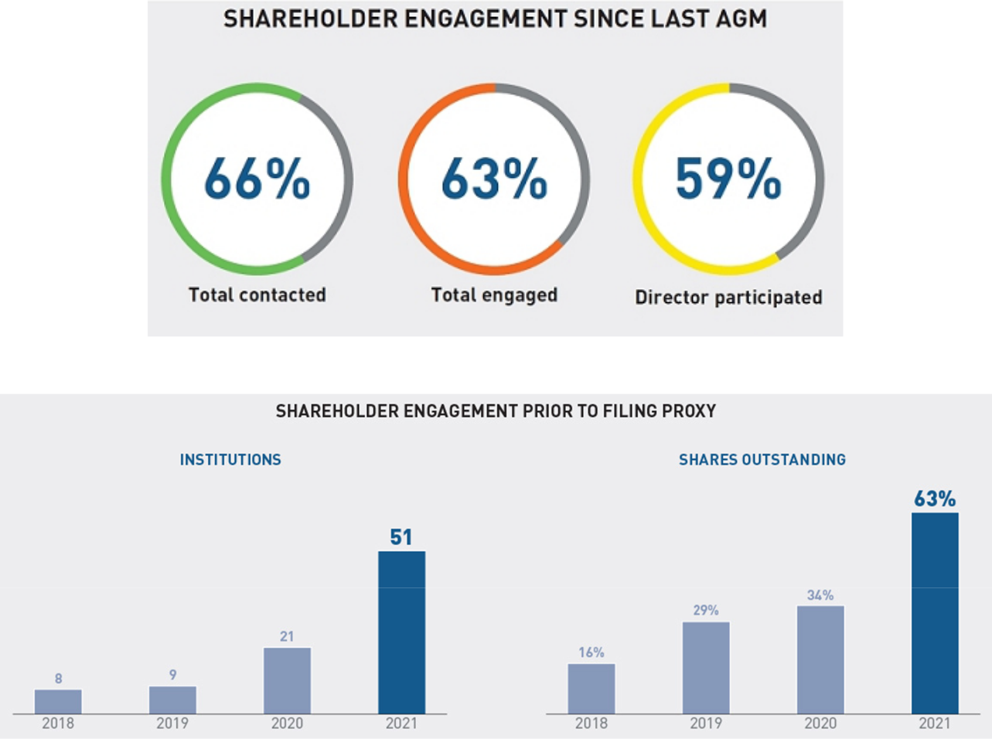

www.activisionblizzard.com ACTIVISION BLIZZARD, INC. 2021 Proxy Statement 58

Back to Contents

What we heard | How we responded |  | Impact of Action
CEO’s EMPLOYMENT AGREEMENT
 | Base Salary
 | ● | CEO elected to take no salary for the last four pay | ● | 15% reduction in 2020 salary
 |  | periods of 2020
 | ● | Reduced CEO 2021 salary by 50% from $1.75 million to | ● | 2021 salary below 25th percentile of peer
 |  | $875,000 |  | group, with commensurate decrease in
 |  |  |  | target annual cash bonus (CAIP)
Quantum of CEO pay
Quantum of CEO pay | Corporate Annual Incentive Plan (CAIP)
exceeds that of some
exceeds that of some | ● | Reduced CAIP cash bonus as a result of salary reduction ● |  | 12% reduction in 2020 target CAIP
peers | ● |  |  | 12% reduction in 2020 target CAIP
 | ● | Capped maximum potential 2021 and 2022 CAIP | ● | 2021 and 2022 target bonuses well below
 |  | payouts to 2X base salary (effectively capped “at target”) |  | 25th percentile of peer group
 | Long-Term Incentives
 | ● | Amended agreement to limit CEO annual LTI award | ● | In aggregate, CEO target compensation
 |  | grant values to no greater than median peer CEO LTI |  | expected to be below median target CEO
 |  | grant values for 2021 and 2022 |  | compensation
Preference for PSUs | ● | Amended LTI program design for 2021 and 2022 | ● | Further strengthen performance linkage of
over stock options |  | extension period to ensure 100% of CEO LTI awards |  | incentives
denominated in performance-vesting restricted share
units (“PSUs”)

Concern regarding additional award potential based on outcome of M&A

- Eliminated potential to earn the “transformative transaction award,” with immediate effect

- Further strengthen pay for performance and further incentivize creation of long-term value

Concern regarding award structures

- Eliminated the “shareholder value creation incentive” with respect to all equity grants made after April 2021, when the 2016 employment agreement was amended

- Further strengthen performance linkage of incentives, and minimize potential for duplicative payments for the same performance results

COMPENSATION PROGRAM DESIGN

Higher emphasis of | ● | Increased financial metric weight, from 60% to 80% for | ● | Enhance alignment of incentive with
annual incentive on |  | the CEO beginning in 2021, and for other executives |  | financial outcomes
financial metrics |  | beginning in 2022
Preference for ESG | ● | Added an ESG component which may include diversity, | ● | Directly link incentive payout with ESG
objectives in incentive |  | inclusion, promotion and the hiring of veterans, and |  | performance
design |  | sustainability as part of executive strategic objectives
 |  | beginning in 2021
COMPENSATION PROGRAM DISCLOSURE
Enhance disclosure of | ● | Enhanced disclosure of target-setting to provide context | ● | Increase transparency of incentive structure
goal-setting process |  | for the rigor of targets in “Corporate Annual Incentive
Plan (CAIP) Bonuses” section of the proxy

Enhance disclosure of strategic component of annual incentive award

- Enhanced disclosure related to strategic objectives and performance for 2020 annual incentive award—see “Corporate Annual Incentive Plan (CAIP) Bonuses” section

- Increase transparency of incentive structure and evaluation

Provide additional disclosure regarding peer group composition

- Enhanced disclosure of peer group analysis process— see “Decision Making Approach to Executive Compensation” section

- Provide context that the most relevant peers are companies that create world class creative content, are at the forefront of digital innovation, and compete globally for talent

www.activisionblizzard.com ACTIVISION BLIZZARD, INC. 2021 Proxy Statement 59

Back to Contents

Further Detail Surrounding CEO Employment Agreement

During engagement with shareholders, we discussed Mr. Kotick’s employment agreement, as shareholders have, over time, expressed some concerns about elements therein as well as the quantum of certain elements of the annual pay program. In these conversations, however, shareholders expressed appreciation for the pay-for-performance design of the program which was put in place to incentivize industry leading results. The Committee believes that these awards directly reflect the significant value Mr. Kotick delivered to shareholders over the past four years as measured by Activision’s market capitalization more than doubling from $27 billion in 2016 to $72 billion as of December 31, 2020, reflecting a compound annual rate of total shareholder return of 27% during that time period. As outlined above, this is also after roughly doubling the market capitalization for the prior contract period (2012 – 2016).

With the term of the 2016 Kotick Employment Agreement (as defined below) expiring in December 2021, the Compensation Committee took steps to specifically address shareholder feedback in both amending his current agreement and extending this agreement through March 31, 2023. The table below provides a snapshot of Mr. Kotick’s current employment agreement and the terms of the agreement extension, highlighting the significant changes in response to shareholder feedback received since the 2020 annual meeting.

Pay Element | 2016-2021 Employment Agreement | 2021-2023 Agreement Extension
BASE SALARY
 | ● $1,750,000 per year | ● | Reduced base salary of $875,000 (<25th percentile of
 |  |  | peer CEOs)
ANNUAL CASH INCENTIVE
Target CAIP | ● Target value of 200% of salary: $3,500,000 | ● | Reduced target value of 200% of salary: $1,750,000
 |  | ● | Maximum payout capped at $1,750,000
 |  | ● | <25th percentile of peer CEOs

Metrics | ● Practice of utilizing a combination of 60%
 | financial metrics and 40% strategic objectives

- 80% financial metrics and introduced 20% strategic objectives linked to ESG goals

LONG-TERM INCENTIVE

Target LTI | ● | Annual LTI subject to Compensation Committee | ● | Grant value of annual LTI awards not to exceed
 |  | approval based on achievement of operating |  | median CEO target grant value of our peer group
 |  | income, earnings per share, and absolute and
 |  | relative TSR
LTI Structure | ● | The Compensation Committee generally | ● | 100% of LTI awards denominated in PSUs
 |  | awarded PSUs and stock options
Additional Provisions ● |  | Transformative transaction award presented | ● | Eliminated this provision
 |  | possibility of additional payment related to
 |  | consummation of significant transaction that
 |  | resulted in substantial and sustained shareholder
 |  | value creation
 | ● | “Shareholder value creation incentive” provided | ● | Will not apply to future grants made after the
 |  | for acceleration and payment at maximum levels |  | agreed extension was entered into
 |  | for some LTI awards, in the event that the
 |  | Company’s stock price doubled during this period

The meaningful changes described above are in direct response to the feedback our Compensation Committee received from shareholders following our 2020 annual meeting. The Board deeply values the views of its shareholders and is committed to continuing to engage on executive compensation and other matters going forward.

www.activisionblizzard.com ACTIVISION BLIZZARD, INC. 2021 Proxy Statement 60

Back to Contents

Compensation Principles and Objectives

Our approach to executive compensation, for our CEO and all other executives, is built on three foundational principles that are rooted in our shareholders’ interests:

Align Compensation with Shareholder Interests—A substantial portion of our executives’ compensation opportunity is variable, stock-based, and linked to performance metrics that are intended to increase shareholder value, resulting in executive compensation that is aligned with the interests of shareholders.

Pay for Performance—Annual and long-term incentive awards are linked to the Company’s financial performance and stock price, incentivizing executives to drive corporate performance.

Pay Competitively—We offer competitive total compensation to attract, retain, and motivate top executives with the characteristics needed to most effectively operate in our industry.

The Compensation Committee takes shareholder feedback into account and regularly reviews and refines our executive compensation program to ensure it supports our foundational compensation principles.

www.activisionblizzard.com ACTIVISION BLIZZARD, INC. 2021 Proxy Statement 61

Back to Contents

Our Commitment to Pay for Performance

Activision Blizzard is committed to pay for performance across the organization. This is reflected in our compensation principles which, at their core, seek to align pay opportunities with the market and pay outcomes with performance, informed by feedback from our shareholders.

 |  | Alignment with | Pay for | Pay
 |  | Shareholder Interests | Performance | Competitively
PERFORMANCE-BASED COMPENSATION DESIGN
● | 99% of 2020 CEO Compensation was performance-based | ✓ | ✓
● | Over 90% of equity granted to other named executive officers over the | ✓ | ✓
 | last three years was performance-based (PSUs or options)
● | In 2020, all stock options were granted with additional performance | ✓ | ✓
 | vesting conditions
● | For the CEO, our performance-based and equity compensation | ✓ | ✓ | ✓
 | weightings of 95%+ are among the highest in our peer group
● | Clearly defined, rigorous performance objectives underpinning | ✓ | ✓
 | incentives: Metrics include AB Adjusted EPS, AB Adjusted Operating
 | Income, AB Adjusted Free Cash Flow and stock price appreciation.
 | Strategic objectives in the CAIP are rigorous stretch objectives – as you
 | will see from 2020’s disclosure, a significant percentage were not
 | achieved and did not pay out
● | More broadly, outside our CEO and other NEOs, equity eligible | ✓ | ✓
 | employees generally receive ~60% of annual grants in PSUs and the
 | balance in stock options
● | Our executives are accountable for operating income, which directly | ✓ | ✓
 | drives the value of our company and the creation of sustainable
 | shareholder value
● | We have very low levels of dilution, in the bottom quartile of our peers | ✓ | ✓
 | over the last three years, resulting in strong ROI for our equity usage
 | and minimal potential dilution for our shareholders
FOCUS ON PEER GROUP BENCHMARKING
● | Each peer company is carefully reviewed for relevance in terms of size, | ✓ |  | ✓
 | operations and innovation, and the extent to which they represent a
 | competitor for executive talent
● | The compensation peer group was updated for 2021, reflecting our | ✓ |  | ✓
 | continued evolution and feedback from our shareholders, resulting in
 | the Company being positioned around median in market capitalization
RISK MITIGATION PRACTICES
● | Robust stock ownership guidelines for all executives | ✓ |  | ✓
● | “Clawback” Policy applicable to both cash and equity incentives | ✓ | ✓ | ✓
● | Formal Compensation Risk Mitigation Programs | ✓ | ✓ | ✓

www.activisionblizzard.com ACTIVISION BLIZZARD, INC. 2021 Proxy Statement 62

Back to Contents

Incentive Structure & Performance Linkage
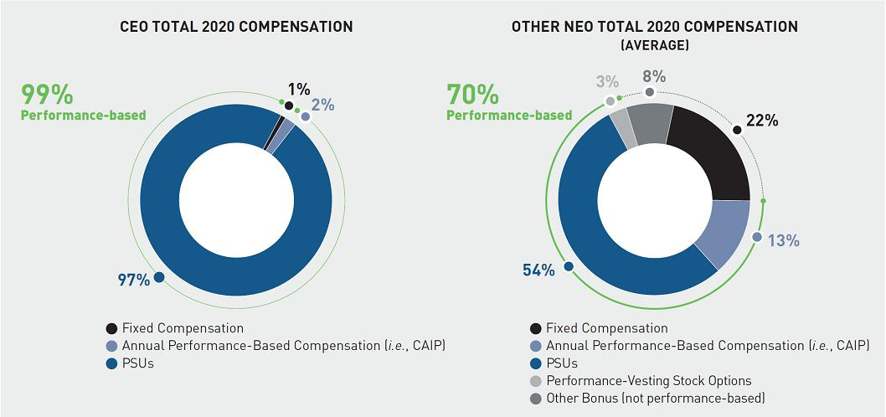

Executive officers are rewarded according to the financial performance of the Company delivering superior shareholder returns and the level at which they achieve the predetermined strategic objectives our Compensation Committee sets for each of them. This approach is designed to hold our executive officers accountable for our performance and thereby align their interests with those of our shareholders. The following table illustrates certain elements of our executive compensation program, with a focus on our use of performance-based incentives⁽¹⁾.

 |  | Service | Performance
Name | Program | Period | Linkage | Pay-For-Performance Linkage
Annual |  |  | 60% financial (36% AB | Rigorous assessment of annual
incentive |  | Up to 1.2 years from | Adjusted OI, 12% Adjusted | performance objectives
 | CAIP | beginning of | EPS, 12% Adjusted FCF),
 |  | performance year | and 40% key annual
 |  |  | strategic priorities
 |  | 3-year awards with |  | Assessment of performance versus
 | PSUs (OI) | 3 1-year |  | objectives established for relevant
 | PSUs (OI) | performance |  | performance period
 |  | periods | AB Adjusted OI,
 |  |  | stock price
 | PSUs (Long-Range | Varies, generally | stock price | Assessment of financial objectives set
 | PSUs (Long-Range | Varies, generally |  | forth in the Company’s long-range
Long-term | Strategic Plan) | 3.5 years from grant |  | forth in the Company’s long-range
Long-term | Strategic Plan) | 3.5 years from grant |  | strategic plan
incentive
incentive |  | Varies, generally up |  | Direct alignment with shareholder
 |  | to 3 years from |  | interests, as any value appreciation is
 |  | grant (10-year |  | contingent on stock price performance
 | Stock Options2 | option term) | Stock price | and, for performance-vesting stock
 |  |  |  | options, assessment of performance
 |  |  |  | versus objectives established for relevant
 |  |  |  | performance period

- This table is not intended to be exhaustive. For example, long-term incentives granted to certain of our NEOs were also subject to an assessment of 2020 performance with respect to TSR and AB Adjusted EPS.

- Not awarded to the CEO in 2020.

www.activisionblizzard.com ACTIVISION BLIZZARD, INC. 2021 Proxy Statement 63

Back to Contents

Our Pay-for-Performance Practices

What We Do | What We Don’t Do
PAY FOR EXCEPTIONAL PERFORMANCE
✓ Compensation mix designed to reward executives for | ✗ No guaranteed salary increases or bonuses – increases
actions that create sustainable shareholder value | based on financial performance
✓ Metrics underpinning performance incentives align with | ✗ No repricing of stock options without shareholder approval
our strategic and financial objectives
✓ Annual and multi-year performance periods ensure focus | ✗ No dividends paid on unearned awards
on short- and long-term performance
✓ Significant majority of equity granted is performance-
based, specifically as PSUs that vest based on
performance measurement against preset goals
✓ Emphasis on multi-year growth metrics ensures
continuous focus on driving incremental shareholder
value
ALIGNMENT OF EXECUTIVE INTERESTS
✓ Robust stock ownership guidelines encourage ownership | ✗ No single trigger change-of-control protection
mentality including CEO requirement of 50x base salary
✓ “Clawback” policy enables recoupment of performance- | ✗ No excise tax gross-up upon change in control termination
based compensation (both cash and equity) in the event
of earnings restatement
COMPENSATION RISK MITIGATION
✓ Formal risk management, governance, and review | ✗ No hedging of Company stock, or using margin accounts
structures, including at least two levels of approval for | to trade Company stock
incentive award payouts

- We utilize formal caps on our incentive programs (both cash and equity) to ensure proper payouts in line with performance

- We manage the use of shareholders’ equity carefully – at the bottom quartile of peer companies to properly manage dilution

www.activisionblizzard.com ACTIVISION BLIZZARD, INC. 2021 Proxy Statement 64

Back to Contents

Putting CEO Pay into Perspective: Aligning Pay and Superior Financial Performance

In 2016, Activision Blizzard reached an all-time high market capitalization of approximately $30 billion, which reflected approximately a doubling of the market capitalization during the CEO’s 2012 to 2016 contract. In 2016, the Board set terms for a new five-year CEO agreement that contemplated aggressive goals, which if achieved at maximum would see us more than double the market value of our Company. This would be an extraordinary achievement, and if we were successful it would reflect substantial value creation for our shareholders. To align pay with these performance expectations we provided for an incentive opportunity commensurate with the challenge.

Mr. Kotick’s compensation as captured in the Summary Compensation Table this year is significantly greater than his historical pay. This primarily was driven by the 2020 equity award, whose grant date fair value reflects the strong stock price performance through the grant date, as well as the expected performance through the measurement period—with such performance ultimately resulting in a TSR compound annual growth of 27% over the 2017 - 2020 performance period. It also reflects the 2021 equity award, which was granted in 2020 with a grant date fair value reflecting the potential achievement of the shareholder value creation incentive and the strong stock price performance over the measurement period. As the 2020 and 2021 awards were granted at, or near, the end of the performance periods, the compensation incorporates the resulting appreciation of both awards over the measurement periods.

The target value of these grants is $49.6 million, as outlined in the “target value” column in the table below.

In 2020, Mr. Kotick received equity grants shown in the Summary Compensation Table (SCT) subject to two different sets of performance criteria as follows:


 |  |  |  |  |  | Grant Date Fair
 |  |  |  |  |  | Value Annualized
 | Grant | Target | Target | Maximum | Grant Date | Over the
Grant | Date | Value | PSUs | PSUs | Fair Value | Performance Period

2020 Long-Term Performance Incentive based on Activision Blizzard’s four-year 2017 – 2020 annualized TSR

Total Intended Award Split into Two Grants

09/09/2020 ⁽¹⁾ |  | $ 17,999,995 | 226,159 | 1,130,795 | $ | 73,958,516 | $ | 18,489,629
12/31/2020 | (2) | $ 10,000,038 | 107,701 | 538,505 | $ | 50,000,189 | $ | 12,500,047
Total |  | $ 28,000,003 | 333,860 | 1,669,300 | $ | 123,958,705 | $ | 30,989,676

2021 Long-Term | 12/31/2020 ⁽³⁾ | $ 21,599,974 | 232,633 | 348,950 | $ | 25,594,283 | $ | 5,118,857
Performance Incentive
based on Activision
Blizzard’s five-year 2017
– 2021 cumulative AB
Adjusted Operating
Income(4)
2020 & 2021 Equity | Total | $ 49,599,977 | — | — | $ | 149,856,770 ⁽⁵⁾ | $ | 36,209,793 (5)
Compensation SCT
Value

- Grant date fair value calculated using a Monte-Carlo valuation model, which resulted in a fair value of approximately 4.1x the target value given our stock price performance through the grant date, as well as estimated performance through the end of the measurement period.
- Grant date fair value calculated using a performance-based multiplier of 5.0x the target award value, based on stock price performance between the inception of the performance period and the date the target value was established, based on stock price performance.
- Grant date fair value calculated using a Monte-Carlo valuation model, which resulted in a fair value of approximately 1.2x the target value based on the likelihood of the “shareholder value creation incentive” being achieved before the end of the measurement period.

- Represents the totality of the 2021 long-term performance grant contemplated by the 2016 Kotick Employment Agreement. Pursuant to the 2021 Kotick Employment Agreement Amendment (as defined below), Mr. Kotick will receive an award of PSUs in 2021, the grant date value of which will not exceed the median CEO long-term incentive target grant values for our peer group, as determine by the Compensation Committee.

- The sum of the aggregate grant date fair value of the 2020 long-term performance grant and 2021 long-term performance grant is $149,552,988. The total 2020 grant date fair value for “stock awards” disclosed in the SCT includes an additional $303,782 in accounting-related adjustments for a 2019 PSU award, as described in footnote (2) to the SCT. For the fair value annualized over the performance period, we have recognized one-third of the $303,782.

www.activisionblizzard.com ACTIVISION BLIZZARD, INC. 2021 Proxy Statement 65

Back to Contents

2020 Long-Term Performance Incentive

Mr. Kotick’s 2020 award was subject to a challenging absolute TSR performance condition over a four-year performance period starting January 1, 2017.

 | Resulting
 | Cumulative | Payment as
Annualized TSR during | 4-Year | Percentage of
4-Year Period | TSR Performance | Target
6% | 26% | 90%
8% | 36% | 100%
13% | 63% | 200%
17% | 87% | 300%
21.5% | 118% | 400%
≥25% | ≥144% | 500%

With our extraordinary annualized four-year TSR of 27%, our CEO earned the maximum incentive payout for this four-year performance period contemplated in his employment agreement back in 2016. The grant date fair value attributable to the 2020 long-term performance grant in our 2020 SCT reflects our strong stock price performance, and expected stock price performance, against the performance goal for the 2020 award as the equity grant was determined at, or near, the end of the performance period. As such, it is not as directly comparable to the value disclosed by other companies that establish all of the terms of their awards at the start of the performance period and prior to any stock price appreciation, because the grant date fair values reflected in the SCT for such awards are typically lower than the CEOs’ payout if they perform well.

2021 Long-Term Performance Incentive under 2016 Employment Agreement

On December 31, 2020 the Company confirmed the target value of the 2021 long-term performance grant contemplated by the 2016 Kotick Employment Agreement. In April 2021, as a part of the negotiated extension of the 2016 Kotick Employment Agreement, the Compensation Committee and Mr. Kotick agreed that the December 31, 2020 establishment of a $21.6 million target value would be the entirety of the 2021 long-term performance grant made under the 2016 Kotick Employment Agreement.

The 2021 award had a grant date fair value calculated using an estimated performance-based multiplier of 1.2x, which contemplated the probability of the “shareholder value creation incentive” being achieved before the end of the underlying performance period and reflecting the appreciation in our stock price since the start of the performance period.

The 2016 Kotick Employment Agreement provided that the 2021 long-term performance grant will be subject to a five-year cumulative operating income performance goal over 2017 – 2021, as follows:

Performance Condition | Performance Goals | Payment as Percentage of Target
Cumulative AB Adjusted | Less than 90% of the objective | 0%
Operating Income | Between 90% - 100% of the objective | 100%
 | Between 100% - 125% of the objective | Calculated based on straight-line interpolation
 |  | up to 150% based on a 2:1 curve
 | 125% of the objective or greater | 150%

Pursuant to the 2021 Kotick Employment Agreement Amendment, Mr. Kotick will receive an award of PSUs in 2021, the grant date value of which will not exceed the median CEO long-term incentive target grant values for our peer group, as determine by the Compensation Committee.

www.activisionblizzard.com ACTIVISION BLIZZARD, INC. 2021 Proxy Statement 66

Back to Contents

Pay-for-Performance Alignment

As noted above, we are proud our absolute TSR performance over the last four years was 27% on an annualized basis, or 164% in total. This growth in our stock price more than doubled the size of the Company one year short of the five-year contract period and correlated with a notable milestone in our Company’s rich history: a new all-time high in our market capitalization of $71.8 billion at the end of 2020. In 2020 alone, the Company increased market capitalization by 57%, driven by strong operational performance and engaged players. Neither of our stand-alone western gaming competitors in the US achieved this level of shareholder value creation.
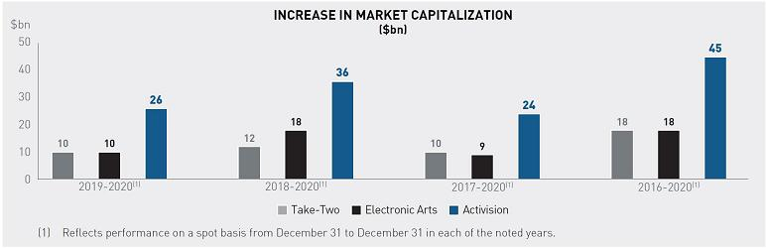

www.activisionblizzard.com ACTIVISION BLIZZARD, INC. 2021 Proxy Statement 67

Back to Contents

When compared to the companies in our 2020 compensation peer group, our relative realizable pay and performance have been consistently aligned. This is true both for 2020 and cumulatively over the last four years during the term of the 2016 Kotick Employment Agreement. Activision Blizzard’s relative performance, measured by operating income growth and TSR, and our CEO’s relative realizable pay, are aligned in both of these time periods.

CEO Pay and Performance are Tightly Aligned
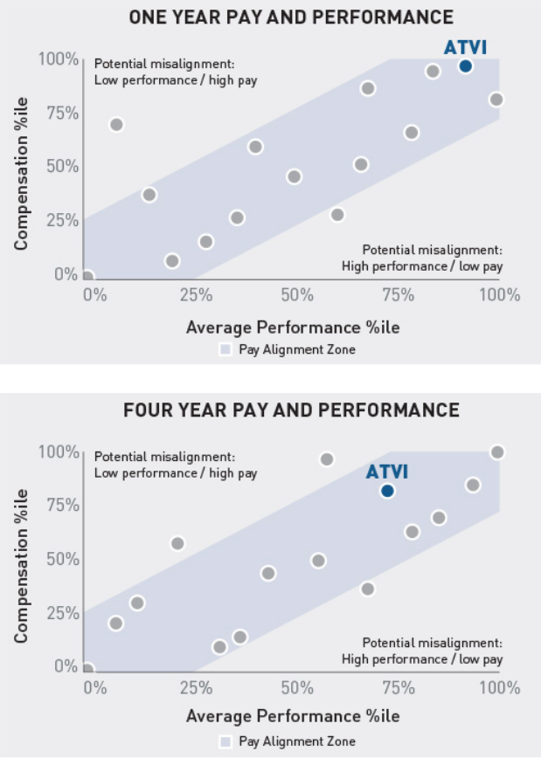

Notes: (1) This analysis shows pay to be tightly aligned with performance. Our CEO relative realizable pay is well within 25 percentile points of relative performance (see alignment zone in blue above). This means our programs are designed effectively and align with our philosophy of paying for performance. (2) Comparisons are made to the companies in our 2020 compensation peer group, modified to account for M&A activity (instead of CBS and Viacom, we compare to ViacomCBS; Twenty First Century Fox is excluded due to no longer being a standalone public company). Details of our peer companies can be found in the “Comparator Company Data and Compensation Surveys Referenced” section. (3) Realizable pay is defined as cash compensation, reflecting base salary plus actual bonus paid, and equity compensation, reflecting the value of grants made during the period valued using each company’s stock price as of December 31, 2020 using the most currently available data from peer filings at the time of analysis. Performance awards are based on actual payouts (if disclosed) and maximum for those not disclosed or where the cycle is incomplete; time-based stock awards are based on the number of shares granted; option awards reflect the intrinsic value. (4) The first performance measure is Total Shareholder Return, which is calculated using stock prices adjusted for stock splits, cash dividends, rights offerings, spin-offs. The second performance measure is operating income growth (total revenues minus total operating expenses). The percentile ranks of these two measures are averaged, and the percentile rank of that average is then plotted in the above charts.

In absolute terms, our CEO’s total realizable pay related directly to his current agreement (base salary, actual annual incentive payouts, and all equity grants valued as of December 31, 2020), represents approximately 1% of the $45 billion value created for our shareholders over the four-year period from January 1, 2017 through December 31, 2020.

Additional details on the CEO’s employment agreement and the equity awards pursuant to it can be found in the “—Employment Agreements—Robert Kotick” section below.

www.activisionblizzard.com ACTIVISION BLIZZARD, INC. 2021 Proxy Statement 68

Back to Contents

Decision-Making Approach to Executive Compensation

Factors Influencing Compensation Decisions

Our Compensation Committee believes that executive pay should be determined using a holistic approach, involving an evaluation of a wide variety of relevant factors. These factors include, but are not limited to:
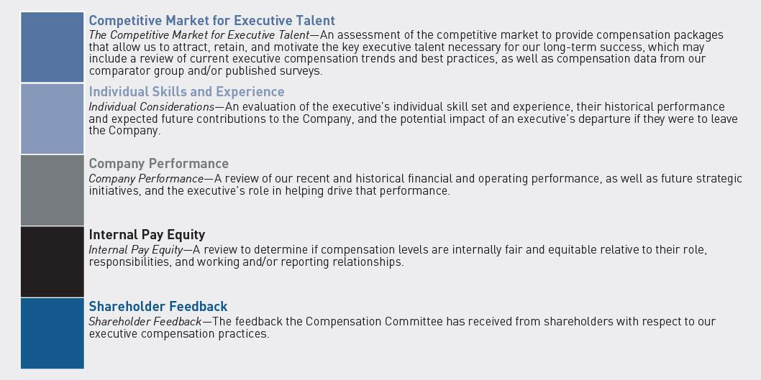

www.activisionblizzard.com ACTIVISION BLIZZARD, INC. 2021 Proxy Statement 69

Back to Contents

The Compensation Committee does not use a predefined framework to weigh the importance of each of these factors, and the emphasis placed on specific factors may vary from executive to executive. Ultimately, the terms on which any given executive officer is employed reflect the Compensation Committee’s independent judgment as to the amount and form of compensation necessary to attract, retain, and motivate that individual. An example of how we reference market data but make our own decisions is evidenced through our primary use of PSUs and stock options that promote pay-for-performance in accordance with our compensation principles. While many of our compensation peers include RSUs either as part of the mix or as the sole vehicle, we actively differentiate ourselves to better align our programs with the interests of our shareholders.

Highly Competitive Business Environment and Associated Talent Requirements

We operate in the interactive entertainment industry, which exists at the nexus of the gaming, media, entertainment, and technology sectors. Finding top executives with the necessary characteristics requires recruitment of executives from a variety of industries including these sectors, which can include some companies that are larger and more mature than ours. In setting executive pay, the Compensation Committee takes into consideration a wide variety of factors, including compensation provided to executives at companies against which we compete, or may compete, for such talent.

Our industry is intensely competitive and constantly evolving. It features a number of unique characteristics, including:

- a dependence on a relatively small number of titles for a disproportionate level of revenues and profits;

- an increasing importance on building and growing franchises with sustained game quality and ongoing content releases;

- rising costs of development, partially due to increasingly complex technological requirements; and

- a global consumer base that expects entertainment content delivered through an increasingly varied range of channels.

We believe that, in order to succeed in this fast-changing business environment, we require executive talent with very specialized qualifications, including:

- significant global experience managing complex brands and franchises;

- in-depth knowledge of sophisticated strategies and operational models in the digital and entertainment segments; and

- aptitude for, and experience in, managing entertainment and technology products and talent in a rapidly-changing, high-risk environment.

Use of Employment Agreements

Our employment agreements with our executives specify base salary, incentive opportunities, and the terms and conditions of the equity awards which may be granted thereunder, as well as provisions regarding the consequences of termination of employment and restrictive covenants, such as non-competition and non-solicitation provisions. The terms of each of these agreements have been ratified by the Compensation Committee, which utilized its judgment to determine the appropriate amount and form of compensation and other terms of employment necessary to recruit, retain, and motivate the executive, based in part upon the specific negotiations with the executive. Please see “— Employment Agreements” below for further information about the agreements with our named executive officers.

Employment agreements are common in the broader, highly competitive entertainment industry from which we recruit talent. We believe that having multi-year employment agreements with our executives is critical in enabling us to attract and retain them. Using multi-year contracts also allows us to create compensation arrangements with a mix of incentive opportunities designed to reward executives for achievement of the Company’s short- and long-term goals, which we view in totality when assessing the executive’s compensation and performance during the term. For example, pursuant to his employment agreement with us, our Chief Executive Officer, Mr. Kotick, has received, or is eligible to receive, incentive awards based on financial metrics such as operating income and earnings per share, and shareholder returns, both absolute and relative, in each case, over a variety of performance and service periods, both within and beyond the term of his agreement. For more information on Mr. Kotick’s employment agreement with the Company, see “—Employment Agreements—Robert Kotick” below.

www.activisionblizzard.com ACTIVISION BLIZZARD, INC. 2021 Proxy Statement 70

Back to Contents

Comparator Company Data and Compensation Surveys Referenced

In selecting a comparator group, the Compensation Committee thoughtfully considers a range of factors to ensure that the companies individually and in aggregate are appropriately relevant. Six factors are used to assess relevance, noting that not all companies will meet all criteria and the Committee’s judgement is required in ultimately assessing direct relevance to Activision Blizzard. These criteria were a helpful reference in our 2021 peer group review, described below, which saw several changes to the prospective peer group as Activision Blizzard continues to evolve within the digital media and entertainment space.


Talent competitors, in particular companies with whom we have or may reasonably expect to compete with for senior talent

Comparable business models in terms of diversified media, world class content creation and digital innovation

Industry peers who, beyond their industry classification, are also relevant in other ways

Comparable geographic footprints, operating globally

Adjacent industry peers who, beyond their industry classification, are relevant in other of these criteria

Within a defined size range with respect to revenue and/or market capitalization

We compete for talent primarily against Tencent, Facebook, Google, Amazon, Apple and Netflix. Because of the relative market value capitalization difference between us and our closest competitors, these companies are not included in our peer group.

The peer group is reviewed periodically to ensure continued relevance and robustness, and to address M&A activity.

For example, in 2019, the following changes were made as a result of M&A transactions:

- Twenty-First Century Fox, Inc. was removed following the acquisition of a majority of its assets by The Walt Disney Company in March 2019, and Fox Corporation, which received the remainder of Twenty-First Century Fox’s assets was added; and

- ViacomCBS Inc. replaced both Viacom and CBS in the comparator group, following the merger of Viacom, Inc. and CBS Corporation in December 2019.

www.activisionblizzard.com ACTIVISION BLIZZARD, INC. 2021 Proxy Statement 71

Back to Contents

The resulting 2020 peer group is comprised of the following 15 companies:

 |  |  |  |  | Within 0.4x-
 |  |  |  | Comparable | 2.5x | Within 0.25x-4x
 | Talent | Industry | Adjacent | Business | revenue | of market cap
 | Competitor | Peer | Industry Peer | Model | (FY2019) | (Dec 31, 2019)
Adobe Inc. | ✓ |  | ✓ | ✓ | ✓ | ✓
Booking Holdings Inc. |  |  | ✓ |  | ✓ | ✓
Discovery, Inc. |  | ✓ |  |  | ✓ | ✓
eBay Inc. |  |  | ✓ |  | ✓ | ✓
Electronic Arts Inc. | ✓ | ✓ |  | ✓ | ✓ | ✓
Expedia Group, Inc. |  |  | ✓ |  | ✓ | ✓
Fox Corporation | ✓ | ✓ |  |  | ✓ | ✓
Intuit Inc. | ✓ |  | ✓ | ✓ | ✓ | ✓
Netflix, Inc. | ✓ | ✓ |  | ✓ |  | ✓
PayPal Holdings, Inc. |  |  | ✓ |  |  | ✓
salesforce.com, inc. | ✓ |  | ✓ |  | ✓ | ✓
Sirius XM Holdings Inc. |  |  | ✓ |  | ✓ | ✓
Symantec Corporation |  |  | ✓ |  | ✓ | ✓
ViacomCBS Inc. |  | ✓ |  | ✓ |  | ✓
The Walt Disney Company | ✓ | ✓ |  | ✓

At the time this peer group was approved, Activision Blizzard’s market capitalization was at the 52nd percentile and net revenues were at the 19th percentile. During 2020, the Compensation Committee reviewed and approved changes to the peer group for 2021. This ensures that the peer group remains relevant and that we continue to compare ourselves to complex, global, operationally complex companies of a similar size, with whom we compete for talent. Following this review three companies (Booking Holdings, Expedia Group, and Symantec Corporation) were removed given their limited continuing relevance from a talent, industry and business model perspective.

Three new companies were identified that, given changes in our respective businesses over the last few years, are deemed relevant compensation peers:

- Liberty Media Corporation;

- Live Nation Entertainment, Inc.; and

- ServiceNow, Inc.

Our evolution within the entertainment industry makes both Liberty Media and Live Nation particularly relevant, given we are increasingly competing for talent within this area. The inclusion of ServiceNow reflects the inherent technology needs of our business and the increasing relevance of this industry adjacency.

www.activisionblizzard.com ACTIVISION BLIZZARD, INC. 2021 Proxy Statement 72

Back to Contents

These companies met the following screening criteria:

 |  |  |  | Comparable | Within 40%-250% | Within 25% to 400%
 | Talent | Industry | Adjacent | Business | of revenue | of market cap (As of
 | Competitor | Peer | Industry Peer | Model | (As of FY2020) December 31, 2020)
Liberty Media Corporation | ✓ | ✓ |  |  | ✓ | ✓
Live Nation Entertainment, Inc. | ✓ | ✓
ServiceNow, Inc. | ✓ |  | ✓ |  | ✓ | ✓

Against this revised peer group at the time of its approval in March 2021 Activision Blizzard was positioned at:

- the 29th percentile on revenue;

- the 54th percentiles on market capitalization; and

- the 85th percentile on net income growth (2018-2020).

This peer group was used to benchmark and determine the changes outlined earlier related to go-forward pay for our CEO under his amended agreement, which is positioned below the peer 25th percentile on target cash compensation, and at or below median on target equity compensation.

In evaluating our executive compensation program, the Compensation Committee utilizes data obtained from SEC filings made by these companies, including named executive officer target and actual compensation, company-wide equity usage rates, and potential dilution. In addition, the Compensation Committee, with the support of its independent compensation consultant and our management, also annually consults third-party surveys prepared by compensation specialists with respect to companies with comparable revenues, market capitalization, industry focus, number of employees, and other similar business-related factors in order to discern broader compensation trends in the market. During 2020, we referenced surveys published by Radford as an additional source of data to provide pay information that is not publicly available.

This compensation data provides an important contextual frame of reference with respect to the markets we compete in. The Compensation Committee also considers other sources to inform compensation structure, including practices of other relevant companies and broader industry trends. The Compensation Committee does not target a specific market percentile, rather it assesses pay levels using a holistic approach. However, in response to shareholder feedback and as detailed earlier, we will be reducing the CEO’s compensation in 2021 and 2022 to better align with the median of our peer group.

Roles of the Key Participants in the Executive Compensation Decision-Making Process

To help inform executive compensation decisions, the Compensation Committee regularly reviews materials, advice, and analysis provided by our management and external compensation consultants in deciding on executive compensation matters, as described in more detail below.

Compensation Committee

- Establishes our executive compensation principles.

- Reviews and approves all compensation of our executive officers.

- Has oversight of the Company’s long-term strategy for employee compensation.

- Has oversight of the principles underlying the design of our incentive plans.

- Reviews and approves the corporate objectives relevant to our chief executive officer’s compensation, evaluates their performance in light of those objectives, and determines their compensation based on that evaluation.

- Selects and monitors the Company’s comparator group.

- Evaluates compensation-related information and recommendations provided by our management and outside advisors.

www.activisionblizzard.com ACTIVISION BLIZZARD, INC. 2021 Proxy Statement 73

Back to Contents

- Annually reviews the compensation payable to our Board.

- Administers our equity incentive plans, including:

– approving equity award guidelines;

– approving all equity awards; and

– monitoring our equity usage and resulting potential dilution.

- Reviews and approves executive officer employment and severance agreements.

- Evaluates broad industry trends and practices.

- Engages, retains, and, where appropriate, terminates its engagement with its independent compensation consultant.

For additional information regarding the Compensation Committee, see “Corporate Governance Matters—Board of Directors and Committees—Board Committees—Compensation Committee” above.

Compensation Committee’s Independent Compensation Consultant

- Reports directly to the Compensation Committee and regularly attends Compensation Committee meetings.

- Consults with the members of the Compensation Committee outside of formal committee meetings and without the participation of management, when requested by the Committee.

- At the Compensation Committee’s direction, interacts with our management from time to time in order to obtain the information it deems necessary to form its recommendations to the Committee.

- Provides the Compensation Committee advice on the appropriateness and market competitiveness of our executive and director compensation programs.

- Presents third-party data and provides advice and expertise on director and executive compensation trends, pay programs and pay levels, and other emerging “best practices” relating to such compensation.

- Analyzes materials provided by our management to the Compensation Committee to ensure that those materials are consistent with the Company’s principles with respect to director and executive compensation and reasonable vis-à-vis the Company’s comparator group.

- Assists the Compensation Committee with its determination as to who should be included in the Company’s comparator group, and reviews current comparator group members.

Since October 2013, the Compensation Committee has retained Exequity as its independent compensation consultant. Other than serving as the consultant to the Compensation Committee, Exequity provides no other services to the Company. The Compensation Committee assessed Exequity’s independence and determined that no conflicts of interest arise. Our Compensation Committee has also retained Paul Hastings, as its legal advisor.

Executive Officers and Management

- Our management assists the Compensation Committee in formulating the Company’s compensation programs and plans, including by, among other things:

– regularly advising the Compensation Committee with respect to our business strategies and operational priorities and plans;

– regularly making recommendations to the Compensation Committee on the Company’s compensation practices, including with respect to effective types of incentive rewards and the individual performance of our executives, as well as pay equity;

– monitoring the Company’s comparator group and trends in the market; and

– supporting the development of the materials for each Compensation Committee meeting.

- Our chief executive officer reviews the performance of the Company’s executive officers (other than themself) and provides their recommendations to the Compensation Committee with respect to our executive officers’ compensation.

- No member of our management has a direct role in determining their own compensation. Further, decisions pertaining to the compensation of our chief executive officer are reviewed and discussed by the Compensation Committee in executive session, without the presence of the chief executive officer or any other member of our management.

During 2020, our Compensation Committee interacted directly with members of our management, as appropriate.

www.activisionblizzard.com ACTIVISION BLIZZARD, INC. 2021 Proxy Statement 74

Back to Contents

Compensation Risk

To help mitigate potential risks, we have adopted several policies that are intended to either align our executives’ long-term interests with those of our shareholders or to provide the Company with certain protections in pre-defined situations.

Clawback Policy

Since approval by the Board in May 2009, Activision Blizzard has maintained a comprehensive “clawback policy”. In the event of an earnings restatement, the Company may seek to recover performance-based compensation paid or awarded to the executives responsible during the restatement period. This includes both short-term compensation under the CAIP and long-term incentive awards and applies to any Section 16 officer. The full “Policy on Recoupment of Performance-Based Compensation” can be found on our website at http://investor.activision.com/corporate-governance.cfm.

Executive Stock Ownership Guidelines

Since approval by the Board in March 2012, with the most recent amendments made in April 2021, Activision Blizzard has imposed stock ownership guidelines to further align the interests of those to whom they apply with our shareholders. Executives have five years from their date of appointment during which to meet the guideline and only stock that is beneficially owned is considered in assessing compliance. The Company’s CEO is expected to beneficially own Company stock with a value at least equal to fifty-times salary, with other named executive officers required to own stock with a value at least equal to one-times salary.

All named executive officers are either in compliance with their full guideline, or progressing towards it within the permitted five-year period. The full “Executive Stock Ownership Guidelines” policy can be found on our website at http://investor.activision.com/corporate-governance.cfm.

Anti-Hedging Policy

We prohibit our employees (including our executives and any entity over which any employee or immediate family member sharing the same household of any employee has or shares voting or investment control) from directly or indirectly “shorting” our securities, engaging in “put” or “call” or other “hedging” transactions involving our stock, or establishing or using a margin account with a broker-dealer to trade our securities.

Incentive Design

We establish maximum payout levels in our annual cash incentives, we utilize a holistic array of performance metrics to ensure performance is evaluated and achieved from an operational, financial and shareholder perspective, and we utilize multi-year performance metrics to ensure performance is sustained and not achieved for a one-year period at the expense of long term growth. Finally, we also maintain Compensation Committee discretion to reduce awards if circumstances beyond those reflected in the metrics need to be considered.

Elements of Our Executive Compensation Program for 2020

An overview of the primary elements of our executive compensation program and their purposes appears below. Not all elements are applicable to all named executive officers. We aim to incentivize our executives to drive corporate financial and operational performance by basing a significant portion of their compensation on achieving financial and strategic objectives. Our compensation principles allow us to attract, retain, and motivate the best talent in our industry, as evidenced by our performance.

Base Salary

In establishing the annual base salary rate for an executive officer, the Compensation Committee considers an individual’s role, performance, and annualized total compensation opportunities; salaries paid to the executive’s peers within the Company; and the total compensation opportunities of executives in comparable positions and with similar responsibilities at other companies by reference to data from our comparator group and published surveys. For information about our comparator group, see “—Decision-Making Approach to Executive Compensation— Comparator Company Data and Compensation Surveys Referenced” above.

www.activisionblizzard.com ACTIVISION BLIZZARD, INC. 2021 Proxy Statement 75

Back to Contents

None of our named executive officers have contractual entitlements to salary increases (see “—Employment
Agreements” below). Salary increases are generally only provided to an executive officer:

- upon their entry into a new or revised employment agreement with the Company or one of its subsidiaries; or

- in connection with our annual review of executive base salaries.


Reduced CEO Compensation

In 2020, the CEO, after consultation with the Compensation Committee, voluntarily elected to take no pay for the last four pay periods of the year, equating to a 15% reduction in his annual salary. Additionally, in April 2021, the CEO agreed, based on discussions with the Compensation Committee, to reduce his salary rate in 2021 from $1,750,000 to $875,000, equating to a 50% reduction in his contractual annual salary. The Compensation Committee took these actions to address shareholder concerns regarding the quantum of

the CEO’s compensation and result in salary being positioned below the current peer 25th percentile of $1,000,000. These are the first changes to his base pay since 2017. The base salaries for our other named executives have not changed since February 2019 or, if more recent, their date of appointment.

The table below reflects the annual base salary rates approved for 2020 during our annual review process, along with any other adjustments since that time:

 |  |  |  |  | Changes to | Salary rate
 | Salary at | Changes | Salary at end |  | rate of salary in | effective
 | beginning of 2020 | during 2020 | of 2020 |  | 2021 vs. 2020 | January 1, 2021
Name | ($) | (%) (1) | ($) (1) |  | (%) | ($)
Robert Kotick | 1,750,000 | ₋₁₅ (1) | 1,494,231 | (1) | ₋₅₀ (2) | 875,000 | (2)
Dennis Durkin | 900,000 | 0 | 900,000 |  | 0 | 900,000
Daniel Alegre | — (3) | — (3) | 1,350,00 |  | 0 | 1,350,000
Claudine Naughton | 650,000 | 0 | 650,000 |  | 0 | 650,000
Chris B. Walther | 845,700 | 0 | 845,700 |  | 0 | 845,700

- Mr. Kotick’s annual base salary remained the same through November 6, 2020, after which he did not receive a salary for the remainder of the year at his request, resulting in an effective salary rate of $1,494,231 as of December 31, 2020.

- Mr. Kotick’s annual base salary rate was further reduced by the Compensation Committee after consultation and agreement with him in 2021 by 50%, as compared to his annual salary rate at the beginning of 2020, to $875,000.

- Mr. Alegre’s employment with us began on April 7, 2020.

www.activisionblizzard.com ACTIVISION BLIZZARD, INC. 2021 Proxy Statement 76

Back to Contents

Corporate Annual Incentive Plan (CAIP) Bonuses

The CAIP is designed to drive our financial results and to incentivize individual contributions toward operational and strategic initiatives. The fundamental structure of the plan is consistent with 2019, with 60% of an executive officer’s opportunity contingent on financial objectives, and 40% contingent on individual strategic objectives aligned with our long-term strategic priorities. In addition, for any bonus to be earned a threshold level of adjusted operating income, set at 90% of the AOP (i.e., the annual operating plan), must be achieved. If this threshold is not achieved, no executive officer is eligible to receive a bonus under the CAIP.

Regardless of performance in the above areas, if AB Adjusted Operating Income is below 90% of target (AOP) no CAIP bonus will be earned.

Target CAIP Awards

In establishing the target payout opportunities for an executive officer under the CAIP for 2020, the Compensation Committee considers the bonus target set forth in their employment agreement, their annualized total compensation opportunities, our desired pay mix, and the total compensation opportunities of the executive’s peers within the Company and in comparable positions and with similar responsibilities at other companies by reference to data from our comparator group and published surveys. The following target opportunities were approved for 2020:

 | Eligible Salary | CAIP Target |  | CAIP Target
Executive | ($)⁽¹⁾ | (%) |  | ($)
Robert Kotick | 1,548,077 | 200 |  | 3,096,154
Dennis Durkin | 934,615 | 150 |  | 1,401,923
Daniel Alegre | 981,346 | 100 | (2) | 981,346
Claudine Naughton | 675,000 | 75 |  | 506,250
Chris Walther | 878,227 | 75 |  | 658,670

- Eligible salary relates to what was paid in 2020 as recorded by payroll, so numbers may vary slightly compared to individual salary rates – since there were 27 pay periods in 2020 (as opposed to the typical 26), these amounts tend to be slightly higher compared to salary rates.
- Mr. Alegre has an opportunity to receive a bonus with a target amount of 100% of his base salary. In addition, he has an opportunity to receive an increase in his target by up to 100% of his base salary for each year in which AB Adjusted EPS is at least 10% greater than the higher of (x) the AB Adjusted EPS AOP objective for the prior year and (y) the prior year’s actual AB Adjusted EPS. For more information on Mr. Alegre’s bonus opportunity under the CAIP, see “—Employment Agreements—Daniel Alegre—Annual Bonus” below.

www.activisionblizzard.com ACTIVISION BLIZZARD, INC. 2021 Proxy Statement 77

Back to Contents

Financial Performance Score (60%)

For each named executive officer, 60% of their target opportunity under the CAIP for 2020 was based on AB Adjusted EPS, AB Adjusted Operating Income, and AB Adjusted Free Cash Flow. The Compensation Committee believes that these financial measures are robust indicators of our overall performance, capturing fluctuations in sales as well as operating costs, and, as such, provide incentives to our executives to achieve objectives that contribute to increasing shareholder value. If 2020 AB Adjusted Operating Income for the year was less than 90% of the AOP, none of our executive officers would have been eligible to receive a bonus under the CAIP for the year, regardless of the level at which their individual financial or strategic objectives was achieved. Assuming the overall threshold objective was satisfied, threshold and maximum opportunities are established in respect of each of the financial objectives.

CAIP goals are set with reference to our AOP, which is set through a rigorous process and includes a detailed review of market trends, a “bottoms-up” build of financial objectives based on each franchise’s content plans, and the creation of a detailed budget with respect to all anticipated operating costs. Ranges are established around the AOP “target” to reflect the minimum level of performance that will be rewarded, and a maximum level of performance reflective of potential stretch scenarios. With regard to maximum levels of performance, while many companies require achievement at 110 - 125% of the target to earn maximum payouts, our plans require achievement of 150 - 200% of target performance to earn maximum payouts.

In 2020, our AOP targets represented significant growth in two of three financial metrics. The AB Adjusted Free Cash Flow target, while rigorous, was set below 2019, reflecting expected cash tax payments for settlements and other matters that were planned in 2020. The threshold, target and maximum were deemed to be appropriate in the context of our AOP:

Financial Performance Measures⁽¹⁾ |  |  |  | 2020 Financial Performance Objectives
(dollars in millions, except share-based |  |  |  | 2020
amounts) | 2019 Actual |  |  | Threshold | 2020 Target |  |  | 2020 Maximum
AB Adjusted Operating Income | $ | 2,080 | $ | 2,262 | $ | 2,513 |  | $ | 5,026
AB Adjusted EPS | $ | 2.25 | $ | 2.34 | $ | 2.60 |  | $ | 5.20
AB Adjusted Free Cash Flow | $ | 1,769 | $ | 1,382 | $ | 1,535 | (2) | $ | 3,070

- The corporate performance measures underlying 2020 performance-related compensation are non-GAAP measures. For more information on these non-GAAP measures, including how these measures are calculated and why our Compensation Committee believes they are an appropriate way to assess our executives’ performance, see “General—Financial Measures Used in this Proxy Statement— Financial Metrics Used to Measure 2020 Compensation-Related Performance” above.

- The 2020 Free Cash Flow target was lower than 2019 due to expected cash tax payments for settlements and other matters that were planned in 2020, along with expected timing impacts from working capital movements.

www.activisionblizzard.com ACTIVISION BLIZZARD, INC. 2021 Proxy Statement 78

Back to Contents

Actual performance resulted in significant growth in all three financial metrics compared to 2019, with results for both AB Adjusted Operating Income and AB Adjusted EPS at 135% of target and AB Adjusted Free Cash Flow at 149% of target:

Financial Performance Measures⁽¹⁾ |  |  |  | Performance Objectives and Actual Results
(dollars in millions, except share-based |  |  |  |  | Actual | Actual | Weighted
amounts) | Weight | AOP Objective |  |  | Results | Achievement | Achievement
AB Adjusted Operating Income | 36% | $ | 2,513 | $ | 3,392 | 135% | 49%
AB Adjusted EPS | 12% | $ | 2.60 | $ | 3.51 | 135% | 16%
AB Adjusted Free Cash Flow | 12% | $ | 1,535 | $ | 2,282 | 149% | 18%
TOTAL WEIGHT/ACHIEVEMENT | 60% |  |  |  |  |  | 83%

- The corporate performance measures underlying 2020 performance-related compensation are non-GAAP measures. For more information on these non-GAAP measures, including how these measures are calculated and why our Compensation Committee believes they are an appropriate way to assess our executives’ performance, see “General—Financial Measures Used in this Proxy Statement— Financial Metrics Used to Measure 2020 Compensation-Related Performance” above.
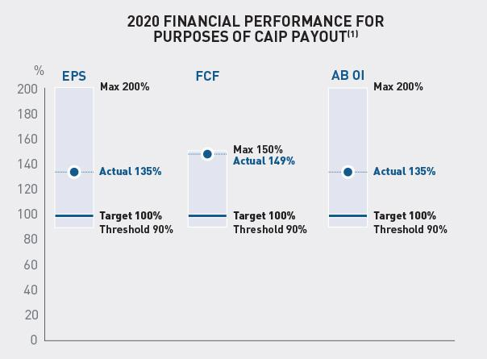

Note: Given our AB Adjusted EPS performance was more than 20% greater than the AB Adjusted EPS AOP objective for the prior year and the prior year’s actual AB Adjusted EPS, Mr. Alegre was eligible to receive a target bonus of 200% of salary in accordance with his employment agreement.

www.activisionblizzard.com ACTIVISION BLIZZARD, INC. 2021 Proxy Statement 79

Back to Contents

Individual Strategic Objectives (40%)

For each named executive officer, 40% of the target opportunity was based on strategic priorities established by the Compensation Committee for the year. Payouts in respect of the strategic objectives can range from 0% - 120% of an executive officer’s target opportunity.

The Compensation Committee believes that the use of strategic objectives, in addition to financial objectives, allows us to incentivize the specific behaviors the Compensation Committee thinks are most critical to the Company’s success, thus best aligning the interests of our executive officers with the Company’s strategic priorities. While the executive officers’ strategic objectives have not been previously made public due to competitive concerns, in response to shareholder feedback, we have outlined them below and committed to do so going forward.

The exact objectives varied by executive officer, reflecting areas of importance and influence by role. For 2020, objectives generally fell into the following categories:

Human Capital: | Organization Structure: | Operational Efficiency: | Performance Culture:
Human Capital: | Developing and implementing | Increasing productivity and | Ensuring a pay-for-performance
Attracting, retaining, and | appropriate organizational | ensuring proper investment | culture is
motivating top talent | plans to deliver on our | levels in core areas of our | embedded at all levels
 | ambitious goals | business | globally

The table below summarizes the objectives for Mr. Kotick and the Compensation Committee’s year-end assessment.

 |  |  |  | Below |  | Above
Area and Summary of Goals |  | Achievement Details | Weighting | Target | Target | Target
● | Prepare organizational structure | The CEO presented recommendations | 25% |  | ✓
 | recommendations for board review | which the board approved by the end of
 |  | 2020
● | Prepare performance and reward | The CEO presented comprehensive | 25% |  | ✓
 | program modifications for | performance and reward changes to the
 | Compensation Committee review | board by the end of 2020
● | Prepare succession plans for key | Succession plans were not sufficiently | 20% | ✓
 | executive roles with appropriate | achieved, as the focus this year was
 | number of ready now/ready soon | largely on hiring and establishing a
 | successors | number of new executive roles
● | Hire and retain key executives, as | While most of the targeted new hires | 15% | ✓
 | well as identify key talent for | were achieved and all key talent
 | succession planning | retained, not all targeted new hires were
 |  | onboard by end of year
● | Develop and execute on specific | Cost savings in aggregate were | 15% | ✓
 | plans for cost savings | achieved, but not within the specific
 |  | parameters assigned by the board
TOTAL ACHIEVEMENT DETERMINED |  |  |  |  | 50%

www.activisionblizzard.com ACTIVISION BLIZZARD, INC. 2021 Proxy Statement 80

Back to Contents

For other NEOs, multiple strategic objectives were shared or were similar. These objectives were not fully met in 2020 and therefore none of these were paid out:

- Implement organizational structure recommendations;

- Implement performance and reward programs to further drive growth and performance;

- Identify and hire key talent for specific roles;

- Succession readiness for key roles; and

- Develop and execute on specific plans for cost savings.

Mr. Durkin had an additional objective covering growth plans for our Leagues business that was not fully met. Ms. Naughton had an additional objective pertaining to a workforce issue that was not fully met. Lastly, Mr. Walther had additional objectives regarding active legal initiatives and other ongoing investigations that were partially met.

It is notable that COVID-19 did have a material impact on the ability for the executive team to accomplish these goals, however, contrary to many other companies, the Compensation Committee did not elect to make any exceptions in awarding partial or full credit for any goals that were not achieved.

We intend to provide scorecards, similar to that provided above for CEO strategic objectives, for the other NEOs in our 2022 proxy filing.

Actual CAIP Awards

Since we exceeded the overall threshold of 90% of the AB Adjusted Operating Income objective set forth in our 2020 AOP, each of our named executive officers was eligible to earn a CAIP payout this year. For 2020, the CAIP payouts directly reflected the Compensation Committee’s assessment of the performance against the financial and strategic objectives, using the formula established at the beginning of the year for each named executive officer, as described above.

 |  | Financial Performance – 60%
 |  | Adjusted | Adjusted | Adjusted | Individual | Total Actual
 | Target | Operating | Earnings per | Free Cash | Performance | Payment | Actual
 | Payment | Income | Share | Flow | Payment | (as % of | Payment
Name | ($) | (36%) | (12%) | (12%) | (40%) | target) | ($)
Robert Kotick | 3,096,154 | 135% | 135% | 149% | 50% | 103% | 3,177,979
Dennis Durkin | 1,401,923 | 135% | 135% | 149% | 0% | 83% | 1,158,588
Daniel Alegre(1), (2) | 1,962,692 | 135% | 135% | 149% | 0% | 83% | 1,622,024
Claudine Naughton | 506,250 | 135% | 135% | 149% | 0% | 83% | 418,379
Chris B. Walther | 658,670 | 135% | 135% | 149% | 29% | 94% | 619,620

- Mr. Alegre has the opportunity to receive a bonus with a target amount of 100% of his base salary. In addition, he has an opportunity to receive an increase in his target by up to 100% of his base salary for each year in which AB Adjusted EPS is at least 10% greater than the higher of (x) the AB Adjusted EPS AOP objective for the prior year and (y) the prior year’s actual AB Adjusted EPS. The objective was met for 2020, which resulted in a total bonus target of 200% (as reflected in this table). For more information on Mr. Alegre’s bonus opportunity under the CAIP, see “—Employment Agreements—Daniel Alegre—Annual Bonus” below.

- Mr. Alegre’s employment with us began on April 7, 2020, and his target and actual payment under the CAIP for 2020 were each based, in part, on the portion of time for which he was our employee during the year.

www.activisionblizzard.com ACTIVISION BLIZZARD, INC. 2021 Proxy Statement 81

Back to Contents

CAIP Enhancements for 2021 and 2022

In response to shareholder feedback received the Committee has committed to two changes in the operation of the
CAIP:

- Disclose ESG objectives, which may include diversity, equity, inclusion, recruiting veterans, and sustainability, will be incorporated into the strategic objective component for 2021.

- The focus on financial performance will increase, with the financial objective component increasing to 80% in 2021 for the CEO and 2022 for all other NEOs with a corresponding reduction in the focus on the strategic objective component to 20%. We believe this continues to place sufficient emphasis on areas of strategic importance, while reflecting shareholder feedback requesting a higher contingency on our financial performance.

Other Cash Programs or Awards

Contract Inducements

Both Mr. Alegre and Ms. Naughton received inducements to compensate for prior employment equity and bonus forfeitures in connection with their entering into an employment agreement with the Company, some or all of which was paid during the year.

Named Executive

Officer Target Value Purpose and Details Clawback Period

Daniel Alegre | $2,500,000 | Sign-on cash to compensate Mr. Alegre for
 |  | forfeited cash and equity incentive awards from
 |  | his former employer

100% if termination occurs prior to the first anniversary of the effective date

50% if termination occurs at any point after the first anniversary, but prior to the second anniversary of the effective date

 | $32,178 | Legal fees incurred in connection with contract | No clawback period
 |  | negotiations.
Claudine Naughton | $425,000 | Sign-on cash –Second installment to | 100% if termination occurs prior to the
 |  | compensate Ms. Naughton for cash and equity | second anniversary of the effective date
 |  | incentive
 |  | awards forfeited from her prior employer

$976,996 Value of relocation benefits and related tax gross-up.

100% if termination occurs prior to the first anniversary of the effective date

For more information, please see “—Employment Agreements—Claudine Naughton—Contract Inducement” and “— Employment Agreements—Daniel Alegre—Contract Inducement” below.

Equity Awards

Equity Granting Philosophy: Driving Shareholder Value Creation

Our equity incentive awards are intended to drive long-term shareholder value creation, create alignment with shareholders’ interests and encourage retention of key executives. During 2020, all equity awards to our CEO were PSUs and equity awards to our other NEOs consisted exclusively of PSUs and performance-vesting stock options. Further, in response to shareholder feedback, all equity awards granted to our CEO in 2021 and 2022 will be performance-vesting restricted share units (i.e., PSUs) and he will not receive time-vesting restricted stock units or stock options pursuant to the Kotick Employment Agreement (as defined below), as amended by the 2021 Kotick Employment Agreement Amendment.

www.activisionblizzard.com ACTIVISION BLIZZARD, INC. 2021 Proxy Statement 82

Back to Contents

In determining the estimated grant value of equity awards to an executive officer, the Compensation Committee considers a number of factors, including their role, their performance, their annualized total compensation opportunities, and the total compensation opportunities of the executive’s peers within the Company and in comparable positions and with similar responsibilities at other companies by reference to data from our comparator group and published surveys.

Generally, we utilize a mix of equity awards:

- PSUs, which are designed to incentivize our executives to achieve specific performance objectives that align with our multi-year business strategy; and

- stock options, which directly align an executive’s interests to those of our shareholders, since any financial gain is directly dependent upon appreciation in the value of our Common Stock and, as such, squarely link executive pay with Company performance.

We believe a combination of PSUs and stock options appropriately balances the various objectives of the equity incentive program promoting long-term value creation critical to driving TSR, directly aligns executive compensation with shareholder interests through share ownership, and encourages our key executives to remain engaged with our organization through the vesting date of the awards.

In 2020, Mr. Alegre was the only NEO to receive stock options. These performance-vesting stock options are contingent on meeting AOP operating income thresholds for 2020, 2021, and 2022.

Disciplined Use of Equity Results in Low Dilution for Shareholders

While we believe that equity awards are an important part of our compensation program, our average run rate over the last three years was 0.85% and ranks among the bottom quartile of our comparator group. Our run rate is calculated as the total number of shares and options granted in a year divided by our basic weighted average common shares outstanding for that year. The three-year average run rate of the companies comprising our comparator group ranges from 0.50% to 2.65%, with a median of 1.19%.

Use of Equity Awards to Reward Performance

As discussed above (see “—Compensation Principles and Objectives”), the Compensation Committee believes that, in general, equity awards made to an executive officer should include an award with performance-based vesting criteria. Consistent with that philosophy, during 2020, no named executive officers received restricted share unit awards with only time-based vesting. Further, a portion of all equity awards granted to our named executive officers during 2020 had vesting that is contingent on the achievement of specified performance objectives. Each named executive officer had equity awards that had the potential to vest based on 2020 financial performance (whether with respect to the year or a period that included the year).

www.activisionblizzard.com ACTIVISION BLIZZARD, INC. 2021 Proxy Statement 83

Back to Contents

The following grants for named executive officers other than the CEO were approved in 2020:

Executive | Grant Type | Performance Metric | Target Award | Eligible Vesting Dates
Daniel Alegre | Performance-vesting | 2020, 2021, and 2022 AB | $5,000,000 | 2/3 on March 30, 2022
 | Stock Options | Adjusted Operating Income |  | 1/3 on March 30, 2023
 | PSUs | 2020, 2021, and 2022 AB | $7,000,000 | 1/3 on March 30, 2021
 |  | Adjusted Operating Income |  | 1/3 on March 30, 2022
 |  |  |  | 1/3 on March 30, 2023
 | PSUs | 2020, 2021, and 2022 AB | $4,000,000 | 1/3 on March 30, 2021
 |  | Adjusted EPS |  | 1/3 on March 30, 2022
 |  |  |  | 1/3 on March 30, 2023
 | PSUs | TSR Performance | $2,000,000 | 1/2 on March 30, 2022
 |  |  |  | 1/2 on March 30, 2023
 | PSUs | Strategic Objectives | $3,000,000 | 100% on January 15, 2021
 | PSUs | EPS Growth | $2,500,000 | 100% on March 30, 2023
 | PSUs | Cumulative 2021, 2022, | $3,000,000 | 100% on March 30, 2024
 |  | and 2023 AB Adjusted
 |  | Operating Income
Chris Walther | PSUs | Cumulative 2021, 2022, | $625,000 | 100% on March 30, 2024
 |  | and 2023 AB Adjusted
 |  | Operating Income

Details of the CEO’s equity awards can be found in the “—Putting CEO Pay Into Perspective: Aligning Pay and Superior Financial Performance” section above.

Evaluating and Rewarding Performance: 2020 Vesting and Cancellation of Performance-Based Equity Awards

The following table shows the extent to which the portion of equity awards granted to each of our non-CEO named executive officers that had the potential to vest based on either our 2020 performance or cumulative 2018 - 2020 performance subject to continued employment through the vesting date.

As we did not achieve all of the applicable goals, equity award achievement ranged from 0% to 135% of target, consistent with our pay-for-performance approach.

 |  |  | Performance Objectives and Actual Results
Financial Performance Measures |  |  | AOP |  | Actual | Actual
(dollars in millions, except share-based amounts) |  |  | Objective |  | Results | Achievement
2020 | AB Adjusted Operating Income | $ | 2,513 | $ | 3,392 | 135%
2020 | Emerging Business Adjusted Operating Income | $ | (3) | $ | (67) | 0%
2020 | AB Adjusted EPS | $ | 2.60 | $ | 3.51 | 135%
Cumulative 2018, 2019, and 2020 AB Adjusted Operating Income |  | $ | 9,095 | $ | 8,158 | 90%

www.activisionblizzard.com ACTIVISION BLIZZARD, INC. 2021 Proxy Statement 84

Back to Contents

This performance resulted in the following award achievements in respect of each of our non-CEO named executive officers:

 |  |  |  | Award |  | Aggregate Shares
 | Grant |  |  | Achievement⁽¹⁾
Executive | Type | Performance Metric |  | (% of Target) | Target | Maximum | Achieved | Vesting Date
Dennis Durkin | PSUs | 2020 | AB Adjusted EPS | 125 | 89,222 | 111,528 | 111,528 | March 30, 2021
 | PSUs | 2020 | AB Adjusted | 125 | 44,611 | 55,764 | 55,764 | March 30, 2021
 |  | Operating Income
 | PSUs | 2020 | Emerging | 0 | 44,611 | 55,764 | 0 | March 30, 2021
 |  | Business Adjusted
 |  | Operating Income
 | PSUs | Cumulative 2018, |  | 90 | 8,214 | 10,268 | 7,368 | March 30, 2021
 |  | 2019, and 2020 AB
 |  | Adjusted Operating
 |  | Income
Daniel Alegre | PSUs | 2020 | AB Adjusted EPS | 135 | 18,240 | 36,480 | 24,651 | March 30, 2021
 | PSUs | 2020 | AB Adjusted | 135 | 31,920 | 79,800 | 43,083 | March 30, 2021
 |  | Operating Income
 | Performance- 2020 |  | AB Adjusted | 100 | 68,940 | 68,940 | 68,940 | March 30, 2022
 | vesting Stock Operating Income
 | Options
Claudine Naughton PSUs |  | 2020 | AB Adjusted | 125 | 21,896 | 27,370 | 27,370 | July 31, 2021
 |  | Operating Income
Chris Walther | PSUs | 2020 | AB Adjusted | 125 | 28,595 | 35,744 | 35,744 | March 14, 2021
 |  | Operating Income
 | PSUs | Cumulative 2018, |  | 90 | 10,268 | 12,835 | 9,210 | March 30, 2021
 |  | 2019, and 2020 AB
Adjusted Operating
Income

Determinations as to Achievement of Performance Metrics

All determinations as to the level of achievement of a performance metric underlying an equity award are made by our Compensation Committee by reference to, in the case of financial metrics, auditable financial measures.

No Dividend Equivalents

None of the outstanding equity awards made to our named executive officers are entitled to receive dividend equivalents, and we do not anticipate making time- or performance-based vesting awards with the right to receive dividend equivalents in the future.

Other Award Terms

Stock options have an exercise price equal to the Nasdaq Official Closing Price of our Common Stock as reported on Nasdaq.com on the effective date of the grant.

Equity awards will generally cease to vest upon the termination of the holder’s employment, and vested stock options will generally remain exercisable for a limited period of time (90 days or less) after the termination date. For the impact of the termination of the employment of each named executive officer on their outstanding equity awards, please see “—Potential Payments upon Termination or Change of Control” below.

www.activisionblizzard.com ACTIVISION BLIZZARD, INC. 2021 Proxy Statement 85

Back to Contents

Incentive Plan Limitations on Equity Awards

Under the 2014 Plan, the plan under which all of our equity incentive awards are now granted, there are limits on the number of stock options we can grant to anyone, including our executive officers, in a single year. There are similar restrictions on the number of restricted share unit awards and performance shares we can grant to any participant in a single year.

Limited Double-Trigger Change-of-Control Arrangements

Aside from our CEO, none of our executives have been provided with any change-of-control protection. Our CEO has been provided with certain protection in the event he is terminated following a change of control (known as a “double trigger”). These benefits are described under “—Potential Payments upon Termination or Change of Control” below. The Compensation Committee believes these arrangements will incentivize our CEO to maintain objectivity in the context of, and contribute to, a potential change-of-control transaction.

Limited Retirement Benefits

We offer a 401(k) plan to all employees in the United States, including our eligible named executive officers, and we match a certain percentage of each employee’s contributions to our 401(k) plan. Please see the “Summary Compensation Table” below for further details. We do not provide any other retirement benefits to our employees, including our named executive officers. We believe that retirement arrangements are particular to, and should remain the responsibility of, each individual officer. The emphasis on minimal retirement arrangements ensures that a substantial portion of our named executive officers’ long-term wealth accumulation depends on the achievement of Activision Blizzard profitability objectives and the appreciation in the value of our Common Stock.

Standard Health and Welfare Benefits

Our named executive officers are eligible to participate in our medical, vision, and dental insurance program, on the same terms as the broad employee population. Please see the “Summary Compensation Table” below for further details.

www.activisionblizzard.com ACTIVISION BLIZZARD, INC. 2021 Proxy Statement 86

Back to Contents

Additional Information

Equity Award Granting Policy

All equity awards are approved by our Compensation Committee with the exception of grants to our non-employee directors, which are approved by the full Board. Pursuant to a policy approved by our Compensation Committee, awards are generally effective on the third trading day following approval unless the Company is in a “trading blackout,” as described in our insider trading and pre-clearance policies, in which case the effective date of the awards is instead one trading day after the blackout period is no longer in effect.

Impact of Tax and Accounting Considerations

Section 162(m) of the Internal Revenue Code—Limits on Compensation Deductibility

Since January 1, 2018, other than any “performance-based” compensation “grandfathered” under the Tax Cuts and Jobs Act transition rules, we are not able to take a U.S. tax deduction for any compensation in excess of $1 million paid to any of our “covered employees,” including our chief executive officer, chief financial officer and next three most highly paid NEOs. We have considered, and will continue to consider, the applicability of the transition rules to our executive compensation. We continue to believe it is important that we retain the flexibility to structure compensation arrangements necessary to attract, retain, and motivate the best executive talent, even if such arrangements result in non-deductible compensation expenses.

Section 409A of the Internal Revenue Code—Limits on Deferral of Compensation

To the extent that any compensation paid or committed to any of our named executive officers constitutes a deferral of compensation within the meaning of Section 409A of the Internal Revenue Code, the Compensation Committee intends to cause that compensation to comply with the requirements of Section 409A and to avoid the imposition of penalty taxes and interest upon the person receiving the compensation.

Accounting Considerations

The Compensation Committee also takes accounting considerations, including the impact of Accounting Standards Codification (“ASC”) Topic 718, into account in structuring compensation programs and determining the form and amount of compensation awarded.

COMPENSATION COMMITTEE REPORT

The Compensation Committee has reviewed and discussed with management the Compensation Discussion and Analysis included under “Executive Compensation—Compensation Discussion and Analysis” above. Based on that review and discussion, the Compensation Committee recommended to our Board that the Compensation Discussion and Analysis be included in this proxy statement and also be incorporated by reference into our Annual Report on Form 10-K for the period ended December 31, 2020.

Members of the Compensation Committee

Robert Morgado (Chairperson), Reveta Bowers, and Dawn Ostroff

www.activisionblizzard.com ACTIVISION BLIZZARD, INC. 2021 Proxy Statement 87

Back to Contents

SUMMARY COMPENSATION TABLE

The table below presents information with respect to each of our named executive officers regarding compensation earned during the periods indicated.

 |  |  |  |  |  |  | Non-Equity
 |  |  |  | Stock |  | Option | Incentive Plan | All Other
Name and Principal |  | Salary | Bonus⁽²⁾ | Awards⁽³⁾ |  | Awards⁽³⁾ | Compensation⁽⁴⁾ | Compensation |  | Total
Position | Year | ($) | ($) | ($) |  | ($) | ($) | ($) |  | ($)
Robert Kotick | 2020 | 1,494,231 | — | 149,856,770 | (1) | — | 3,177,979 | 84,338 | (5) | 154,613,318
Chief Executive
Chief Executive | 2019 | 1,756,731 | — | 6,269,752 |  | 19,137,241 | 2,870,966 | 88,206 |  | 30,122,896
Officer |  |  |  |  |  | 19,137,241 | 2,870,966 | 88,206 |  | 30,122,896
 | 2018 | 1,756,731 | — | 7,495,745 |  | 19,037,673 | 2,461,848 | 89,007 |  | 30,841,004
Dennis Durkin(6) | 2020 | 906,923 | — | 10,904,713 |  | — | 1,158,588 | 29,530 | (5) | 12,999,754
Executive Advisor
Executive Advisor | 2019 | 901,731 | 3,750,000 | 3,716,989 |  | — | 1,081,818 | 61,215 |  | 9,511,753
and Former Chief |  |  |  |  |  | — | 1,081,818 | 61,215 |  | 9,511,753
Financial Officer
Financial Officer | 2018 | 624,808 | — | — |  | — | 273,914 | 29,303 |  | 928,025
Daniel Alegre(7) | 2020 | 1,002,115 | 2,500,000 | 5,780,803 |  | 1,654,560 | 1,622,024 | 40,335 | (5) | 12,599,837
President and
Chief Operating
Officer
Claudine Naughton | 2020 | 655,000 | 425,000 | 1,327,992 |  | — | 418,379 | 997,148 | (4) | 3,823,519
Chief People
Chief People | 2019 | 250,000 | 425,000 | 1,140,834 |  | 2,303,429 | 170,986 | 98,605 |  | 4,388,854
Officer |  |  |  |  |  | 2,303,429 | 170,986 | 98,605 |  | 4,388,854
Chris B. Walther | 2020 | 852,205 | — | 1,747,440 |  | — | 619,620 | 51,727 | (4) | 3,270,992
Chief Legal Officer
Chief Legal Officer | 2019 | 836,381 | 500,000 | 3,131,722 |  | — | 628,083 | 64,805 |  | 5,160,991
 | 2018 | 759,238 | 500,000 | 2,837,227 |  | — | 583,161 | 83,532 |  | 4,763,158

- These amounts include equity grants made in 2020 for our CEO’s performance over the four-year term of the 2016 Kotick Employment Agreement, as described in further detail in “—Compensation Discussion and Analysis—Putting CEO Pay Into Perspective: Aligning Pay and Superior Financial Performance.”

- The amount paid to Mr. Durkin in 2019 consists of an inducement to enter into his employment agreement with us, dated as of January 2, 2019 (the “Durkin Employment Agreement”), which was paid in cash in January 2019 (see “—Employment Agreements—Dennis Durkin— Contract Inducement” below), which was necessary to induce Mr. Durkin to resume the role of Chief Financial Officer after the unanticipated departure of our prior CFO. The amount paid to Mr. Alegre in 2020 consists of an inducement to enter into his employment agreement with us, dated as of April 7, 2020 (the “Alegre Employment Agreement”), which was paid in cash shortly after he commenced employment (see “—Employment Agreements—Daniel Alegre—Contract Inducement” below). The amounts paid to Ms. Naughton in 2019 and 2020 consist of inducements to enter into her employment agreement with us, dated as of August 14, 2019 (the “Naughton Employment Agreement”). One half was paid in cash in August 2019 and the remaining half was paid in cash in August 2020 (see “— Employment Agreements—Claudine Naughton—Contract Inducement” below). The amounts paid to Mr. Walther for 2019 and 2018 represent a special performance award he received in 2017 in recognition of his significant contributions to the Company, one-half of which was paid in cash in each of June 2018 and June 2019.

- The amounts in the Stock Awards column represent the aggregate grant date fair value of restricted share units (which have time- and/or performance-based vesting conditions) awarded in the period, computed in accordance with ASC Topic 718. The amounts in the Option Awards column represent the aggregate grant date fair value of stock options which have time- and/or performance-based vesting conditions awarded in the period computed in accordance with ASC Topic 718. As such, in the year of grant, the full aggregate grant date fair value appears, rather than the portion expensed for financial statement reporting purposes in that year.

Assumptions and key variables used in the calculation of the grant date fair values for 2020, 2019 and 2018 are discussed in the footnotes to our audited financial statements included in our Form 10-K filings for those respective years.

In 2019 and 2018, Mr. Kotick received PSUs that were subject to performance conditions that included three-year EPS targets yet to be determined. In 2020, the Compensation Committee set the three-year EPS targets for these PSUs resulting in an incremental accounting value of $303,782 for the 2019 awards and no incremental value for the 2018 awards. These incremental accounting values are included in Mr. Kotick’s 2020 Stock Award values shown above.

www.activisionblizzard.com ACTIVISION BLIZZARD, INC. 2021 Proxy Statement 88

Back to Contents

Stock awards for each fiscal year include awards subject to non-market performance conditions, which were valued based on the probability at grant that performance targets will be achieved, and awards subject to market performance conditions, which were valued using a Monte-Carlo simulation, which already factors in the possibility that the awards will be earned at maximum. Assuming the highest level of non-market performance conditions are achieved, the grant date stock award values of our performance-vesting equity awards would have been as follows:

 | Robert Kotick | Dennis Durkin | Daniel Alegre | Claudine Naughton | Chris B. Walther
 | ($) | ($) | ($) | ($) | ($)
2020 | 173,127,976^{(a),(b)} | 13,630,952 | 12,268,735^{(a),(c)} | 1,659,991 | 2,184,316
2019 | 15,674,380 | 4,646,256 | — | 1,426,029 | 2,092,222
2018 | 18,739,364 | — | — | — | 3,546,560

  - Stock awards for Mr. Kotick and Mr. Alegre in 2020 include awards subject to market performance conditions. The above table uses the same grant date values shown in the Summary Compensation Table for Mr. Kotick’s 2020 market awards ($73,958,516, and $50,000,189 respectively), as well as the maximum estimated award for the 2021 award granted in 2020 under the 2016 Kotick Employment Agreement of $32,239,444 for Mr. Kotick and $993,852 and $1,120,255.20 for Mr. Alegre.

  - Stock awards for Mr. Kotick include the incremental maximum accounting values of $8,516,869 (2019) and $8,412,958 (2018) for the PSUs discussed earlier in this footnote (2).

  - Stock awards for Mr. Alegre include stock options granted in 2020 with performance-based vesting. The above table uses the same grant date fair value of $1,654,560 used in Summary Compensation Table for these options.

- The amount in this column for each year for each named executive officer represents cash incentives paid under the CAIP. For a discussion of non-equity incentive plans, see “—Compensation Discussion and Analysis—Elements of Our Executive Compensation Program for 2020—Corporate Annual Incentive Plan (CAIP) Bonuses” above.

- The “all other compensation” for 2020 consists of the following:

 | Perquisites, |  |  |  | Retirement
 | gifts, |  |  | Taxable income | plan “matching” | Life and disability | Total “Other
 | and awards |  | Relocation | reimbursement | contributions | insurance premiums | Compensation”
Name | ($) |  | ($) | ($) | ($)^{(a)} | ($) | ($)
Robert Kotick | — |  |  | — | 6,500 | 77,838 | 84,338
Dennis Durkin | — |  |  | — | 6,500 | 23,030 | 29,530
Daniel Alegre | 32,178 | (b) |  | — | 1,558 | 6,599 | 40,335
Claudine |  |  | 611,551 ^{(c)} | 365,445 ^{(d)} | 6,500 | 13,652 | 997,148
Naughton
Chris B. | — |  |  | — | 6,500 | 45,227 | 51,727
Walther

  - These amounts represent “matching” contributions by us under our 401(k) plan.

  - This amount represents legal fees Mr. Alegre incurred in connection with the negotiation of the Alegre Employment Agreement, which we paid on his behalf.

  - This amount represents expenses Ms. Naughton incurred in connection with her relocation to the Los Angeles area that were paid for by the Company.

  - This amount represents a reimbursement for taxes incurred on the compensation referenced in footnote (c).

We have calculated the incremental cost to us of the compensation listed above based on the amount of payments made by us for the provision of such benefits.

- Mr. Durkin served as our Chief Financial Officer from March 1, 2012 until May 30, 2017. He served as our Chief Corporate Officer from May 10, 2017 through January 1, 2019, at which point he, again, became our Chief Financial Officer. On March 29, 2021, Mr. Durkin retired as our Chief Financial Officer and has served as an executive advisor since that time.

- Mr. Alegre’s employment with us began on April 7, 2020.

www.activisionblizzard.com ACTIVISION BLIZZARD, INC. 2021 Proxy Statement 89

Back to Contents

GRANTS OF PLAN-BASED AWARDS FOR 2020

The table below provides information regarding the grants of plan-based awards made to each of our named executive officers during 2020:

 |  |  |  |  | Estimated Future Payouts Under
 |  |  |  |  | Non-Equity Incentive Plan Awards
 |  |  |  |  | Threshold | Target | Maximum
Name | Grant Type |  | Grant Date | Approval Date⁽¹⁾ | ($) | ($) | ($)
Robert Kotick | CAIP(3) |  |  |  | 1,050,000 | 3,500,000 | 5,670,000
 | 2014 Plan/PSUs |  | 9/3/20 | 9/3/20
 | 2014 | Plan/PSUs | 9/3/20 | 9/3/20
 | 2014 Plan/PSUs |  | 9/9/20 | 9/3/20
 | 2014 | Plan/PSUs | 12/31/20 | 12/31/20
 | 2014 Plan/PSUs |  | 12/31/20 | 12/31/20
Dennis Durkin | CAIP(3) |  |  |  | 405,000 | 1,350,000 | 2,187,000
 | 2014 Plan/PSUs |  | 3/5/20 | 3/5/20
 | 2014 | Plan/PSUs | 3/5/20 | 3/5/20
Daniel Alegre | CAIP(3) |  |  |  | 297,230⁽¹¹⁾ | _{991,233}(11) (12) | 3,211,595⁽¹¹⁾ ⁽¹²⁾
 | 2014 | Plan/PSUs | 5/7/20 | 4/28/20⁽¹³⁾
 | 2014 Plan/PSUs |  | 5/7/20 | 4/28/20⁽¹³⁾
 | 2014 | Plan/PSUs | 5/7/20 | 4/28/20⁽¹³⁾
 | 2014 Plan/PSUs |  | 12/31/20 | 4/28/20⁽¹³⁾
 | 2014 | Plan/Options | 5/7/20 | 4/28/20⁽¹³⁾
Claudine Naughton | CAIP(3) |  |  |  | 146,250 | 487,500 | 789,750
 | 2014 | Plan/PSUs | 3/5/20 | 3/5/20
Chris B. Walther | CAIP(3) |  |  |  | 190,283 | 634,275 | 1,027,526
 | 2014 | Plan/PSUs | 3/5/20 | 3/5/20

- Reflects the date on which the Compensation Committee approved the grant of an equity award or, if later in the case of a performance-vesting award, the date on which the Compensation Committee established the performance metric underlying such award or a component thereof.

- The grant date fair value of the stock and option awards is computed in accordance with ASC Topic 718. Please see footnote (2) to the Summary Compensation Table for information about the assumptions and key variables used in the calculation of the grant date fair values. All stock options awarded have an exercise price equal to the fair market value of a share of our Common Stock on the date of grant.

- Each of our named executive officers had an opportunity to earn a CAIP bonus for their 2020 performance. None were entitled to a minimum amount thereunder, and each would have been entitled to receive $0 if the 2020 AB Adjusted Operating Income was not at least 90% of the AB Adjusted Operating Income objective set forth in the AOP for the year. The threshold bonus for each NEO was based on their base salary in effect at the time the opportunity was approved by our Compensation Committee and assumes 90% achievement of the AB Adjusting Operating Income objective set forth in the AOP for the year and the other financial objectives established for them under the CAIP and 0% achievement of their strategic objectives. The target bonus for each NEO was based on their base salary rate in effect at the time the opportunity was approved by our Compensation Committee and assumes 100% achievement of the financial and strategic objectives established for them under the CAIP. The maximum bonus opportunity for each was based on their base salary rate in effect at the time the opportunity was approved by our Compensation Committee and assumes either 150% or 200% achievement of their financial objectives, as the case may be, and 120% achievement of their and strategic objectives. Actual payments under the CAIP vary for each executive based on their actual base salary, their target opportunity, their financial and strategic objectives, including the relative weighting with respect to each, and their and the Company’s performance measured against those objectives. For more information about the CAIP and the opportunities for each of our participating NEOs thereunder, including the maximum bonus opportunity for each, and the actual payouts please see “—Compensation Discussion and Analysis—Elements of Our Executive Compensation Program for 2020— Corporate Annual Incentive Plan (CAIP) Bonuses” above.

- On December 28, 2018, pursuant to the 2016 Kotick Employment Agreement, the Compensation Committee awarded Mr. Kotick PSUs. These PSUs vest on March 31, 2023, subject to Mr. Kotick’s continued employment through that date, by reference to the cumulative AB Adjusted EPS objective for 2020, 2021, and 2022 to be established by the Compensation Committee for that three-year period. This award is subject to accelerated vesting pursuant to Section 12 of the Kotick Employment Agreement. The cumulative AB Adjusted EPS objective for this award was established in 2020 and, in accordance with ASC Topic 718, there is no incremental amount attributable thereto (the amount attributable to the “shareholder value creation incentive” having been previously reported). For more information on this award, see “—Employment Agreements—Robert Kotick—Equity Awards— 2018 Equity Awards—2018 PSUs (Three-Year Cumulative AB Adjusted EPS)” and “—Outstanding Equity Awards” below.

www.activisionblizzard.com ACTIVISION BLIZZARD, INC. 2021 Proxy Statement 90

Back to Contents

 | Estimated Future Payouts Under |  |  | All Other Stock | All Other Option |  | Grant Date Fair
 |  |  |  | Awards: Number of | Awards: Number of | Exercise or | Value of Stock
 | Equity Incentive Plan Awards
 |  |  |  | Shares of | Securities Underlying | Base Price of | and Option
 | Threshold | Target | Maximum | Stock or Units | Options | Option Awards | Awards⁽²⁾
(#) |  | (#) | (#) | (#) | (#) | ($/Sh) | ($)
 | —(4) | —(4) | —(4) |  |  |  | —(4)
 | —(5) | —(5) | —(5) |  |  |  | 303,782 | (5)
192,235⁽⁶⁾ |  | 226,159⁽⁶⁾ | 1,130,795⁽⁶⁾ |  |  |  | 73,958,516⁽⁶⁾
 | 91,546⁽⁷⁾ | 107,701⁽⁷⁾ | 538,505⁽⁷⁾ |  |  |  | 50,000,189 | (7)
 | — | 232,633⁽⁸⁾ | 348,950⁽⁸⁾ |  |  |  | 25,594,283⁽⁸⁾
75,839⁽⁹⁾ |  | 89,222⁽⁹⁾ | 111,528⁽⁹⁾ |  |  |  | 5,452,356⁽⁹⁾
 | 80,300⁽¹⁰⁾ | 89,222⁽¹⁰⁾ | 111,528⁽¹⁰⁾ |  |  |  | 5,452,356 | (10)
 | 9,120⁽¹⁴⁾ | 18,240⁽¹⁴⁾ | 36,480⁽¹⁴⁾ |  |  |  | 1,333,344 | (14)
15,960⁽¹⁵⁾ |  | 31,920⁽¹⁵⁾ | 79,800⁽¹⁵⁾ |  |  |  | 2,333,352⁽¹⁵⁾
 | 6,840⁽¹⁶⁾ | 13,680⁽¹⁶⁾ | 20,520⁽¹⁶⁾ |  |  |  | 993,852 | (16)
6,840⁽¹⁷⁾ |  | 13,680⁽¹⁷⁾ | 20,520⁽¹⁷⁾ |  |  |  | 1,120,255⁽¹⁷⁾
 | — | 68,940⁽¹⁸⁾ | — |  |  | 73.10⁽¹⁸⁾ | 1,654,560 | (18)
 | 19,706⁽¹⁹⁾ | 21,896⁽¹⁹⁾ | 27,370⁽¹⁹⁾ |  |  |  | 1,327,992 | (19)
 | 24,306⁽²⁰⁾ | 28,595⁽²⁰⁾ | 35,744⁽²⁰⁾ |  |  |  | 1,747,440 | (20)

- On August 12, 2019, pursuant to the 2016 Kotick Employment Agreement, the Compensation Committee awarded Mr. Kotick PSUs. These PSUs vest on March 31, 2022, subject to Mr. Kotick’s continued employment through that date, by reference to a cumulative AB Adjusted EPS objective for 2019, 2020, and 2021 to be established by the Compensation Committee for that three-year period . This award is subject to accelerated vesting pursuant to Section 12 of the Kotick Employment Agreement. The cumulative AB Adjusted EPS objective for this award was established in 2020 and, in accordance with ASC Topic 718, only the incremental amount attributable thereto is reflected in this table (the amount attributable to the “shareholder value creation incentive” having been previously reported). For more information on this award, see “—Employment Agreements— Robert Kotick—Equity Awards—2019 Equity Awards—2019 PSUs (Three-Year Cumulative AB Adjusted EPS)” and “—Outstanding Equity Awards” below.

- On September 9, 2020, pursuant to the 2016 Kotick Employment Agreement, the Compensation Committee awarded Mr. Kotick PSUs. These PSUs vest March 1, 2021, subject to Mr. Kotick’s continued employment through that date, by reference to the performance of our cumulative TSR as compared to the rate of return of the S&P 500 Total Return Index for the period from January 1, 2017 through December 31, 2020. For more information on this award see “—Employment Agreements—Robert Kotick—Equity Awards—2020 Equity Awards—2020 Long-Term Performance Incentive” and “—Outstanding Equity Awards” below.

- On December 31, 2020, pursuant to the 2016 Kotick Employment Agreement, the Compensation Committee awarded Mr. Kotick PSUs. These PSUs vest March 1, 2021, subject to Mr. Kotick’s continued employment through that date, by reference to the performance of our cumulative TSR as compared to the rate of return of the S&P 500 Total Return Index for the period from January 1, 2017 through December 31, 2020. For more information on this award see “—Employment Agreements—Robert Kotick—Equity Awards—2020 Equity Awards—2020 Long-Term Performance Incentive” and “—Outstanding Equity Awards” below.

- On December 31, 2020, pursuant to the 2016 Kotick Employment Agreement, the Compensation Committee awarded Mr. Kotick PSUs. These PSUs vest March 31, 2022, subject to Mr. Kotick’s continued employment through that date, by reference to cumulative AB Adjusted Operating Income for 2017, 2018, 2019, 2020, and 2021. For more information on this award see “—Employment Agreements—Robert Kotick—Equity Awards—2020 Equity Awards—2021 Long-Term Performance Incentive Granted in 2020 under the 2016 Kotick Employment Agreement” and “—Outstanding Equity Awards” below. This award is subject to accelerated vesting pursuant to Section 12 of the Kotick Employment Agreement, which is reflected in the grant date fair value of the award. For more information, see “—Employment Agreements—Robert Kotick” below.

www.activisionblizzard.com ACTIVISION BLIZZARD, INC. 2021 Proxy Statement 91

Back to Contents

- On March 8, 2019, pursuant to the Durkin Employment Agreement, the Compensation Committee awarded Mr. Durkin PSUs. In accordance with ASC Topic 718, only the portion of the award for which the performance metrics were established during 2020 (i.e., one-half of the award) is reflected in this table. One-half of the PSUs reflected in this table vest on March 30, 2021, subject to Mr. Durkin’s continued employment through that date, by reference to the AB Adjusted Operating Income objective set forth in our 2020 AOP as follows: (a) if actual performance is below 85% of the objective, no PSUs vest; (b) if actual performance falls between 85% and 125% of the objective, the number of PSUs that vest is between 85% and 125% of the target (i.e., between 37,919 and 55,764 PSUs), determined using straight-line interpolation; and (c) if actual performance is 125% or more of the objective, 125% of the target number of PSUs (i.e., 55,764 PSUs) vest. The other half of these PSUs vest on March 30, 2021, subject to Mr. Durkin’s continued employment through that date, by reference to the Emerging Business Adjusted Operating Income objective set forth in our 2020 AOP as follows: (a) if actual performance is below 85% of the objective, no PSUs vest; (b) if actual performance falls between 85% and 125% of the objective, the number of PSUs that vest is between 85% and 125% of the target (i.e., between 37,919 and 55,764 PSUs), determined using straight-line interpolation; and (c) if actual performance is 125% or more of the objective, 125% of the target number of PSUs (i.e., 55,764 PSUs) vest. For more information on this award, see “—Outstanding Equity Awards” below.

- On March 8, 2019, pursuant to the Durkin Employment Agreement, the Compensation Committee awarded Mr. Durkin PSUs, the performance metrics for which were established during 2020. These PSUs vest on March 30, 2021, subject to Mr. Durkin’s continued employment through that date, by reference to the AB Adjusted EPS objective set forth in our 2020 AOP as follows: (a) if actual performance is below 90% of the objective, no PSUs vest; (b) if actual performance falls between 90% and 125% of the objective, the number of PSUs that vest is between 90% and 125% of the target (i.e., between 80,300 and 111,528 PSUs), determined using straight-line interpolation; and (c) if actual performance is 125% or more of the objective, 125% of the target number of PSUs (i.e., 111,528 PSUs) vest. For more information on this award, see “—Outstanding Equity Awards” below.

- Mr. Alegre’s employment with us began on April 7, 2020 and his threshold, target, and maximum bonus under the CAIP for 2020 were each based, in part, on the portion of time for which he was our employee during the year.

- In addition to Mr. Alegre’s opportunity to receive a bonus with a target amount of 100% of his base salary (which is reflected in the target column of this table), he also has an opportunity to receive an additional bonus of up to 100% of his base salary for each year in which AB Adjusted EPS is at least 10% greater than the higher of (x) the AB Adjusted EPS AOP objective for the prior year and (y) the prior year’s actual AB Adjusted EPS (the higher of the two, the “EPS Objective”). This additional opportunity is included in the maximum column of this table. For more information on Mr. Alegre’s bonus opportunity under the CAIP, see “—Employment Agreements—Daniel Alegre—Annual Bonus” below.

- These equity awards were approved during a “trading blackout” as described in our insider trading and pre-clearance policies, so, in accordance with our equity awarding procedures, the grant date of the awards was the first trading day after that trading blackout period was no longer in effect. See “—Compensation Discussion and Analysis—Decision-Making Approach to Executive Compensation—Equity Award Granting Policy” above.

- On May 7, 2020, pursuant to the Alegre Employment Agreement, the Compensation Committee awarded Mr. Alegre PSUs. In accordance with ASC Topic 718, only the portion of the award for which the performance metrics were established during 2020 (i.e., one-third of the award) is reflected in this table. The PSUs reflected in this table vest on March 30, 2021, subject to Mr. Alegre’s continued employment through that date, by reference to the AB Adjusted EPS objective set forth in our 2020 AOP. For more information on this award see “—Employment Agreements—Daniel Alegre— Contract Inducement—PSUs (AB Adjusted EPS)” and “—Outstanding Equity Awards” below.

- On May 7, 2020, pursuant to the Alegre Employment Agreement, the Compensation Committee awarded Mr. Alegre PSUs. In accordance with ASC Topic 718, only the portion of the award for which the performance metrics were established during 2020 (i.e., one-third of the award) is reflected in this table. The PSUs reflected in this table vest on March 30, 2021, subject to Mr. Alegre’s continued employment through that date, by reference to the AB Adjusted Operating Income objective set forth in our 2020 AOP. For more information on this award see “—Employment Agreements—Daniel Alegre—Contract Inducement—PSUs (AB Adjusted Operating Income)” and “—Outstanding Equity Awards” below.

- On May 7, 2020, pursuant to the Alegre Employment Agreement, the Compensation Committee awarded Mr. Alegre PSUs. These PSUs vest on March 30, 2022, subject to Mr. Alegre’s continued employment through that date, by reference to the performance of our cumulative TSR as compared to the rate of return of the S&P 500 Total Return Index for the period from the date on which Mr. Alegre’s employment under the Alegre Employment Agreement began (i.e., April 7, 2020) through December 31, 2021. For more information on this award see “—Employment Agreements —Daniel Alegre—Contract Inducement—PSUs (Relative TSR)” and “—Outstanding Equity Awards” below.

- On May 7, 2020, pursuant to the Alegre Employment Agreement, the Compensation Committee awarded Mr. Alegre PSUs. These PSUs on March 30, 2023, subject to Mr. Alegre’s continued employment through that date, by reference to the performance of our cumulative TSR as compared to the rate of return of the S&P 500 Total Return Index for the period from December 31, 2020 through December 31, 2022. For more information on this award see “—Employment Agreements—Daniel Alegre—Contract Inducement—PSUs (Relative TSR)” and “—Outstanding Equity Awards” below.

- On May 7, 2020, pursuant to the Alegre Employment Agreement, the Compensation Committee awarded Mr. Alegre performance-vesting stock options to purchase shares of our Common Stock. In accordance with ASC Topic 718, only the portion of the award for which the performance metrics were established during 2020 (i.e., one-third of the award) is reflected in this table. The options vest on March 30, 2022, subject to Mr. Alegre’s continued employment through that date, based upon the achievement of the AB Adjusted Operating Income objective set forth in our 2020 AOP. For more information on this award see “—Employment Agreements—Daniel Alegre—Contract Inducement— Performance-Vesting Stock Options” and “—Outstanding Equity Awards” below.

- On November 11, 2019, pursuant to the Naughton Employment Agreement, the Compensation Committee awarded Ms. Naughton PSUs. In accordance with ASC Topic 718, only the portion of the award for which the performance metrics were established during 2020 (i.e., one-third of the award) is reflected in this table. These PSUs vest on July 31, 2021, subject to Ms. Naughton’s continued employment through that date, by reference to the AB Adjusted Operating Income objective set forth in our 2020 AOP. For more information on this award see “—Employment Agreements— Claudine Naughton—Contract Inducement” and “—Outstanding Equity Awards” below.

- On November 7, 2016, pursuant to Walther Employment Agreement, the Compensation Committee awarded Mr. Walther PSUs. In accordance with ASC Topic 718, only the portion of the award for which the performance metrics were established during 2020 (i.e., one-fourth of the award) is reflected in this table. These PSUs vest on March 14, 2021, subject to Mr. Walther’s continued employment through that date, by reference to the AB Adjusted Operating Income objective set forth in our 2020 AOP as follows: (a) if actual performance is below 85% of the objective, no PSUs vest; (b) if actual performance falls between 85% and 125% of the objective, the number of PSUs that vest is between 85% and 125% of the target (i.e., between 24,306 and 35,744 PSUs), determined using straight-line interpolation; (c) if actual performance is 125% or more of the objective, 125% of the target number of PSUs (i.e., 35,744 PSUs) vest. For more information on this award see “—Outstanding Equity Awards” below.

www.activisionblizzard.com ACTIVISION BLIZZARD, INC. 2021 Proxy Statement 92

Back to Contents

OUTSTANDING EQUITY AWARDS AT DECEMBER 31, 2020

The table below sets forth the outstanding equity awards for each of our named executive officers as of December 31, 2020:

 |  | Option Awards |  |  |  |  |  | Stock Awards
 |  |  |  |  |  |  |  |  |  | Equity
 |  |  | Equity |  |  |  |  |  | Equity | Incentive
 |  |  | Incentive |  |  |  |  |  | Incentive | Plan Awards:
 |  |  | Plan |  |  |  |  | Market | Plan Awards: | Market or
 |  |  | Awards: |  |  |  | Number of | Value of | Number of | Payout Value
 | Number of | Number of | Number of |  |  |  | Shares | Shares or | Unearned | of Unearned
 | Securities | Securities | Securities |  |  |  | or Units | Units of | Shares, | Shares, Units,
 | Underlying | Underlying | Underlying |  |  |  | of Stock | Stock | Units, or | or Other
 | Unexercised | Unexercised | Unexercised | Option |  |  | That | That Have | Other Rights | Rights That
 | Options | Options | Unearned | Exercise | Option |  | Have Not | Not | That Have | Have Not
 | Exercisable⁽¹⁾ | Unexercisable | Options | Price | Expiration |  | Vested | Vested⁽²⁾ | Not Vested | Vested⁽²⁾
Name | (#) | (#) | (#) | ($) | Date |  | (#) | ($) | (#) | ($)
Robert |  |  |  |  |  |  | 1,130,795⁽³⁾ | 104,994,316
Kotick
Kotick |  |  |  |  |  |  | 538,505⁽³⁾ | 50,000,189
 |  |  |  |  |  |  |  |  | 71,988⁽⁴⁾ | 6,684,086⁽⁵⁾
 |  |  |  |  |  |  |  |  | 175,972⁽⁶⁾ | 16,339,000⁽⁷⁾
 |  |  |  |  |  |  |  |  | 54,230⁽⁸⁾ | 5,035,256⁽⁹⁾
 |  |  |  |  |  |  |  |  | 106,838⁽¹⁰⁾ | 9,919,908⁽¹¹⁾
 |  |  |  |  |  |  |  |  | 106,202⁽¹²⁾ | 9,860,856⁽¹³⁾
 |  |  |  |  |  |  |  |  | 53,232⁽¹⁴⁾ | 4,942,591⁽¹⁵⁾
 |  |  |  |  |  |  |  |  | 232,633⁽¹⁶⁾ | 21,599,974⁽¹⁷⁾
 | — | 190,712⁽¹⁸⁾ |  | 62.51 | 8/7/2027
 | — | 925,057⁽¹⁹⁾ |  | 50.85 | 11/21/2028
 | — | 1,086,109⁽²⁰⁾ |  | 47.08 | 8/12/2029
Dennis |  |  |  |  |  |  | 7,368⁽²¹⁾ | 684,119
Durkin
 |  |  |  |  |  |  | 55,764⁽²²⁾ | 5,177,687
 |  |  |  |  |  |  | 111,528⁽²³⁾ | 10,355,375
 | 37,720 | — |  | 62.51 | 8/7/2027
Daniel |  |  |  |  |  |  | 41,040⁽²⁴⁾ | 3,810,564
Alegre
Alegre |  |  |  |  |  |  | 24,651⁽²³⁾ | 2,288,845
 |  |  |  |  |  |  | 43,083⁽²⁵⁾ | 4,000,257
 |  |  |  |  |  |  |  |  | 27,360⁽²⁶⁾ | 2,540,376⁽²⁷⁾
 |  |  |  |  |  |  |  |  | 36,480⁽²⁸⁾ | 3,387,168⁽²⁹⁾
 |  |  |  |  |  |  |  |  | 63,839⁽³⁰⁾ | 5,927,451⁽³¹⁾

www.activisionblizzard.com ACTIVISION BLIZZARD, INC. 2021 Proxy Statement 93

Back to Contents

 |  | Option Awards |  |  |  |  |  | Stock Awards
 |  |  |  |  |  |  |  |  |  | Equity
 |  |  | Equity |  |  |  |  |  | Equity | Incentive
 |  |  | Incentive |  |  |  |  |  | Incentive | Plan Awards:
 |  |  | Plan |  |  |  |  | Market | Plan Awards: | Market or
 |  |  | Awards: |  |  |  | Number of | Value of | Number of | Payout Value
 | Number of | Number of | Number of |  |  |  | Shares | Shares or | Unearned | of Unearned
 | Securities | Securities | Securities |  |  |  | or Units | Units of | Shares, | Shares, Units,
 | Underlying | Underlying | Underlying |  |  |  | of Stock | Stock | Units, or | or Other
 | Unexercised | Unexercised | Unexercised | Option |  |  | That | That Have | Other Rights | Rights That
 | Options | Options | Unearned | Exercise | Option |  | Have Not | Not | That Have | Have Not
 | Exercisable⁽¹⁾ | Unexercisable | Options | Price | Expiration |  | Vested | Vested⁽²⁾ | Not Vested | Vested⁽²⁾
Name | (#) | (#) | (#) | ($) | Date |  | (#) | ($) | (#) | ($)
 |  |  |  |  |  |  |  |  | 32,723⁽³²⁾ | 3,038,331
 |  |  |  |  |  |  |  |  | 39,267⁽³³⁾ | 3,645,941⁽³⁴⁾
 |  | 68,940⁽³⁵⁾ | 137,878⁽³⁶⁾ | 73.10 | 5/7/2030
Claudine |  |  |  |  |  |  | 27,370⁽³⁷⁾ | 2,541,305
Naughton
Naughton |  |  |  |  |  |  |  |  | 21,896⁽³⁸⁾ | 2,033,044⁽³⁹⁾
 | — | 130,309⁽⁴⁰⁾ |  | 52.52 | 11/11/2029
Chris B. |  |  |  |  |  |  | 35,744⁽⁴²⁾ | 3,318,830
Walther⁽⁴¹⁾
 |  |  |  |  |  |  | 9,210⁽⁴³⁾ | 855,148
 |  |  |  |  |  |  | 31,146⁽⁴⁴⁾ | 2,891,906
 |  |  |  |  |  |  |  |  | 11,598⁽⁴⁵⁾ | 1,076,874⁽⁴⁶⁾
 |  |  |  |  |  |  |  |  | 9,520⁽⁴⁷⁾ | 883,932⁽⁴⁸⁾
 |  |  |  |  |  |  |  |  | 8,181⁽⁴⁹⁾ | 759,606⁽⁵⁰⁾
 |  | 45,030⁽⁵¹⁾ |  | 41.09 | 11/7/2026

- All exercisable stock options were vested as of December 31, 2020.

- Calculated using the Nasdaq Official Closing Price of $92.85 per share of our Common Stock on December 31, 2020, the last trading day of 2020.

- These PSUs vested on March 1, 2021, following the Compensation Committee’s determination that the Company’s cumulative TSR as compared to the rate of return of the S&P 500 Total Return Index for the period from January 1, 2017 through December 31, 2020 was achieved at the maximum level of performance.

- The number of PSUs reflected in the table is the target amount; the maximum number of PSUs subject to the award is 143,976. These PSUs vest on March 15, 2021, by reference to the performance of our cumulative TSR as compared to the rate of return of the S&P 500 Total Return Index for the period from the grant date (i.e., August 7, 2017) through December 31, 2020, subject to Mr. Kotick’s continued employment through such date. Please see “—Employment Agreements—Robert Kotick—Equity Awards—2017 Equity Awards—2017 PSUs (Relative TSR)” below.

- This value is based on the target amount; if the highest level of performance is assumed, the market value of the unvested PSUs, calculated in the manner described in footnote (2), would be $13,368,172.

- The number of PSUs reflected in the table is the target amount; the maximum number of PSUs subject to the award is 439,930. These PSUs vest on March 15, 2021, based upon the level of performance measured by reference to cumulative AB Adjusted Operating Income for 2018, 2019, and 2020 set forth in the Company’s 2017 long-range strategic plan for that three-year period, and further subject to an initial performance objective based on cumulative AB Adjusted EPS for the second half of 2017 and 2018 being met, subject to Mr. Kotick’s continued employment through such date. Please see “—Employment Agreements—Robert Kotick—Equity Awards—2017 Equity Awards—2017 PSUs (Three-Year Cumulative AB Adjusted Operating Income)” below. This award is subject to accelerated vesting pursuant to Section 12 of the Kotick Employment Agreement. Please see “—Employment Agreements—Robert Kotick” below.

- This value is based on the target amount; if the highest level of performance is assumed, the market value of the unvested PSUs, calculated in the manner described in footnote (2), would be $40,847,501.

www.activisionblizzard.com ACTIVISION BLIZZARD, INC. 2021 Proxy Statement 94

Back to Contents

- The number of PSUs reflected in the table is the target amount; the maximum number of PSUs subject to the award is 135,575. These PSUs vest on March 31, 2022, by reference to the performance of our cumulative TSR as compared to the rate of return of the S&P 500 Total Return Index for the period from the grant date (i.e., December 28, 2018 through December 31, 2021, subject to Mr. Kotick’s continued employment through such date. Please see “—Employment Agreements—Robert Kotick—Equity Awards—2018 Equity Awards —2018 PSUs (Relative TSR)” below. This award is subject to accelerated vesting pursuant to Section 12 of the Kotick Employment Agreement. Please see “—Employment Agreements—Robert Kotick” below.

- This value is based on the target amount; if the highest level of performance is assumed, the market value of the unvested PSUs, calculated in the manner described in footnote (2), would be $12,588,139.

- The number of PSUs reflected in the table is the target amount; the maximum number of PSUs subject to the award is 267,095. These PSUs vest on March 31, 2023, based upon the level of performance measured by reference to cumulative AB Adjusted EPS for 2020, 2021, and 2022, subject to Mr. Kotick’s continued employment through such date. Please see “—Employment Agreements—Robert Kotick —Equity Awards—2018 Equity Awards—2018 PSUs (Three-Year Cumulative AB Adjusted EPS)” below. This award is subject to immediate vesting pursuant to Section 12 of the Kotick Employment Agreement. Please see “—Employment Agreements—Robert Kotick” below.

- This value is based on the target amount; if the highest level of performance is assumed, the market value of the unvested PSUs, calculated in the manner described in footnote (2), would be $24,799,771.

- The number of PSUs reflected in the table is the target amount; the maximum number of PSUs subject to the award is 265,505. These PSUs vest on March 31, 2022, based upon the level of performance measured by reference to cumulative AB Adjusted EPS for 2019, 2020, and 2021, subject to Mr. Kotick’s continued employment through such date. Please see “—Employment Agreements—Robert Kotick —Equity Awards—2019 Equity Awards—2019 PSUs (Three-Year Cumulative AB Adjusted EPS)” below. This award is subject to accelerated vesting pursuant to Section 12 of the Kotick Employment Agreement. Please see “—Employment Agreements—Robert Kotick” below.

- This value is based on the target amount; if the highest level of performance is assumed, the market value of the unvested PSUs, calculated in the manner described in footnote (2), would be $24,652,139.

- The number of PSUs reflected in the table is the target amount; the maximum number of PSUs subject to the award is 133,080. These PSUs vest on March 31, 2023, based upon the level of performance measured by reference to the Company’s relative TSR during a performance period from the grant date through December 31, 2022, subject to Mr. Kotick’s continued employment through such date. Please see “—Employment Agreements—Robert Kotick—Equity Awards—2019 Equity Awards—2019 PSUs (Relative TSR)” below. This award is subject to accelerated vesting pursuant to Section 12 of the Kotick Employment Agreement. Please see “—Employment Agreements—Robert Kotick” below.

- This value is based on the target amount; if the highest level of performance is assumed, the market value of the unvested PSUs, calculated in the manner described in footnote (2), would be $12,356,478.

- The number of PSUs reflected in the table is the target amount; the maximum number of PSUs subject to the award is 348,950. These PSUs vest on March 31, 2022, based upon the level of performance measured by reference to cumulative AB Adjusted Operating Income for 2017, 2018, 2019, 2020, and 2021, subject to Mr. Kotick’s continued employment through such date. Please see “—Employment Agreements—Robert Kotick—Equity Awards—2020 Equity Awards—2021 Long-Term Performance Incentive” below. This award is subject to accelerated vesting pursuant to Section 12 of the Kotick Employment Agreement. Please see “—Employment Agreements— Robert Kotick” below.

- This value is based on the target amount; if the highest level of performance is assumed, the market value of the unvested PSUs, calculated in the manner described in footnote (2), would be $32,400,008.

- These stock options vest on December 31, 2021, subject to Mr. Kotick’s continued employment through such date. This award is subject to accelerated vesting pursuant to Section 12 of the Kotick Employment Agreement. Please see “—Employment Agreements—Robert Kotick” below.

- These stock options vest on December 31, 2022, subject to Mr. Kotick’s continued employment through such date. This award is subject to accelerated vesting pursuant to Section 12 of the Kotick Employment Agreement. Please see “—Employment Agreements—Robert Kotick” below.

- These stock options vest on December 31, 2023, subject to Mr. Kotick’s continued employment through such date. This award is subject to accelerated vesting pursuant to Section 12 of the Kotick Employment Agreement. Please see “—Employment Agreements—Robert Kotick” below.

- These PSUs vested on March 30, 2021, following the Compensation Committee’s determination that cumulative AB Adjusted Operating Income for 2018, 2019, and 2020 was 90% of the target objective set forth in the Company’s 2017 long-range strategic plan for that three-year period. The number of PSUs reflected in the table does not include 846 PSUs that were canceled following the Compensation Committee’s determination that AB Adjusted Operating Income for 2018, 2019, and 2020 was less than 100% of the target objective.

- These PSUs vested on March 30, 2021, following the Compensation Committee’s determination that AB Adjusted Operating Income for 2020 was 125% or more of the target objective set forth in our 2020 AOP. The number of PSUs reflected in the table does not include 44,611 PSUs that were canceled on March 4, 2021 following the Compensation Committee’s determination that the Emerging Business Adjusted Operating Income for 2020 was not at least 85% of the target objective set forth in our 2020 AOP.

- These PSUs vested on March 30, 2021, following the Compensation Committee’s determination that AB Adjusted EPS for 2020 was 135% of the target objective set forth in our 2020 AOP.

- These PSUs vested on January 15, 2021, following the Compensation Committee’s determination that Mr. Alegre achieved the strategic objectives the CEO approved for him for 2020.

- These PSUs vested on March 30, 2021, following the Compensation Committee’s determination that AB Adjusted Operating Income for 2020 was 135% of the target objective set forth in our 2020 AOP.

- The number of PSUs reflected in the table is the target amount; the maximum number of PSUs subject to the award is 41,040. One-half of these PSUs vest on each of March 30, 2022 and March 30, 2023, based upon the Company’s cumulative TSR as compared to the rate of return of the S&P 500 Total Return Index for the periods from the date of grant through December 31, 2021 and December 31, 2022, respectively, in each case subject to Mr. Alegre’s continued employment through the relevant date.

www.activisionblizzard.com ACTIVISION BLIZZARD, INC. 2021 Proxy Statement 95

Back to Contents

- This value is based on the target amount; if the highest level of performance is assumed, the market value of the unvested PSUs, calculated in the manner described in footnote (2), would be $3,810,564.

- The number of PSUs reflected in the table is the target amount; the maximum number of PSUs subject to the award is 72,960. One-half of these PSUs vest on each of March 30, 2022 and March 30, 2023, based upon the level of performance measured by reference to AB Adjusted EPS set forth in its AOP for 2021 and 2022, respectively, in each case subject to Mr. Alegre’s continued employment through the relevant date.

- This value is based on the target amount; if the highest level of performance is assumed, the market value of the unvested PSUs, calculated in the manner described in footnote (2), would be $6,774,336.

- The number of PSUs reflected in the table is the target amount; the maximum number of PSUs subject to the award is 159,598. One-half of these PSUs vest on each of March 30, 2022 and March 30, 2023, based upon the level of performance measured by reference to AB Adjusted Operating Income for 2021 and 2022, respectively, in each case subject to Mr. Alegre’s continued employment through the relevant date.

- This value is based on the target amount; if the highest level of performance is assumed, the market value of the unvested PSUs, calculated in the manner described in footnote (2), would be $14,818,674.

- These PSUs vest on March 30, 2023, based upon the level of performance measured by reference to year-over-year AB Adjusted EPS growth for 2021 relative to 2020, subject to Mr. Alegre’s continued employment through the such date.

- The number of PSUs reflected in the table is the target amount; the maximum number of PSUs subject to the award is 49,084. The PSUs vest on March 30, 2024, based upon the level of performance measured by reference to the Company’s cumulative AB Adjusted Operating Income for 2021, 2022, and 2023 established by the Compensation Committee for that three-year period, subject to Mr. Alegre’s continued employment through such date.

- This value is based on the target amount; if the highest level of performance is assumed, the market value of the unvested PSUs, calculated in the manner described in footnote (2), would be $4,557,449.

- These stock options vest on March 30, 2022, subject to Mr. Alegre’s continued employment through such date following the Compensation Committee’s determination that AB Adjusted Operating Income for 2020 was at least 50% of the target objective set forth in our 2020 AOP.
- One-half of these performance-vesting stock options vest on each of March 30, 2022, and March 30, 2023, in each case only if the Company’s AB Adjusted Operating Income is at least 50% of the objective for the respective prior year as set forth in our AOP for that year, subject to Mr. Alegre’s continued employment through the relevant date.

- These PSUs vest on July 31, 2021, subject to Ms. Naughton’s continued employment through such date, following the Compensation Committee’s determination that AB Adjusted Operating Income for 2020 was 125% or more of the target objective set forth in our 2020 AOP.

- The number of PSUs reflected in the table is the target amount; the maximum number of PSUs subject to the award is 27,370. These PSUs vest on July 31, 2022, , subject to Ms. Naughton’s continued employment through such date, based upon the level of performance measured by reference to AB Adjusted Operating Income for 2021 set forth in our 2021 AOP.

- This value is based on the target amount; if the highest level of performance is assumed, the market value of the unvested PSUs, calculated in the manner described in footnote (2), would be $2,541,305.

- Two-thirds of these options vest on July 31, 2021, and one-third of these options vest on July 31, 2022, in each case subject to Ms. Naughton’s continued employment through the relevant date.

- As a result of Mr. Walther’s transfer by gift, all of his outstanding equity awards are held in the name of the Walther-Stockton 2013 Family Trust. Mr. Walther and his wife, Susan Stockton, are co-trustees of the trust and share voting and investment power with respect to those securities.

- These PSUs vested on March 14, 2021, following the Compensation Committee’s determination that AB Adjusted Operating Income for 2020 was 125% or more of the target objective set forth in our 2020 AOP.

- These PSUs vested on March 30, 2021, following the Compensation Committee’s determination that cumulative AB Adjusted Operating Income for 2018, 2019, and 2020 was 90% of the target objective set forth in the Company’s 2017 long-range strategic plan for that three-year period. The number of PSUs reflected in the table does not include 1,058 PSUs that were canceled following the Compensation Committee’s determination that AB Adjusted Operating Income for 2017, 2018, and 2019 was less than 100% of the target objective.

- These RSUs vest on March 31, 2022, subject on Mr. Walther’s continued employment through such date.

- The number of PSUs reflected in the table is the target amount; the maximum number of PSUs subject to the award is 14,498. These PSUs vest on March 30, 2022, subject to Mr. Walther’s continued employment through such date based upon the level of performance measured by reference to the Company’s cumulative AB Adjusted Operating Income for 2019, 2020, and 2021 set forth in the Company’s 2018 long-range strategic plan for that three-year period.

- This value is based on the target amount; if the highest level of performance is assumed, the market value of the unvested PSUs, calculated in the manner described in footnote (2), would be $1,346,139.

- The number of PSUs reflected in the table is the target amount; the maximum number of PSUs subject to the award is 11,900. The PSUs vest on March 30, 2023, subject to Mr. Walther’s continued employment through such date, based upon the level of performance measured by reference to the Company’s cumulative AB Adjusted Operating Income for 2020, 2021, and 2022 as set forth in the Company’s 2019 long-range strategic plan for that three-year period.

- This value is based on the target amount; if the highest level of performance is assumed, the market value of the unvested PSUs, calculated in the manner described in footnote (2), would be $1,104,915.

- The number of PSUs reflected in the table is the target amount; the maximum number of PSUs subject to the award is 10,226. The PSUs vest on March 30, 2024, subject to Mr. Walther’s continued employment through such date, based upon the level of performance measured by reference to the Company’s cumulative AB Adjusted Operating Income for 2021, 2022, and 2023 established by the Compensation Committee for that three-year period.

- This value is based on the target amount; if the highest level of performance is assumed, the market value of the unvested PSUs, calculated in the manner described in footnote (2), would be $949,484.

- These options vested on March 14, 2021.

For the impact of the termination of the employment of each named executive officer on their equity awards, please see “—Potential Payments upon Termination or Change of Control” below.

www.activisionblizzard.com ACTIVISION BLIZZARD, INC. 2021 Proxy Statement 96

Back to Contents

OPTION EXERCISES AND STOCK VESTED FOR 2020

The table below provides information about the value realized by our named executed officers during 2020 from the exercise of stock options and vesting of restricted share units:

 | Option Awards |  |  | Stock Awards
 | Number of Shares | Value Realized on |  | Number of Shares | Value Realized on
 | Acquired on Exercise | Exercise |  | Acquired on Vesting | Vesting
Name | (#) | ($) |  | (#) | ($)⁽¹⁾
Robert Kotick | — | — |  | — | —
Dennis Durkin | 50,000 | 3,588,980 |  | 92,113 | 5,385,847
Daniel Alegre | — | — |  | — | —
Claudine Naughton | — | — |  | 22,606 | 1,867,934
Chris B. Walther(2) | 135,092 | 1,879,130 |  | 29,523 | 1,743,038

- The “Value Realized on Vesting” is computed by multiplying the number of shares of stock or units by the Nasdaq Official Closing Price of our Common Stock on the vesting date (or if that date is not a trading date, the immediately preceding trading date).

- The awards that vested for Mr. Walther during 2020 were held in the Walther-Stockton 2013 Family Trust.

EMPLOYMENT AGREEMENTS

The following is a summary of the material terms set forth in each employment agreement to which we were party with a named executive officer during 2020, with the exception of provisions regarding payments and benefits upon termination or a change of control, which are described under “—Potential Payments upon Termination or Change of Control” below.

Robert Kotick

Term & Title

Robert Kotick is party to an employment agreement with us, dated as of October 1, 2016 (the “2016 Kotick Employment Agreement”), and amended on April 28, 2021 (such amendment, the “2021 Kotick Employment Agreement Amendment,” and as so amended, the “Kotick Employment Agreement”), pursuant to which he serves as our Chief Executive Officer. Our Founder, Mr. Kotick has served as our senior-most executive officer since 1991. Mr. Kotick’s term of employment under the Kotick Employment Agreement began on October 1, 2016 and continues through March 31, 2023.

The “transformative transaction award” was eliminated from the Kotick Employment Agreement by the 2021 Kotick Employment Agreement Amendment.

Base Salary

Pursuant to the 2016 Kotick Employment Agreement, Mr. Kotick’s annual base salary was decreased to $1.75 million as of January 1, 2017. Further, in consultation with the Compensation Committee, Mr. Kotick agreed to reduce his annual base salary for 2020 to $1.47 million and, in 2021, pursuant to the 2021 Kotick Employment Agreement Amendment, further reduced it to $875,000. The Kotick Employment Agreement does not provide for an increase, or review, of Mr. Kotick’s annual base salary during the term of that agreement. For more information about Mr. Kotick’s base salary, see “—Compensation Discussion and Analysis—Elements of Our Executive Compensation Program for 2020—Base Salary” above.

www.activisionblizzard.com ACTIVISION BLIZZARD, INC. 2021 Proxy Statement 97

Back to Contents

Annual Bonus

Mr. Kotick is entitled to an annual bonus, with a target amount of 200% of his base salary. The form of such bonus (i.e., whether cash or equity) shall be determined by the Compensation Committee at its discretion. For more information about performance-based bonuses, see “—Compensation Discussion and Analysis—Elements of Our Executive Compensation Program for 2020—Corporate Annual Incentive Plan (CAIP) Bonuses” above. The annual bonus percentage has not changed, but actual amounts will be reduced in line with the reduced salary outlined in the annual base salary description above. In addition, as part of the negotiation of the 2021 Kotick Employment Agreement Amendment, Mr. Kotick and the Compensation Committee agreed to set the maximum potential annual bonus equal to the target level of 200% of base salary. The 2021 Kotick Employment Agreement Amendment also provides that 80% of Mr. Kotick’s target bonus opportunity will be based on financial metrics and that the remaining 20% will be based on measurable ESG initiatives.

Equity Awards

2016 PSUs

As an inducement to enter into the 2016 Kotick Employment Agreement, on November 22, 2016, Mr. Kotick received an equity award consisting of PSUs, where target performance would have resulted in the vesting of 605,327 PSUs (the number of which was based on a target grant date value of approximately $22.5 million) and maximum performance would have resulted in the vesting of 250% of the target, or 1,513,317 PSUs.

The target number of these PSUs vested on March 31, 2019, following Mr. Kotick’s continued employment through that date and the Compensation Committee’s determination that the cumulative AB Adjusted EPS for the period from October 1, 2016 through December 31, 2017 was at least $2.00. Further, as that metric was satisfied, there was an opportunity for the additional 907,990 PSUs to vest on that date, as follows:

- up to one-third of the additional PSUs, based upon the AB Adjusted Operating Income objective set forth in our 2016 AOP;

- up to one-third of the additional PSUs, based upon the AB Adjusted Operating Income objective set forth in our 2017 AOP; and

- up to one-third of the additional PSUs, based upon the AB Adjusted Operating Income objective set forth in our 2018 AOP.

In each case and for each tranche, these additional PSUs were eligible to vest as follows:

- if actual performance was less than or equal to 100% of the objective, no additional PSUs would vest;

- if actual performance was between 100% and 137.5% of the objective, a number of additional PSUs of between zero and 250% of the target (i.e., between zero and 302,663 PSUs) would vest, determined using straight-line interpolation; and

- if actual performance was 137.5% or more of the objective, 250% of the target number of additional PSUs (i.e., 302,663 PSUs) would vest.

Following the Compensation Committee’s determination that AB Adjusted Operating Income for 2016 was 114% of the target objective set forth in our 2016 AOP and that AB Adjusted Operating Income for 2017 was 117% of the target objective set forth in our 2017 AOP, a total of 251,788 additional PSUs vested on March 31, 2019. No additional shares vested following the Compensation Committee’s determination that AB Adjusted Operating Income for 2018 was 91% of the target objective set forth in our 2018 AOP.

2017 Equity Awards

Pursuant to the 2016 Kotick Employment Agreement, on August 7, 2017, Mr. Kotick received equity awards consisting of options and PSUs.

2017 Stock Options

Mr. Kotick was awarded an option to purchase 190,712 shares of our Common Stock, the number of which was based on a target grant date value of approximately $4.5 million, which vest in full on December 31, 2021, subject to

his continued employment through that date (unless Mr. Kotick vests as a result of Section 12 of the Kotick Employment Agreement).

2017 PSUs (Relative TSR)

Mr. Kotick was awarded PSUs, where target performance would have resulted in the vesting of 71,988 PSUs (the number of which was based on a target grant date value of approximately $4.5 million) and maximum performance would have resulted in the vesting of 200% of the target, or 143,976 PSUs.

www.activisionblizzard.com ACTIVISION BLIZZARD, INC. 2021 Proxy Statement 98

Back to Contents

These PSUs vest on March 15, 2021, subject to Mr. Kotick’s continued employment through that date, by reference to the performance of our cumulative TSR as compared to the rate of return of the S&P 500 Total Return Index for the period from the date of grant through December 31, 2020, as follows:

- if our TSR is less than the rate of return of the S&P 500 Total Return Index, no PSUs vest;

- if our TSR is equal to the rate of return of the S&P 500 Total Return Index, 100% of the target number of PSUs vest;

- if our TSR minus the rate of return of the S&P 500 Total Return Index is between 0 percentage points and 50 percentage points, the number of PSUs that vest is between 100% and 200% of the target, determined using straight-line interpolation; and

- if our TSR minus the rate of return of the S&P 500 Total Return Index is 50 percentage points or more, 200% of the target number of PSUs vest.

Our TSR is measured by reference to the increase or decrease, as the case may be, between $60.21 (i.e., the average of the Nasdaq Official Closing Price of our Common Stock for the 30 trading days ended on the date of grant) and the average of the Nasdaq Official Closing Price of our Common Stock for the 30 trading days ended on December 31, 2020. The rate of return of the S&P 500 Total Return Index is measured by reference to the increase or decrease, as the case may be, between $4,740.37 (i.e., the average of the closing value of the S&P 500 Total Return Index for the thirty trading days ending on the date of grant) and the average of the closing value of the S&P 500 Total Return Index for the thirty trading days ending on December 31, 2020.

2017 PSUs (Three-Year Cumulative AB Adjusted Operating Income)

Mr. Kotick was also awarded PSUs, where target performance would have resulted in the vesting of 175,972 PSUs (the number of which was based on a target grant date value of approximately $11 million) and maximum performance would have resulted in the vesting of 250% of the target, or 439,930 PSUs.

These PSUs vest on March 15, 2021, subject to Mr. Kotick’s continued employment through that date, if and only if the cumulative AB Adjusted EPS for the period from July 1, 2017 through December 31, 2018 is at least $2.20 (unless Mr. Kotick vests as a result of Section 12 of the Kotick Employment Agreement and otherwise by reference to the cumulative AB Adjusted Operating Income objective for 2018, 2019, and 2020 set forth in the Company’s 2017 long-range strategic plan for that three-year period as follows:

- if actual performance is below 90% of the cumulative AB Adjusted Operating Income objective, no PSUs vest;

- if actual performance is between 90% and 100% of the cumulative AB Adjusted Operating Income objective, the number of PSUs that vest is between 90% and 100% of the target, determined using straight-line interpolation;

- if actual performance is 100% of the cumulative AB Adjusted Operating Income objective, 100% of the target number of PSUs vest;

- if actual performance is between 100% and 137.5% of the cumulative AB Adjusted Operating Income objective, the number of PSUs that vest is between 100% and 250% of the target, determined using straight-line interpolation; and

- if actual performance is 137.5% or more of the cumulative AB Adjusted Operating Income objective, 250% of the target number of PSUs vest.

2018 Equity Awards

Pursuant to the 2016 Kotick Employment Agreement, on November 21, 2018 and December 28, 2018, Mr. Kotick received equity awards consisting of options and PSUs.

2018 Stock Options

Mr. Kotick was awarded an option to purchase 925,057 shares of our Common Stock, the number of which was based on a target grant date value of approximately $19.5 million, which vest in full on December 31, 2022, subject to his continued employment through that date (unless Mr. Kotick vests as a result of Section 12 of the Kotick Employment Agreement).

2018 PSUs (Relative TSR)

Mr. Kotick was awarded PSUs, where target performance results in the vesting of 54,230 PSUs (the number of which was based on a target grant date value of approximately $3.5 million) and maximum performance results in the vesting of 250% of the target, or 135,575 PSUs.

www.activisionblizzard.com ACTIVISION BLIZZARD, INC. 2021 Proxy Statement 99

Back to Contents

These PSUs vest on March 31, 2022, subject to Mr. Kotick’s continued employment through that date (unless Mr. Kotick vests as a result of Section 12 of the Kotick Employment Agreement), by reference to the performance of our cumulative TSR as compared to the rate of return of the S&P 500 Total Return Index for the period from the date of grant through December 31, 2021, as follows:

- if our TSR is less than 90% of the rate of return of the S&P 500 Total Return Index, no PSUs vest;

- if our TSR is 90% of the rate of return of the S&P 500 Total Return Index, 50% of the target number of PSUs vest;

- if our TSR is between 90% and 100% of the rate of return of the S&P 500 Total Return Index, the number of PSUs that vest is between 50% and 100% of the target, determined using straight-line interpolation;

- if our TSR is equal to the S&P 500 Total Return Index, 100% of the target number of PSUs vest;

- if our TSR minus the rate of return of the S&P 500 Total Return Index is between 0 percentage points and 50 percentage points, the number of PSUs that vest is between 100% and 250% of the target, determined using straight-line interpolation; and

- if our TSR minus the rate of return of the S&P 500 Total Return Index is 50 percentage points or more, 250% of the target number of PSUs vest.

Our TSR is measured by reference to the increase or decrease, as the case may be, between $48.59 (i.e., the average of the closing price of our Common Stock as reported on Nasdaq for the 30 trading days ended on the date of grant) and the average of the closing price of our Common Stock as reported on Nasdaq for the 30 trading days ended on December 31, 2021. The rate of return of the S&P 500 Total Return Index is measured by reference to the increase or decrease, as the case may be, between $5,205.37 (i.e., the average of the closing value of the S&P 500 Total Return Index for the thirty trading days ending on the date of grant) and the average of the closing value of the S&P 500 Total Return Index for the thirty trading days ending on December 31, 2021.

2018 PSUs (Three-Year Cumulative AB Adjusted EPS)

Mr. Kotick was also awarded PSUs, where target performance results in the vesting of 106,838 PSUs (the number of which was based on a target grant date value of approximately $5 million) and maximum performance results in the vesting of 250% of the target, or 267,095 PSUs.

These PSUs vest on March 31, 2023 unless Mr. Kotick vests as a result of Section 12 of the Kotick Employment Agreement by reference to the cumulative AB Adjusted EPS objective for 2020, 2021, and 2022 to be established by the Compensation Committee for that three-year period, as follows and subject to Mr. Kotick’s continued employment through that date:

- if actual performance is below 90% of the cumulative AB Adjusted EPS objective, no PSUs vest;

- if actual performance is between 90% and 100% of the cumulative AB Adjusted EPS objective, the number of PSUs that vest is between 90% and 100% of the target, determined using straight-line interpolation;

- if actual performance is 100% of cumulative AB Adjusted EPS objective, 100% of the target number of PSUs vest;

- if actual performance is between 100% and 137.5% of the cumulative AB Adjusted EPS objective, the number of PSUs that vest is between 100% and 250% of the target, determined using straight-line interpolation; and

- if actual performance is 137.5% or more of the cumulative AB Adjusted EPS objective, 250% of the target number of PSUs vest.

2019 Equity Awards

Pursuant to the 2016 Kotick Employment Agreement, on August 12, 2019, Mr. Kotick received equity awards consisting of options and PSUs.

2019 Stock Options

Mr. Kotick was awarded an option to purchase 1,086,109 shares of our Common Stock, the number of which was based on a target grant date value of approximately $19.5 million, which vest in full on December 31, 2023, subject to his continued employment through that date unless Mr. Kotick vests as a result of Section 12 of the Kotick Employment Agreement.

2019 PSUs (Relative TSR)

Mr. Kotick was awarded PSUs, where target performance results in the vesting of 53,232 PSUs (the number of which was based on a target grant date value of approximately $3.5 million) and maximum performance results in the vesting of 250% of the target, or 133,080 PSUs.

www.activisionblizzard.com ACTIVISION BLIZZARD, INC. 2021 Proxy Statement 100

Back to Contents

These PSUs vest on March 31, 2023 unless Mr. Kotick vests as a result of Section 12 of the Kotick Employment Agreement by reference to the performance of our cumulative TSR as compared to the rate of return of the S&P 500 Total Return Index for the period from the date of grant through December 31, 2022, as follows and subject to Mr. Kotick’s continued employment through that date:

- if our TSR is less than 90% of the rate of return of the S&P 500 Total Return Index, no PSUs vest;

- if our TSR is 90% of the rate of return of the S&P 500 Total Return Index, 50% of the target number of PSUs vest;

- if our TSR is between 90% and 100% of the rate of return of the S&P 500 Total Return Index, the number of PSUs that vest is between 50% and 100% of the target, determined using straight-line interpolation;

- if our TSR is equal to the S&P 500 Total Return Index, 100% of the target number of PSUs vest;

- if our TSR minus the rate of return of the S&P 500 Total Return Index is between 0 percentage points and 50 percentage points, the number of PSUs that vest is between 100% and 250% of the target, determined using straight-line interpolation; and

- if our TSR minus the rate of return of the S&P 500 Total Return Index is 50 percentage points or more, 250% of the target number of PSUs vest.

Our TSR is measured by reference to the increase or decrease, as the case may be, between $47.41 (i.e., the average of the closing price of our Common Stock as reported on Nasdaq for the 30 trading days ended on the date of grant) and the average of the closing price of our Common Stock as reported on Nasdaq for the 30 trading days ended on December 31, 2022. The rate of return of the S&P 500 Total Return Index is measured by reference to the increase or decrease, as the case may be, between $5,974.42 (i.e., the average of the closing value of the S&P 500 Total Return Index for the thirty trading days ending on the date of gran) and the average of the closing value of the S&P 500 Total Return Index for the thirty trading days ending on December 31, 2022.

2019 PSUs (Three-Year Cumulative AB Adjusted EPS)

Mr. Kotick was also awarded PSUs, where target performance results in the vesting of 106,202 PSUs (the number of which was based on a target grant date value of approximately $5 million) and maximum performance results in the vesting of 250% of the target, or 265,505 PSUs.

These PSUs vest on March 31, 2022 unless Mr. Kotick vests as a result of Section 12 of the Kotick Employment Agreement by reference to the cumulative AB Adjusted EPS objective for 2019, 2020, and 2021 to be established by the Committee for the three-year period, as follows and subject to Mr. Kotick’s continued employment through that date:

- if actual performance is below 90% of the cumulative AB Adjusted EPS objective, no PSUs vest;

- if actual performance is between 90% and 100% of the cumulative AB Adjusted EPS objective, the number of PSUs that vest is between 90% and 100% of the target, determined using straight-line interpolation;

- if actual performance is 100% of cumulative AB Adjusted EPS objective, 100% of the target number of PSUs vest;

- if actual performance is between 100% and 137.5% of the cumulative AB Adjusted EPS objective, the number of PSUs that vest is between 100% and 250% of the target, determined using straight-line interpolation; and

- if actual performance is 137.5% or more of the cumulative AB Adjusted EPS objective, 250% of the target number of PSUs vest.

2020 Equity Awards

2020 Long-Term Performance Incentive

Pursuant to the 2016 Kotick Employment Agreement, on September 9, 2020, Mr. Kotick received an equity award consisting of PSUs, where target performance would have resulted in the vesting of 226,159 PSUs (the number of which was based on a target grant date value of approximately $18 million) and maximum performance would have resulted in the vesting of 500% of the target, or 1,130,795 PSUs. In addition, on December 31, 2020, Mr. Kotick received an incremental equity award consisting of PSUs, where target performance would have resulted in the vesting of 107,701 PSUs (the number of which was based on a target grant date value of approximately $10 million) and maximum performance would have resulted in the vesting of 500% of the target, or 538,505 PSUs. Together, these equity awards represent the 2020 long-term performance grant contemplated by the 2016 Kotick Employment Agreement.

www.activisionblizzard.com ACTIVISION BLIZZARD, INC. 2021 Proxy Statement 101

Back to Contents

These PSUs vest on March 1, 2021, by reference to the performance of our cumulative TSR as compared to the rate of return of the S&P 500 Total Return Index for the period from January 1, 2017 through December 31, 2020, as follows and subject to Mr. Kotick’s continued employment through that date:

If the compound annual growth rate for our TSR for the period from January 1, 2017 through December 31, 2020 was at least 6%, the award would vest as follows (and if actual performance was between any two points, the amount earned would be determined using straight-line interpolation):

 | Resulting | Payment as
Annualized TSR during | Cumulative 4-Year | Percentage of
4-Year Period | TSR Performance | Target
6% | 26% | 90%
8% | 36% | 100%
13% | 63% | 200%
17% | 87% | 300%
21.5% | 118% | 400%
≥25% | ≥144% | 500%

If our annualized TSR for that period was below 6% but was both (1) positive (i.e., equal to or greater than 0%) and
- greater than or equal to the median TSR of the companies which comprise the Standard and Poor’s 500 Index during that period (the “S&P 500 Median TSR”), the award would vest by reference to the difference between our TSR and S&P 500 Median TSR (i.e., our TSR minus that index’s median rate of return) for the period from January 1,

2017 to December 31, 2020 (“TSR Performance Relative to S&P 500 Median”), as follows:

- if our TSR Performance Relative to S&P 500 Median was 0%, 90% of the target would be earned;

- if our TSR Performance Relative to S&P 500 Median was more than 0% but less than 10%, between 90% and 100% of the target would be earned, determined using straight-line interpolation; and

- if our TSR Performance Relative to S&P 500 Median was 10% or more, 120% of the target would be earned.

If our annualized TSR for that period was negative (i.e., less than 0%) but was greater than or equal to the S&P 500
Median TSR, the award would vest by reference to our TSR Performance Relative to S&P 500 Median, as follows:

- if our TSR Performance Relative to S&P 500 Median was 0%, 85% of the target would be earned; and

- if our TSR Performance Relative to S&P 500 Median was more than 0%, 100% of the target would be earned.

For the sake of clarity, if our annualized TSR for the period from January 1, 2017 to December 31, 2020 was neither positive nor greater than or equal to the S&P 500 Median TSR, the 2020 long-term performance grant would be canceled and Mr. Kotick would not receive anything thereunder (unless Mr. Kotick’s employment was terminated in certain circumstances described in Section 10 of the 2016 Kotick Employment Agreement prior to the end of that period). Please see “—Grants of Plan-Based Awards for 2020” above for more information about that award.

Following the Compensation Committee’s determination that the performance of our cumulative TSR as compared to the rate of return of the S&P 500 Total Return Index for the period from January 1, 2017 through December 31, 2020, was approximately 27.45%, an aggregate of 1,669,300 shares vested on March 1, 2021.

2021 Long-Term Performance Incentive Granted in 2020 under the 2016 Kotick Employment Agreement

Pursuant to the 2016 Kotick Employment Agreement, on December 31, 2020, Mr. Kotick received an equity award consisting of PSUs, where target performance would have resulted in the vesting of 232,633 PSUs (the number of which was based on a target grant date value of approximately $21.6 million) and maximum performance would have resulted in the vesting of 150% of the target, or 348,950 PSUs. Although the 2016 Kotick Employment Agreement contemplated a substantially higher award, Mr. Kotick and the Compensation Committee have

www.activisionblizzard.com ACTIVISION BLIZZARD, INC. 2021 Proxy Statement 102

Back to Contents

agreed that this award fully satisfies the expectations with respect to the 2021 long-term performance grant under the terms of the 2016 Kotick Employment Agreement.

These PSUs vest on March 31, 2022 (unless Mr. Kotick vests as a result of Section 12 of the Kotick Employment Agreement), by reference to the cumulative AB Adjusted OI objective for 2017, 2018, 2019, 2020, and 2021 for the five-year period, as follows and subject to Mr. Kotick’s continued employment through that date:

- if actual performance is less than 90% of the objective, no PSUs vest;

- if actual performance is between 90% and 100% of the objective, 100% of the target will be earned;

- if actual performance is between 100% and 125% of the objective, the amount earned will be between 100% and 150% of the target, determined using straight-line interpolation; and

- if actual performance is 125% or more of the objective, 150% of the target will be earned.

Please see “—Grants of Plan-Based Awards for 2020” above for more information about that award.

Future Long-Term Incentive Awards

Pursuant to the 2021 Kotick Employment Agreement Amendment, Mr. Kotick will receive an award of PSUs in each of 2021 and 2022. The grant date value of each award will be no greater than the median of the aggregate grant date values of the long-term incentive grants made to the chief executive officers of our then-applicable comparator group, as determined by the Compensation Committee. Each will vest by reference to a cumulative financial metric for a three-year period to be established by the Compensation Committee.

Shareholder Value Creation Incentive

Pursuant to Section 12 of the Kotick Employment Agreement, subject to Mr. Kotick’s continued employment, if, at any time prior to December 31, 2021, the average Nasdaq Official Closing Price of our Common Stock is (a) at least two times the average Nasdaq Official Closing Price of our Common Stock during the period from October 1, 2016 to December 31, 2016 (i.e., the average closing price is at least two times $39.98, or $79.96, per share, subject to adjustments by the Compensation Committee to prevent dilution or enlargement as a result of any dividend, stock split, or substantially similar change in our capital structure), and (b) remains at or above that level for at least 90 consecutive trading days, the equity awards granted to Mr. Kotick during 2017, 2018, 2019 and 2020 which are then outstanding, with the exception of the 2017 and 2020 PSUs which vest by reference to our relative TSR performance, will vest (assuming, for all performance-based awards, maximum performance). This “shareholder value creation incentive,” which has been achieved for all applicable awards (subject to Compensation Committee certification), will not apply to any long-term incentive awards granted on or after the date of the 2021 Kotick Employment Agreement Amendment.

Transformative Transaction Award

The “transformative transaction award” was eliminated from the employment agreement by the 2021 Kotick Employment Agreement Amendment.

Pursuant to the 2016 Kotick Employment Agreement, upon the Compensation Committee’s determination, at its discretion, that we had consummated a transformative transaction during the term of Mr. Kotick’s employment under the 2016 Kotick Employment Agreement, he would have received a special award, the form of which would have been determined by the Compensation Committee at its discretion. For a transaction (or series of transactions) to have qualified as transformative, it (or they) must, at a minimum:

- resulted in accretive value to our then-current shareholders of at least 15% over our market capitalization as of the date immediately prior to the public announcement of the transaction (or, for a series of transactions, the first transaction in the series); and

- that accretion must have been maintained for six consecutive months following the consummation of the transaction (or, for a series of transactions, the last transaction in the series).

The 2016 Kotick Employment Agreement provided that the value of such award would be determined by the Compensation Committee and included guidelines for such determination.

Other Benefits

Mr. Kotick is entitled to participate in all benefit plans generally available to our executive officers. In addition, we are required to maintain a supplemental term life insurance policy in the amount of $18 million for the benefit of his estate through March 15, 2022, and, from

www.activisionblizzard.com ACTIVISION BLIZZARD, INC. 2021 Proxy Statement 103

Back to Contents

March 16, 2022, until the tenth anniversary of his employment agreement (i.e., October 1, 2026), to reimburse him for up to $80,000 per year of premiums in respect of his then-existing life insurance policies.

Further, we will pay reasonable expenses related to Mr. Kotick’s use of non-commercial transportation services for business-related travel, including any such services provided by a Federal Aviation Administration-certified charter operator indirectly owned and managed by him. Please see “Certain Relationships and Related Person Transactions —Relationships and Transactions—Business Use of Aircraft Indirectly Owned by Our Chief Executive Officer” for more information about our arrangement with this charter operator.

Restrictive Covenants

Until the second anniversary of the expiration of the term of his employment under the agreement, Mr. Kotick is restricted from soliciting the employment of anyone then employed by the Company or our affiliates (or anyone who was employed by us or them during the then-most recent six-month period). Mr. Kotick is also prohibited from competing with us during the term of his employment under the Kotick Employment Agreement.

In addition, during the term of his employment under the Kotick Employment Agreement, Mr. Kotick is prohibited from disclosing or using our confidential information except as required in the course of his employment and, until the second anniversary of the expiration of the term of his employment under the agreement, he cannot use such information to induce any of our employees or business partners to terminate or alter its relationship with us.

Dennis Durkin

Term & Title

Dennis Durkin was party to an employment agreement with us (i.e., the Durkin Employment Agreement), pursuant to which he served as our Chief Financial Officer from January 2, 2019 through March 29, 2021. Mr. Durkin continues to serve, “at will,” as an executive advisor.

Base Salary

Pursuant to the Durkin Employment Agreement, Mr. Durkin’s annual base salary was $900,000 as of January 2, 2019. It was, and will be, periodically reviewed and may be increased at the Compensation Committee’s discretion. For more information about Mr. Durkin’s base salary, see “—Compensation Discussion and Analysis—Elements of Our Executive Compensation Program for 2020—Base Salary” above.

Annual Bonus

Pursuant to the Durkin Employment Agreement, Mr. Durkin was eligible for an annual bonus under the CAIP with a target amount of 150% of his base salary, based on the Compensation Committee’s assessment of his overall performance and the Company’s performance. The form of such bonus (i.e., whether cash or equity) was to be determined by the Compensation Committee at its discretion. For more information about performance-based bonuses, see “—Compensation Discussion and Analysis—Elements of Our Executive Compensation Program for 2020—Corporate Annual Incentive Plan (CAIP) Bonuses” above.

Contract Inducement

As an inducement to enter into the Durkin Employment Agreement, on March 8, 2019, Mr. Durkin received an equity award consisting of PSUs. Please see Mr. Durkin’s Form 4 filed with the SEC on March 12, 2019, our proxy statement for our 2020 annual meeting filed with the SEC on Schedule 14A on April 24, 2020, and “—Grants of Plan-Based Awards” above for more information about that award.

He also received a payment of $3.75 million in cash shortly after his term under the Durkin Employment Agreement began. If his employment had been terminated for any reason other than by us without cause or by him for good reason, or due to his death or disability, prior to December 31, 2019, Mr. Durkin would have had to repay the bonus in full.

Other Benefits

Pursuant to the Durkin Employment Agreement, Mr. Durkin was entitled to participate in all benefit plans generally available to our executive officers, and we were required to maintain a $3 million supplemental term life insurance policy for the benefit of his estate throughout

www.activisionblizzard.com ACTIVISION BLIZZARD, INC. 2021 Proxy Statement 104

Back to Contents

the term of his employment under the Durkin Employment Agreement.

Restrictive Covenants

Until the second anniversary of the termination of his employment, Mr. Durkin is restricted from soliciting the employment of anyone then-employed by the Company or our subsidiaries. In addition, Mr. Durkin is prohibited from disclosing or using our confidential information during his employment, except as required in the course of his employment, and at all times following the termination of his employment. Mr. Durkin was also prohibited from competing with us during the term of his employment under the Durkin Employment Agreement and is restricted from inducing any of our business partners to terminate or alter its relationship with us while he is our employee.

Daniel Alegre

Term & Title

Daniel Alegre is party to an employment agreement with us, dated as of March 9, 2020 (i.e., the Alegre Employment Agreement), pursuant to which he serves as our President and Chief Operating Officer. Mr. Alegre’s term of employment under the Alegre Employment Agreement began on April 7, 2020, and continues through March 31, 2022 (subject to our right to extend for an additional year).

Base Salary

Pursuant to the Alegre Employment Agreement, Mr. Alegre’s annual base salary was $1.35 million as of April 7, 2020. It will be periodically reviewed and may be increased—but not decreased—at the Compensation Committee’s discretion. For more information about Mr. Alegre’s base salary, see “—Compensation Discussion and Analysis— Elements of Our Executive Compensation Program for 2020—Base Salary” above.

Annual Bonus

Mr. Alegre is eligible for an annual bonus under the CAIP with a target amount of 100% of his base salary.

He also has an opportunity to increase his CAIP target each year by up to 100% of his base salary if AB Adjusted EPS is at least 10% greater than the EPS Objective (i.e., the higher of (x) the AB Adjusted EPS AOP objective for the prior year and (y) the prior year’s actual AB Adjusted EPS), such that his total target bonus opportunity under the CAIP for any year may be up to 200% of his base salary, by reference to the EPS Objective, as follows:

- if actual performance is less than 110% of the EPS Objective, his target bonus will not change;

- if actual performance is 112% of the EPS Objective, his target bonus will be increased by 20% of his base salary;

- if actual performance is 114% of the EPS Objective, his target bonus will be increased by 40% of his base salary;

- if actual performance is 116% of the EPS Objective, his target bonus will be increased by 60% of his base salary;

- if actual performance is 118% of the EPS Objective, his target bonus will be increased by 80% of his base salary;

- if actual performance is 120% or more of the EPS Objective, his target bonus will be increased by 100% of his base salary.

If actual performance falls between any of the two points, the amount by which his target bonus will be increased will be determined using straight-line interpolation (e.g., if actual performance is 117.5%, the amount by which his target bonus will be increased will be by 75% of his base salary).

The actual amount of any bonus paid to Mr. Alegre under the CAIP will be determined based on the Compensation Committee’s assessment of his overall performance and the Company’s performance. For more information about performance-based bonuses, see “—Compensation Discussion and Analysis—Elements of Our Executive Compensation Program for 2020—Corporate Annual Incentive Plan Bonuses” above.

Contract Inducement

As an inducement to enter into the Alegre Employment Agreement, on May 7, 2020, Mr. Alegre received an equity award consisting of performance-vesting stock

www.activisionblizzard.com ACTIVISION BLIZZARD, INC. 2021 Proxy Statement 105

Back to Contents

options and PSUs and a cash payment with a two-year clawback or recoupment period. These were directly related to Mr. Alegre’s prior compensation, including outstanding unvested equity at his former employer.

Performance-Vesting Stock Options

Mr. Alegre was awarded 206,818 performance-vesting stock options, one-third of which vests on March 30, 2022, subject to Mr. Alegre’s continued employment through that date, if the AB Adjusted Operating Income for 2020 is 50% or more of the AB Adjusted Operating Income objective set forth in our 2020 AOP, one-third of which vests on March 30, 2022, subject to Mr. Alegre’s continued employment through that date, if the AB Adjusted Operating Income for 2021 is 50% or more of the AB Adjusted Operating Income objective set forth in our 2021 AOP, and the final third of which vests on March 30, 2023, subject to Mr. Alegre’s continued employment through that date, if the AB Adjusted Operating Income for 2022 is 50% or more of the AB Adjusted Operating Income objective set forth in our 2022 AOP. Please see “—Grants of Plan-Based Awards for 2020” above for more information about that award.

PSUs (AB Adjusted EPS)

Mr. Alegre was awarded PSUs, where target performance would result in the vesting of 54,720 PSUs (the number of which was based on a target grant date value of approximately $4 million) and maximum performance results in the vesting of 200% of the target, or 109,440 PSUs. One-third of the award vests on each of March 30, 2021, 2022 and 2023, in each case based upon the level of performance measured by reference to the AB Adjusted EPS objective set forth in our AOP for the prior year as follows and subject to Mr. Alegre’s continued employment through that date:

- if actual performance is below 85% of the AB Adjusted EPS objective, no PSUs vest;

- if actual performance is between 85% and 89.99% of the AB Adjusted EPS objective, 50% of the target number of PSUs vest;

- if actual performance is between 90% and 200% of the AB Adjusted EPS objective, the number of PSUs that vest is between 90% and 200% of the target, determined using straight-line interpolation; and

- if actual performance is 200% or more of the AB Adjusted EPS objective, 200% of the target number of PSUs vest.

Please see “—Grants of Plan-Based Awards for 2020” above for more information about that award.

PSUs (AB Adjusted Operating Income)

Mr. Alegre was also awarded PSUs, where target performance would result in the vesting of 95,759 PSUs (the number of which was based on a target grant date value of approximately $7 million) and maximum performance results in the vesting of 250% of the target, or 239,398 PSUs. One-third of the award vests on each of March 30, 2021, 2022 and 2023, in each case based upon the level of performance measured by reference to the AB Adjusted OI objective set forth in our AOP for the prior year as follows and subject to Mr. Alegre’s continued employment through that date:

- if actual performance is below 85% of the objective, no PSUs vest;

- if actual performance between 85% and 89.99% of the objective, 50% of the target number of PSUs vest;

- if actual performance is between 90% and 250% of the objective, the number of PSUs that vest is between 90% and 250% of the target, determined using straight-line interpolation; and

- if actual performance is 250% or more of the objective, 250% of the target number of PSUs vest.

Please see “—Grants of Plan-Based Awards for 2020” above for more information about that award.

PSUs (Relative TSR)

Mr. Alegre was also awarded PSUs, where target performance would result in the vesting of 27,360 PSUs (the number of which was based on a target grant date value of approximately $2 million) and maximum performance results in the vesting of 150% of the target, or 41,040 PSUs. One-half of the award vests on March 30, 2022 by reference to the performance of our cumulative TSR as compared to the rate of return of the S&P 500 Total Return Index for the period from the date on which Mr. Alegre’s employment under the Alegre Employment Agreement began (i.e., April 7, 2020) through December 31, 2021, and the other half of the award vests on March 30, 2023 by reference to the performance of our cumulative TSR as compared to the rate of return of the S&P 500 Total Return Index for the period from December 31, 2020 through December 31, 2022, in each case as follows and subject to Mr. Alegre’s continued employment through such vesting date:

www.activisionblizzard.com ACTIVISION BLIZZARD, INC. 2021 Proxy Statement 106

Back to Contents

- if our TSR minus the rate of return of the S&P 500 Total Return Index for the period is less than 5 percentage points, no PSUs vest;

- if our TSR minus the rate of return of the S&P 500 Total Return Index for the period is between 5 percentage points and 10 percentage points, the number of PSUs that vest is between 50% and 100% of the target, determined using straight-line interpolation;

- if our TSR minus the rate of return of the S&P 500 Total Return Index for the period is between 10 percentage points and 15 percentage points, the number of PSUs that vest is between 100% and 150% of the target, determined using straight-line interpolation; and

- if our TSR minus the rate of return of the S&P 500 Total Return Index is 15 percentage points or more, 150% of the target number of PSUs vest.

Our TSR is measured by reference to the increase or decrease, as the case may be, between the average of the Nasdaq Official Closing Price of our Common Stock for the 30 trading days ended on the first date of the measurement period (i.e., $57.89 for the first tranche of the award and $83.80 for the second) and the average of the Nasdaq Official Closing Price of our Common Stock for the 30 trading days ended the last date of the measurement period (i.e., on December 31, 2021 for the first tranche and December 31, 2022 for the second). The rate of return of the S&P 500 Total Return Index is measured by reference to the increase or decrease, as the case may be, between the average of the closing value of the S&P 500 Total Return Index for the thirty trading days ended on the first date of the measurement period (i.e., $5,477.61 for the first tranche of the award and $7,575.70 for the second) and the average of the closing value of the S&P 500 Total Return Index for the 30 trading days ended the last date of the measurement period (i.e., on December 31, 2021 for the first tranche and December 31, 2022 for the second).

Please see “—Grants of Plan-Based Awards for 2020” above for more information about that award.

PSUs (Strategic Objectives)

Mr. Alegre was also awarded 41,040 PSUs (the number of which was based on a target grant value of approximately $3 million). The award vested in full on January 15, 2021, following the Compensation Committee’s determination that Mr. Alegre achieved the strategic objectives the CEO approved for him for 2020.

Additional Inducement

Mr. Alegre also received a payment of $2.5 million in cash shortly after he commenced employment. If his employment had been terminated for any reason other than by us without cause or by him for good reason, or due to his death or disability, prior to the first anniversary of the effective date of the Alegre Employment Agreement (i.e., prior to April 7, 2021), Mr. Alegre would have had to repay the bonus payment in full. If his employment is terminated for any reason other than by us without cause or by him for good reason, or due to his death or disability, prior to the second anniversary of the effective date of the Alegre Employment Agreement (i.e., prior to April 7, 2022), Mr. Alegre will have to repay one-half of the bonus payment.

Annual Equity Awards

Mr. Alegre is eligible to receive annual equity grants of PSUs, with vesting based on (1) the achievement of financial objectives set forth in the Company’s long-range strategic plans, with a target value of $3,000,000 per year and/or (2) AB Adjusted Earnings Per Share growth, with a target value of $2,500,000 per year.

On November 2, 2020, Mr. Alegre was awarded PSUs, where target performance would result in the vesting of 39,267 PSUs (the number of which was based on a target grant date value of approximately $3,000,000) and maximum performance results in the vesting of 125% of the target, or 49,084 PSUs. The award vests in full on March 30, 2024, based upon the level of performance measured by reference to the cumulative AB Adjusted OI objective established by the Compensation Committee for 2021, 2022 and 2023, as follows and subject to Mr. Alegre’s continued employment through that date:

- if actual performance is below 85% of the objective, no PSUs vest;

- if actual performance is between 85% and 125% of the objective, the number of PSUs that vest is between 85% and 125% of the target, determined using straight-line interpolation; and

- if actual performance is 125% or more of the objective, 125% of the target number of PSUs vest.

www.activisionblizzard.com ACTIVISION BLIZZARD, INC. 2021 Proxy Statement 107

Back to Contents

On November 2, 2020, Mr. Alegre was also awarded PSUs, where target performance would result in the vesting of 32,723 PSUs (the number of which was based on a target grant date value of approximately $2,500,000). The award vests in full on March 30, 2023, based upon the level of performance AB Adjusted EPS for 2020 measured by reference to the EPS Objective for 2020, as follows and subject to Mr. Alegre’s continued employment through that date:

- if actual performance is less than 110% of the objective, no PSUs vest;

- if actual performance is between 110% and 112% of the objective, the number of PSUs that vest is between 0% and 20% of the target, determined using straight-line interpolation;

- if actual performance is 112% of the objective, 20% of the target number of PSUs vest

- if actual performance is between 112% and 114% of the objective, the number of PSUs that vest is between 20% and 40% of the target, determined using straight-line interpolation;

- if actual performance is 114% of the objective, 40% of the target number of PSUs vest;

- if actual performance is between 114% and 116% of the objective, the number of PSUs that vest is between 40% and 60% of the target, determined using straight-line interpolation;

- if actual performance is 116% of the objective, 60% of the target number of PSUs vest;

- if actual performance is between 116% and 118% of the objective, the number of PSUs that vest is between 60% and 80% of the target, determined using straight-line interpolation;

- if actual performance is 118% of the objective, 80% of the target number of PSUs vest;

- if actual performance is between 118% and 120% of the objective, the number of PSUs that vest is between 80% and 100% of the target, determined using straight-line interpolation; and

- if actual performance is 120% or more of the objective, 100% of the target number of PSUs vest.

Other Benefits

Mr. Alegre is entitled to participate in all benefit plans generally available to our executive officers, and we are required to maintain a $5 million supplemental term life insurance policy for the benefit of his estate and a $5 million supplemental term life insurance policy for the benefit of his wife’s estate throughout the term of Mr. Alegre’s employment under the Alegre Employment Agreement.

He also received certain relocation assistance (which, if his employment had been terminated for any reason other than by us without cause or by him for good reason, or due to his death or disability, prior to the first anniversary of the effective date of the Alegre Employment Agreement payment date (i.e., prior to April 7, 2021), he would have had to repay).

Restrictive Covenants

Until the second anniversary of the termination of his employment, Mr. Alegre is restricted from soliciting the employment of anyone then-employed by the Company or our subsidiaries. In addition, Mr. Alegre is prohibited from disclosing or using our confidential information during his employment, except as required in the course of his employment, and at all times following the termination of his employment. Mr. Alegre is also not permitted to seek or negotiate for other employment before the final six months of the term of his employment under the Alegre Employment Agreement. Mr. Alegre is also prohibited from competing with us during the term of his employment under the Alegre Employment Agreement and is restricted from inducing any of our business partners to terminate or alter its relationship with us while he is our employee.

www.activisionblizzard.com ACTIVISION BLIZZARD, INC. 2021 Proxy Statement 108

Back to Contents

Claudine Naughton

Term & Title

Claudine Naughton is party to an employment agreement with us, dated as of July 24, 2019 (i.e., the Naughton Employment Agreement), pursuant to which she serves as our Chief People Officer. Ms. Naughton’s term of employment under the Naughton Employment Agreement began on August 14, 2019, and continues through July 31, 2021 (subject to our right to extend for an additional year).

Base Salary

Pursuant to the Naughton Employment Agreement, Ms. Naughton’s annual base salary was $650,000 as of August 14, 2019. It was, and will be, periodically reviewed and may be increased at the Compensation Committee’s discretion. For more information about Ms. Naughton’s base salary, see “—Compensation Discussion and Analysis— Elements of Our Executive Compensation Program for 2020—Base Salary” above.

Annual Bonus

Ms. Naughton is eligible for an annual bonus under the CAIP with a target amount of 75% of her base salary, the actual amount of which will be determined based on the Compensation Committee’s assessment of her overall performance and the Company’s performance. For more information about performance-based bonuses, see “— Compensation Discussion and Analysis—Elements of Our Executive Compensation Program for 2020—Corporate Annual Incentive Plan (CAIP) Bonuses” above.

Contract Inducement

As an inducement to enter into the Naughton Employment Agreement, on November 11, 2019, Ms. Naughton received an equity award consisting of stock options and PSUs. Please see “—Grants of Plan-Based Awards for 2020” above and our proxy statement for our 2020 annual meeting filed with the SEC on Schedule 14A on April 24, 2020, for more information about that award.

Ms. Naughton also received a payment of $425,000 in cash shortly after she commenced employment and an additional payment of $425,000 in cash in August 2020. If her employment had been terminated for any reason other than by us without cause or by her for good reason, or due to her death or disability, prior to the first anniversary of the effective date of the Naughton Employment Agreement (i.e., prior to August 14, 2020), Ms. Naughton would have had to repay the bonus payment she received in 2019. If her employment is terminated for any reason other than by us without cause or by her for good reason, or due to her death or disability, prior the second anniversary of the effective date of the Naughton Employment Agreement (i.e., August 14, 2021), Ms. Naughton will have to repay the bonus payment she received in 2020.

Other Benefits

Ms. Naughton is entitled to participate in all benefit plans generally available to our executive officers and we are required to maintain a $2 million supplemental term life insurance policy for the benefit of her estate throughout the term of her employment under the Naughton Employment Agreement.

She also received certain relocation assistance (which, if her employment had been terminated for any reason other than by us without cause or by her for good reason, or due to her death or disability, prior to the first anniversary of the effective date of the Naughton Employment Agreement payment date (i.e., prior to August 24, 2020), she would have had to repay).

Restrictive Covenants

Until the second anniversary of the termination of her employment, Ms. Naughton is restricted from soliciting the employment of anyone then-employed by the Company or our subsidiaries. In addition, Ms. Naughton is prohibited from disclosing or using our confidential information during her employment, except as required in the course of her employment, and at all times following the termination of her employment. Ms. Naughton is also not permitted to seek or negotiate for other employment before the final six months of the term of her employment under the Naughton Employment Agreement. Ms. Naughton is also prohibited from competing with us during the term of her employment under the Naughton Employment Agreement and is restricted from inducing any of our business partners to terminate or alter its relationship with us while she is our employee.

www.activisionblizzard.com ACTIVISION BLIZZARD, INC. 2021 Proxy Statement 109

Back to Contents

Chris B. Walther

Term & Title

Chris B. Walther was party to an employment agreement with us, (i.e., the Walther Employment Agreement), pursuant to which he served as our Chief Legal Officer from October 1, 2016 through March 31, 2021. Mr. Walther continues to serve as our Chief Legal Officer, “at will.”

Base Salary

Pursuant to the Walther Employment Agreement, Mr. Walther’s annual base salary was $707,911 as of October 1, 2016. It was, and will be, periodically reviewed and may be increased at the Compensation Committee’s discretion. For more information about Mr. Walther’s base salary, see “—Compensation Discussion and Analysis—Elements of Our Executive Compensation Program for 2020—Base Salary” above.

Annual Bonus

Pursuant to the Walther Employment Agreement, Mr. Walther was eligible for an annual bonus under the CAIP with a target amount of 75% of his base salary, the actual amount of which would be determined based on the Compensation Committee’s assessment of his overall performance and the Company’s performance. For more information about performance-based bonuses, see “—Compensation Discussion and Analysis—Elements of Our Executive Compensation Program for 2020—Corporate Annual Incentive Plan (CAIP) Bonuses” above.

Contract Inducement

As an inducement to enter into the Walther Employment Agreement, on November 7, 2016, Mr. Walther received an equity award consisting of stock options and PSUs. Please see Mr. Walther’s Form 4 filed with the SEC on November 9, 2016, for information about that award.

Annual Equity Awards

Pursuant to the Walther Employment Agreement, Mr. Walther was eligible to receive annual grants of PSUs, with vesting based on the achievement of financial objectives set forth in the Company’s long-range strategic plans, with a target value of $625,000 per year. Please see Mr. Walther’s Form 4 filed with the SEC on November 8, 2017, for information about the PSUs Mr. Walther was awarded on November 2, 2020. Please see our proxy statement for our 2019 annual meeting filed with the SEC on Schedule 14A on April 23, 2020, for information about the PSUs Mr. Walther was awarded on November 12, 2018. On November 2, 2020, Mr. Walther was awarded PSUs, where target performance would result in the vesting of 8,181 PSUs (the number of which was based on a target grant date value of approximately $625,000) and maximum performance results in the vesting of 125% of the target, or 10,226 PSUs. The award vests in full on March 30, 2024, based upon the level of performance measured by reference to the cumulative AB Adjusted OI objective established by the Compensation Committee for 2021, 2022 and 2023 as follows and subject to Mr. Walther’s continued employment through that date:

- if actual performance is below 85% of the objective, no PSUs vest;

- if actual performance is between 85% and 125% of the objective, the number of PSUs that vest is between 85% and 125% of the target, determined using straight-line interpolation; and

- if actual performance is 125% or more of the objective, 125% of the target number of PSUs vest.

Other Benefits

Pursuant to the Walther Employment Agreement, Mr. Walther was entitled to participate in all benefit plans generally available to our executive officers, and we were required to maintain a $2 million supplemental term life insurance policy for the benefit of his estate throughout the term of his employment under the Walther Employment Agreement.

Restrictive Covenants

Until the second anniversary of the termination of his employment, Mr. Walther is restricted from soliciting the employment of anyone then-employed by the Company or our subsidiaries (or anyone who was employed by us or them during his final 90 days of employment). In addition, Mr. Walther is prohibited from disclosing or using our

confidential information during his employment, except as required in the course of his employment, and at all times following the termination of his employment. Mr. Walther was also not permitted to seek or negotiate for other employment before the final six months of the term of his employment under the Walther Employment Agreement. Mr. Walther was also prohibited from competing with us during the term of his employment under the Walther Employment Agreement and is restricted from inducing any of our business partners to terminate or alter its relationship with us while he is our employee.

www.activisionblizzard.com ACTIVISION BLIZZARD, INC. 2021 Proxy Statement 110

Back to Contents

POTENTIAL PAYMENTS UPON TERMINATION OR CHANGE OF CONTROL

The tables below outline the potential payments to our named executive officers upon the occurrence of certain termination events or a change of control, assuming that each of these events occurred on December 31, 2020. Amounts shown do not include earned but unpaid salary, accrued but unused vacation, unreimbursed business expenses, and any amounts then due under our benefit plans, programs, or policies (collectively, “accrued obligations”).

Potential Payments upon Termination or Change of Control to Robert Kotick

 |  |  |  |  | Termination
 |  |  |  |  | by Activision
 |  |  |  |  | Blizzard
 |  |  |  | Termination | Without Cause
 |  |  |  | by Activision | or Termination
 |  |  |  | Blizzard | by Employee
 |  |  | Termination | Without Cause | for Good Reason
 |  |  | by Activision | or Termination | Following a
 |  |  | Blizzard | by Employee | Change of
 | Death⁽¹⁾ | Disability⁽¹⁾ | For Cause⁽²⁾ | for Good Reason⁽³⁾ | Control⁽⁴⁾
Name and Type of Payment/Benefit | ($) | ($) | ($) | ($) | ($)
Robert Kotick
Salary-based severance | 0 | 1,467,308 | 0 | 2,934,616 | 4,401,924
Lump-sum bonus-based severance(5) | 2,870,966 | 2,870,966 | 0 | 12,632,399 | 17,359,609
Benefits continuation(6) | 29,212 | 264,524 | 264,524 | 264,524 | 264,524
Impact on equity awards(7) | 249,344,310 | 249,344,310 | 0 | 249,344,310 | 270,944,284
TOTAL | 252,244,488 | 253,947,108 | 264,524 | 265,175,849 | 292,970,341

(1) Termination due to Death or Disability

Upon a termination due to death or disability (which termination due to disability is subject to certain advance notice requirements), Mr. Kotick would have received:

- any earned but unpaid bonuses for prior years (of which there were none as of December 31, 2020);

- an amount equal to the bonus he received under the CAIP for the year immediately preceding the year in which the termination occurs, multiplied by a fraction, the numerator of which is the number of days worked during the year in which the termination occurred and the denominator of which is 365;

- immediate vesting of his stock options (which would remain exercisable for five years);

- continued vesting of his unvested restricted share units (all of which have vesting tied to performance) based on the actual attainment of the underlying performance targets, as if his employment had not been terminated; and

- continuation of health/medical insurance benefits for him and his then-current spouse and minor children, as applicable, for a period of two years following his termination date.

www.activisionblizzard.com ACTIVISION BLIZZARD, INC. 2021 Proxy Statement 111

Back to Contents

Upon a termination due to disability, Mr. Kotick would also have received:

- an amount equal to 100% of his annual base salary (at the rate in effect on his termination date), payable in equal installments over the 12-month period following his termination date; and

- continuation of his supplemental life insurance benefits via our reimbursement of the premiums in respect of his existing policy through its expiration on March 15, 2022, and, from March 16, 2022, until the tenth anniversary of his employment agreement (i.e., October 1, 2026), of up to $80,000 per year of premiums in respect of his then-existing policies.

(2) Termination for Cause

Upon a termination for cause, all of Mr. Kotick’s unvested equity and vested but unexercised options would have been forfeited. Mr. Kotick would have received:

- any earned but unpaid bonuses for prior years (of which there were none as of December 31, 2020); and

- continuation of his supplemental life insurance benefits via our reimbursement of the premiums in respect of his existing policy through its expiration on March 15, 2022, and, from March 16, 2022, until the tenth anniversary of his employment agreement (i.e., October 1, 2026), of up to $80,000 per year of premiums in respect of his then-existing policies.

Under the Kotick Employment Agreement, “cause” means a determination by our Board that Mr. Kotick: (1) engaged in an act of fraud or embezzlement in respect of us or our funds, properties, or assets; (2) was convicted of, or pled guilty or nolo contendere to, a felony under the laws of the United States or any state thereof; (3) engaged in willful misconduct or gross negligence in connection with the performance of his duties that has caused or is highly likely to cause severe harm to us; (4) was intentionally dishonest in the performance of his duties under his employment agreement and such dishonesty had a material adverse effect on us; or (5) materially breached his material obligations under his employment agreement.

(3) Termination Without Cause or for Good Reason

Upon a termination of employment by us without cause or for good reason, other than during the 12-month period following a change of control, Mr. Kotick would have received:

- any earned but unpaid bonuses for prior years (of which there were none as of December 31, 2020);

- a bonus under the CAIP for the year in which the termination occurred based on actual performance, multiplied by a fraction, the numerator of which is the number of days worked during the year in which the termination occurred and the denominator of which is 365;

- an amount equal to 200% of the sum of (1) his base salary (at the rate in effect on his termination date), and (2) his target annual bonus for 2016, the year in which the term of his employment under the Kotick Employment Agreement began (which was $4,727,210), payable in equal installments over the 12-month period following his termination date;

- immediate vesting of his stock options (which would remain exercisable for five years);

- continued vesting of his unvested restricted share units (all of which have vesting tied to performance) based on the actual attainment of the underlying performance targets, as if his employment had not been terminated;

- continuation of health/medical insurance benefits for him and his then-current spouse and minor children for a period of two years following his termination date; and

- continuation of his supplemental life insurance benefits via our reimbursement of the premiums in respect of his existing policy through its expiration on March 15, 2022, and, from March 16, 2022, until the tenth anniversary of his employment agreement (i.e., October 1, 2026), of up to $80,000 per year of premiums in respect of his then-existing policies.

Under the Kotick Employment Agreement, subject to certain advance notice requirements and our right to cure, “good reason” means the occurrence of any of the following without Mr. Kotick’s consent: (1) a reduction in his base salary or target annual bonus; (2) a material reduction in certain benefits to which he is contractually entitled; (3) the assignment to him of any duties materially inconsistent with his position, duties, responsibilities, authority, or status with us or a material adverse change in his duties, responsibilities, authorities, reporting responsibilities, titles, or offices as in effect prior to such assignment or change (including his ceasing to have the title of chief executive officer of Activision Blizzard (or, following a change of control, our successor or ultimate parent entity)); (4) his failure to be

nominated for election as a member of our Board; (5) our material breach or failure to perform, when due, any of our obligations under his employment

www.activisionblizzard.com ACTIVISION BLIZZARD, INC. 2021 Proxy Statement 112

Back to Contents

agreement; (6) any purported termination of his employment in contravention of the notice provision of his employment agreement; (7) a good faith determination by him that he is not able to discharge his duties effectively by reason of directives from our Board requiring him to perform duties not directly related to our operations; or (8) any purported termination of his employment in violation of our bylaws.

(4) Termination Without Cause or for Good Reason following a Change of Control

Upon a termination of employment by us without cause or for good reason during the 12-month period following a change of control, Mr. Kotick would have received:

- any earned but unpaid bonuses for prior years (of which there were none as of December 31, 2020);

- a bonus under the CAIP for the year in which the termination occurred based on actual performance, multiplied by a fraction, the numerator of which is the number of days worked during the year in which the termination occurred and the denominator of which is 365;

- an amount equal to 300% of the sum of (1) his base salary (at the rate in effect on his termination date) and (2) his target annual bonus for 2016, the year in which the term of his employment under the Kotick Employment Agreement began (which was $4,727,210), payable in equal installments over the 12-month period following his termination date;

- immediate vesting of his stock options (which would remain exercisable until their original expiration date);

- immediate vesting of his 2020 PSUs (all of which have vesting tied to performance), with vesting based upon, for each tranche, the greater of target performance and actual performance, as determined by the Compensation Committee immediately prior to the change of control, based upon the committee’s assessment of the projected performance through the end of the applicable performance period;

- continued vesting of his other unvested restricted share units (all of which have vesting tied to performance) as if his employment had not been terminated, based on the actual attainment of the underlying performance targets;

- continuation of health/medical insurance benefits for him and his then-current spouse and minor children for a period of two years following his termination date; and

- continuation of his supplemental life insurance benefits via our reimbursement of the premiums in respect of his existing policy through its expiration on March 15, 2022, and, from March 16, 2022, until the tenth anniversary of his employment agreement (i.e., October 1, 2026), of up to $80,000 per year of premiums in respect of his then-existing policies.

To the extent that any amount would constitute a “parachute payment” within the meaning of Section 280G of the Code and would be subject to the excise tax imposed by Section 4999 of the Code (the “excise tax”), then the payments would be payable either (A) in full, notwithstanding that some or all portion of such payment may be subject to the excise tax or (B) in such lesser amount that would result in no portion of such payments being subject to excise tax, whichever of the foregoing amounts, taking into account the applicable federal, state and local income or excise taxes (including the excise tax) results in Mr. Kotick’s receipt on an after-tax basis, of the greater amount.

Under the Kotick Employment Agreement, “change of control” means: (a) the acquisition of 25% or more of our outstanding voting stock; (b) the failure of the directors who constituted our Board as of the effective date of his employment agreement (i.e., October 1, 2016) (or replacements who are approved by a majority of such directors) to constitute a majority of our Board, other than as a result of (x) voluntary resignations or removals for good cause or

- appointments as a result of an actual or threatened proxy contest; or (c) a consolidation, merger, or sale of all or substantially all of our assets in which our shareholders immediately prior to such transaction do not retain in excess of 65% of the combined voting power of the corporation or other person or entity resulting from that transaction in substantially the same proportion as their ownership of the voting securities of Activision Blizzard immediately before the transaction.

www.activisionblizzard.com ACTIVISION BLIZZARD, INC. 2021 Proxy Statement 113

Back to Contents

(5) Lump-Sum Bonus-Based Severance

The amounts shown in the table represent:

- a multiple of Mr. Kotick’s target bonus under the CAIP for a termination without cause or for good reason, as described in footnotes (3) and (4); and

- for all termination scenarios other than a termination for cause, a bonus for the year in which the termination occurred (or in the case of death or disability, the year prior to the year in which the termination occurred) based on actual performance for that year, multiplied by a fraction, the numerator of which is the number of days worked during the year in which the termination occurred and the denominator of which is 365.

Amounts shown for the pro rata bonus have already been disclosed in the Summary Compensation Table. Please see “—Summary Compensation Table” above.

(6) Continuation of Insurance Benefits

Please see footnotes (1) – (4) for a description of continuation of insurance benefits under the various termination scenarios. The amounts shown in the table represent the estimated cost to us for continuation of health/medical and/or life insurance benefits, as applicable, based on the cost to us of providing those benefits as of December 31, 2020.

(7) Impact on Equity

Please see footnotes (1), (3) and (4) for a description of the impact of a termination of employment under the various termination scenarios on Mr. Kotick’s equity awards. The amounts shown in the table represent the following:

- Termination due to death or disability, without cause or for good reason other than during the 12-month period following a change of control:

– all outstanding stock options (which would have vested immediately), calculated by multiplying the number of shares underling each such award by the difference between the exercise price per share of each such award from the Nasdaq Official Closing Price of $92.85 per share of our Common Stock on December 31, 2020; and

– the 2020 PSUs (which would have continued to vest as if his employment had not been terminated), calculated as the product of the maximum number of PSUs subject to each award and the Nasdaq Official Closing Price of $92.85 per share of our Common Stock on December 31, 2020) (although the market price of our Common Stock at the time of vesting—March 1, 2021—could not have been determined on December 31, 2021, the performance period underlying the award had been completed and the maximum level of performance had been achieved).

For purposes of this table, no value is attributed to Mr. Kotick’s other outstanding restricted share units (all of which have vesting tied to performance), which would have continued to vest under various termination scenarios in accordance with their vesting schedules based on actual performance at the end of the performance period, because neither the level of performance that will be achieved nor the market price of our Common Stock at the time of vesting could be determined as of December 31, 2020.

- Termination without cause or for good reason during the 12-month period following a change of control:

– all outstanding stock options (which would have vested immediately), calculated as described above; and

– the 2020 PSUs (which would have vested immediately at the greater of target and actual), calculated as described above.

Please see “—Outstanding Equity Awards at December 31, 2020” above for details about the equity awards made to Mr. Kotick that were outstanding as of December 31, 2020. For more information on the equity awards, see “— Employment Agreements—Robert Kotick” above.

www.activisionblizzard.com ACTIVISION BLIZZARD, INC. 2021 Proxy Statement 114

Back to Contents

Potential Payments upon Termination to Dennis Durkin

 |  |  |  |  | Termination by
 |  |  |  | Termination by | Activision Blizzard
 |  |  |  | Activision Blizzard | Without Cause or
 |  |  |  | Without Cause or | Termination by
 |  |  | Termination by | Termination by | Employee for Good
 |  |  | Activision Blizzard | Employee for | Reason Following a
 | Death⁽¹⁾ | Disability⁽¹⁾ | For Cause⁽²⁾ | Good Reason⁽³⁾ | Change of Control⁽⁴⁾
Name and Type of Payment/Benefit | ($) | ($) | ($) | ($) | ($)
Dennis Durkin
Salary-based severance | 0 | 0 | 0 | 212,885 | 212,885
TOTAL | 0 | 0 | 0 | 212,885 | 212,885

(1) Termination due to Death or Disability

Mr. Durkin, who is not on a fixed term contract, is not eligible for payments and benefits on a termination due to death or disability and all of his unvested equity would have been forfeited. Vested options would continue to be exercisable for (1) one year.

(2) Termination for Cause

Mr. Durkin is not eligible for payments and benefits on a termination for cause and all of his unvested equity and vested but unexercised options would have been forfeited.

Under the Durkin Employment Agreement, “cause” means our reasonable and good-faith determination that he: (1) engaged in gross negligence in the performance of his duties or willfully and continuously failed or refused to perform any duties reasonably requested in the course of his employment; (2) engaged in fraud, dishonesty, or any other serious misconduct that caused, or has the potential to cause, harm to us or our subsidiaries, including our business or reputation; (3) materially violated any of our lawful directives or policies, any such directives or policies of our subsidiaries or any applicable laws, rules, or regulations in connection with the performance of his duties; (4) materially breached his employment agreement; (5) materially breached any proprietary information or confidentiality agreement with us or our subsidiaries; (6) was convicted of, or pled guilty or no contest to, a felony or crime involving dishonesty or moral turpitude; or (7) materially breached his fiduciary duties to us or our subsidiaries.

(3) Termination Without Cause or for Good Reason

Upon a termination of his employment by us without cause or by him for good reason, Mr. Durkin would have received:

- any earned but unpaid bonuses for prior years (of which there were none as of December 31, 2020); and

- salary continuation for three months (at the rate in effect on his termination date).

All of his unvested equity would have been forfeited and vested options would have continued to be exercisable for 90 days.

Under the Durkin Employment Agreement, subject to certain advance notice requirements and our right to cure, “good reason” means a relocation of his principal place of business to a location more than 35 miles from our current headquarters that materially and adversely affects Mr. Durkin’s commute.

(4) Termination Without Cause or for Good Reason following a Change of Control

Mr. Durkin is not eligible for enhanced payments or benefits in the event of a change of control, whether or not he is terminated in connection therewith.

www.activisionblizzard.com ACTIVISION BLIZZARD, INC. 2021 Proxy Statement 115

Back to Contents

Potential Payments upon Termination to Daniel Alegre, Claudine Naughton and Chris B. Walther

 |  |  |  |  | Termination by
 |  |  |  |  | Activision
 |  |  |  |  | Blizzard
 |  |  |  |  | Without Cause or
 |  |  |  | Termination by | Termination by
 |  |  |  | Activision | Employee for
 |  |  |  | Blizzard | Good
 |  |  | Termination | Without Cause or | Reason Following
 |  |  | by Activision | Termination by | a
 |  |  | Blizzard For | Employee for | Change of
 | Death⁽¹⁾ | Disability⁽¹⁾ | Cause⁽²⁾ | Good Reason⁽³⁾ | Control⁽⁴⁾
Name and Type of Payment/Benefit | ($) | ($) | ($) | ($) | ($)
Daniel Alegre
Salary-based severance | 1,890,000 | 1,181,250 | 0 | 1,181,250 | 1,181,250
Lump-sum bonus-based severance(5) | 1,622,024 | 1,622,024 | 0 | 1,622,024 | 1,622,024
Additional severance(6) | — | — | — | —
Benefits continuation(7) | 0 | 0 | 0 | 0 | 0
Impact on equity awards(8) | — | — | 0 | — | —
TOTAL | 3,512,024 | 2,803,274 | 0 | 2,803,274 | 2,803,274
Claudine Naughton
Salary-based severance | 1,265,000 | 368,958 | 0 | 368,958 | 368,958
Lump-sum bonus-based severance(5) | 418,379 | 418,379 | 0 | 418,379 | 418,379
Additional severance(6) | 766,677 | 766,677 | 0 | 766,677 | 766,677
Benefits continuation(7) | 0 | 6,920 | 0 | 6,920 | 6,920
Impact on equity awards(8) | — | — | 0 | — | —
TOTAL | 2,450,056 | 1,560,934 | 0 | 1,560,934 | 1,560,934
Chris B. Walther
Salary-based severance | 1,652,368 | 206,546 | 0 | 206,546 | 206,546
Lump-sum bonus-based severance(5) | 619,620 | 619,620 | 0 | 619,620 | 619,620
Additional severance(6) | — | — | 0 | — | —
Benefits continuation(7) | 0 | 0 | 0 | 0 | 0
Impact on equity awards(8) | — | — | 0 | — | —
TOTAL | 2,271,988 | 826,166 | 0 | 826,166 | 826,166
www.activisionblizzard.com |  |  | ACTIVISION BLIZZARD, INC. 2021 Proxy Statement 116

Back to Contents

(1) Termination due to Death or Disability

In the event of a termination due to death, each of Mr. Alegre, Ms. Naughton or Mr. Walther would have received:

- any earned but unpaid bonuses for prior years (of which there were none as of December 31, 2020);

- a bonus under the CAIP for the year in which the termination occurred based on actual performance, multiplied by a fraction, the numerator of which is the number corresponding to the month in which the termination occurred and the denominator of which is 12;

- a lump-sum payment equal to 200% of their annual base salary (at the rate in effect on their termination date), less any payments received or to which they became entitled under Company-provided life insurance (which payments, for purposes of this table, are assumed to be zero);

- “additional severance” as described in footnote (6); and

- “additional equity amounts” (of which there were none as of December 31, 2020) as described in footnote (8)).

In the event of a termination due to disability, each executive would have received:

- any earned but unpaid bonuses for prior years (of which there were none as of December 31, 2020);

- a bonus under the CAIP for the year in which the termination occurred based on actual performance, multiplied by a fraction, the numerator of which is the number corresponding to the month in which the termination occurred and the denominator of which is 12;

- salary continuation through the expiration date of their employment agreement (at the rate in effect on their termination date), less any payments received or to which they became entitled under Company-provided long-term disability insurance (which payments, for purposes of this table, are assumed to be zero);

- “additional severance” as described in footnote (6); and

- “additional equity amounts” (of which there were none as of December 31, 2020) as described in footnote (8)).

In addition, upon a termination due to disability, Ms. Naughton and her current spouse and minor children, if any, would have continued to receive the same level of health/medical insurance or coverage (via COBRA or otherwise) that was provided to her immediately prior to her termination of employment for a one (1) year period.

Except as described in footnote (8), all of the executives’ unvested equity would have been forfeited and vested options would continue to be exercisable for (1) one year.

(2) Termination for Cause

None of Mr. Alegre, Ms. Naughton or Mr. Walther would have received any payment in connection with their termination for cause, and all of their unvested equity and vested but unexercised options would have been forfeited.

Under each of the Alegre Employment Agreement, Naughton Employment Agreement and Walther Employment Agreement, “cause” means: our reasonable and good-faith determination that the executive: (1) engaged in gross negligence in the performance of their duties or willfully and continuously failed or refused to perform any duties reasonably requested in the course of their employment; (2) engaged in fraud, dishonesty, or any other serious misconduct that caused, or has the potential to cause, harm to us or our subsidiaries, including our business or reputation; (3) materially violated any of our lawful directives or policies, any such directives or policies of our subsidiaries or any applicable laws, rules, or regulations in connection with the performance of their duties;

- materially breached their employment agreement; (5) materially breached any proprietary information or confidentiality agreement with us or our subsidiaries; (6) was convicted of, or pled guilty or no contest to, a felony or crime involving dishonesty or moral turpitude; or (7) materially breached their fiduciary duties to us or our subsidiaries.

(3) Termination Without Cause or for Good Reason

Upon a termination by us without cause or for good reason, each of Mr. Alegre, Ms. Naughton and Mr. Walther would have received:

- any earned but unpaid bonuses for prior years (of which there were none as of December 31, 2020);

- a bonus under the CAIP for the year in which the termination occurred based on actual performance,

www.activisionblizzard.com ACTIVISION BLIZZARD, INC. 2021 Proxy Statement 117

Back to Contents

multiplied by a fraction, the numerator of which is the number corresponding to the month in which the termination occurred and the denominator of which is 12;

- salary continuation through the expiration date of their employment agreement (at the rate in effect on their termination date); and

- “additional severance” as described in footnote (6); and

- “additional equity amounts” (of which there were none as of December 31, 2020) as described in footnote (8)).

In addition, Ms. Naughton and her current spouse and minor children, if any, would have continued to receive the same level of health/medical insurance or coverage (via COBRA or otherwise) that was provided to her immediately prior to her termination of employment for a one year period.

Except as described in footnote (8), all of the executives’ unvested equity would have been forfeited and vested options would continue to be exercisable for 90 days.

Under each of the Alegre Employment Agreement, Naughton Employment Agreement and Walther Employment Agreement, subject to certain advance notice requirements and our right to cure, “good reason” means a relocation of the executive’s principal place of business to a location more than 50 miles from our current headquarters that materially and adversely affects the executive’s commute.

Pursuant to the terms of each employment agreement, these payments and benefits would have ceased if the executive breached the post-termination provisions of their employment agreement. Please see “—Employment Agreements—Restrictive Covenants” above for a description of those obligations.

In addition, if the executive obtains any subsequent employment, any severance payable to them in the form of salary continuation would have been offset by the amount of their salary from their then-current employer (which payments, for the purposes of this table, are assumed to be zero).

(4) Termination Without Cause or for Good Reason following a Change of Control

None of Mr. Alegre, Ms. Naughton or Mr. Walther are eligible for enhanced payments or benefits in the event of a change of control, whether or not they is terminated thereafter.

(5) Lump-Sum Bonus-Based Severance

The amounts shown in the table represent the pro rata bonus for the year in which the termination occurred. These amounts have already been disclosed in the Summary Compensation Table. Please see “—Summary Compensation Table” above. The executives are not entitled to a bonus with respect to the year of termination of employment in connection with a termination for cause.

(6) Additional Severance

If Mr. Alegre, Ms. Naughton or Mr. Walther had been terminated due to disability, by us without cause or by the executive for good reason, or, in the case of Mr. Alegre or Ms. Naughton, due to death, the executive would have been eligible for additional severance, payable in a lump sum, as follows:

- Mr. Alegre: If such termination occurs after the end of 2020 and/or 2021 (but, in either case before March 30, 2020) or after the end of 2022 (but before March 30, 2023), and AB Adjusted Operating Income for the applicable year (i.e., 2020 and/or 2021, on the one hand, or 2022) is 90% or more of the target set forth in the Company’s AOP for the year, Mr. Alegre would receive a payment of $1,667,667 million (which amounts are cumulative to the extent the underlying conditions are met, so that a termination prior to March 30, 2022 could result in payment of $3,335,334).

- Mr. Walther: If such termination occurs after the end of 2020 (but before March 14, 2021), and (2) AB Adjusted Operating Income for 2020 was both (x) 85% or more of the target set forth in the Company’s AOP for the year and (y) positive, Mr. Walther would receive a payment of $700,000.

- Ms. Naughton: If such termination occurs after the end of 2019 and/or 2020 (but, in either case, before July 31, 2021) or after the end of 2021 (but before July 31, 2022), if AB Adjusted Operating Income for the applicable year (i.e., 2019 and/or 2020, on the one hand, or 2021, on the other) is both (x) 90% or more of the target set forth in the Company’s AOP for the year

www.activisionblizzard.com ACTIVISION BLIZZARD, INC. 2021 Proxy Statement 118

Back to Contents

and (y) positive, Ms. Naughton would receive a payment of $766,667 (which amounts are cumulative to the extent the underlying conditions are met, so that a termination prior to July 31, 2021 could result in payment of $1,533,334).

AB Adjusted Operating Income goals for both 2019 and 2020 were positive and higher than both 85% and 90%, as applicable.

For purposes of this table, the amounts shown represent only the payments that would have been received if a termination of employment had occurred on December 31, 2020.

(7) Continuation of Insurance Benefits

Only Ms. Naughton is eligible for continuation of health/medical and/or life insurance benefits. The amounts shown in the table represent the estimated cost to us of providing those benefits as of December 31, 2020.

(8) Impact on Equity

As described in footnotes (1) – (4), generally unvested equity would have been forfeited upon any termination of employment and vested options would have been forfeited upon a termination for cause. However, in the event of a termination due to death, disability, by us without cause or by Mr. Alegre, Ms. Naughton or Mr. Walther, as the case may be, for good reason between the end of a performance period underlying a tranche of certain grants and the vesting date for that tranche, as an inducement to enter into their employment agreement, they (or their heirs or estate) would be eligible to receive “additional equity amounts” in consideration of the termination of the restricted share units prior to their vesting as follows:

- Mr. Alegre: If such termination occurs between the end of a performance period underlying a tranche of any of the restricted share units granted to him on May 7, 2020 and the vesting date for that tranche (e.g., between January 1, 2021 and March 30, 2021) and the performance objective under that tranche (e.g., the AB Adjusted EPS objective for 2020) has been achieved: Mr. Alegre (or his heirs or estate) would receive a payment equal to the product of (x) the number of shares he would have received upon vesting of that tranche of the award had it not been canceled upon his termination and (y) the Nasdaq Official Closing Price per share of our Common Stock on May 7, 2020 (i.e., $73.10), in consideration of the termination of the restricted share units prior to their vesting.

- Mr. Walther: If such termination occurs between the end of a performance period underlying a tranche of the restricted share units granted to him on November 7, 2016 and the vesting date for that tranche (e.g., between January 1, 2021 and March 14, 2021) and the performance objective under that tranche of that grant had been achieved (e.g., the AB Adjusted Operating Income objective for 2020), Mr. Walther would receive a payment equal to the product of (x) the number of shares he would have received upon vesting of that tranche of the award had it not been canceled upon his termination and (y) the Nasdaq Official Closing Price per share of our Common Stock on November 7, 2016 (i.e., $41.09), in consideration of the termination of the restricted share units prior to their vesting.

- Ms. Naughton: If such termination occurs between the end of a performance period underlying a tranche of the restricted share units granted to her on November 11, 2019 and the vesting date for that tranche (e.g., between January 1, 2021 and July 31, 2021) and the performance objective under that tranche of that grant (e.g., the AB Adjusted Operating Income objective for 2020) has been achieved: Ms. Naughton would receive a payment equal to the product of (x) the number of shares she would have received upon vesting of that tranche of the award had it not been canceled upon her termination and (y) the Nasdaq Official Closing Price per share of our Common Stock on November 11, 2019 (i.e., $52.52), in consideration of the termination of the restricted share units prior to their vesting.

For purposes of this table, additional equity amounts are assumed to be zero, as the executives would not have been entitled to anything in respect thereof for a termination as of December 31, 2020.

www.activisionblizzard.com ACTIVISION BLIZZARD, INC. 2021 Proxy Statement 119

Back to Contents

CEO PAY RATIO

NOTE: Our CEO’s reported compensation for 2020 was largely driven by the successful achievement of a performance-based equity incentive covering a four-year period from 2017-2020. This is different from most companies that determine the value of incentive awards at the beginning of a performance period, rather than near the end of the period when the actual value of an executive’s performance and impact on the Company can be measured more accurately.
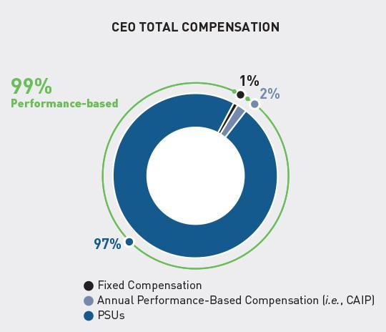

SEC rules require annual disclosure, of a reasonable estimate of the ratio of the annual total compensation of the company’s principal executive officer to the company’s median employee’s annual total compensation.

To identify our median employee for purposes of this disclosure, we first defined a pool of all individuals employed by us (other than our principal executive officer) on a chosen date—November 15, 2020. We then determined which of those individuals would be considered “employees” for this purpose by applying the definitions provided under applicable local tax laws. We included all such employees whether employed on a full-time, part-time, or seasonal basis.

In considering our work force outside of the United States, and as permitted by the rule’s de minimis exemption, we excluded from this pool employees located in certain non-U.S. jurisdictions for ease and reliability of data gathering. Specifically, we excluded all employees located in Mexico (2 employees), Malta (5 employees), Brazil (7 employees), Japan (10 employees), Netherlands (103 employees), Australia (111 employees), Taiwan (135 employees), and Germany (151 employees) from the pool of employees used to identify our median employee. The aggregate number of employees excluded, 524, equals approximately 4.73% of our global employee population. Excluding these employees resulted in the reduction of our employee pool from 11,068 employees to 10,544 employees.

Finally, to identify the median employee from that pool, we compared their base salaries, as we believe base salary is a consistently applied compensation measure that is a consistent and reasonable approach to determining compensation across our diverse employee populations. To do so, we used the annual base salaries of salaried employees and hourly wages of hourly employees. Wages and salaries were annualized for permanent employees that were not employed for the full year of 2020. For part-time employees, annualization was based on hours worked, without any full-time equivalent adjustment. The wages and salaries of fixed-term employees were not annualized. We applied the U.S. dollar exchange rates used in our 2020 annual operating plan to any element of base salary paid in non-U.S. currency.

Our principal executive officer is our Chief Executive Officer, Mr. Kotick. The form and amount of our Chief Executive Officer’s proxy-reported compensation for 2020 is consistent with the terms of his employment agreement and reflects, among other things, our Compensation Committee’s assessment of his performance for the year.

As we have described in our pay-for-performance analysis, the 2020 equity grant and 2021 equity grant (under Mr. Kotick’s agreement) were made late in 2020, and therefore the fair value reflects the significant growth in our stock price when measuring the performance against the performance targets. This is not directly comparable to value disclosed by other companies who establish all of the terms of their awards at the start of the performance period. If we consider these awards at their target value (vs. maximum), which we believe would be a more consistent way to apply and compare to other companies, the CEO-to-median employee pay ratio would be 549 to 1.

We calculated annual total compensation for our median employee using the same methodology as we

www.activisionblizzard.com ACTIVISION BLIZZARD, INC. 2021 Proxy Statement 120

Back to Contents

use for our named executive officers as set forth in the “Summary Compensation Table” above. For 2020, the annual total compensation of our median employee, who was not granted an equity award during 2020, was $99,100. The reported annual total compensation of our Chief Executive Officer for 2020 was $154,613,318. Most of that total compensation is equity that was earned for performance over a four-year performance period. Based on this, our estimate of the CEO-to-median employee pay ratio is 1,560 to 1.

We encourage shareholders to consider this ratio in a broader context:

- Our CEO’s compensation in 2020 is largely driven by the 2020 equity grant and the exceptional achievement over the 2017–2020 performance period, during which time the Company increased shareholder value by $45 billion. This equity award and its associated metrics was contemplated in the 2016 employment agreement, and related to a four–year performance period.

- 99% of our CEO’s compensation this year was performance-based (cash bonus and/or equity incentives).

As a result of the wide variety of job functions within our Company, across numerous global jurisdictions, the compensation paid to our employees differs greatly between departments, experience levels, and locations. We believe that our employees are fairly compensated and appropriately incentivized.

Given the different methodologies that various public companies will use to determine an estimate of their pay ratio, the estimated ratio reported above should not be used as a basis for comparison between companies.

www.activisionblizzard.com ACTIVISION BLIZZARD, INC. 2021 Proxy Statement 121

Back to Contents

PROPOSAL 2 ADVISORY VOTE TO APPROVE THE COMPANY’S EXECUTIVE COMPENSATION

GENERAL

Our shareholders are being provided the opportunity to cast a non-binding, advisory vote (commonly known as a “say-on-pay”) on the compensation of the executive officers named in the “Summary Compensation Table” above (i.e., the named executive officers).

Accordingly, you are being asked to approve the following resolution at the Annual Meeting:

“Resolved, that the shareholders APPROVE, on an advisory basis, the compensation of the Company’s named executive officers as disclosed pursuant to Item 402 of Regulation S-K, including the Compensation Discussion and Analysis, the compensation tables and related narrative discussion.”

Prior to casting your vote, we encourage you to read the “Compensation Discussion and Analysis” section of this proxy statement, which describes our executive compensation policies and practices, including a number of important changes made to them, as well as the Summary Compensation Table and other compensation tables and related narrative discussions, which provide detailed information on the compensation of our named executive officers. Our Compensation Committee and Board believe that our compensation policies and practices align with shareholder interests, by emphasizing pay for performance and enabling us to attract, retain, and motivate the key executive talent necessary to achieve our financial and strategic goals.

REQUIRED VOTE AND BOARD RECOMMENDATION

The affirmative vote of the holders of a majority of the voting power of the shares present in person or by proxy and entitled to vote on the matter at the Annual Meeting is required for the approval of proposal 2. As an advisory vote, the proposal is non-binding on the Company, our Board, and our Compensation Committee. However, our Board and its Compensation Committee value the opinions expressed by our shareholders and will carefully consider the outcome of the vote when making future executive compensation decisions. Our Board ultimately has a duty to act in what it believes to be the best interests of the Company and all of its shareholders.

The Board has adopted a policy of providing for annual say-on-pay advisory votes. As such, we expect that the next say-on-pay vote will be held at our 2022 annual meeting and the next say-on-pay frequency vote will be held at our 2023 annual meeting.

YOUR BOARD UNANIMOUSLY RECOMMENDS THAT YOU VOTE FOR THE APPROVAL OF THE COMPANY’S EXECUTIVE COMPENSATION, AS DISCLOSED IN THIS PROXY STATEMENT.

www.activisionblizzard.com ACTIVISION BLIZZARD, INC. 2021 Proxy Statement 122

Back to Contents

DIRECTOR COMPENSATION

GENERAL

Pursuant to our director compensation program, our non-employee directors receive a mix of cash and equity awards, with the majority of the compensation in the form of equity. The amount of compensation paid to each director depends on their role and responsibilities. Mr. Kotick, our Chief Executive Officer and only employee director, does not receive any compensation for his service on our Board.

The Compensation Committee annually reviews the total compensation paid to our non-employee directors and each element of our director compensation program and makes recommendations to our Board regarding the program as needed. In making these recommendations, our Compensation Committee takes various factors into consideration, including our directors’ responsibilities, their experience and skills, and the competitiveness of the form and amount of our director compensation by reference to the comparator group against which the Compensation Committee benchmarks our executive compensation. Please see “Executive Compensation—Compensation Discussion and Analysis—Decision-Making Approach to Executive Compensation—Comparator Company Data and Compensation Surveys Referenced” above for further information about our comparator group. The Compensation Committee engages an independent compensation consultant to assist in this review (and, since 2013, has retained Exequity as its independent compensation consultant). Our executive officers may assist the Compensation Committee in obtaining benchmarking and other information relevant to determining director compensation, but our management has no role in recommending or determining the amount or form of director compensation.

CASH COMPENSATION

The following table sets forth a summary of the cash elements of our director compensation program that has been in effect since May 1, 2018. Directors do not receive any additional payments for attending Board or committee meetings.

Annual Retainer |  | $ | 90,000
Add’l. for Serving as Chairperson of the Board of Directors |  | $ | 150,000
Add’l. for Serving as Lead Independent Director |  | $ | 50,000
Add’l. for Serving as Chairperson of the Audit Committee |  | $ | 40,000
Add’l. for Serving as Chairperson of the Compensation Committee |  | $ | 40,000
Add’l. for Serving as Chairperson of the Nominating and Corporate Governance Committee |  | $ | 30,000
Add’l. for Serving as an Audit Committee Member (other than as the Chairperson) |  | $ | 11,000
Add’l. for Serving as a Compensation Committee or Nominating and Corporate Governance Committee Member |  | $ | 5,500
(other than as the Chairperson)
Per Day for Special Assignments in connection with Board duties |  | $ | 5,500
www.activisionblizzard.com | ACTIVISION BLIZZARD, INC. 2021 Proxy Statement 123

Back to Contents

EQUITY COMPENSATION

Our Board believes that directors more effectively represent our shareholders, whose interests our Board is charged with protecting, if they are shareholders themselves. Each non-employee director is entitled, upon their election or appointment to our Board and upon each subsequent re-election to our Board, to receive restricted share units representing the right to receive shares of our Common Stock. The grant date value of those restricted share units is $250,000, provided that, in the event of an election or appointment at any time other than at the Board meeting immediately following an annual meeting of our shareholders, the grant of restricted share units will be pro-rated based on the amount of time from the date of such election or appointment until the then-expected date of the Company’s next annual meeting of shareholders. The actual number of shares underlying the restricted share units is determined by dividing the grant date fair value of the award by the Nasdaq Official Closing Price of our Common Stock on the date of grant. The award of restricted share units is approved by our Board promptly following a non-employee director’s election, appointment, or re-election to the Board and is made three business days following the date of the Board’s approval of such grant. Each award vests in four equal installments (on a quarterly basis during the year following the date of grant), subject to continued service on our Board.

STOCK OWNERSHIP GUIDELINES

Pursuant to our director compensation program and our Corporate Governance Principles and Policies, each non-employee director is expected, within four years following their initial election to our Board, to beneficially own shares of our Common Stock (including any restricted share units representing the right to receive shares of our Common Stock) having an aggregate value at least equal to five times the amount of the annual cash retainer we then pay directors for regular service on our Board. Currently, this equates to beneficially owning shares of our Common Stock with a value of $450,000. The value of shares owned by each non-employee director is calculated as of January 4th of each applicable year (or if that date is not a trading date, the next trading date) based on the higher of: (a) the Nasdaq Official Closing Price of our Common Stock on that day; and (b) the Nasdaq Official Closing Price of our Common Stock on the date of grant (or if that date is not a trading date, the next trading date), for any shares awarded to the director by us, and the actual cost to the director for any other shares (including shares acquired upon exercise of a stock option). Non-employee directors are subject to these guidelines for as long as they continue to serve on our Board. As of January 4, 2021, all non-employee directors who, as of that date, had been a member of our Board for four or more years were in compliance with these guidelines.

INDEMNIFICATION

We maintain a directors and officers insurance policy that covers all our directors with respect to claims arising out of an alleged wrongful act by them in their capacity as directors of Activision Blizzard. Further, our Certificate of Incorporation and our bylaws require us to indemnify our directors and officers to the fullest extent permitted by the Delaware General Corporation Law.

In addition, we have entered into indemnification agreements with certain of our non-employee directors that require us, among other things, to indemnify those directors against certain liabilities that may arise by reason of their status or service as directors, provided that they acted in good faith and in a manner they reasonably believed to be in, or not opposed to, our best interests (and, with respect to any criminal action, suit, or proceeding, that they had no reasonable cause to believe that their conduct was unlawful). The indemnification agreements also require us to advance expenses incurred by our non-employee directors as a result of any proceeding against them as to which they could be indemnified.

www.activisionblizzard.com ACTIVISION BLIZZARD, INC. 2021 Proxy Statement 124

Back to Contents

REIMBURSEMENT OF EXPENSES AND LIMITED BENEFITS

All our directors are reimbursed by us for expenses incurred in connection with their service on our Board. We also reimburse our directors’ spouses for travel, lodging, and related expenses they incur in attending business-related meetings or events at our request, though such occurrences are uncommon. Pursuant to our director compensation program and the Company’s Corporate Governance Principles and Policies, our Board may provide our directors with other benefits. For example, on rare occasions, if a director’s spouse accompanies them on a business trip other than at our request, we may provide that person with travel and lodging at our expense when the incremental cost to us for doing so is negligible.

DIRECTOR COMPENSATION FOR 2020

The following table sets forth a summary of information regarding the compensation of our directors for 2020, other than Mr. Kotick, as the compensation he received as an employee of the Company is included in the “Summary Compensation Table” above, and he does not receive any additional compensation for his Board service.

 | Fees Earned | Stock | Option | All Other
 | in Cash | _{Awards}(1)(2)(3) | Awards⁽³⁾ | Compensation | Total
Name | ($) | ($) | ($) | ($) | ($)
Reveta Bowers | 95,500 | 249,631 | — | — | 345,131
Robert Corti | 130,000 | 249,631 | — | — | 379,631
Hendrik Hartong III | 101,000 | 249,631 | — | — | 350,631
Brian Kelly | 240,000 | 249,631 | — | — | 489,631
Barry Meyer | 95,500 | 249,631 | — | — | 345,131
Robert Morgado | 210,000 | 249,631 | — | — | 459,631
Peter Nolan | 101,000 | 249,631 | — | — | 350,631
Dawn Ostroff(4) | 53,056 | 249,631 |  |  | 302,687
Casey Wasserman | 95,500 | 249,631 | — | — | 345,131
Elaine Wynn(5) | 42,444 | — | — | — | 42,444

- The amounts in the Stock Awards column represent the aggregate grant date fair value of stock awards (which consist of restricted share units) made in 2020 to each person who served on our Board during the year who is not an NEO (computed in accordance with ASC Topic 718). As such, the amount shown represents the full aggregate grant date fair value, rather than the portion expensed for financial statement reporting purposes in 2020. Assumptions and key variables used in the calculation of these grant date fair values are discussed in footnote 16 to our audited financial statements included in our 2020 10-K.

- Each person who served on our Board during 2020 who was not an NEO received 3,425 restricted share units with a grant date fair value of $249,631 (computed in accordance with ASC Topic 718). Assumptions and key variables used in the calculation of these grant date fair values are discussed in footnote 16 to our audited financial statements included in our 2020 10-K.

- The following table presents, as of December 31, 2020, the number of shares underlying outstanding stock options and stock awards (which consist of restricted share units) held by each director who served in 2020 and who is not an NEO:

- Ms. Ostroff’s service on the Board began on June 11, 2020.

- Ms. Wynn’s service on the Board ended on June 11, 2020.

www.activisionblizzard.com ACTIVISION BLIZZARD, INC. 2021 Proxy Statement 125

Back to Contents

 | Number of Shares Underlying | Number of Shares Underlying Unvested
 | Options as of December 31, 2020 | Stock Awards as of December 31, 2020
Name | (#) | (#)
Reveta Bowers | — | 1,712
Robert Corti | — | 1,712
Hendrik Hartong III | — | 1,712
Brian Kelly | 80,676 | 1,712
Barry Meyer | — | 1,712(a)
Robert Morgado | 44,000 | 1,712
Peter Nolan | — | 1,712
Dawn Ostroff | — | 1,712
Casey Wasserman | — | 1,712^{(b)}
Elaine Wynn | — | —

- These restricted share units are held in trust—one-half in the Barry Meyer Separate Property Trust and one-half in the Barry and Wendy Meyer Trust.

- These restricted share units are held in the Casey Wasserman Living Trust.

www.activisionblizzard.com ACTIVISION BLIZZARD, INC. 2021 Proxy Statement 126

Back to Contents

CERTAIN RELATIONSHIPS AND RELATED PERSON TRANSACTIONS

POLICIES AND PROCEDURES REGARDING TRANSACTIONS WITH RELATED PARTIES

Related Person Transactions Policy

We have a Related Person Transactions Policy pursuant to which the Audit Committee evaluates transactions, arrangements, or relationships (or any series of similar transactions, arrangements, or relationships) in which: (1) we were, are, or will be a participant, whether directly or indirectly; (2) the amount involved exceeds $120,000; and (3) a related person had, has, or will have a direct or indirect interest. For the purposes of the policy, a “related person” is

- any person who is, or was at any time since the beginning of our last fiscal year, a director, a person nominated for election to our Board, or one of our executive officers, (b) any person who beneficially owns more than 5% of our Common Stock, or (c) any person who is, or was at any time since the beginning of our last fiscal year, an immediate family member of any person covered by (a) or (b).

Our Related Person Transactions Policy is generally designed to capture any transaction for which disclosure by the Company would be required pursuant to Item 404 of Regulation S-K promulgated under the Securities Act of 1933, as amended.

Under our Related Person Transactions Policy, our Chief Legal Officer is generally responsible for making an initial determination as to whether something is a related party transaction within the meaning of the policy and notifying the Audit Committee if they conclude that it is. The Audit Committee evaluates each related person transaction taking into consideration the following factors:

- the purpose of the transaction and what benefit it provides to the Company;

- the terms of the transaction and whether they are arm’s-length;

- the direct or indirect nature of the related person’s interest in the transaction;

- the availability of comparable goods or services from non-related persons;

- whether the transaction was initiated by the Company or the related person;

- whether the transaction was undertaken in the ordinary course of our business;

- the expected term of the transaction and the approximate dollar value involved in the transaction, particularly as it relates to the related person;

- the related person’s interest in the transaction;

- the potential for reputational harm;

- applicable law and listing standards;

- our Certificate of Incorporation and our bylaws; and

- any other facts and circumstances the Audit Committee believes to be relevant.

The Audit Committee may approve or ratify the related party transaction if it determines that the transaction is in the best interests of the Company and consistent with law and our Certificate of Incorporation and our bylaws. If the Audit Committee does not approve or ratify the transaction, it may be voided, terminated, or amended by us, if so directed by the Audit Committee.

Code of Conduct and Conflicts of Interest

Our Code of Conduct addresses the handling of actual and potential conflicts of interest between our interests and the interests of our employees, including our executive officers, and our directors, which may include related party transactions. In accordance with our Code of Conduct, such actual or potential conflicts of interest must be disclosed to the Company. Once disclosed, our legal department, working with relevant parties, will evaluate the conflict and determine how to manage or resolve it.

www.activisionblizzard.com ACTIVISION BLIZZARD, INC. 2021 Proxy Statement 127

Back to Contents

RELATIONSHIPS AND TRANSACTIONS

Business Use of Aircraft Indirectly Owned by Our Chief Executive Officer

Our CEO indirectly owns aircraft that are operated by a Federal Aviation Administration -certified charter operator which is indirectly owned and managed by him. From time to time, our CEO and other executives and directors of the Company use these aircraft for travel in connection with our business. We currently pay for such use an amount that is not greater than 95% of the charter operator’s regular hourly flight charges plus 100% of the actual, third-party costs incurred by the charter operator in obtaining goods and services for the flights. In addition, the charter operator does not charge us customary cancellation fees or require us to commit to a customary block charter guarantee. Further, our arrangement with the charter operator allows us to avoid the expense of operating an in-house flight department. During 2020, the Company paid $2,599,152 for business-related use of these aircraft, including by our employees, executives and directors. Our use of these aircraft was authorized by the Audit Committee, which believes that this arrangement provides us with substantial value because our cost is less than the cost we would incur if we were to charter aircraft from another charter operator and pay market rates or the outlay of substantial Company capital to own and operate our own aircraft. In addition, the arrangement allows for greater time efficiency and productivity and enhanced safety and security for our executives and directors.

www.activisionblizzard.com ACTIVISION BLIZZARD, INC. 2021 Proxy Statement 128

Back to Contents

AUDIT-RELATED MATTERS

INDEPENDENT REGISTERED PUBLIC ACCOUNTING FIRM FEES

The table below sets forth the categories and amounts (including out-of-pocket expenses incurred by PricewaterhouseCoopers LLP (“PwC”) in connection with providing such services and billed to us) paid to PwC for professional audit services for the audit of the Company’s financial statements for the years ended December 31, 2020 and 2019, and fees billed for other services in fiscal years 2020 and 2019.

 |  |  | Year Ended
 | December 31, 2020 |  | December 31, 2019
Audit Fees(1) | $ | 8,028,335 | $ | 8,655,487
Audit-Related Fees(2) |  | 33,000 |  | 75,000
Tax Fees(3) |  | 2,974,245 |  | 2,804,430
All Other Fees(4) |  | 9,200 |  | 9,200
TOTAL | $ | 11,044,780 | $ | 11,544,117

- Audit Fees: This category includes services provided in connection with the annual audit of our financial statements (including required quarterly reviews of financial statements included in our Quarterly Reports on Form 10-Q), services provided in connection with the annual audit of our internal control over financial reporting, as required by Section 404 of the Sarbanes Oxley Act of 2002, statutory audits required for certain of our non-U.S. subsidiaries, consents, assistance with, and review of, documents filed with the SEC, and other services that are normally provided in connection with statutory or regulatory filings or engagements.

- Audit-Related Fees: This category includes fees primarily related to compliance attestation services.

- Tax Fees: This category includes services rendered for U.S. and foreign tax compliance and returns, transfer pricing, research and development tax credit, and other technical tax consulting.

- All Other Fees: This category includes fees for all other services except those described above. Amounts relate to assistance with international industry filings, as well as license fees paid for an online research tool and disclosure checklist.

PRE-APPROVAL POLICIES AND PROCEDURES

In accordance with its charter, the Audit Committee must approve all audit and non-audit services before they are provided by PwC.

At the beginning of each year, the Audit Committee approves a budget with respect to audit and non-audit services expected to be provided during the year by PwC. Within that budget, the Audit Committee approves spending attributable to specified classes of services that PwC has historically provided. If proposed services do not fall within one of the classes pre-approved at the beginning of the year, the services must be pre-approved by the chairperson of the Audit Committee and reported to the Audit Committee at its full next meeting. Further, if proposed services would result in the aggregate spending in a particular category—audit, audit-related, tax, and all other—exceeding the pre-approved annual budget for that category of services, those proposed services must first be pre-approved by the chairperson of the Audit Committee and reported to the Audit Committee at its next full meeting.

All services provided to the Company by PwC for 2020 were approved by the Audit Committee in accordance with these pre-approval policies and procedures.

www.activisionblizzard.com ACTIVISION BLIZZARD, INC. 2021 Proxy Statement 129

Back to Contents

AUDIT COMMITTEE REPORT

Roles and Responsibilities: Management is responsible for our system of internal control over financial reporting. Our independent registered public accounting firm, PwC, is responsible for performing an independent audit of our consolidated financial statements and the effectiveness of our internal control over financial reporting in accordance with the standards of the Public Company Accounting Oversight Board (United States) (“PCAOB”), and for issuing a report thereon. The Audit Committee is responsible for overseeing management’s conduct of the financial reporting process and our system of internal control over financial reporting.

Required Disclosures and Discussions: The Audit Committee has reviewed and discussed with both management and our independent registered public accounting firm all annual audited financial statements prior to their issuance. In connection with these reviews, management advised the Audit Committee that each set of financial statements reviewed had been prepared in accordance with generally accepted accounting principles (i.e., GAAP), and reviewed significant accounting and disclosure issues with the Audit Committee. These reviews included discussions with the independent registered public accounting firm with regards to the matters required to be discussed by both the PCAOB and the SEC, including the quality of our accounting principles, the reasonableness of significant judgments and the clarity of disclosure in the financial statements. In addition, the Audit Committee has received and reviewed the written disclosures and the letter from our independent registered public accounting firm under the applicable requirements of the PCAOB regarding the independent registered public accounting firm’s communications with the Audit Committee concerning independence, and has discussed with such firm its independence, including a review of its audit and non-audit fees.

Committee Recommended Including the Financial Statements in the Annual Report: Based on these reviews and discussions, all of the Audit Committee members, whose names are listed below, recommended to our Board that it approve the inclusion of our audited financial statements in our Annual Report on Form 10-K for the period ended December 31, 2020 for filing with the SEC.

Members of the Audit Committee

Robert Corti (Chairperson), Hendrik Hartong III, and Peter Nolan

www.activisionblizzard.com ACTIVISION BLIZZARD, INC. 2021 Proxy Statement 130

Back to Contents

PROPOSAL 3 RATIFICATION OF APPOINTMENT OF INDEPENDENT REGISTERED PUBLIC ACCOUNTING FIRM

The Audit Committee of our Board has appointed PwC to serve as the Company’s independent registered public accounting firm for the current fiscal year ending December 31, 2021. Please see “Audit-Related Matters— Independent Registered Public Accounting Firm Fees” above for a description of the services provided to us by PwC during the years ended December 31, 2020 and 2019.

The Company has engaged PwC as our independent registered public accounting firm since 2008.

The Audit Committee meets annually without PwC present to evaluate PwC’s independence and performance in deciding whether to retain PwC or engage a different independent registered public accounting firm. During these reviews, the committee may consider, among other things:

- the quality and efficiency of the services provided by PwC, including input from our management on PwC’s performance, including its effectiveness at demonstrating independent judgment, objectivity, and professional skepticism;

- PwC’s judgments on critical accounting matters;

- the quality and candor of PwC’s communications with the Audit Committee and our management;

- external data on PwC’s audit quality and performance, including recent PCAOB reports on PwC and its peer firms;

- PwC’s independence and its processes for maintaining its independence;

- PwC’s technical expertise and knowledge of the Company’s global operations and industry;

- PwC’s global capabilities; and

- the appropriateness of PwC’s fees, PwC’s tenure as our independent registered public accounting firm, including the benefits of a longer tenure, and the controls and processes in place that help ensure PwC’s continued independence.

Benefits of Long Tenure Independence Controls

- Enhanced audit quality—PwC has significant institutional knowledge and deep expertise regarding the Company’s global business, accounting policies and practices, and internal control over financial reporting, and this enhances audit quality.

- Competitive fees—In part because of PwC’s familiarity with the Company, we believe the fees we pay PwC are competitive with those of other independent registered public accounting firms.

- Avoid costs and onboarding associated with new auditor— Bringing on a new auditor requires expenses related to educating the new auditor and a significant time commitment that could distract from our management’s focus on financial reporting and internal controls.

- Audit Committee oversight—Oversight includes regular private sessions with PwC, discussion with PwC about the scope of its audit, a comprehensive annual evaluation when determining whether to continue to engage PwC.
- Selection of Lead Engagement Partner—The Audit Committee and its chairperson are actively involved in the selection of the new lead engagement partner in connection with the mandated rotation of that position every five years. In 2019, in connection with the mandated rotation of PwC’s lead engagement partner effective beginning with PwC’s audit of the Company’s 2020 financial statements, we interviewed candidates who met professional, industry and personal criteria, and selected finalists. The chairperson of the Audit Committee participated in interviews with the finalists and helped select the lead engagement partner.

- Rigorous limits on non-audit services—We require Audit Committee pre-approval of non-audit services, prohibit certain types of non-audit services that would otherwise be permissible under SEC rules, and only engage PwC when it is best-suited for the job.

- PwC’s strong internal independence process—PwC conducts periodic internal reviews of its audit and other work, assesses the adequacy of partners and other personnel working on the Company’s account, and rotates the lead engagement partner consistent with independence requirements.
- Strong regulatory framework—PwC, as an independent registered public accounting firm, is subject to PCAOB inspections, “Big 4” peer reviews, and PCAOB and SEC oversight.
- Restrictions on hiring—The Audit Committee has adopted restrictions on our hiring of current or former partners and employees of the Company’s independent registered public accounting firm.

www.activisionblizzard.com ACTIVISION BLIZZARD, INC. 2021 Proxy Statement 131

Back to Contents

Based on the most recent such evaluation, the Audit Committee and the Board believe that retaining PwC to serve as the Company’s independent registered public accounting firm for the year ending December 31, 2021, is in the best interests of the Company and its shareholders. While our Audit Committee has the responsibility of selecting our auditors, and shareholder approval is not required for the appointment of PwC as our independent registered public accounting firm, we believe that our shareholders should have the opportunity to ratify such appointment, and we are requesting that they do so at the Annual Meeting.

Representatives of PwC are expected to be present at the Annual Meeting and will have the opportunity to make a statement if they desire to do so. They are also expected to be available to respond to appropriate questions.

REQUIRED VOTE AND BOARD RECOMMENDATION

The affirmative vote of the holders of a majority of the voting power of the shares present in person or by proxy and entitled to vote on the matter at the Annual Meeting is required for the approval of proposal 3. In the event our shareholders fail to ratify the appointment, our Audit Committee will reconsider its selection next year. Even if the appointment is ratified, our Audit Committee may direct the appointment of a different independent registered public accounting firm at any time during the year if the Audit Committee determines that such a change would be in the best interests of the Company and our shareholders.

YOUR BOARD UNANIMOUSLY RECOMMENDS THAT YOU VOTE FOR THE RATIFICATION OF THE APPOINTMENT OF PWC AS THE COMPANY’S INDEPENDENT REGISTERED PUBLIC ACCOUNTING FIRM.

www.activisionblizzard.com ACTIVISION BLIZZARD, INC. 2021 Proxy Statement 132

Back to Contents

BENEFICIAL OWNERSHIP MATTERS

SECURITY OWNERSHIP OF OUR OFFICERS AND DIRECTORS

The following table sets forth information, as of April 1, 2021, with respect to the beneficial ownership of our Common Stock by (1) our named executive officers, (2) each director and each nominee for election as director, and (3) all current executive officers and directors as a group. Unless otherwise noted, the persons named in the table have sole voting and investment power with respect to all shares shown as beneficially owned by such shareholder.

 | Shares of Activision Blizzard Beneficially Owned
 | Shares | Right to | Total Shares Owned | Percent of
 | Owned | Acquire⁽¹⁾ | plus Right to Acquire | Outstanding
Name | (#) | (#) | (#) | Shares⁽²⁾ (%)
Daniel Alegre | 36,285 | — | 36,285 | *
Reveta Bowers | 13,086 | — | 13,086 | *
Robert Corti | 118,818⁽³⁾ | — | 118,818 | *
Dennis Durkin | 234,834 | 37,720⁽⁴⁾ | 272,554 | *
Hendrik Hartong III | 39,474⁽⁵⁾ | — | 39,474 | *
Brian Kelly | 1,443,382⁽⁶⁾ | 80,676⁽⁴⁾ | 1,524,058 | *
Robert Kotick | 3,564,360⁽⁷⁾ | — | 3,564,360 | *
Barry Meyer | 48,854⁽⁸⁾ | — | 48,854 | *
Robert Morgado | 117,221⁽⁹⁾ | 44,000⁽⁴⁾ | 161,221 | *
Claudine Naughton | — | — | — | —
Peter Nolan | 171,865⁽¹⁰⁾ | — | 171,865 | *
Dawn Ostroff | 2,569 | — | 2,569 | *
Chris B. Walther | 39,684⁽¹¹⁾ | — | 39,684 | *
Casey Wasserman | 20,861⁽¹²⁾ | — | 20,861 | *
All current directors and executive officers as a group | 5,851,293⁽¹³⁾ | 162,396⁽⁴⁾ | 6,013,689 | .77
(14 persons)
www.activisionblizzard.com |  | ACTIVISION BLIZZARD, INC. 2021 Proxy Statement 133

Back to Contents

- Less than 1%.

- Consists of shares of our Common Stock that may be acquired upon (a) the exercise of stock options to purchase shares of our Common Stock that are exercisable on or within 60 days of April 1, 2021 (i.e., by May 31, 2021), and (b) the vesting of restricted share units reflecting the right to receive shares of our Common Stock that vest, or the settlement of vested restricted share units that settle, within 60 days of April 1, 2021 (i.e., by May 31, 2021).

- The percent of outstanding shares was calculated by dividing the number of shares of our Common Stock beneficially owned by each beneficial owner or group of beneficial owners as of April 1, 2021 (including the number of shares that each beneficial owner or group of beneficial owners had the right to acquire within 60 days of that date) by the sum of (a) the total number of shares of our Common Stock outstanding on that date (i.e., 776,918,654) and (b) the number of shares that may be acquired by such beneficial owner or group of beneficial owners within 60 days of that date.

- Consists of shares held jointly by Mr. Corti and his wife, JoAnn Corti, who share voting and investment power with respect to such shares.

- Consists of options to purchase shares of our Common Stock.

- Consists of (a) 34,974 shares directly held by Mr. Hartong, (b) 2,500 shares held in a trust for one of Mr. Hartong’s sons, (c) 1,000 shares held in a trust for another of Mr. Hartong’s sons, and (d) 1,000 shares held in a trust for Mr. Hartong’s daughter.

- Consists of (a) 19,357 shares directly held by Mr. Kelly, (b) 574,721 shares held by ASAC TJKS LLC, a limited liability company managed by Mr. Kelly, (c) one share held by ASAC II LLC, a limited liability company of which Messrs. Kelly and Kotick are the managers, as to which Mr. Kelly disclaims beneficial ownership except to the extent of his pecuniary interest therein, (d) 805,949 shares held by the 31427N Trust, of which Mr. Kelly is the trustee, as to which Mr. Kelly disclaims beneficial ownership, (e) 43,352 shares held by the Brian & Joelle Kelly Family Foundation, a charitable foundation of which Mr. Kelly is a trustee, as to which Mr. Kelly disclaims beneficial ownership, and (f) two shares held indirectly by Delmonte Investments, LLC, of which Mr. Kelly is a member and manager.

- Consists of (a) 3,155,773 shares of our Common Stock held in the 10122B Trust, of which Mr. Kotick is the trustee and the sole beneficiary, (b) one share held by ASAC II LLC, a limited liability company of which Messrs. Kelly and Kotick are the managers, as to which Mr. Kotick disclaims beneficial ownership except to the extent of his pecuniary interest therein, (c) 36,918 shares held in a grantor retained annuity trust for the benefit of Mr. Kotick’s immediate family, as to which Mr. Kotick disclaims beneficial ownership, (d) 371,666 shares held in the 1011 Foundation, Inc., a charitable foundation of which Mr. Kotick is the president, as to which Mr. Kotick disclaims beneficial ownership, and (e) two shares held indirectly by Delmonte Investments, LLC, of which Mr. Kotick is a member and manager.

- Consists of (a) 24,426 shares held by The Barry Meyer Separate Property Trust, a trust for the benefit of Mr. Meyer’s wife and children of which Mr. Meyer is the trustee, and (b) 24,428 shares held by The Barry and Wendy Meyer Trust, of which Mr. Meyer and his wife, Wendy Meyer, are co-trustees and share voting and investment power with respect thereto.

- Consists of (a) 77,730.32 shares of our Common Stock held by Mr. Morgado and (b) 39,490.68 shares held by the Robert J. and Mary Lou Morgado Charitable Trust, a charitable foundation of which Mr. Morgado is a trustee, as to which Mr. Morgado disclaims beneficial ownership.

- Consists of (a) 83,523 shares of our Common Stock held by Mr. Nolan, (b) 54,792 shares held by the Nolan Family Trust, and (c) 33,550 shares held by MIROEL Investments, LLC, of which Mr. Nolan owns one percent and the remainder is split among three trusts for the benefit of Mr. Nolan’s children and the Nolan Family Trust.

- Consists of shares held in the Walther-Stockton 2013 Family Trust. Mr. Walther and his wife, Susan Stockton, are co-trustees of the trust and share voting and investment power with respect to those securities.

- Consists of (a) 20,856 shares of our Common Stock held by the Casey Wasserman Living Trust and (b) 5.46 shares held by Mr. Wasserman’s wife.

- Includes shares of our Common Stock held indirectly by the individuals named in the table, as described above.

www.activisionblizzard.com ACTIVISION BLIZZARD, INC. 2021 Proxy Statement 134

Back to Contents

SECURITY OWNERSHIP OF HOLDERS OF MORE THAN 5% OF OUR COMMON STOCK

The following table sets forth information as to any person (including any “group” as that term is used in Section 13(d)

- of the Exchange Act) known by us to be the beneficial owner of more than 5% of our Common Stock. The information in the table is based on a review of filings made with the SEC on Schedules 13D and 13G and the assumption that each of the persons named in the table continued to own the number of shares reflected in the table on April 1, 2021. As of April 1, 2021, there were 776,918,654 shares of our Common Stock outstanding.

 | Shares of Activision Blizzard | Percent of
 | Beneficially Owned | Outstanding Shares
The Vanguard Group | 59,862,085(1) | 7.71%
100 Vanguard Blvd.
Malvern, PA 19355
BlackRock, Inc. | 58,457,312(2) | 7.52%
55 East 52nd Street
New York, NY 10055
FMR LLC | 48,456,463(3) | 6.24%
245 Summer Street
Boston, Massachusetts 02210

- This information is based solely on a Schedule 13G/A filed with the SEC by The Vanguard Group, together with various of its direct and indirect subsidiaries, in their various fiduciary and other capacities, on February 10, 2021. The Vanguard Group reported that it has shared voting power over 1,306,529 shares of our Common Stock, sole dispositive power over 56,448,883 shares of our Common Stock, and shared dispositive power over 3,413,202 shares of our Common Stock.

- This information is based solely on a Schedule 13G/A filed with the SEC by BlackRock, Inc., together with various of its direct and indirect subsidiaries, in their various fiduciary and other capacities, on January 29, 2021. BlackRock, Inc. reported that it has sole voting power over 51,065,643 shares of our Common Stock and sole dispositive power over 58,457,312 shares of our Common Stock.

- This information is based solely on a Schedule 13G/A filed with the SEC jointly by FMR LLC, together with various of its direct and indirect subsidiaries, in their various fiduciary and other capacities, and Abigail P. Johnson on February 8, 2021. FMR LLC reported that it has sole voting power over 7,986,762 shares of our Common Stock and sole dispositive power over 48,456,463 shares of our Common Stock.

www.activisionblizzard.com ACTIVISION BLIZZARD, INC. 2021 Proxy Statement 135

Back to Contents

EQUITY COMPENSATION PLAN INFORMATION

The following table sets forth information, as of December 31, 2020, with respect to shares of our Common Stock that may be issued under our existing equity compensation plans.

 | Number of shares of |  | Number of shares of
 | Common Stock to be | Weighted average | Common Stock remaining
 | issued upon exercise of | exercise price of | available for future
 | outstanding options, | outstanding options, | issuance under equity
 | warrants, and rights | warrants, and rights | compensation plans
Plan Category | (#)⁽¹⁾ | ($)⁽²⁾ | (#)
Equity compensation plans approved by
shareholders:
Activision Blizzard, Inc. 2008 Incentive Plan, | 379,145 | 14.51 | —(3)
as amended and restated (the “2008 Plan”)
Activision Blizzard, Inc. 2014 Incentive | 17,997,321(5) | 55.35 | 23,277,381(6)
Plan (i.e., the 2014 Plan)(4)
All shareholder approved plans | 18,376,466(5) | 53.98 | 23,277,381
Equity compensation plans not
approved by shareholders:
None | — | N/A | —
All non-shareholder approved plans | — | N/A | —
TOTAL | 18,376,466(5) | 53.98 | 23,277,381

- Reflects options to purchase shares of our Common Stock and, in the case of the 2014 Plan, 7,109,517 restricted share units, 5,724,365 of which have vesting tied to performance, each reflecting the right to receive a share of our Common Stock. This table excludes an aggregate of 37,141 shares issuable upon exercise of outstanding options and vesting of outstanding restricted share units assumed by the Company in connection with the 2016 acquisition of King. The weighted average exercise price of the excluded options is $12.39.

- As there is no exercise price for restricted share units, the values in this column represent the weighted average exercise price of any outstanding stock options under the relevant plan.

- Upon adoption of the 2014 Plan, we ceased making awards under the 2008 Plan.

- The 2014 Plan permits the granting of non-qualified stock options, incentive stock options, stock appreciation rights (“SARs”), restricted shares, restricted share units, performance shares, performance units, and any other equity-based awards to our and any of our subsidiaries’ directors, officers, and other employees and consultants.

- The number of shares assumes target performance for all outstanding unvested performance-vesting restricted share units (i.e., PSUs). If achievement of maximum performance is assumed, the number of shares of Common Stock to be issued upon exercise of outstanding options, warrants, and rights as of December 31, 2020, would be 21,629,726 shares under the 2014 Plan and 22,008,871 shares under all shareholder approved plans.

- The number of shares reserved for issuance under the 2014 Plan may be increased from time to time by: (X) the number of shares
relating to awards outstanding under the 2008 Plan that: (a) expire, or are forfeited, terminated, or canceled, without the issuance of shares; (b) are settled in cash in lieu of shares; or (c) are exchanged, prior to the issuance of shares of our Common Stock, for awards not involving our Common Stock; (Y) if the exercise price of any stock option outstanding under the 2008 Plan is, or the tax withholding requirements with respect to any award outstanding under the 2008 Plan are, satisfied by withholding shares otherwise then deliverable in respect of the award or the actual or constructive transfer to the Company of shares already owned, the number of shares equal to the withheld or transferred shares; and (Z) if a SAR is exercised and settled in shares, the number of shares equal to the difference between the total number of shares with respect to which the award is exercised and the number of shares actually issued or transferred. The number of shares available for issuance under the 2014 Plan, as reflected in this table, assumes target performance of outstanding PSUs. If achievement of maximum performance is assumed, the number available for issuance under the 2014 Plan as of December 31, 2020, would be 19,644,976 shares.

www.activisionblizzard.com ACTIVISION BLIZZARD, INC. 2021 Proxy Statement 136

Back to Contents

INFORMATION ABOUT THE 2021 ANNUAL MEETING

- Who may vote at the Annual Meeting?

- Only shareholders of record at the close of business on April 19, 2021 (the “record date”), are entitled to notice of, or to vote at, the Annual Meeting. There were 777,012,463 shares of our Common Stock outstanding and entitled to vote on the record date.

A list of the shareholders entitled to vote at the Annual Meeting will be available for examination by any shareholder of record, for any purpose germane to the Annual Meeting, at, and for the ten days prior to, the Annual Meeting at www.viewproxy.com/ATVI/2021.

- How many votes may I cast?

- Each share of our Common Stock outstanding and entitled to vote that a shareholder holds on the record date is entitled to one vote on each matter presented for action at the Annual Meeting.

- What if I hold my shares through a broker? What is the difference between holding shares as a “shareholder of record” and holding shares as a “beneficial owner”?

- If your shares are held through a broker, bank, or any other nominee, you hold your shares in “street name,” and you are considered the “beneficial owner” of those shares. This proxy statement and any accompanying materials have been provided to you by your broker, bank, or other holder of record. As a beneficial owner, you are entitled to direct the firm that holds your shares how to vote your shares, unless you obtain a “legal proxy” from the broker, bank, or other nominee that holds your shares, giving you the right to vote the shares at the meeting yourself.

If your shares are registered in your name with our stock transfer agent, Broadridge Financial Solutions, you are the “shareholder of record.” This proxy statement and any accompanying materials have been provided to you directly by Activision Blizzard.

- Can my broker vote my shares without my instruction? What are “broker non-votes”?

- If you are a beneficial owner and you do not provide voting instructions to the broker, bank, or other nominee that holds your shares in its name, that firm is only allowed to exercise its discretion to vote your shares on certain matters, but will not be allowed to vote your shares with respect to any “non-discretionary” items, resulting in a so-called “broker non-vote” with respect to such items. Proposal 3—the ratification of PwC as the Company’s independent registered public accounting firm—is the only matter for consideration at the Annual Meeting upon which brokers can exercise discretion to vote your shares. For all matters other than proposal 3, you must submit voting instructions to the firm that holds your shares if you want your vote to count. A broker non-vote will occur if you do not provide instructions to your broker, bank, or other nominee with respect to proposals 1 or 2.

- How many votes must be present in order for business to be conducted?

- In order for business to be conducted at the Annual Meeting, a quorum must be present. A quorum consists of the presence, in person or by proxy, of a majority of the shares of our Common Stock entitled to vote at the Annual Meeting. Both abstentions and broker non-votes will be included for purposes of determining whether a quorum is present at the Annual Meeting.

www.activisionblizzard.com ACTIVISION BLIZZARD, INC. 2021 Proxy Statement 137

Back to Contents

- What are my voting options with respect to each proposal and how many votes are required to approve each proposal?

A:

 | Voting | Vote Required to | Broker Discretionary | Effect of Broker | Effect of
Proposal | Options | Adopt Proposal | Voting Allowed | Non-Votes | Abstentions
Proposal 1 — Election | For, against, or | The number of votes cast “for” the No |  | No Effect | No Effect
of Directors | abstain with | nominee exceeds the number of
 | respect to each | votes cast “against” the nominee
 | nominee | by the holders of shares present
 |  | in person or by proxy at the
 |  | Annual Meeting and entitled to
 |  | vote on the election of directors

Proposal 2 — Advisory For, against, or

Vote to Approve Our abstain
Executive Compensation

Affirmative vote of the holders of No No Effect Against
a majority of the voting power of
the shares present in person or
by proxy at the Annual Meeting

and entitled to vote on the matter

Proposal 3 — | For, against, or | Affirmative vote of the holders of Yes | N/A | Against
Ratification of | abstain | a majority of the voting power of
Appointment of Our |  | the shares present in person or
Independent Registered |  | by proxy at the Annual Meeting
Public Accounting Firm |  | and entitled to vote on the matter

- What are the ways I can vote?

- Shareholders at the close of business on April 19, 2021, can vote in person during the virtual Annual Meeting or via proxy in the manner described herein. Any shareholder who holds shares in street name through a broker, bank, or other nominee will receive separate instructions from the firm holding their shares describing the procedures for instructing the voting of those shares.

- What does it mean to vote by proxy? Who represents my shares at the Annual Meeting?

- A vote via proxy authorizes Robert Kotick (our Chief Executive Officer), Brian Bulatao (our Chief Administrative Officer), and Frances Townsend (our Corporate Secretary), and each of them, with full power of substitution, to vote and otherwise represent all of the shares that you are entitled to vote at the Annual Meeting, in accordance with your instructions, with the same effect as if you were present at the meeting and voting such shares.

www.activisionblizzard.com ACTIVISION BLIZZARD, INC. 2021 Proxy Statement 138

Back to Contents

- How do I vote by proxy?

- Shareholders of record may vote by proxy in three ways:

  - Vote by Internet. Record holders can vote online prior to 11:59 p.m., Eastern Time, on June 13, 2021. Go to www.proxyvote.com, which is available 24 hours a day until the deadline. You will need your 16-digit control number which appears on the notice of Internet availability of proxy materials or proxy card you received.

  - Vote by Telephone. Record holders can vote by phone prior to 11:59 p.m., Eastern Time, on June 13, 2021. Call (800) 690-6903, which is available 24 hours a day until the deadline. You will need your 16-digit control number which appears on the notice of Internet availability of proxy materials or proxy card you received.

  - Vote by Mail. Record holders can vote by mail if they received a printed copy of the proxy card. Complete and return that proxy card in the postage-paid envelope provided. If you are a shareholder of record and you choose to vote by mail, your vote will be counted so long as it is received prior to the closing of the polls at the meeting, but we urge you to complete, sign, date, and return the proxy card as soon as possible.


By Internet

www.proxyvote.com

By telephone

Call (800) 690-6903 or

the number on your

proxy card.

By mail

Sign, date and return

your proxy card.

You need only vote in one way (e.g., if you vote by Internet or telephone, you need not return the proxy card).

- What if I vote by proxy but do not provide specific instructions for some or all of the items?

- The shares of our Common Stock represented by all valid proxies we receive prior to the Annual Meeting that are not properly revoked prior to being voted at the Annual Meeting will be voted at the Annual Meeting as directed. If no directions are specified, those proxies will be voted FOR each of the ten director nominees named in this proxy statement (proposal 1), FOR the advisory approval of the Company’s executive compensation, as disclosed in this proxy statement (proposal 2), and FOR the ratification of PwC as the Company’s independent registered public accounting firm for 2021 (proposal 3).

- If I have voted by proxy, can I change my vote?

- If you are a shareholder of record, you may revoke or change your proxy at any time before the proxy is voted at the Annual Meeting by: (1) sending a written notice of revocation of the proxy which is received by our Corporate Secretary at Activision Blizzard, Inc., 3100 Ocean Park Boulevard, Santa Monica, California 90405, prior to the Annual Meeting; (2) properly delivering a subsequently dated proxy; or (3) voting in person during the virtual Annual Meeting.

- How do I attend and vote at the virtual Annual Meeting?

- To attend and participate in the meeting, visit https://viewproxy.com/ATVI/. You will need to enter your name, phone number, and email address. Following the submission of your information, you will receive an email confirming your registration, as well as the password to attend the Annual Meeting.

If you were a beneficial owner of record (i.e., you hold your shares through a broker, bank or other nominee) at the close of business on April 19, 2021, and you wish to vote at the Annual Meeting, you must also provide a legal proxy from your bank (which may be uploaded to the registration website or sent via email to virtualmeeting@viewproxy.com) in advance of the meeting. If you do request and receive a legal proxy from your broker, bank or other nominee, you will not be able to give any further voting instructions to your broker, bank or nominee to vote the shares on your behalf. You will only be able to vote at the virtual Annual Meeting.

Instructions on how to connect and participate via the Internet, including how to demonstrate proof of stock ownership, are posted at https://viewproxy.com/ATVI/.

www.activisionblizzard.com ACTIVISION BLIZZARD, INC. 2021 Proxy Statement 139

Back to Contents

- When can I join the virtual Annual Meeting?

- You may log into the Annual Meeting platform beginning at 8:45 a.m., Pacific Time, on June 14, 2021. The Annual Meeting will begin promptly at 9:00 a.m., Pacific Time. We encourage you to access the Annual Meeting prior to the start time.

- What if I do not have Internet access?

- Please call (631) 992-3221 and use the Conference ID 299-836-759 to listen to the Annual Meeting via telephone. If you participate via telephone, you will not be able to vote your shares or ask questions during the Annual Meeting.

- How can I ask questions?

- We invite shareholders to submit questions for consideration at the virtual Annual Meeting by accessing the virtual Annual Meeting website available at https://viewproxy.com/ATVI/2021. Shareholders will be able to access the meeting and submit questions in advance when registering for the meeting as discussed above in “How do I attend and vote at the virtual Annual Meeting?” You will also be able to submit questions at any time during the week prior to the Annual Meeting (beginning at 9:00 a.m., Pacific Time, on June 7, 2021 and continuing through June 13, 2021 at 5:00 p.m., Pacific Time). Shareholders will also be able to submit questions during the meeting by typing their questions into the Questions/Chat pane of the control panel. Questions should relate to the official business of the meeting, and management proposals in particular. Management will seek to answer questions at the relevant time when the proposal or matter is up for consideration.

- What if I have technical difficulties accessing or during the virtual Annual Meeting?

- If you encounter difficulties accessing the meeting of during the meeting, please go to www.viewproxy.com/ATVI/2021/VM, e-mail VirtualMeeting@viewproxy.com or call (866) 612-8937 for assistance. Technical support will be available starting at 9:00 a.m., Pacific Time, on June 14, 2021 and will remain available until thirty minutes after the virtual Annual Meeting has concluded.

- What if I have additional questions?

- If you have any additional questions, you may contact our Investor Relations department at (310) 255-2000 or submit a request in writing by email to ir@activision.com.

www.activisionblizzard.com ACTIVISION BLIZZARD, INC. 2021 Proxy Statement 140

Back to Contents

DIRECTOR NOMINATIONS AND OTHER SHAREHOLDER PROPOSALS FOR OUR 2022 ANNUAL MEETING

- How do I nominate a director for election at the 2022 annual meeting and what is the deadline for that submission?

- Under our bylaws, shareholders who are entitled to vote at the meeting may nominate a person for election to our Board at the 2022 annual meeting of our shareholders by providing proper notice to us in a timely manner. The shareholder must also be a shareholder of record of Activision Blizzard at the time notice is given. For such a nomination to be considered timely, we must receive it no earlier than February 14, 2022, and no later than March 16, 2022 (unless the date of our 2022 annual meeting is advanced by more than 30 days or delayed by more than 30 days from the anniversary date of the Annual Meeting, in which case the notice must be submitted no earlier than 120 days prior to the meeting and no later than the later of the 90th day before the meeting and the 10th day following the day on which notice of the date of the meeting is first mailed to the shareholders or public disclosure of the date of the annual meeting is first made, whichever first occurs). To be proper, the notice must be in writing and contain all the information required by our bylaws (e.g., a description of any material interest of such person or the shareholder nominating them and other information that would be required to be included in our proxy statement for the meeting if such person was nominated by our Board) and include such person’s written consent to being named in the proxy statement as a nominee and to serve as a director if elected.

In addition, we have a “proxy access” provision in our bylaws that permits a shareholder, or group of no more than 20 shareholders, owning at least 3% of the Company’s outstanding Common Stock continuously for at least three years, to nominate and include in our proxy materials for an annual meeting director nominees constituting up to two individuals or 20% of the Board, whichever is greater, provided the shareholder(s) and nominee(s) satisfy the requirements in our bylaws. For a proxy access nomination to be considered timely for the 2022 annual meeting, we must receive it no earlier than December 1, 2021, and no later than December 31, 2021 (unless the date of our 2022 annual meeting is advanced by more than 30 days or delayed by more than 70 days from the anniversary date of the Annual Meeting, in which case the notice must be submitted no earlier than 150 days prior to the meeting and not later than the later of the 120th day before the meeting and the 10th day following the day on which notice of the date of the meeting is first mailed to the shareholders or public disclosure of the date of the annual meeting is first made, whichever first occurs). To be proper, any such proxy access nomination must be in writing and contain all the information required by our bylaws (e.g., a description of any material interest of such person or the shareholder(s) nominating them and other information that would be required to be included in our proxy statement for the meeting if such person was nominated by our Board) and include such person’s written consent to being named in the proxy statement as a nominee and to serve as a director if elected.

Any such nomination should be sent to our Corporate Secretary at Activision Blizzard, Inc., 3100 Ocean Park Boulevard, Santa Monica, California 90405.

Shareholders may also submit director candidates directly to our Nominating and Corporate Governance Committee for consideration, as described under “Corporate Governance Matters—Board of Directors and Committees—Identification of Candidates for Election to Our Board—Shareholder Recommendation of Director Candidates.”

- How do I submit a proposal for the 2022 annual meeting and what is the deadline for that submission?

- Any shareholder may present a proposal for inclusion in our proxy statement for, and for consideration at, the 2022 annual meeting of our shareholders by submitting their proposal to us in writing, in a timely manner. The shareholder must also be a shareholder of record of Activision Blizzard at the time of notice is given. For such notice to be considered timely, we must receive it on or before December 31, 2021 (unless the date of our 2022 annual meeting is advanced by more than 30 days or delayed by more than 30 days from the anniversary date of the Annual Meeting, in which case the proposal must be received a reasonable time before we begin to print and mail our proxy materials for our 2022 annual meeting). For such proposal to be included in our proxy statement, it must otherwise be in compliance with Rule 14a-8 under the Exchange Act.

www.activisionblizzard.com ACTIVISION BLIZZARD, INC. 2021 Proxy Statement 141

Back to Contents

Shareholders who wish to present proposals before our 2022 annual meeting, but do not intend for those proposals to be included in the proxy statement for that meeting, may utilize the procedure in our bylaws. Under our bylaws, such proposals may be made by shareholders who are entitled to vote at the meeting by providing proper notice to us in a timely manner containing the information required by our bylaws. The shareholder must also be a shareholder of record of Activision Blizzard at the time of the giving of the notice. For such notice to be considered timely, we must receive it no earlier than February 14, 2022, and no later than March 16, 2022 (unless the date of our 2022 annual meeting is advanced by more than 30 days or delayed by more than 30 days from the anniversary date of the Annual Meeting, in which case the notice must be submitted no earlier than 120 days prior to the meeting and no later than the later of the 90th day before the meeting and the 10th day following the day on which notice of the date of the meeting is first mailed to the shareholders or public disclosure of the date of the annual meeting is first made, whichever first occurs). To be proper, the notice must be in writing and contain all the information required by our bylaws (e.g., a brief description of the business, the proposed text of any proposal regarding such business, the reasons for conducting such business at the meeting, any material interest in such business of such shareholder and the information that would be required to be included in our proxy statement for the meeting if such proposed business were to be brought by our Board) and it must pertain to business that is a proper matter for shareholder action under the Delaware General Corporation Law.

Any such proposal should be sent to our Corporate Secretary at Activision Blizzard, Inc., 3100 Ocean Park Boulevard, Santa Monica, California 90405.

www.activisionblizzard.com ACTIVISION BLIZZARD, INC. 2021 Proxy Statement 142

Back to Contents

AVAILABILITY OF PROXY MATERIALS ON THE INTERNET; DELIVERY OF DOCUMENTS TO SECURITY HOLDERS SHARING AN ADDRESS; FINANCIAL AND OTHER INFORMATION

- What do I do if I only received a printed notice about the availability of the proxy materials on the Internet and want a physical copy in the future?

- In lieu of distributing a printed copy of proxy materials for the Annual Meeting to every shareholder, we are making this proxy statement and our annual report for the period ended December 31, 2020 available to our shareholders on the Internet. Each of our shareholders who, as of the date on which such notice is mailed, has not requested to receive all proxy materials from us in printed form or via email will receive a printed notice regarding the Internet availability of those materials, which will include instructions on how to access them, as well as how to vote online.

If you received the notice and would prefer to receive a copy of the materials for the Annual Meeting or future annual meetings of our shareholders via email or would prefer to receive a printed copy of those materials via mail, in each case at no charge, please follow the instructions for obtaining the materials on the notice.

- What do I do if I received a physical copy of the proxy materials and only want an electronic copy in the future?

- If you received a printed copy of these materials and would prefer, in the future, to receive them via email or to receive a printed notice regarding their availability on the Internet, please call our Investor Relations department at (310) 255-2000 or submit a request in writing to Activision Blizzard, Inc., 3100 Ocean Park Boulevard, Santa Monica, California 90405, Attention: Investor Relations, or by email to ir@activision.com.

- What do I do if my household received multiple copies of the proxy materials and only wants one? What do I do if I only received one copy of the proxy materials but want one for each member of my household holding stock?

- The SEC has adopted rules that permit companies to deliver a single notice regarding the availability of proxy materials on the Internet or a single copy of proxy materials to multiple shareholders sharing an address, unless a company has received contrary instructions from one or more of the shareholders at that address. In accordance with those rules, we may deliver a single notice or copy of proxy materials to multiple shareholders sharing an address but, upon request, will promptly deliver a separate notice or a separate copy of proxy materials to one or more shareholders at a shared address to which a single notice or a single copy of proxy materials was delivered. Shareholders may request a separate notice or a separate copy of proxy materials by calling our Investor Relations department at (310) 255-2000 or by mailing a request to our Corporate Secretary at Activision Blizzard, Inc., 3100 Ocean Park Boulevard, Santa Monica, California 90405. Shareholders at a shared address who receive multiple notices or multiple copies of proxy materials may request to receive a single notice or a single copy of proxy materials in the future in the same manner as described above.

- How can I get a copy of the 2021 annual report to shareholders or the 2020 10-K?

- Our annual report to shareholders for the period ended December 31, 2020, including financial statements, is being provided to our shareholders at the same time as this proxy statement. If you would like to receive a copy of our 2020 10-K, or any of the exhibits listed therein, please call our Investor Relations department at (310) 255-2000 or submit a request in writing to Activision Blizzard, Inc., 3100 Ocean Park Boulevard, Santa Monica, California 90405, Attention: Investor Relations, or by email to ir@activision.com, and we will provide you with our 2020 10-K without charge, or any of the exhibits listed therein upon the payment of a nominal fee (i.e., the expenses we incur in providing you with the requested exhibits).

www.activisionblizzard.com ACTIVISION BLIZZARD, INC. 2021 Proxy Statement 143

Back to Contents

OTHER MATTERS

COSTS OF THE ANNUAL MEETING AND PROXY SOLICITATION

The Company will bear the entire cost of the Annual Meeting and this proxy solicitation, including the preparation, assembly, printing, and mailing of this proxy statement, the proxy card, the notice regarding the Internet availability of proxy materials, and any additional solicitation materials we send to shareholders. We have retained Alliance Advisors, LLC as proxy solicitor for a fee of $12,500 plus its out-of-pocket expenses. In addition, proxies may be solicited, personally or by mail, telephone, or email or other electronic means, by our directors, officers, and employees without additional compensation. We will also reimburse brokers, banks, and other nominees holding shares for beneficial owners of our Common Stock for their expenses in forwarding the proxy materials to those beneficial owners.

OTHER MATTERS COMING BEFORE THE ANNUAL MEETING

Our Board knows of no matters other than those described in this proxy statement that are expected to come before the Annual Meeting. Pursuant to our bylaws, the deadline for shareholders to notify us of any proposals or director nominations to be presented for action at the Annual Meeting has passed. The proxy may be voted at the discretion of the named proxies on matters incident to the conduct of the meeting.

YOUR VOTE IS IMPORTANT.

Whether or not you plan to attend the Annual Meeting, you are urged to promptly vote your shares by proxy. You may vote your shares by proxy by following the instructions under the heading “Information About the 2021 Annual Meeting” in this proxy statement. If you attend the Annual Meeting, you may withdraw your proxy and vote in person if you so desire.

www.activisionblizzard.com ACTIVISION BLIZZARD, INC. 2021 Proxy Statement 144

Back to Contents

HELPFUL RESOURCES

ANNUAL MEETING

Proxy Statement | investor.activision.com/sec.cfm
Annual Report | investor.activision.com/annual-reports.cfm
Voting for Record Holders | www.proxyvote.com
SEC Information on Proxy Matters | www.sec.gov/spotlight/proxymatters.shtml
BOARD OF DIRECTORS
Board of Directors | www.activisionblizzard.com/board-of-directors
Audit Committee Charter | investor.activision.com/audit-committee-charter-0
NCGC Charter | investor.activision.com/nominating-and-corporate-governance-committee-charter-1
Compensation Committee Charter | investor.activision.com/compensation-committee-charter-0
FINANCIAL REPORTING
Annual Reports | investor.activision.com/annual-reports.cfm
Quarterly Reports | investor.activision.com/results.cfm
COMPANY BUSINESS
Corporate Website | www.activisionblizzard.com/
Senior Corporate Management | www.activisionblizzard.com/leadership
Investor Relations | investor.activision.com/
Latest News | investor.activision.com/releases.cfm
Events and Presentations | investor.activision.com/events.cfm
GOVERNANCE DOCUMENTS
Bylaws | investor.activision.com/by-laws
Certificate of Incorporation | investor.activision.com/certificate-incorporation-1
Code of Conduct | www.activisionblizzard.com/code-of-conduct/
Corporate Governance Principles and Policies | investor.activision.com/corporate-governance-principles-and-policies-1
Equal Employment Opportunity Policy | investor.activision.com/Equal-Employment-Opportunity-Policy-PDF
Political Activities Disclosure | investor.activision.com/Political-Disclosure-PDF
Executive Stock Ownership Guidelines | investor.activision.com/executive-stock-ownership-guidelines-0
Policy on Recoupment of Performance-Based | investor.activision.com/policy-recoupment-performance-based-compensation
Compensation Related to Certain Financial
Restatements
Related Person Transactions Policy | investor.activision.com/related-person-transactions-policy-0

Web links throughout this document are provided for convenience only, and the content on the referenced websites does not constitute a part of this proxy statement.

www.activisionblizzard.com ACTIVISION BLIZZARD, INC. 2021 Proxy Statement 145

Back to Contents
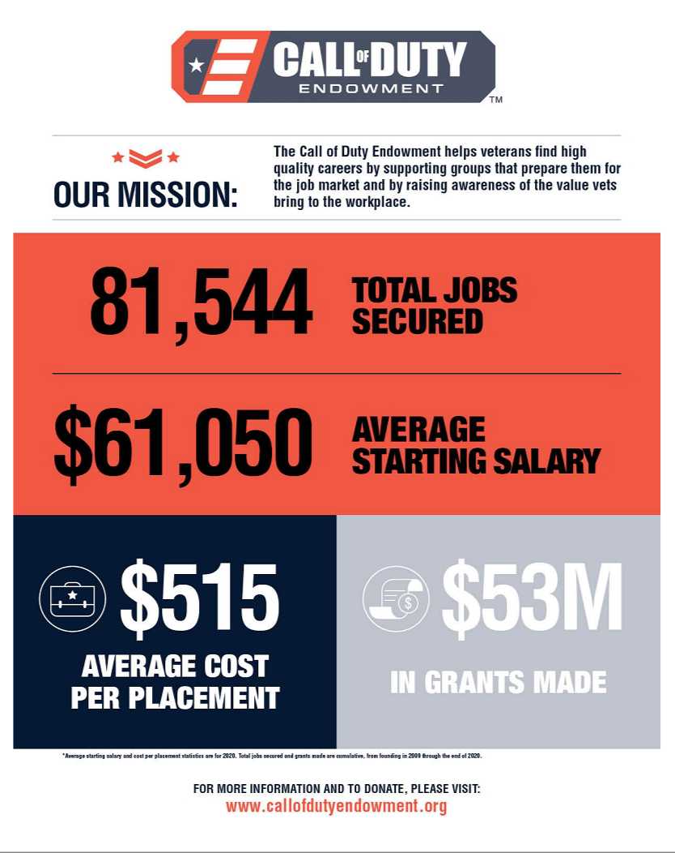

Back to Contents
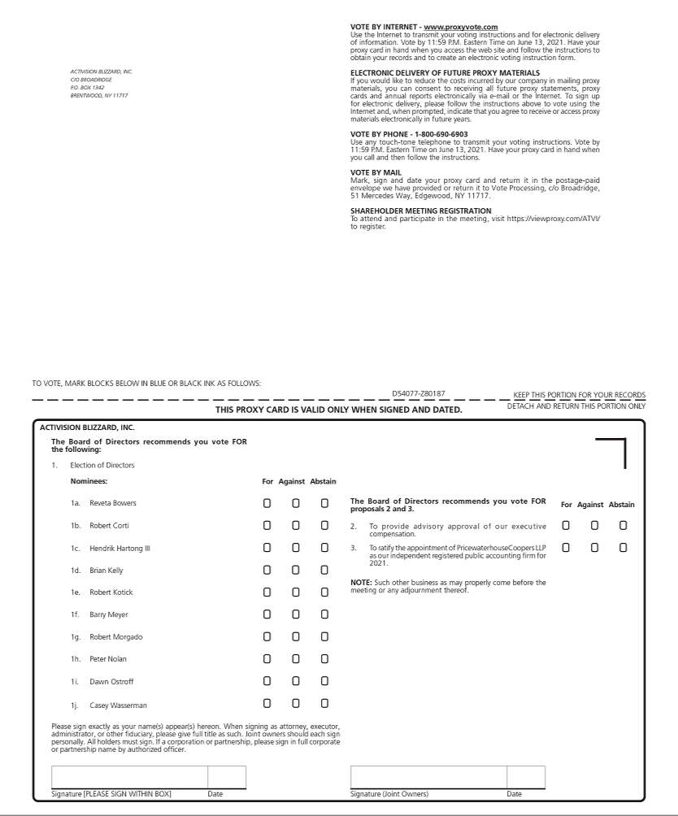

Back to Contents


